**THE IDEAL OPTION TO UNVEIL GALAPAGOS'UNDERWATER WONDERS EXPLORE THE GALAPAGOS ISLANDS DIFFERENTLY**

**8 DAYS / 7 NIGHTS**

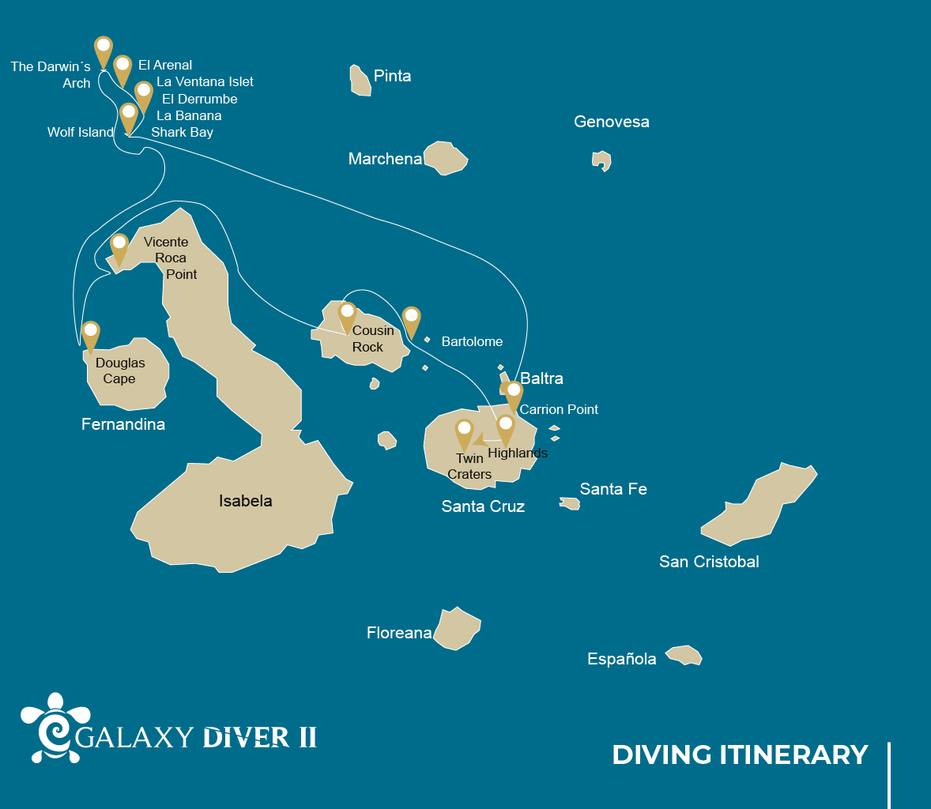

|  |  |  |  |
| --- | --- | --- | --- |
|  | | | **# DIVING** |
| WEDNESDAY | AM | Santa Cruz Island : Baltra - airport (arrival) | - |
|  | PM | Santa Cruz Island : Baltra Check Dive - GD2 | 1 |
| THURSDAY | AM | Santa Cruz Island : Diving at Punta Carrion | 2 |
|  | PM | Navigation : In route to Wolf Island | - |
| FRIDAY | AM | Wolf Island : Shark Bay / La Banana | 2 |
|  | PM | Wolf Island : La Ventana Islet / El Derrumbe | 2 |
| SATURDAY | AM | Darwin Island : El Arenal | 2 |
|  | PM | Darwin Island : The Darwin's Tower | 2 |
| SUNDAY | AM | Darwin Island : El Arenal | 2 |
|  | PM | Wolf Island : El Derrumbe and Shark Bay | 2 |
| MONDAY | AM | Fernandina Island : Douglas Cape | 2 |
|  | PM | Isabela Island : Vicente Roca Point | 1 |
| TUESDAY | AM | Santiago Island : Cousin Rock | 2 |
|  | PM | Santa Cruz Island : Highlands | - |
| WEDNESDAY | AM | Santa Cruz Island : Baltra - airport (return) |  |
|  | PM | Santa Cruz Island : Baltra - airport (return) | - |

DAY 1

AM: BALTRA (AIRPORT)

Welcome to Galapagos! Upon arrival at Baltra Airport, your naturalist guide will greet you and assist with the transfer to Itabaca Channel. This initial journey offers your first connection with the archipelago as you take a short ferry ride to Santa Cruz Island. Along the way, observe Baltra’s arid landscape and learn about its history as a former U.S. WWII airbase. This is just the beginning of the many fascinating stories awaiting you on your adventure.

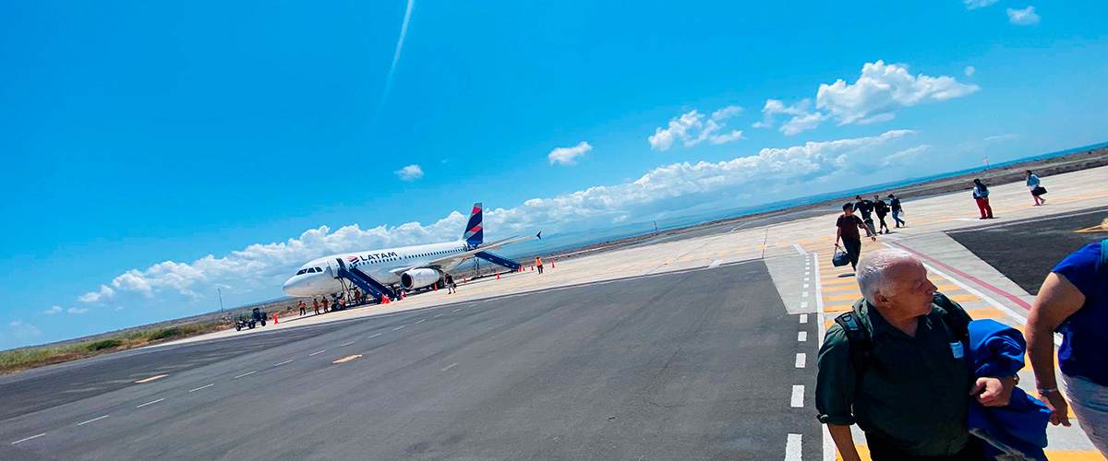

|  |  |
| --- | --- |
| **Immersions:** | - |

PM: BALTRA NORTHEAST / CHECK DIVE

Welcome to the Galapagos Islands! Today, we embark on an exciting diving adventure aboard the Galaxy Diver 2. Our journey begins at Baltra Airport, where our guide and the friendly crew will welcome us and assist with our luggage. From there, we’ll transfer to the yacht, settle in, and prepare to explore the stunning dive sites awaiting us in the days ahead. With crystal-clear waters and mesmerizing marine life, this expedition promises to be unforgettable.

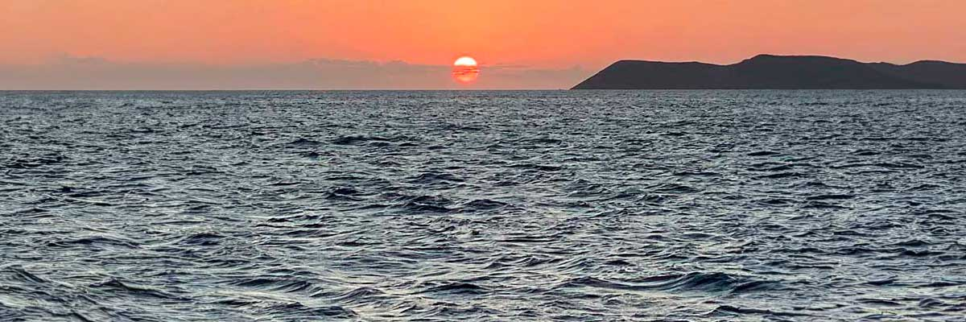

|  |  |
| --- | --- |
| **Food**: | -/L/D |
| **Lodging**: | M/Y Galaxy Diver II |
| **Immersions:** | 1 |

DAY 2

AM: CARRION POINT

As the sun rises on our first day of diving aboard the Galaxy Diver yacht, we can feel the excitement building for what's in store at our first dive site, Punta Carrion. We gather our gear, and with the guidance of our expert dive master instructors, we dive into the crystal-clear waters surrounding the stunning Santa Cruz Island. Descending deeper into the underwater world of Punta Carrion, we'll be immediately mesmerized by the incredible visibility and the abundance of marine life that surrounds us—schools of hammerhead and whale sharks, this last one available between June to December. At the same time, playful sea lions dart in and out of the rocky underwater cliffs.

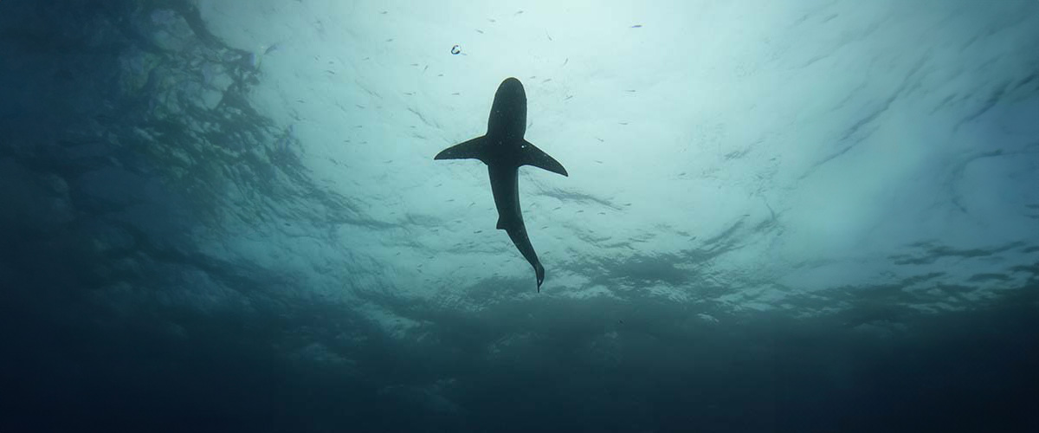

|  |  |
| --- | --- |
| **Immersions:** | 2 |

PM: IN ROUTE TO WOLF ISLAND

We learn more about the vivid and colorful world of tropical fish as we continue our exploration, including groups of surgeonfish, angelfish, and parrotfish. Luckily, we can even find a few secretive seahorses hidden in the reef's crevices. Later, we joyfully discuss our underwater excursions. At the same time, the onboard cook makes a lovely lunch when we return to the Galaxy Diver. Finally, in the late afternoon, we'll begin our 14 hours of navigation through the Galapagos Sea to Wolf Island.

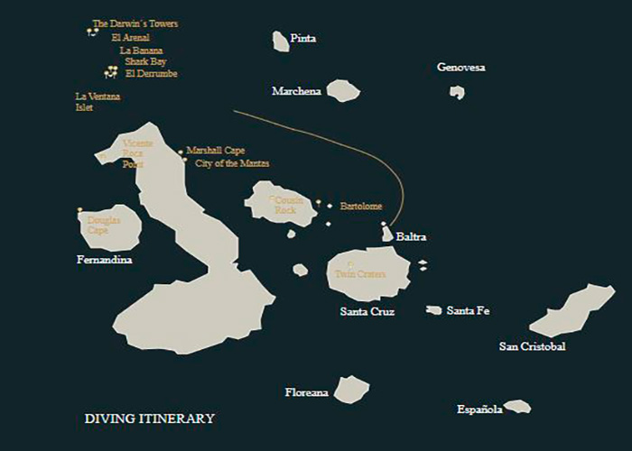

|  |  |
| --- | --- |
| **Food**: | B/L/D |
| **Lodging**: | M/Y Galaxy Diver II |
| **Immersions:** | - |

DAY 3

AM: SHARK BAY / LA BANANA - A MAGNIFICENT MARINE EXPEDITION

Shark Bay at Wolf Island is one of the most exhilarating dive sites in the Galapagos. Its waters are home to massive schools of hammerhead and Galapagos sharks, and with some luck, we might even spot the ocean’s giants—whale sharks. The area is teeming with marine life, from Galapagos rays to sea turtles and tropical fish. After an unforgettable dive, we head to La Banana for a more playful but equally mesmerizing experience: sea lions darting and twirling around us, showcasing their incredible agility and curiosity in their natural habitat.

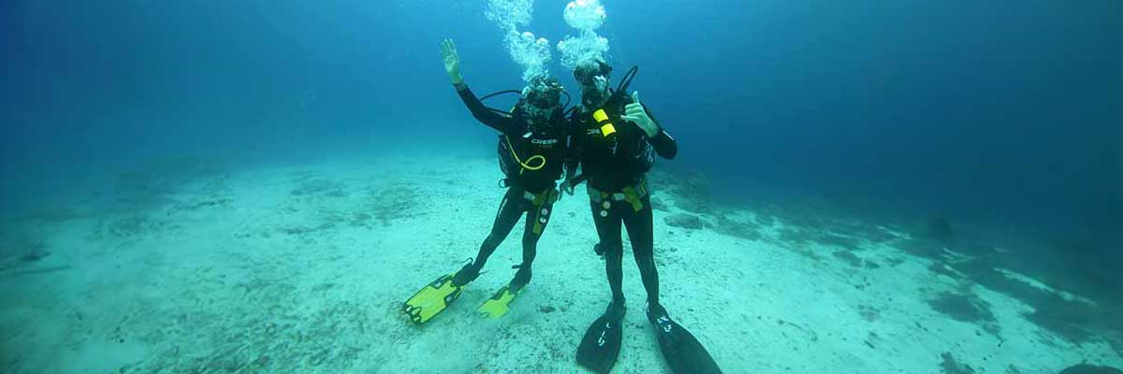

|  |  |
| --- | --- |
| **Immersions:** | 2 |

PM: LA VENTANA ISLET / EL DERRUMBE A MAGNIFICENT MARINE EXPEDITION

The Landslide at Wolf Island is one of the most famous dive sites in the Galapagos, accessible only by liveaboard. Named after German geologist Theodor Wolf, who mapped and studied the archipelago, this marine sanctuary teems with life. Schools of hammerhead and Galapagos sharks dominate the scene, while the occasional whale shark graces the depths. Rays, sea turtles, marine mammals, and an array of tropical fish add to the site’s dynamic ecosystem, making every dive an extraordinary adventure.

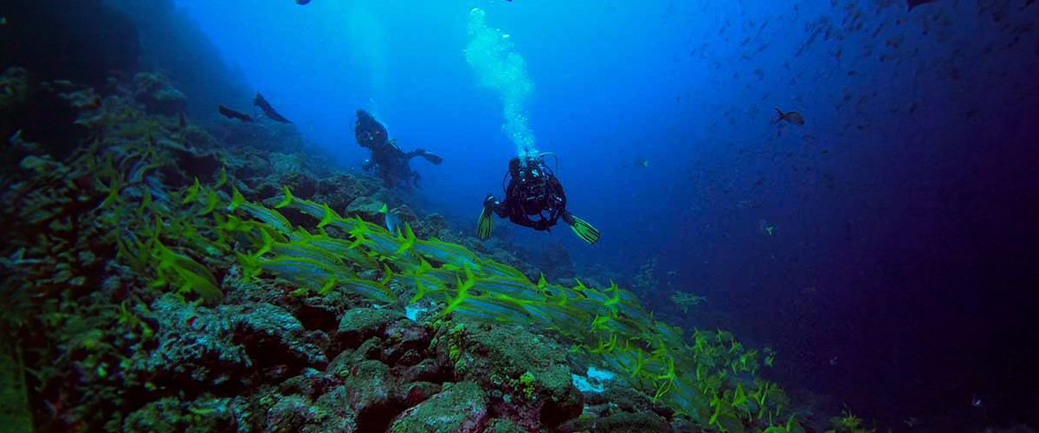

|  |  |
| --- | --- |
| **Food**: | B/L/D |
| **Lodging**: | M/Y Galaxy Diver II |
| **Immersions:** | 2 |

DAY 4

AM: EL ARENAL

Located deep in the Pacific, Darwin Island is a marine sanctuary renowned for its biodiversity. Alongside Wolf, it is one of the world’s premier dive spots. At El Arenal, a legendary site beneath Darwin’s Arch, nutrient-rich waters create an unparalleled spectacle. Dolphins hunt schools of fish while hammerhead and Galapagos sharks patrol the depths. If lucky, you may encounter whale sharks, tiger sharks, or even orcas. With moderate to strong currents and outstanding visibility, this site offers an unforgettable experience for diving enthusiasts.

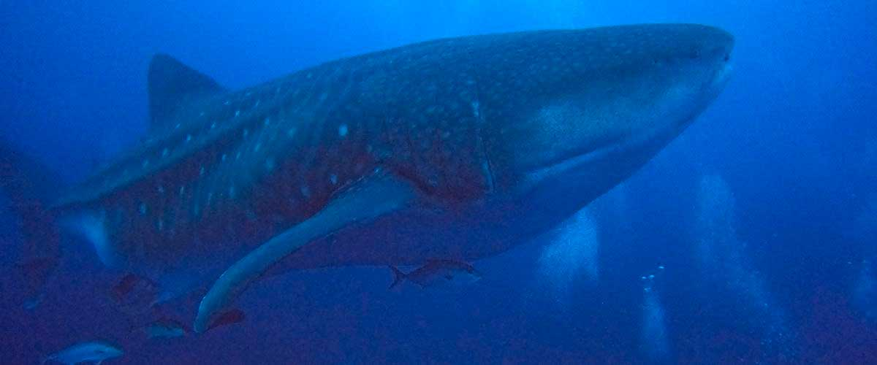

|  |  |
| --- | --- |
| **Immersions:** | 2 |

PM: THE DARWINS TOWER

We head to Darwin’s Tower, better known as Darwin’s Arch, one of the most legendary dive sites on the planet. This majestic rock formation serves as a gathering point for Galapagos’ incredible marine biodiversity. Beneath the waves, an awe-inspiring spectacle unfolds: vibrant coral reefs teeming with life, schools of colorful tropical fish, and, most impressively, the imposing presence of hammerhead sharks gliding gracefully through the depths. The experience of diving here is truly unmatched—one that will stay with you forever.

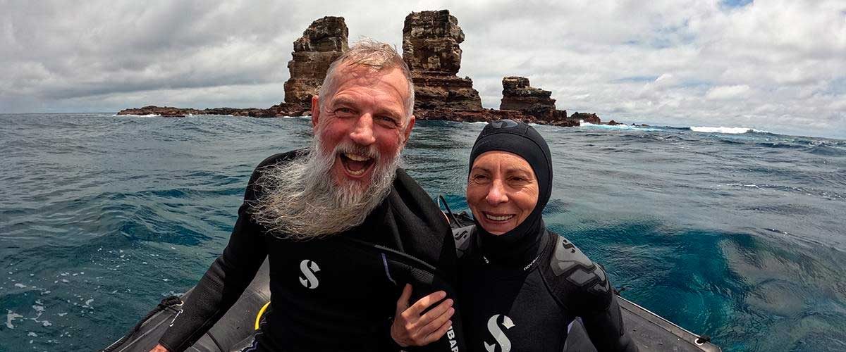

|  |  |
| --- | --- |
| **Food**: | B/L/D |
| **Lodging**: | M/Y Galaxy Diver II |
| **Immersions:** | 2 |

DAY 5

AM: EL ARENAL

We begin our day at El Arenal, one of the most thrilling dive sites in the Galapagos. As we descend, we enter a vibrant world of coral reefs and stunning volcanic formations. The marine life here is truly spectacular—hammerhead and Galapagos sharks roam in large schools while dolphins weave through fish shoals. If luck is on our side, we might spot whale sharks, tiger sharks, or even orcas. This site is not only remarkable for its wildlife but also for its striking geological formations, a testament to the archipelago’s volcanic past.

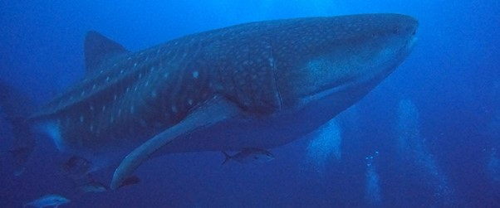

|  |  |
| --- | --- |
| **Immersions:** | 2 |

PM: EL DERRUMBE AND SHARK BAY

After an exhilarating morning dive, we explore El Derrumbe, a site filled with underwater cliffs and caves teeming with marine life. Here, youandamp;#039;ll encounter sea turtles, eagle rays, and playful sea lions. But what makes this site truly remarkable is the rare chance to dive with bull sharks in shallow waters. Our final dive takes us to Shark Bay, an underwater paradise home to Galapagos sharks and, from July to November, the elusive whale shark, offering an awe-inspiring encounter with one of the oceanandamp;#039;s true giants.

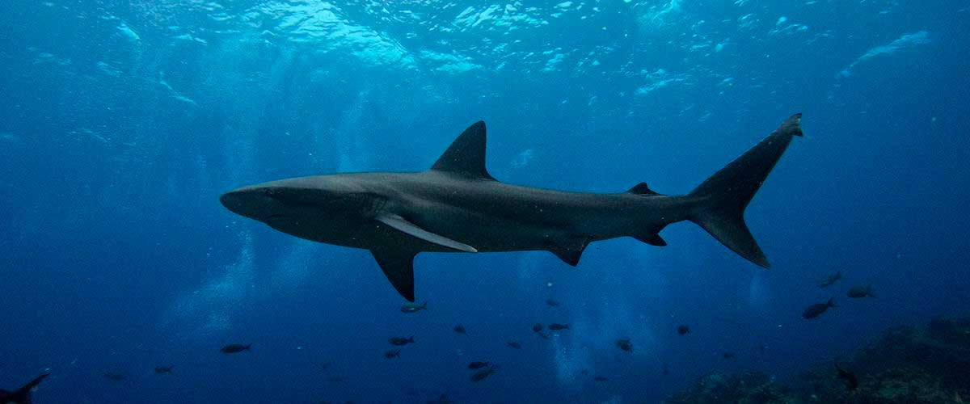

|  |  |
| --- | --- |
| **Food**: | B/L/D |
| **Lodging**: | M/Y Galaxy Diver II |
| **Immersions:** | 2 |

DAY 6

AM: DOUGLAS CAPE

Start your morning with a dive at Douglas Cape, a rare opportunity to observe Galapagos marine iguanas in their daily routine. First, they bask in the sun on the shore, preparing for their underwater feeding session. For about 20 minutes, they glide gracefully through the water, feeding on algae—an elegant contrast to their rugged, land-dwelling appearance. Upon emerging, they return to the rocks and expel excess salt through a unique spitting behavior. In addition to these fascinating reptiles, you may encounter Galapagos penguins, sharks, and vibrant schools of tropical fish.

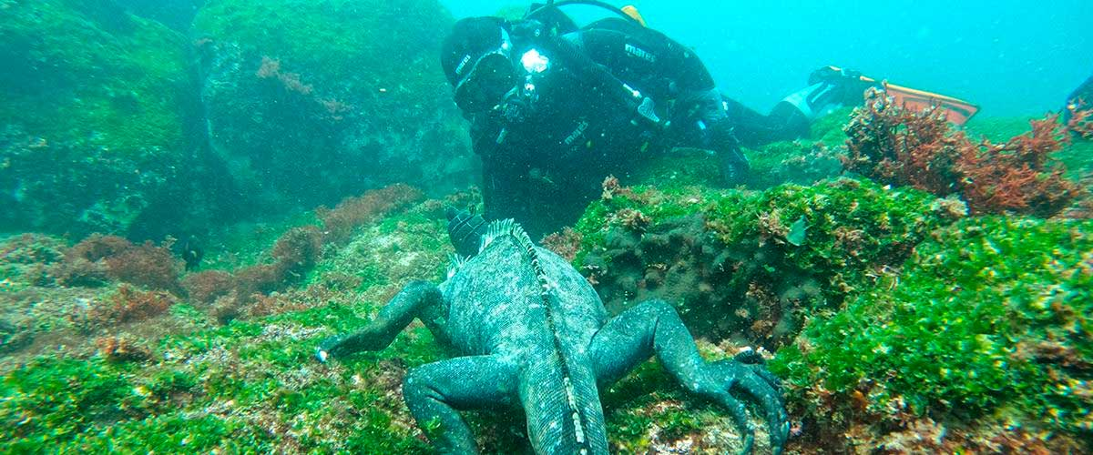

|  |  |
| --- | --- |
| **Immersions:** | 1 |

PM: VICENTE ROCA POINT

Vicente Roca Point offers a breathtaking natural spectacle, featuring some of the tallest cliffs in Galapagos and intriguing volcanic formations. While there are no trails, a dinghy tour along the shore provides an up-close look at the areaand#039;s rich wildlife. Highlights include flightless cormorants, blue-footed boobies, pelicans, and sea turtles. The site is also home to Galapagos fur seals and marine iguanas basking on the rocks. Moreover, the deep waters surrounding the area make it an excellent spot for dolphin and whale sightings.

Stunning Views, Galapagos penguins, Flightless cormorants, Marine iguanas, Sea turtles

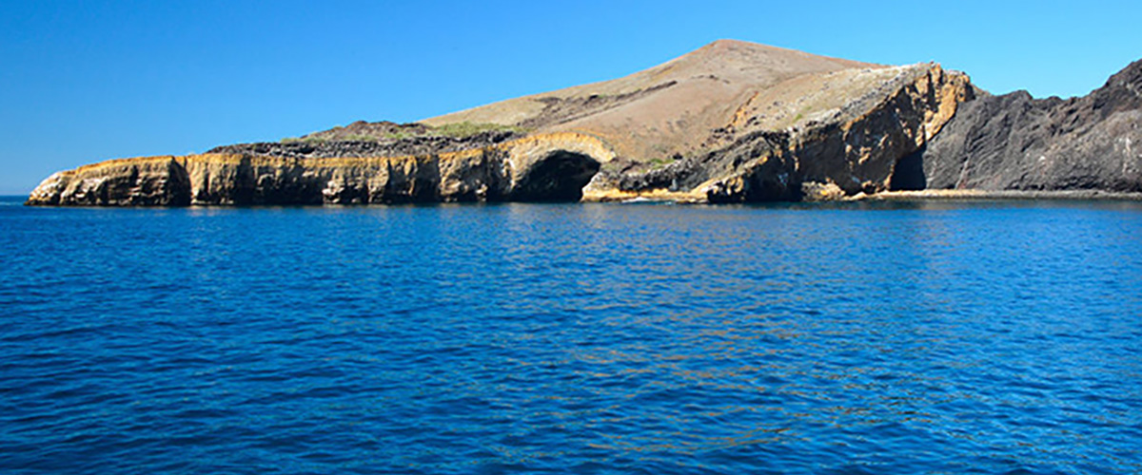

|  |  |
| --- | --- |
| **Food**: | B/L/D |
| **Lodging**: | M/Y Galaxy Diver II |
| **Immersions:** | 1 |

DAY 7

AM: COUSIN ROCK

Our final dive takes us to Cousin Rock, a fascinating dive site where corals and gorgonians create a mesmerizing underwater scene. Seahorses, reef fish, and colorful nudibranchs hide among the formations. Watch the agile coral hawkfish darting around, and as we dive deeper, we might spot graceful eagle rays gliding by or a white-tip shark resting in a crevice. If lucky, we could encounter schools of barracudas and mobula rays. To end on a high note, playful sea lions will join us for a final underwater adventure.

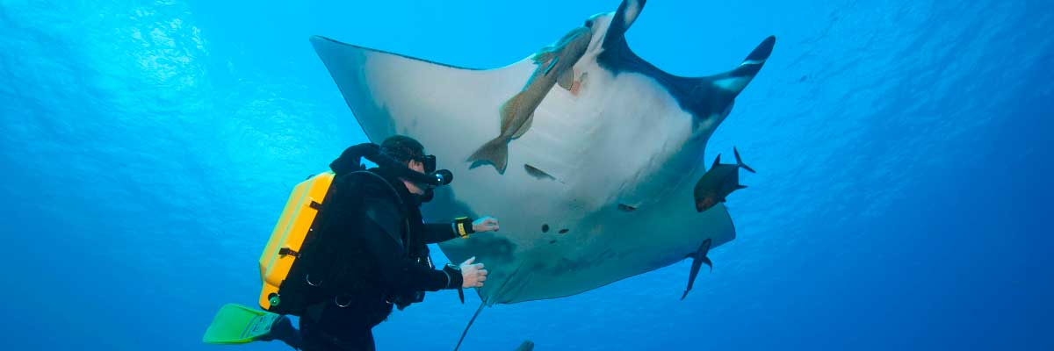

|  |  |
| --- | --- |
| **Immersions:** | 2 |

PM: HIGHLANDS

Begin your Galapagos adventure with a scenic bus ride into the lush Santa Cruz highlands. Walk through a reserve, spotting giant tortoises—some over 600 pounds—grazing peacefully. Discover endemic birds like finches and flycatchers. If included in your itinerary, explore a lava tunnel, a fascinating remnant of the volcanic forces that shaped these islands.

Lava tunnels, Darwin finches, Galapagos flycatchers, Giant tortoises, Barn owls, White-cheeked pintails

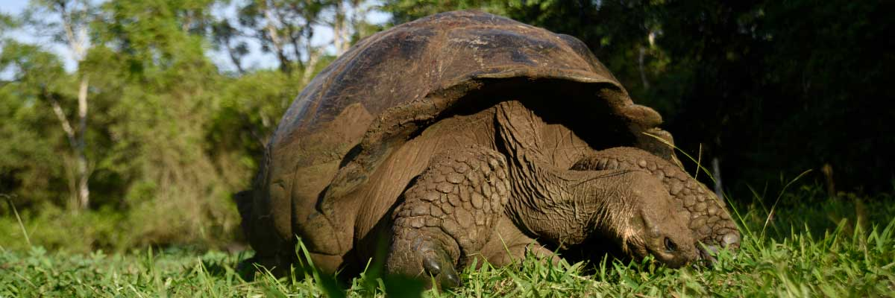

|  |  |
| --- | --- |
| **Food**: | B/L/D |
| **Lodging**: | M/Y Galaxy Diver II |
| **Immersions:** | - |

DAY 8

PM: BALTRA (AIRPORT)

Your Galapagos adventure comes to an end. Today, you will be transferred to Baltra Airport, where your National Park naturalist guide will assist you with final details before your flight back to mainland Ecuador. As you bid farewell to this paradise, take with you the unforgettable memories of one of the world’s most extraordinary destinations.



|  |  |
| --- | --- |
| **Immersions:** | - |

PM: BALTRA (AIRPORT)

Your Galapagos adventure comes to an end. Today, you will be transferred to Baltra Airport, where your National Park naturalist guide will assist you with final details before your flight back to mainland Ecuador. As you bid farewell to this paradise, take with you the unforgettable memories of one of the world’s most extraordinary destinations.



|  |  |
| --- | --- |
| **Food**: | B/-/- |
| **Lodging**: | M/Y Galaxy Diver II |
| **Immersions:** | - |

GLOSSARY

|  |  |  |
| --- | --- | --- |
| **Feeding** | **Breakfast** | B |
| **Lunch** | L |
| **Dinner** | D |
| **Difficulty of the hike** | **Level 1** | Easy |
| **Level 2** | Moderate |
| **Level 3** | Difficult |