**The Unforgettable Journey Among Land Giants and Marine Marvels**

**6 DAYS / 5 NIGHTS**

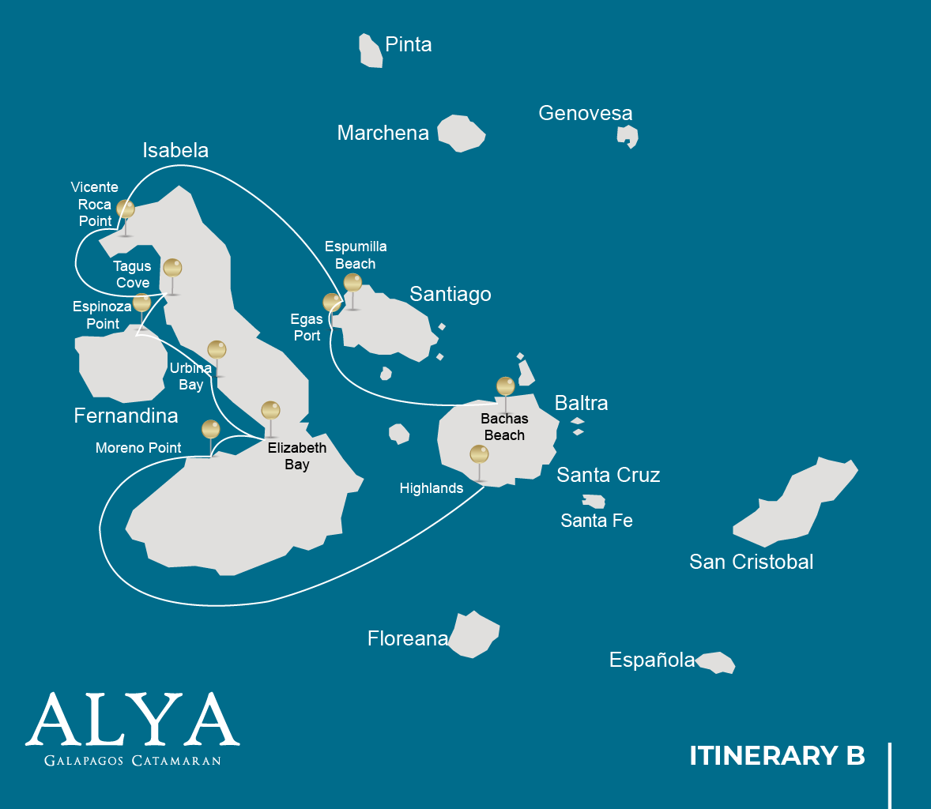

|  |  |  |  |  |  |  |  |
| --- | --- | --- | --- | --- | --- | --- | --- |
|  | | | **Hiking** | **Snorkel** | **Panga Ride** | **Paddle Board** | **Kayak** |
| MONDAY | AM | **Santa Cruz Island :** Baltra - airport (arrival) |  |  |  |  |  |
|  | PM | **Santa Cruz Island :** Highlands | * |  |  |  |  |
| TUESDAY | AM | **Isabela Island :** Moreno Point | * | * | * |  |  |
|  | PM | **Isabela Island :** Elizabeth Bay |  |  | * | * | * |
| WEDNESDAY | AM | **Isabela Island :** Urbina Bay | * | * |  |  |  |
|  | PM | **Fernandina Island :** Espinoza Point | * | * | * |  |  |
| THURSDAY | AM | **Isabela Island :** Tagus Cove | * | * | * | * | * |
|  | PM | **Isabela Island :** Vicente Roca Point |  | * | * |  |  |
| FRIDAY | AM | **Santiago Island :** Espumilla Beach | * |  |  |  |  |
|  | PM | **Santiago Island :** Egas Port | * | * |  |  |  |
| SATURDAY | AM | **Santa Cruz Island :** Bachas Beach | * |  |  |  |  |
|  | PM | **Santa Cruz Island :** Baltra - airport (return) |  |  |  |  |  |

DAY 1

AM: BALTRA AIRPORT

Your voyage to the captivating Galapagos Islands commences! Upon your arrival at Baltra Airport, you'll be greeted by our National Park-certified naturalist guide, ready to introduce you to the unique wonders of this pristine archipelago.

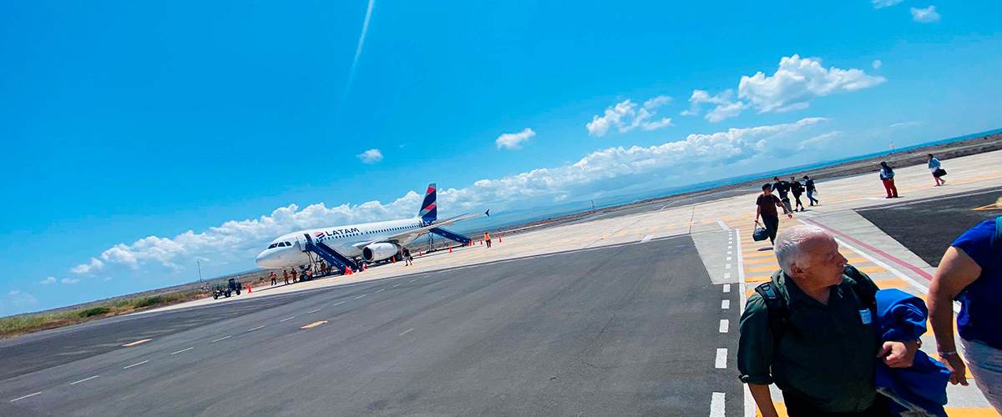

|  |  |
| --- | --- |
| **Trail:** |  |
| **Level**: | 1 |
| **Activities:** | - |

PM: HIGHLANDS

Embark on a highlands adventure, either from Baltra or Puerto Ayora. A bus journey brings you to the verdant highland forests, home to Galapagos Giant tortoises. You'll find these impressive creatures, weighing up to 300 kg/600 lbs, casually grazing or lounging in freshwater ponds. The highlands also host a variety of bird species seldom seen in the lowlands. Depending on your itinerary, explore a lava tunnel and delve into the geological history of these volcanic islands.

Lava tunnels, Darwin finches, Galapagos flycatchers, Giant tortoises, Barn owls, White-cheeked pintails

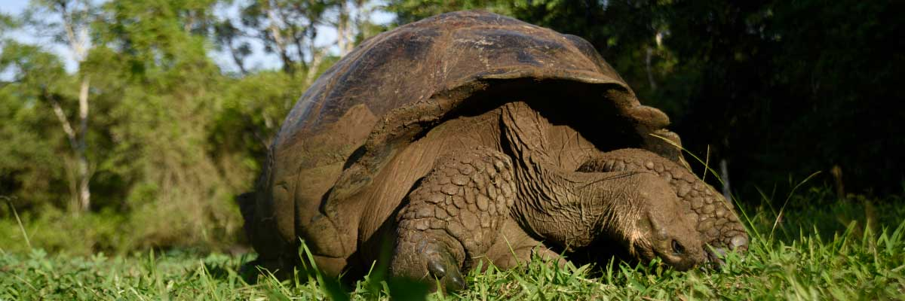

|  |  |
| --- | --- |
| **Food**: | -/L/D |
| **Trail:** | 1-1,5 km / 0,6-0,9 mi |
| **Lodging**: | M/C Alya |
| **Level**: | 1 |
| **Activities:** | HIKING |

DAY 2

AM: MORENO POINT

Commence your day at the enchanted Moreno Point. The extensive lava fields may first appear lifeless, but within its borders lie scattered brackish lagoons teeming with life such as flamingos, gallinules, ducks, and herons. Along the coast, keep an eye out for penguins, marine iguanas, flightless cormorants, blue-footed boobies, sea lions, oystercatchers, and other shore birds.

Snorkel Experience: Dip into the refreshing water and explore a mesmerizing underwater world populated by sea turtles, cormorants, and a myriad of fish species. Look carefully within the long seaweeds; you might discover a charming sea horse.

**Highlights:**  Stunning Views, Galapagos mockingbirds, Darwin finches, American flamingoes, Flightless cormorants, Marine iguanas, Ducks, Gallinules

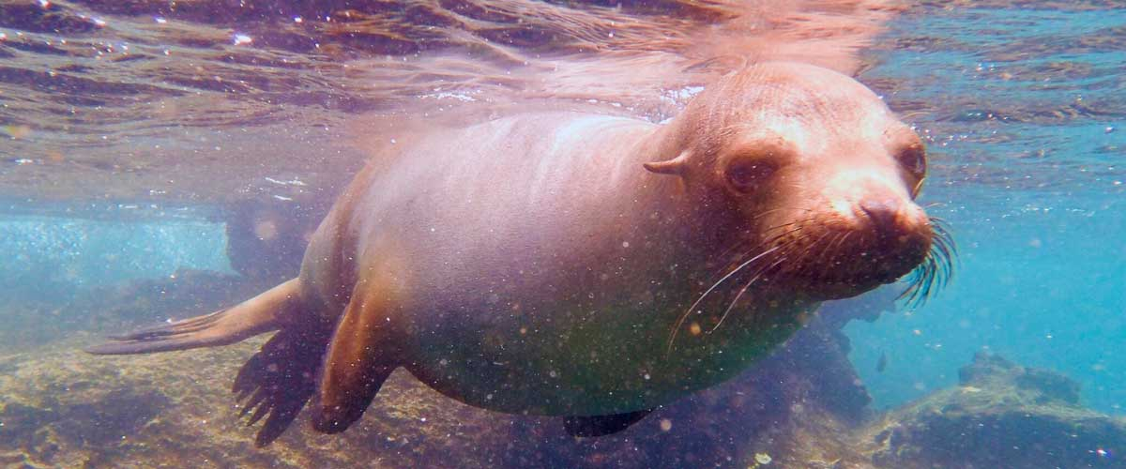

|  |  |
| --- | --- |
| **Trail:** | 1,6 km / 1 mi |
| **Level**: | 3 |
| **Activities:** | HIKING,SNORKEL,PANGA RIDE |

PM: ELIZABETH BAY

Elizabeth Bay, your afternoon stop, is a sheltered bay encircled by towering mangroves and barren lava fields. There are no trails here, so you'll undertake a dinghy tour to explore the teeming channels, pools, and coves. This location is one of the finest to observe Galapagos penguins, flightless cormorants, blue-footed boobies, pelicans, rays, and sea turtles.

**Highlights:** Mangroves, Rays, Herons, Galapagos penguins, Galapagos hawks, Flightless cormorants, Sea turtles

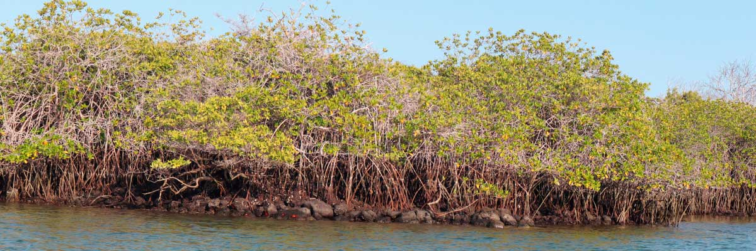

|  |  |
| --- | --- |
| **Food**: | B/L/D |
| **Trail:** | 1,4 km / 0,8 mi |
| **Lodging**: | M/C Alya |
| **Level**: | 1 |
| **Activities:** | PANGA RIDE,PADDLE BOARD,KAYAK |

DAY 3

AM: URBINA BAY

Urbina Bay, known for its dramatic uplift during the 1950s, awaits your visit in the morning. As you traverse the trail, observe small shells and corals, indicators that this area was submerged just over sixty years ago. Here you can encounter land iguanas and, during certain seasons, giant tortoises. Galapagos hawks nest in the area, often seen soaring or perched on trees.

Snorkel Experience: Snorkel from the beach to spot sea turtles, flightless cormorants, and penguins. The area also boasts an abundance of fish.

**Highlights:**  Stunning Views, Galapagos mockingbirds, Galapagos hawks, Darwin finches, Galapagos flycatchers, Galapagos land iguanas

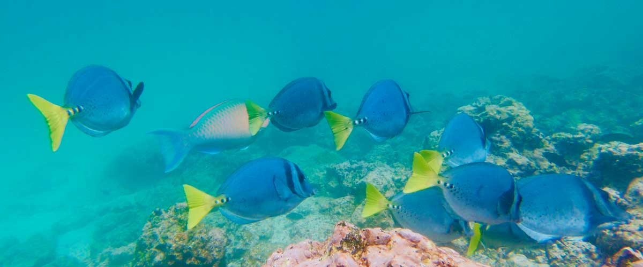

|  |  |
| --- | --- |
| **Trail:** | 1,2 km / 0,7 mi. Long trail 3,0 km / 1,8 mi |
| **Level**: | 1 |
| **Activities:** | HIKING,SNORKEL |

PM: ESPINOZA POINT

Espinoza Point is a National Park gem located at the base of an imposing volcano (the most active in the Galapagos islands). Upon landing, be greeted by hundreds of marine iguanas in the largest colony for the species. Also present are sea lions, flightless cormorants, herons, pelicans, oystercatchers, sea turtles, shorebirds, and more. Look to the mangroves where Galapagos hawks often perch, on the lookout for prey.

Snorkel Experience: Immerse yourself in the nutrient-rich waters around Espinoza Point, brimming with a plethora of fish and sea turtles. Witness marine iguanas feeding underwater amidst a cornucopia of seaweeds.

**Highlights:** Stunning Views, Herons, Galapagos penguins, Oystercatchers, Galapagos hawks, Marine iguanas, Sea turtles, Shorebirds

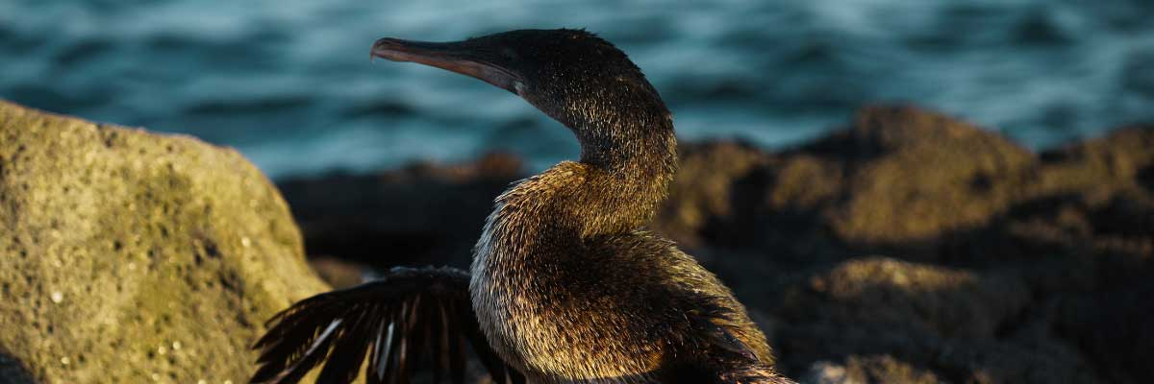

|  |  |
| --- | --- |
| **Food**: | B/L/D |
| **Trail:** | 1,6 km / 1 mi |
| **Lodging**: | M/C Alya |
| **Level**: | 2 |
| **Activities:** | HIKING,SNORKEL,PANGA RIDE |

DAY 4

AM: TAGUS COVE

Tagus Cove, a location visited by Charles Darwin during his Galapagos exploration, offers a dry Palo Santo forest where Darwin finches and mockingbirds reside. Take in the marvelous views of Darwin's Lake and the grand volcanos of northern Isabela. A boat tour along the coast will reveal penguins, cormorants, marine iguanas, and the Galapagos martin, an endangered endemic species.

Snorkel Experience: Dive into the nutrient-rich waters around Tagus Cove, where many sea turtles, a great diversity of fish, and penguins await, feasting on large schools of anchovies. Cormorants are commonly spotted underwater as they chase fish through the reef.

**Highlights:**  Stunning Views, Herons, Galapagos penguins, Galapagos hawks, Flightless cormorants, Marine iguanas, Sea turtles, Sea stars

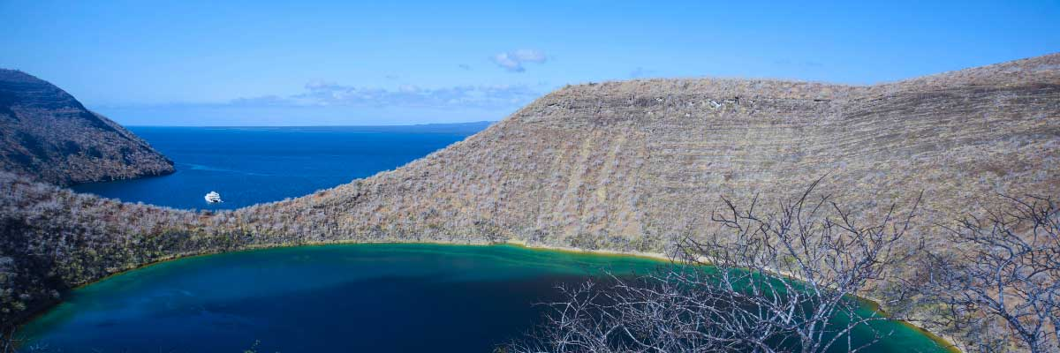

|  |  |
| --- | --- |
| **Trail:** | 2,6 km / 1,6 mi |
| **Level**: | 3 |
| **Activities:** | HIKING,SNORKEL,PANGA RIDE,PADDLE BOARD,KAYAK |

PM: VICENTE ROCA POINT

Vicente Roca Point, surrounded by some of the tallest cliffs in the Galapagos, is ideal for observing breathtaking landscapes and interesting volcanic features. A dinghy tour will offer closer views of pelicans, flightless cormorants, sea turtles, boobies, Galapagos fur seals, and marine iguanas. Whales and dolphins also frequent the area.

Snorkel Experience: Venture beneath the waves to see sea turtles, penguins, sea lions, cormorants, rays, and many different fish species. Watch for fan corals, sponges, and other invertebrates growing on the walls.

**Highlights:** Stunning Views, Galapagos penguins, Flightless cormorants, Marine iguanas, Sea turtles

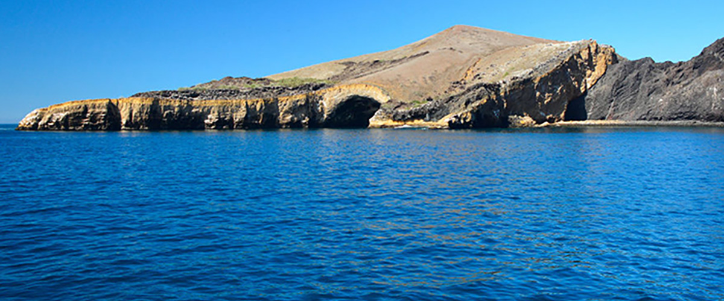

|  |  |
| --- | --- |
| **Food**: | B/L/D |
| **Trail:** | 1,4 km / 0,8 mi |
| **Lodging**: | M/C Alya |
| **Level**: | 1 |
| **Activities:** | SNORKEL,PANGA RIDE |

DAY 5

AM: ESPUMILLA BEACH

Discover the beauty of Espumilla Beach, a long stretch of rusty-brown sand on Santiago’s northern coast. Surrounded by dense mangroves and a captivating dry forest, it is home to various bird species, including the Galapagos hawk, finches, mockingbirds, and doves. During the rainy season, the salt pan bursts with life as flamingos and ducks wade through the shallow waters. This destination blends stunning landscapes with rich biodiversity, making it a perfect spot for birdwatching and nature immersion.

**Highlights:**  Stunning Views, Herons, Galapagos mockingbirds, Oystercatchers, Galapagos hawks, Darwin finches, Bobbies

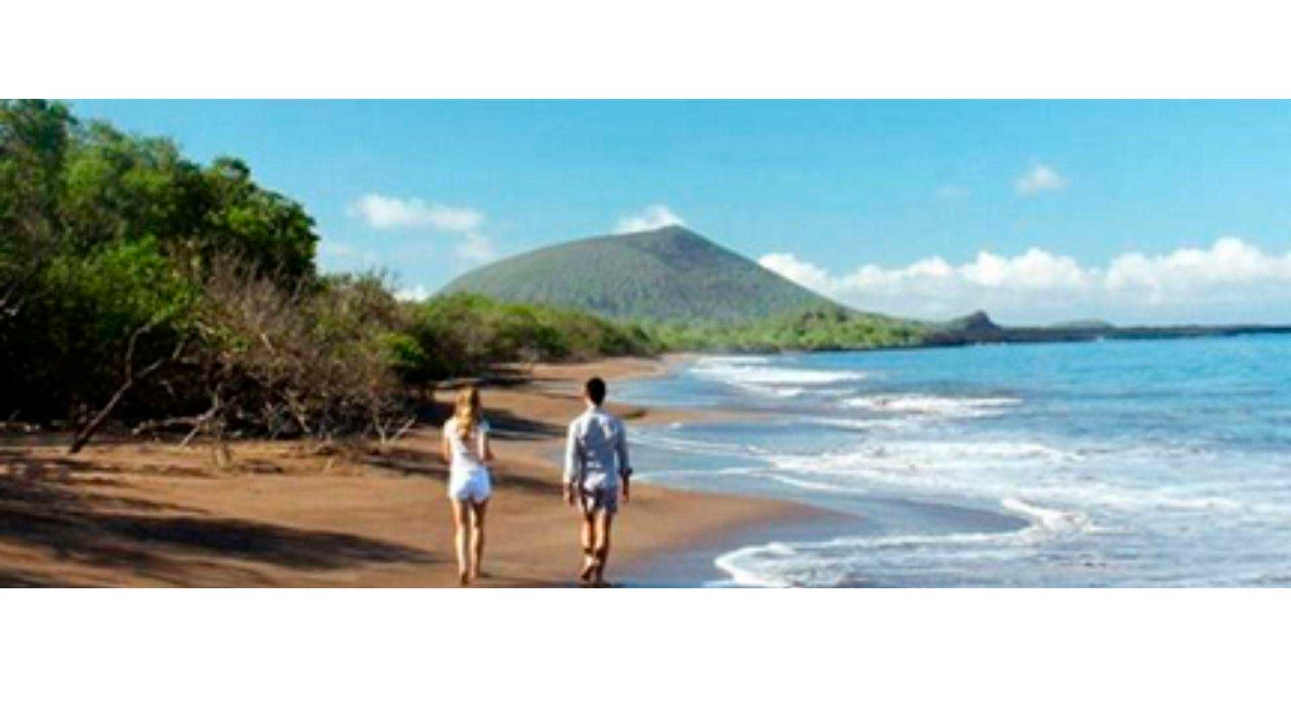

|  |  |
| --- | --- |
| **Trail:** | 2,3 km / 1,4 mi (plus an extra loop 1 km - 0,6 mi) |
| **Level**: | 1 |
| **Activities:** | HIKING |

PM: EGAS PORT

Puerto Egas is a fascinating destination where history and wildlife intertwine. While there is no actual port, remnants of 1960s colonization attempts still stand. The coastal trail is teeming with marine iguanas basking in the sun and sea lions resting on the rocks. Herons, oystercatchers, and shorebirds complete this thriving ecosystem. Towards the end of the trail, the grottos are home to a small colony of the elusive Galapagos fur seal. Additionally, land iguanas were reintroduced to the island in 2019 after over a century of absence.

Snorkel Experience: A snorkeling session from the beach will lead you to an area of rocky bottoms, excellent for observing fish, turtles, and reef sharks. Sea lions often frequent this area and are typically open to interacting with divers.

**Highlights:** Stunning Views, Herons, Galapagos sea lions, Galapagos fur seals, Oystercatchers, Galapagos hawks, Darwin finches, Marine and land iguanas, Galapagos doves, Shorebirds

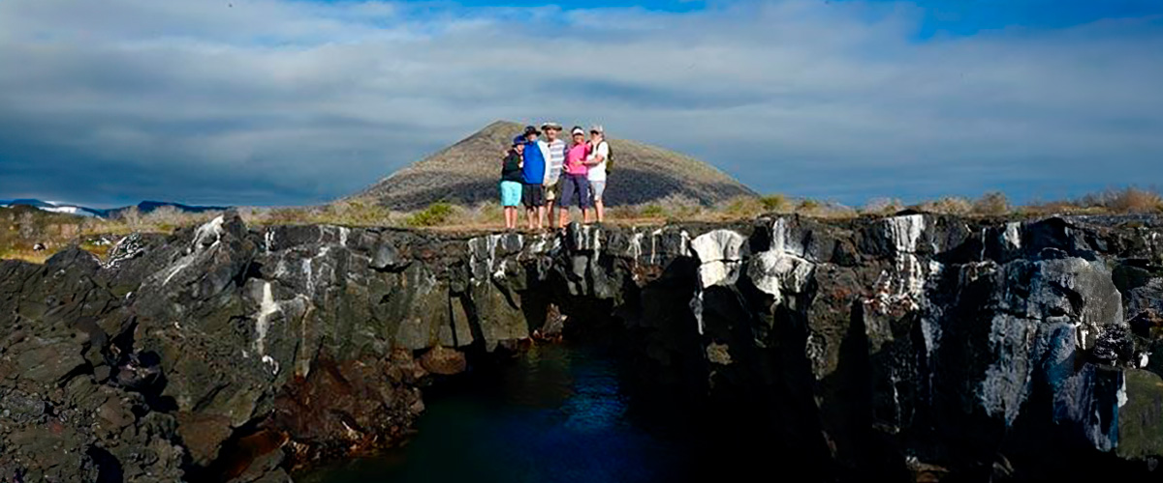

|  |  |
| --- | --- |
| **Food**: | B/L/D |
| **Trail:** | 2,3 km / 1,4 mi |
| **Lodging**: | M/C Alya |
| **Level**: | 1 |
| **Activities:** | HIKING,SNORKEL |

DAY 6

AM:BACHAS

End your Galapagos adventure at Bachas Beach, a key sea turtle nesting site from November to May. At low tide, remnants of WWII barges emerge from the white sand. Explore its saltwater lagoons, home to flamingos, herons, and aquatic birds. After this final stop, transfer to the airport for your flight back to the mainland, concluding an unforgettable journey.

Stunning Views, Blue footed boobies, White-cheeked pintails, American flamingoes, Sandpipers, Lava gulls

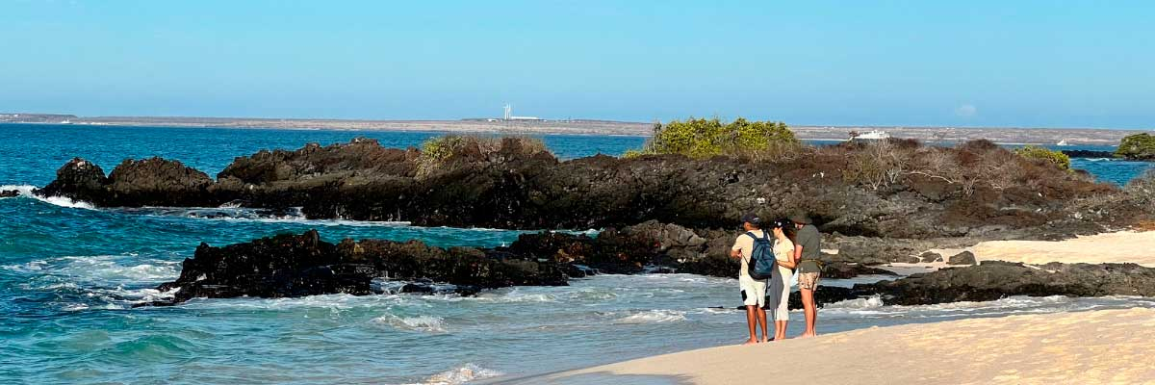

|  |  |
| --- | --- |
| **Trail:** | 1,6 km / 1 mi |
| **Level**: | 1 |
| **Activities:** | HIKING |

PM: BALTRA (AIRPORT)

Your Galapagos adventure comes to an end. Today, you will be transferred to Baltra Airport, where your National Park naturalist guide will assist you with final details before your flight back to mainland Ecuador. As you bid farewell to this paradise, take with you the unforgettable memories of one of the world’s most extraordinary destinations.



|  |  |
| --- | --- |
| **Food**: | B/-/- |
| **Trail:** |  |
| **Lodging**: | M/C Alya |
| **Level**: | 1 |
| **Activities:** | - |

GLOSSARY

|  |  |  |  |
| --- | --- | --- | --- |
| **Feeding** | | **Breakfast** | B |
| **Lunch** | L |
| **Dinner** | D |
| **Difficulty of the hike** | | **Level 1** | Easy |
| **Level 2** | Moderate |
| **Level 3** | Difficult |