**GALAXY DIVER II OFFERS YOU AN ULTIMATE GALAPAGOS ADVENTURE**

**8 DAYS / 7 NIGHTS**

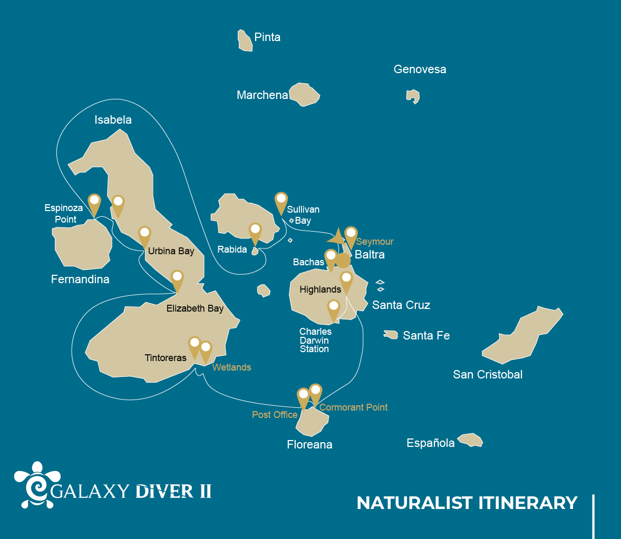

|  |  |  |  |  |  |
| --- | --- | --- | --- | --- | --- |
|  | | | **Hiking** | **Snorkel** | **Panga Ride** |
| WEDNESDAY | AM | **Santa Cruz Island :** Baltra - airport (arrival) |  |  |  |
|  | PM | **Santa Cruz Island :** Bachas Beach | * |  |  |
| THURSDAY | AM | **Santiago Island :** Sullivan Bay | * | * |  |
|  | PM | **Rabida Island :** Rabida | * | * | * |
| FRIDAY | AM | **Fernandina Island :** Espinoza Point | * | * |  |
|  | PM | **Isabela Island :** Tagus Cove | * | * | * |
| SATURDAY | AM | **Isabela Island :** Urbina Bay | * | * |  |
|  | PM | **Isabela Island :** Elizabeth Bay |  |  | * |
| SUNDAY | AM | **Isabela Island :** Tintoreras | * | * | * |
|  | PM | **Isabela Island :** Wetlands - Isabela | * |  |  |
| MONDAY | AM | **Floreana Island :** Post Office Bay | * | * |  |
|  | PM | **Floreana Island :** Cormorant Point | * | * | * |
| TUESDAY | AM | **Santa Cruz Island :** Highlands | * |  |  |
|  | PM | **Santa Cruz Island :** Charles Darwin Station | * |  |  |
| WEDNESDAY | AM | **Seymour Island :** North Seymour | * |  |  |
|  | PM | **Santa Cruz Island :** Baltra - airport (return) |  |  |  |

DAY 1

AM: BALTRA AIRPORT

Welcome to Galapagos! Upon arrival at Baltra Airport, your naturalist guide will greet you and assist with the transfer to Itabaca Channel. This initial journey offers your first connection with the archipelago as you take a short ferry ride to Santa Cruz Island. Along the way, observe Baltra’s arid landscape and learn about its history as a former U.S. WWII airbase. This is just the beginning of the many fascinating stories awaiting you on your adventure.

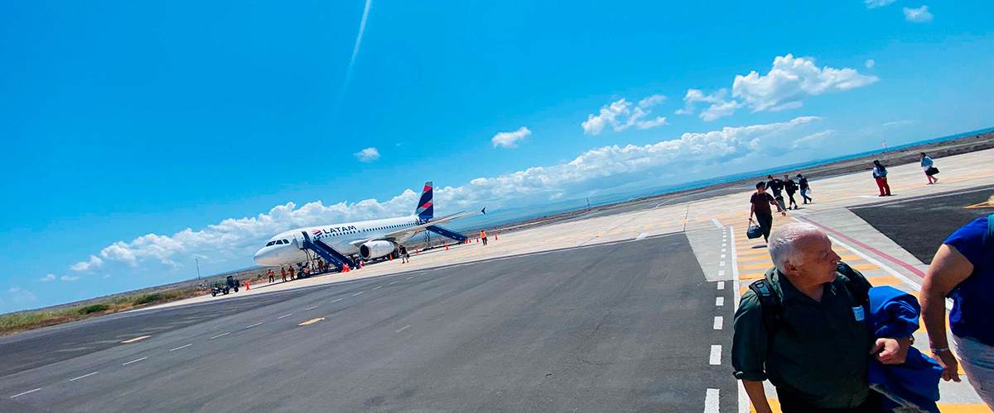

|  |  |
| --- | --- |
| **Trail:** |  |
| **Level**: | 1 |
| **Activities:** | - |

PM: BACHAS BEACH

End your Galapagos adventure at Bachas Beach, a key sea turtle nesting site from November to May. At low tide, remnants of WWII barges emerge from the white sand. Explore its saltwater lagoons, home to flamingos, herons, and aquatic birds. After this final stop, transfer to the airport for your flight back to the mainland, concluding an unforgettable journey.

Stunning Views, Blue footed boobies, White-cheeked pintails, American flamingoes, Sandpipers, Lava gulls

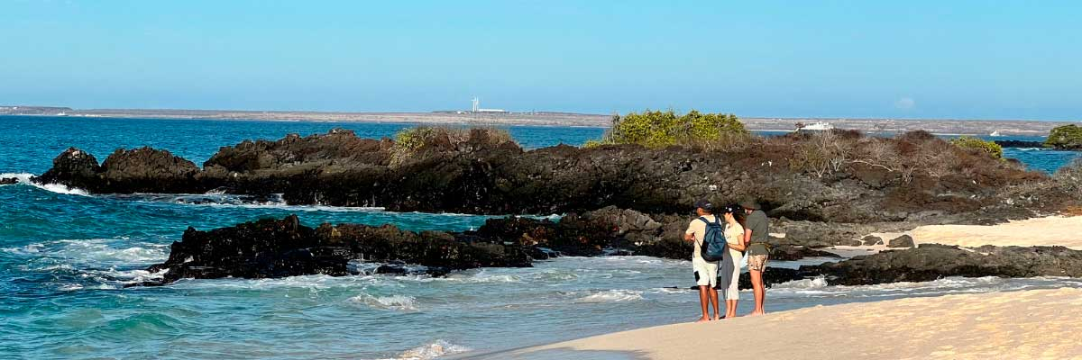

|  |  |
| --- | --- |
| **Food**: | -/L/D |
| **Trail:** | 1,6 km / 1 mi |
| **Lodging**: | M/Y Galaxy Diver II |
| **Level**: | 1 |
| **Activities:** | HIKING |

DAY 2

AM: SULLIVAN BAY

Walking through Sullivan Bay is a fascinating journey into the volcanic origins of the Galapagos Islands. The trail crosses a vast Pahoehoe lava flow, showcasing unique textures that reveal the story of past eruptions. While the terrain may seem desolate at first, a closer look unveils pioneer plants, scurrying lava lizards, and small birds adapted to this extreme environment. Along the shore, the stark landscape is brightened by the presence of penguins, pelicans, and oystercatchers, adding a vibrant contrast to the stunning volcanic scenery.

Snorkel Experience: After the hike, unwind with a swim or snorkeling session from a coral-sand beach or a dinghy. The contrast with the barren land is striking—schools of fish, Galapagos penguins, reef sharks, sea turtles, and rays thrive in this vibrant marine ecosystem.

**Highlights:**  Lava tubes, Galapagos penguins, Oystercatchers, Galapagos hawks

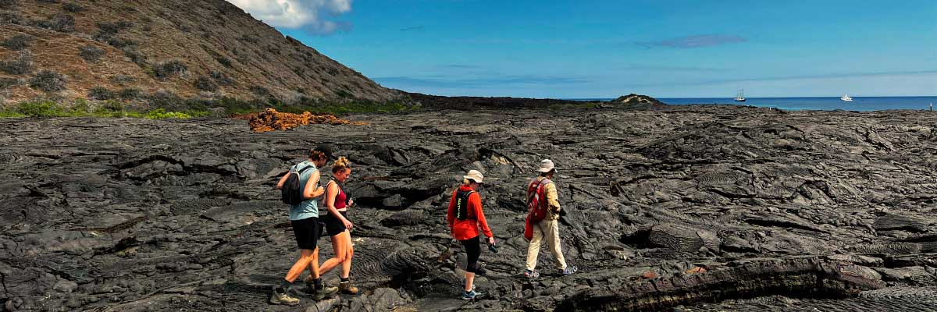

|  |  |
| --- | --- |
| **Trail:** | 2,2 km / 1,4 mi |
| **Level**: | 1 |
| **Activities:** | HIKING,SNORKEL |

PM: RABIDA

Rabida Island is one of the most distinctive in the archipelago, with its red sand and iron-rich volcanic formations. On the beach, a colony of sea lions basks in the sun, while a small saltwater lagoon shelters flamingos, ducks, and stilts. The inland trail offers stunning views of the beach and lagoon, with Darwin’s finches, flycatchers, and mockingbirds along the way. Coastal cliffs provide a vantage point to spot Nazca and blue-footed boobies, brown noddies, and herons. Rabida is also one of the few places where you can see both species of sea lions: the Galapagos sea lion and the fur seal.

Snorkel Experience: From Rabida’s red beach, snorkel in protected waters teeming with tropical fish, sea lions, and reef sharks. The rocky walls shelter a stunning array of marine invertebrates.

**Highlights:** Red-sand beach, Galapagos sea lions, Galapagos hawks, Darwin finches, Galapagos flycatchers

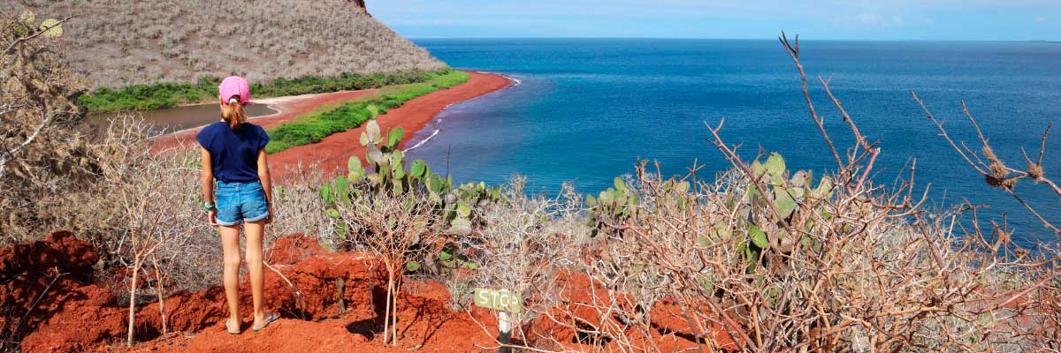

|  |  |
| --- | --- |
| **Food**: | B/L/D |
| **Trail:** | 2 km / 1,2 mi |
| **Lodging**: | M/Y Galaxy Diver II |
| **Level**: | 1 |
| **Activities:** | HIKING,SNORKEL,PANGA RIDE |

DAY 3

AM: ESPINOZA POINT

Espinoza Point is a true natural wonder, set at the base of the most active volcano in Galapagos. As you step ashore, you’ll be greeted by the largest colony of marine iguanas basking on black volcanic rocks. Sea lions lounge on the beach while their pups explore tide pools. Flightless cormorants patrol the shoreline, and in the mangroves, Galapagos hawks scan for prey. Blessed with cold, plankton-rich waters, this area teems with life—herons, oystercatchers, pelicans, and sea turtles all thrive in this untouched habitat.

Snorkel Experience: The nutrient-rich waters of Espinoza Point attract fish, sea turtles, and foraging cormorants. Watch marine iguanas feeding on algae and follow a cormorant as it chases fish through the reef—an unforgettable snorkeling experience in Galapagos.

**Highlights:**  Stunning Views, Herons, Galapagos penguins, Oystercatchers, Galapagos hawks, Marine iguanas, Sea turtles, Shorebirds

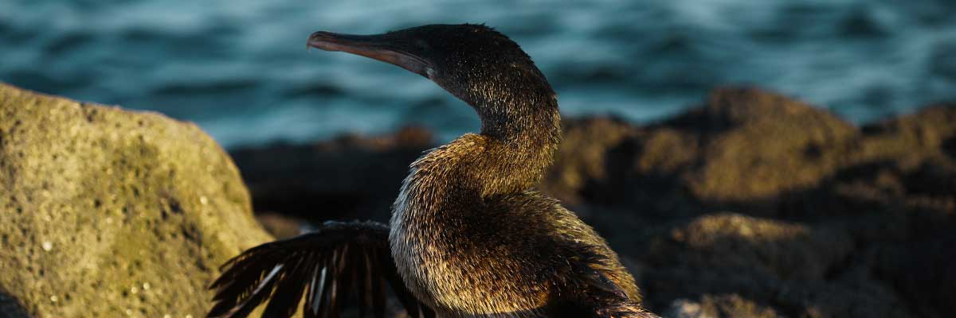

|  |  |
| --- | --- |
| **Trail:** | 1,6 km / 1 mi |
| **Level**: | 1 |
| **Activities:** | HIKING,SNORKEL |

PM: TAGUS COVE

Tagus Cove is steeped in history, once visited by Charles Darwin during his Galapagos exploration. A scenic trail winds through dry Palo Santo forests, where Darwin’s finches and mockingbirds can be spotted. At the top, breathtaking views of Lake Darwin and Isabela’s towering volcanoes await. A boat tour along the shore provides a chance to observe Galapagos penguins, flightless cormorants, marine iguanas, and the elusive Galapagos martin, one of the rarest and most endangered birds in the archipelago.

Snorkel Experience: The nutrient-rich waters of Tagus Cove attract sea turtles, tropical fish, and penguins feasting on anchovies. Flightless cormorants can often be seen chasing fish underwater, creating a truly unique snorkeling experience.

**Highlights:** Stunning Views, Herons, Galapagos penguins, Galapagos hawks, Flightless cormorants, Marine iguanas, Sea turtles, Sea stars

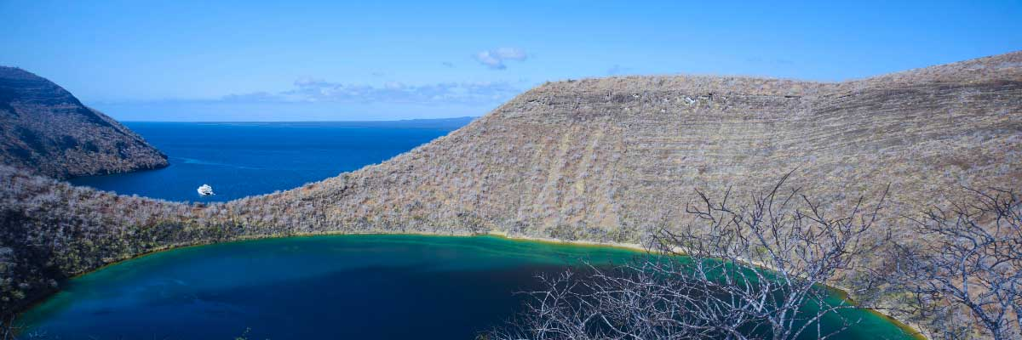

|  |  |
| --- | --- |
| **Food**: | B/L/D |
| **Trail:** | 2,6 km / 1,6 mi |
| **Lodging**: | M/Y Galaxy Diver II |
| **Level**: | 1 |
| **Activities:** | HIKING,SNORKEL,PANGA RIDE |

DAY 4

AM: URBINA BAY

Our journey begins at Urbina Bay, a unique Galapagos site where a dramatic geological uplift in the 1950s exposed hectares of previously submerged land. As you walk along the trail, you’ll find fossilized shells and corals, a fascinating reminder of the area’s underwater history. The region is also home to land iguanas and, in certain seasons, giant tortoises roaming the terrain. Additionally, Galapagos hawks are often seen soaring overhead or perched on trees, surveying their surroundings with their sharp gaze.

Snorkel Experience: Swim into the clear waters of Urbina Bay alongside sea turtles, flightless cormorants, and penguins. The vibrant marine ecosystem is teeming with colorful fish, making for an unforgettable underwater experience.

**Highlights:**  Stunning Views, Galapagos mockingbirds, Galapagos hawks, Darwin finches, Galapagos flycatchers, Galapagos land iguanas

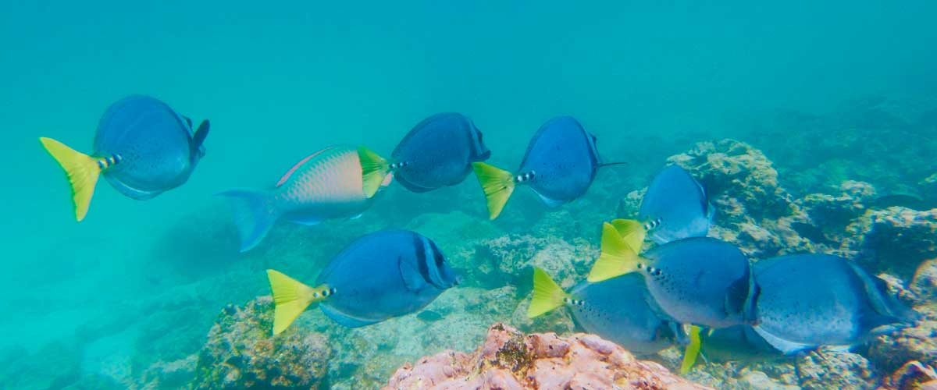

|  |  |
| --- | --- |
| **Trail:** | 1,2 km / 0,7 mi. Long trail 3,0 km / 1,8 mi |
| **Level**: | 1 |
| **Activities:** | HIKING,SNORKEL |

PM: ELIZABETH BAY

As the afternoon progresses, we venture into the stunning Elizabeth Bay, a peaceful sanctuary surrounded by towering mangroves and stark lava fields. With no trails to follow, we explore this natural wonder by dinghy, navigating through channels and coves bustling with marine life. This is one of the best places to spot the rare Galapagos penguin, with a total population of only about 3,000. The bay is also a nesting site for flightless cormorants, while blue-footed boobies and pelicans dive for fish. Watch for graceful rays and sea turtles gliding through the clear waters.

**Highlights:** Mangroves, Rays, Herons, Galapagos penguins, Galapagos hawks, Flightless cormorants, Sea turtles

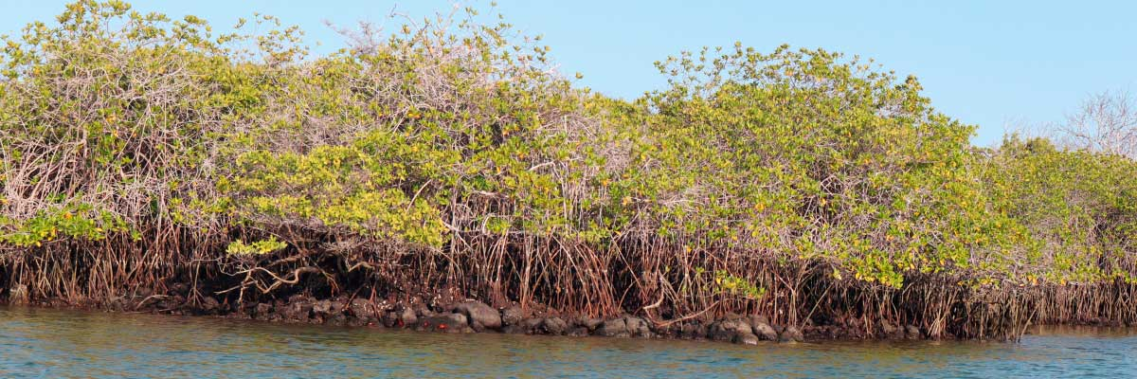

|  |  |
| --- | --- |
| **Food**: | B/L/D |
| **Trail:** | 1,4 km / 0,8 mi |
| **Lodging**: | M/Y Galaxy Diver II |
| **Level**: | 1 |
| **Activities:** | PANGA RIDE |

DAY 5

AM: TINTORERAS

Located close to Puerto Villamil, Tintoreras is a small islet teeming with wildlife. Its shores are filled with sunbathing marine iguanas and resting sea lions. In its shallow channels, rays and sea turtles glide gracefully, while reef sharks, locally known as "Tintoreras" patrol the area. Herons and gulls are frequent visitors, and with some luck, you might spot a Galapagos penguin, as a few individuals inhabit the region. This site offers a perfect glimpse into Isabela's rich natural heritage.

**Highlights:**  White-tipped and black-tipped reef sharks, Sea turtles, Manta rays

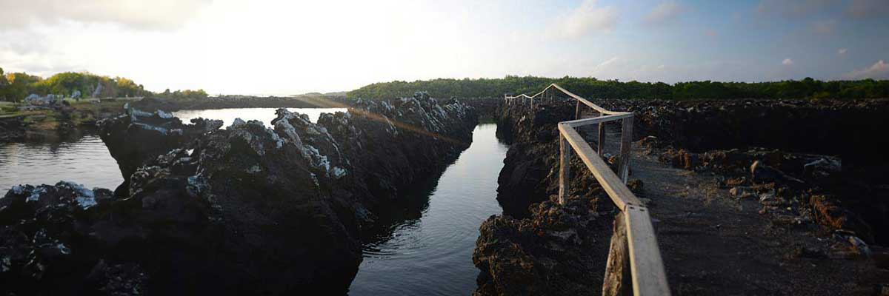

|  |  |
| --- | --- |
| **Trail:** | 1,1 km / 0,7 mi |
| **Level**: | 1 |
| **Activities:** | HIKING,SNORKEL,PANGA RIDE |

PM: WETLANDS

Villamil’s wetlands form an extensive network of lagoons, channels, and coves near town. Surrounded by lush mangroves, these saltwater lagoons provide a vital refuge for numerous bird species. Among the most striking residents are American flamingos, filtering water with their curved beaks, as well as white-cheeked pintails, gallinules, stilts, and various herons. The main trail starts in town and ends at the Tortoise Breeding Center, offering a perfect opportunity to observe the rich local wildlife while exploring this pristine ecosystem.

**Highlights:** Stunning Views, Herons, American flamingoes, Ducks, Gallinules

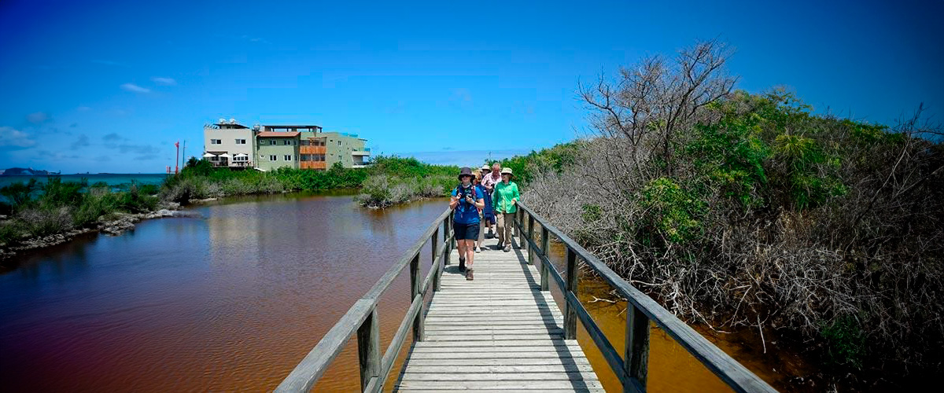

|  |  |
| --- | --- |
| **Food**: | B/L/D |
| **Trail:** | 1,2 km / 0,8 mi |
| **Lodging**: | M/Y Galaxy Diver II |
| **Level**: | 1 |
| **Activities:** | HIKING |

DAY 6

AM: POST OFFICE BAY

Step into the past at Post Office Bay on Floreana, where sailors established a barrel-based mail system in the 1700s, still in use today. Beyond its historic charm, the bay was a key stop for whalers seeking freshwater and tortoises. This site also boasts a scenic beach, and incredible wildlife, including sea lions, green sea turtles, reef sharks, and, if luck is on your side, the elusive Galapagos penguin.

Snorkel Experience: Dive straight from the beach and explore a mesmerizing underwater world filled with sea turtles, rays, and schools of tropical fish. If lucky, catch a glimpse of a Galapagos penguin darting through the waves.

**Highlights:**  Galapagos penguins, Marine iguanas, Sea turtles, Finches, Shorebirds

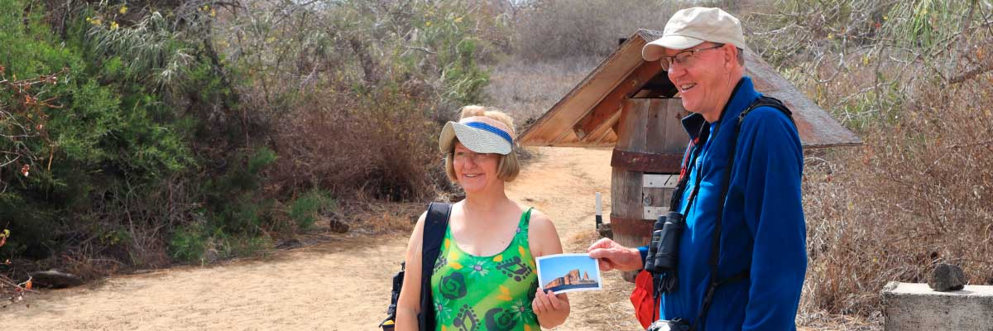

|  |  |
| --- | --- |
| **Trail:** | 0,7 km / 0,4 mi |
| **Level**: | 1 |
| **Activities:** | HIKING,SNORKEL |

PM: CORMORANT POINT

Located in northern Floreana, Punta Cormorant is a paradise for nature lovers. Its coastal lagoon hosts flamingos, white-cheeked pintails, and black-necked stilts, while its white sand beach is a crucial nesting site for green sea turtles. In recent years, blue-footed boobies have started nesting along the trail. This is also a great site for spotting endemic plants. For snorkeling, Devil’s Crown—a heavily eroded volcanic formation—offers an unparalleled experience, attracting reef sharks, rays, sea turtles, and massive schools of tropical fish.

Snorkel Experience: Explore Devil’s Crown, one of the best snorkeling spots in the Galapagos. Its currents attract reef sharks, turtles, rays, and massive schools of fish like snappers, parrotfish, and angelfish.

**Highlights:** Galapagos sea lions, Blue footed boobies, Galapagos shearwaters, American flamingoes, Sea turtles, Tropicbirds, Frigatebirds

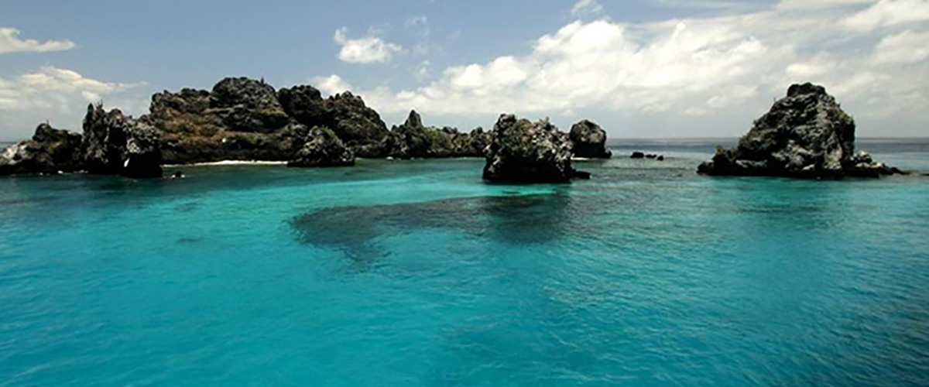

|  |  |
| --- | --- |
| **Food**: | B/L/D |
| **Trail:** | 1,6 km / 1 mi |
| **Lodging**: | M/Y Galaxy Diver II |
| **Level**: | 1 |
| **Activities:** | HIKING,SNORKEL,PANGA RIDE |

DAY 7

AM: HIGHLANDS

Begin your Galapagos adventure with a scenic bus ride into the lush Santa Cruz highlands. Walk through a reserve, spotting giant tortoises—some over 600 pounds—grazing peacefully. Discover endemic birds like finches and flycatchers. If included in your itinerary, explore a lava tunnel, a fascinating remnant of the volcanic forces that shaped these islands.

**Highlights:**  Lava tunnels, Darwin finches, Galapagos flycatchers, Giant tortoises, Barn owls, White-cheeked pintails

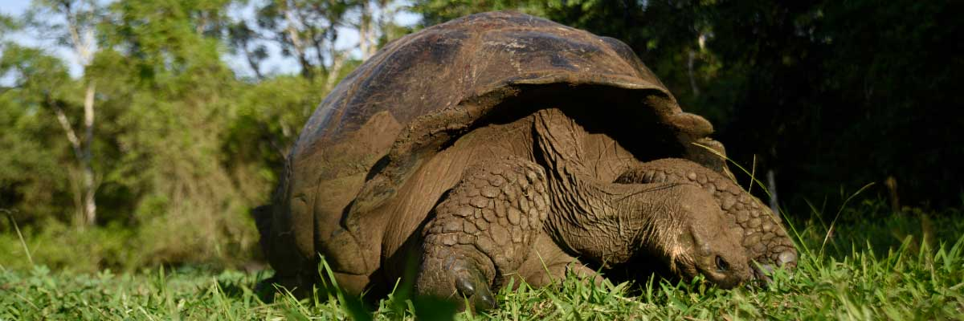

|  |  |
| --- | --- |
| **Trail:** | 1-1,5 km / 0,6-0,9 mi |
| **Level**: | 1 |
| **Activities:** | HIKING |

PM: CHARLES DARWIN STATION

Explore the Charles Darwin Research Station, a center dedicated to wildlife conservation and research. Witness breeding programs helping restore giant tortoise populations, learn about projects tackling invasive species, and see conservationists working to protect the fragile Galapagos ecosystem.

**Highlights:** Galapagos giant tortoise and land iguanas breeding program, Galapagos mockingbirds, Darwin finches, Galapagos flycatchers

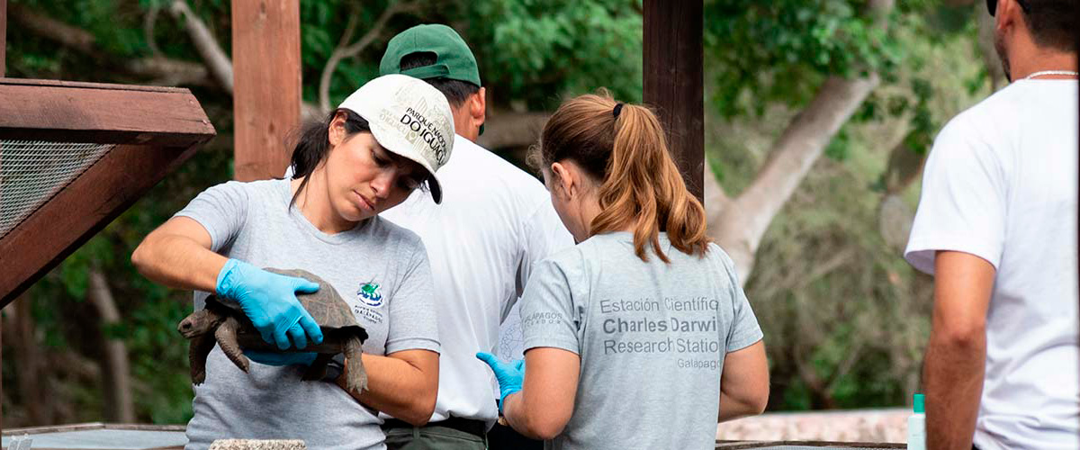

|  |  |
| --- | --- |
| **Food**: | B/L/D |
| **Trail:** | 2 km / 1,2 mi |
| **Lodging**: | M/Y Galaxy Diver II |
| **Level**: | 1 |
| **Activities:** | HIKING |

DAY 8

AM: SEYMOUR

North Seymour Island is a paradise for bird watchers, with large colonies of magnificent and great frigatebirds inflating their red throat pouches in an impressive courtship display. On the ground, blue-footed boobies perform their famous mating dance, while swallow-tailed gulls perch on cliffs overlooking the sea. Inland, land iguanas have thrived thanks to conservation efforts, while marine iguanas bask on the rocks near playful sea lions body surfing the waves.

Snorkel Experience: Explore Seymour’s underwater world, home to incredible biodiversity. Swim alongside sea lions, sharks, turtles, rays, and tropical fish. If you're lucky, you might spot eels hiding among the rocks in this thriving marine ecosystem.

Galapagos sea lions, Magnificent and great frigatebirds, Land and marine iguanas, Darwin finches

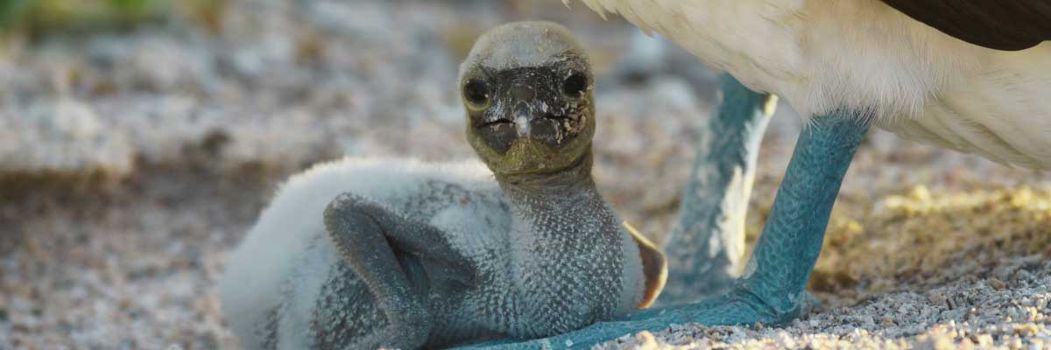

|  |  |
| --- | --- |
| **Trail:** | 1,4 km / 0,8 mi |
| **Level**: | 1 |
| **Activities:** | HIKING |

PM: BALTRA (AIRPORT)

Your Galapagos adventure comes to an end. Today, you will be transferred to Baltra Airport, where your National Park naturalist guide will assist you with final details before your flight back to mainland Ecuador. As you bid farewell to this paradise, take with you the unforgettable memories of one of the world’s most extraordinary destinations.



|  |  |
| --- | --- |
| **Food**: | B/-/- |
| **Trail:** |  |
| **Lodging**: | M/Y Galaxy Diver II |
| **Level**: | 1 |
| **Activities:** | - |

GLOSSARY

|  |  |  |
| --- | --- | --- |
| **Feeding** | **Breakfast** | B |
| **Lunch** | L |
| **Dinner** | D |
| **Difficulty of the hike** | **Level 1** | Easy |
| **Level 2** | Moderate |
| **Level 3** | Difficult |