The Galapagos’ Southeast Wonders
5 Days – 4 Nights
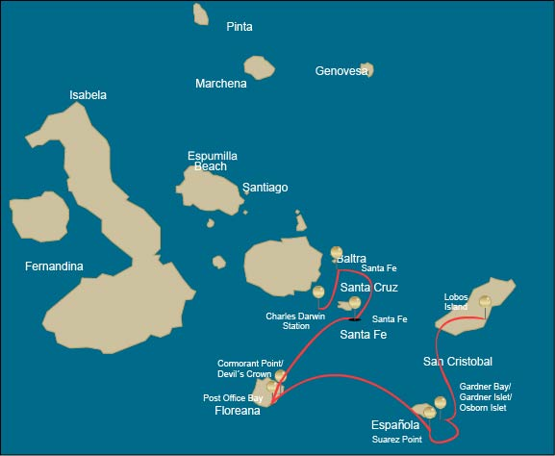
 |  |  | Hiking | Snorkel | Panga Ride | Paddle Board | Kayak
TUESDAY | AM | San Cristobal Island : San Cristobal- Airport (arrival)
 | PM | San Cristobal Island : Lobos Island | *
WEDNESDAY | AM | Española Island : Gardner Bay / Islote Gardner / Osborn Islote | * | * | *
 | PM | Española Island : Suarez Point | *
THURSDAY | AM | Floreana Island : Post Office Bay | * | *
 | PM | Floreana Island : Cormorant Point / Devil's Crown | * | * | *
FRIDAY | AM | Santa Fe Island : Santa Fe | * | * | * | * | *
 | PM | South Plazas Island : South Plaza | * |  | * | * | *
SATURDAY | AM | Santa Cruz Island : Charles Darwin Station | *
 |  | Santa Cruz Island : Baltra - airport (return)

DAY 1

AM: EMBARKATION TO THE GALAPAGOS ISLANDS - SAN CRISTOBAL AIRPORT
Embark on an unforgettable journey to the Galapagos Islands, where nature thrives in its purest form. Your adventure begins at San Cristobal’s modest yet bustling airport, where a seasoned naturalist guide will greet you. This guardian of the ecosystem will introduce you to a world of breathtaking landscapes and unparalleled biodiversity. Feel the excitement as you step into this living sanctuary, a UNESCO World Heritage site, marking the beginning of an extraordinary exploration.


Trail:
Level: | 1
Activities: | -

PM: ENCOUNTERING WILDLIFE AT LOBOS ISLAND
Venture to Lobos Island, a tranquil islet secluded from San Cristobal by a slim channel. This nature's cradle, amidst a serene bay, is the playground for sea lion pups frolicking in tidal pools. The island might be modest in size, but it bursts with life, particularly with “lobos marinos” or sea lions. As you step ashore, welcoming committees of sea lions would greet you, only to be outraged by the male frigatebirds inland, presenting their inflamed red balloons amidst the verdant foliage. Stay vigilant for the blue-footed boobies nesting on the trails, ready to treat you to a display of their whimsical courtship dance

Stunning Views, Galapagos sea lions, Magnificent and great frigatebirds, San Cristobal Lava Lizards
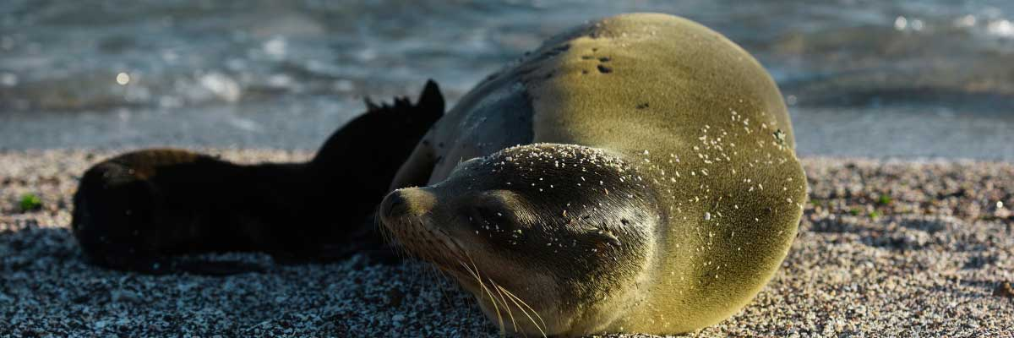
Food: | -/L/D
Trail: | 0,6 km / 0,4 mi
Lodging: | M/C Galaxy Sirius
Level: | 3
Activities: | HIKING

DAY 2

AM: A TROPICAL PARADISE - GARDNER BAY
Embrace the morning at Gardner Bay, a pristine piece of paradise in the Galapagos archipelago. Sugar-white coral sands merge with crystal-clear turquoise waters, creating a tropical oasis. Watch as the beach becomes a theatre, starring sun-basking sea lions in a playful performance. This idyllic setting invites you to stroll along the coast, immersing yourself in an enlightening experience as you delve into the biology of the endemic fauna - from the melodious Española mockingbird and the unique marine iguanas to the regal Galapagos hawks.

Highlights: Herons, Galapagos mockingbirds, Galapagos hawks, Darwin finches, Marine iguanas, Waved Albatross, Lava lizards
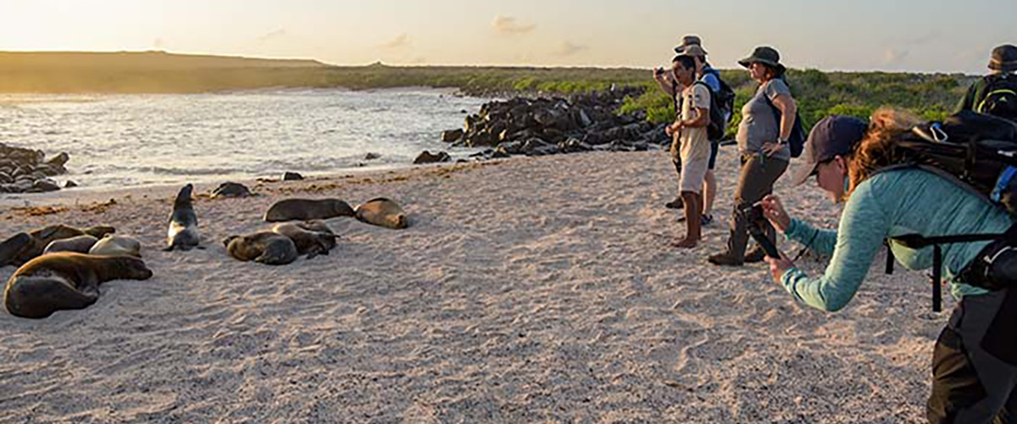
Trail: | 0,8 km / 0,5 mi
Level: | 1
Activities: | HIKING,SNORKEL,PANGA RIDE

PM: A WALK-THROUGH NATURE’S GALLERY - SUAREZ POINT
Embark on an adventure to Suarez Point, one of the Galapagos’ greatest natural wonders. This rocky trail is a haven for wildlife lovers, featuring an incredible array of species. Upon arrival, sea lions and marine iguanas welcome you as the first hosts of this nature spectacle. As you explore further, witness a vibrant mosaic of seabird colonies, from blue-footed and Nazca boobies to graceful frigatebirds and tropicbirds. The highlight of this journey is meeting the waved albatross, the island’s largest bird, impressing visitors with its powerful flight and intricate courtship display (present from April to January).

Highlights: Stunning Views, Herons, Galapagos mockingbirds, Galapagos hawks, Darwin finches, Marine iguanas, Waved Albatross, Lava lizards
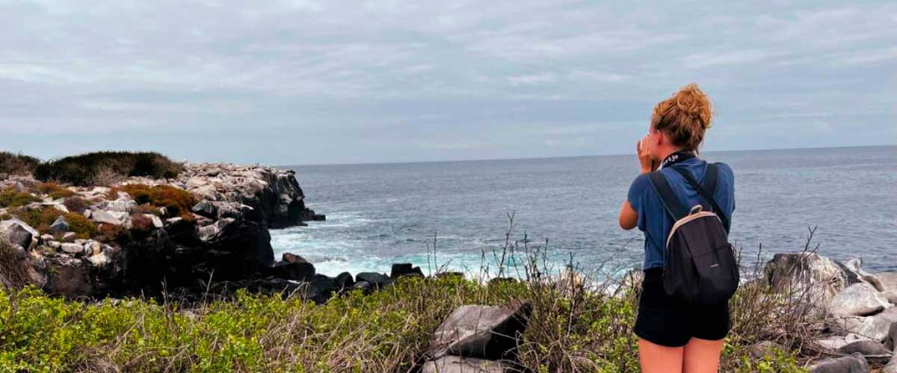
Food: | B/L/D
Trail: | 1,7 km / 1,1 mi
Lodging: | M/C Galaxy Sirius
Level: | 3
Activities: | HIKING

DAY 3

AM: MAIL FROM THE PAST - POST OFFICE BAY
Step into the past at Post Office Bay on Floreana, where sailors established a barrel-based mail system in the 1700s, still in use today. Beyond its historic charm, the bay was a key stop for whalers seeking freshwater and tortoises. This site also boasts a scenic beach, and incredible wildlife, including sea lions, green sea turtles, reef sharks, and, if luck is on your side, the elusive Galapagos penguin.

Highlights: Galapagos penguins, Marine iguanas, Sea turtles, Finches, Shorebirds
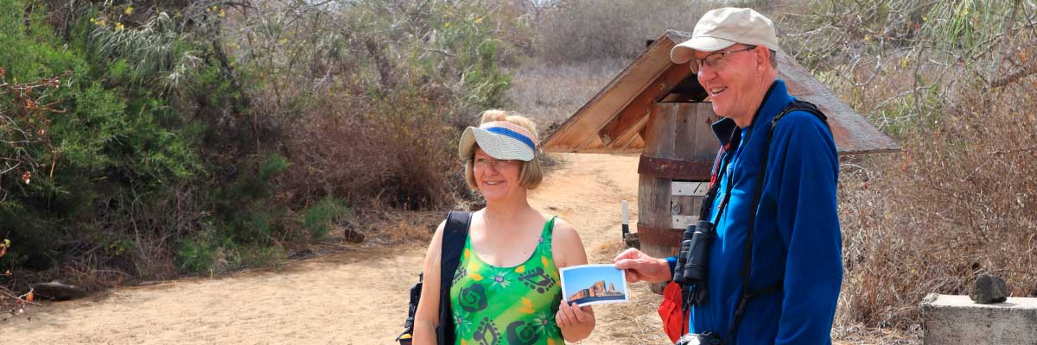
Trail: | 0,7 km / 0,4 mi
Level: | 1
Activities: | HIKING,SNORKEL

PM: THE WONDER OF NATURE - CORMORANT POINT / DEVIL’S CROWN
Head north to Punta Cormorant, a natural sanctuary featuring a coastal lagoon teeming with American flamingos, white-cheeked pintails, and black-necked stilts. This area is known for its white sand beach, a crucial nesting site for green sea turtles, and the recent arrival of blue-footed boobies nesting near the trail. The island’s unique flora adds to the charm of this remarkable landscape. Then, embark on an unforgettable snorkeling adventure at Devil’s Crown, an eroded volcanic crater whose currents attract a thriving marine ecosystem, including reef sharks, rays, sea turtles, and a dazzling variety of tropical fish.

Highlights: Sea turtle nesting site, Galapagos shearwaters, Tropicbirds, Frigatebirds, Finches, Shorebirds
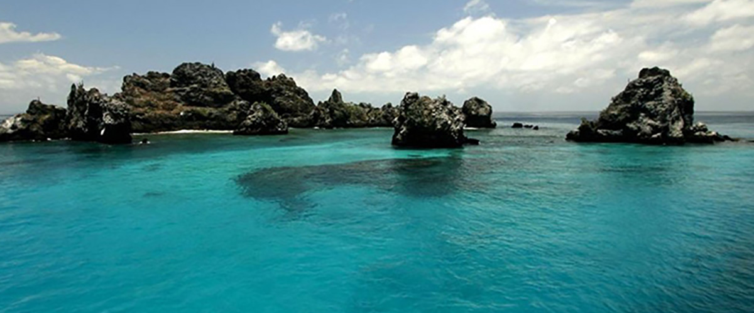
Food: | B/L/D
Trail: | 1,6 km / 1 mi
Lodging: | M/C Galaxy Sirius
Level: | 1
Activities: | HIKING,SNORKEL,PANGA RIDE

DAY 4

AM: THE CONTRASTING BEAUTY OF SANTA FE
Lead in the day with the stark beauty of Santa Fe, where the towering figures of giant Prickly-pear cacti strikingly contrast the rugged landscape of lava rocks. Tucked within one of the Galapagos' most breathtaking bays, Santa Fe's turquoise waters, and white-sand beaches form an inviting residence for a sizable colony of sea lions you'll find lounging about. As you venture inland, remember to look down to spot the endemic Santa Fe land iguanas, but also glance upward to catch sight of the Galapagos hawks perched atop cacti, keeping a keen eye out for prey. You'll likely encounter Darwin finches, Galapagos doves, mockingbirds, and lively lava lizards along the trail.

Highlights: Stunning Views, Galapagos sea lions, Galapagos hawks, Galapagos doves, Santa Fe land iguanas, Reef sharks
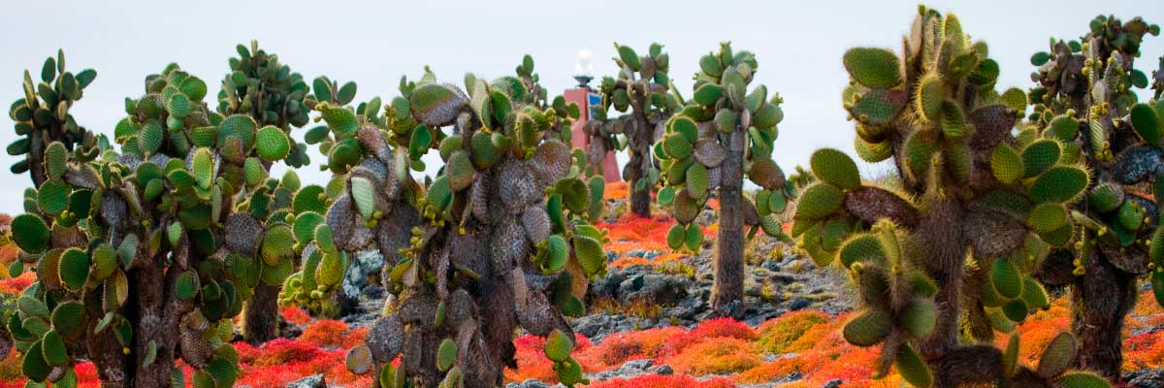
Trail: | 0,8 km / 0,5 mi
Level: | 1
Activities: | HIKING,SNORKEL,PANGA RIDE,PADDLE BOARD,KAYAK

PM: WILD WONDERLAND - SOUTH PLAZAS
Your afternoon destination is South Plazas, one of a twin pair of islands where the northern sibling is reserved exclusively for scientific research. Though petite in size, this islet brims with a fantastic array of wildlife. Upon landing, Galapagos land iguanas will welcome you from beneath prickly-pear cacti, eagerly awaiting their fruit. Sea lions populate the island in large numbers, allowing you to observe their fascinating social dynamics, from playful pups splashing in tide pools to formidable males protecting their territories. Your trail eventually leads you to a cliff, a vantage point to observe a myriad of seabirds, including frigatebirds, red-billed tropicbirds, boobies, swallow-tailed gulls, and pelicans. A verdant carpet of reddish succulent vegetation dotted with scattered cacti blankets the island, giving South Plazas a genuinely unique personality.

Highlights: Stunning Views, Boobies, Galapagos sea lions, Galapagos shearwaters, Galapagos land iguanas, Tropicbirds, Pelicans
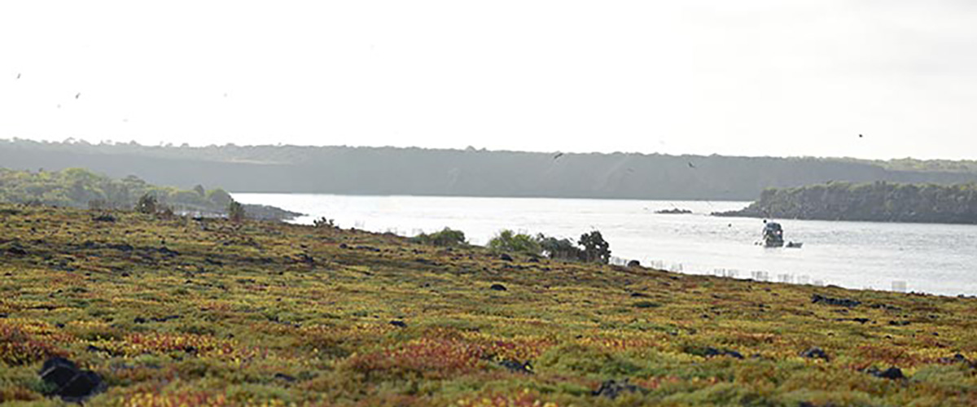
Food: | B/L/D
Trail: | 1,4 km / 0,8 mi
Lodging: | M/C Galaxy Sirius
Level: | 2
Activities: | HIKING,PANGA RIDE,PADDLE BOARD,KAYAK

DAY 5

AM: THE CRADLE OF CONSERVATION - CHARLES DARWIN STATION
Explore the Charles Darwin Research Station, a center dedicated to wildlife conservation and research. Witness breeding programs helping restore giant tortoise populations, learn about projects tackling invasive species, and see conservationists working to protect the fragile Galapagos ecosystem.

Galapagos giant tortoise and land iguanas breeding program, Galapagos mockingbirds, Darwin finches, Galapagos flycatchers
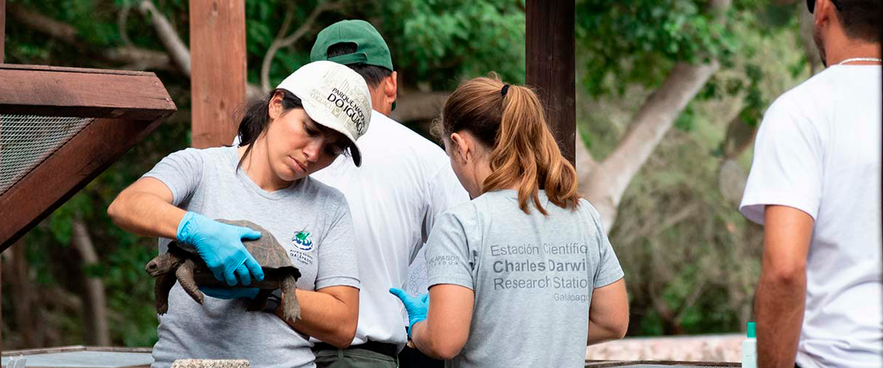
Trail: | 2 km / 1,2 mi
Level: | 1
Activities: | HIKING

AM: BALTRA (AIRPORT)
Your Galapagos adventure comes to an end. Today, you will be transferred to Baltra Airport, where your National Park naturalist guide will assist you with final details before your flight back to mainland Ecuador. As you bid farewell to this paradise, take with you the unforgettable memories of one of the world’s most extraordinary destinations.

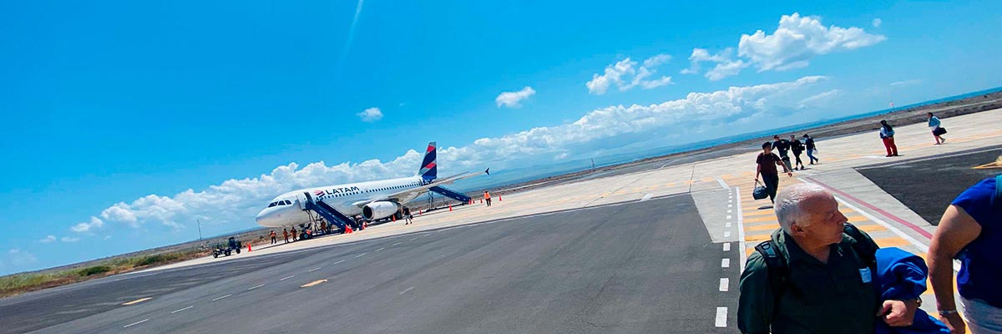
Food: | B/-/-
Trail:
Lodging: | M/C Galaxy Sirius
Level: | 1
Activities: | -

GLOSSARY
Feeding |  | Breakfast | B
 |  | Lunch | L
 |  | Dinner | D
Difficulty of the hike |  | Level 1 | Easy
 |  | Level 2 | Moderate
 |  | Level 3 | Difficult
✔ noneX none
• none

