**Hidden Jewels of the Western Islands**

**6 Days – 5 Nights**

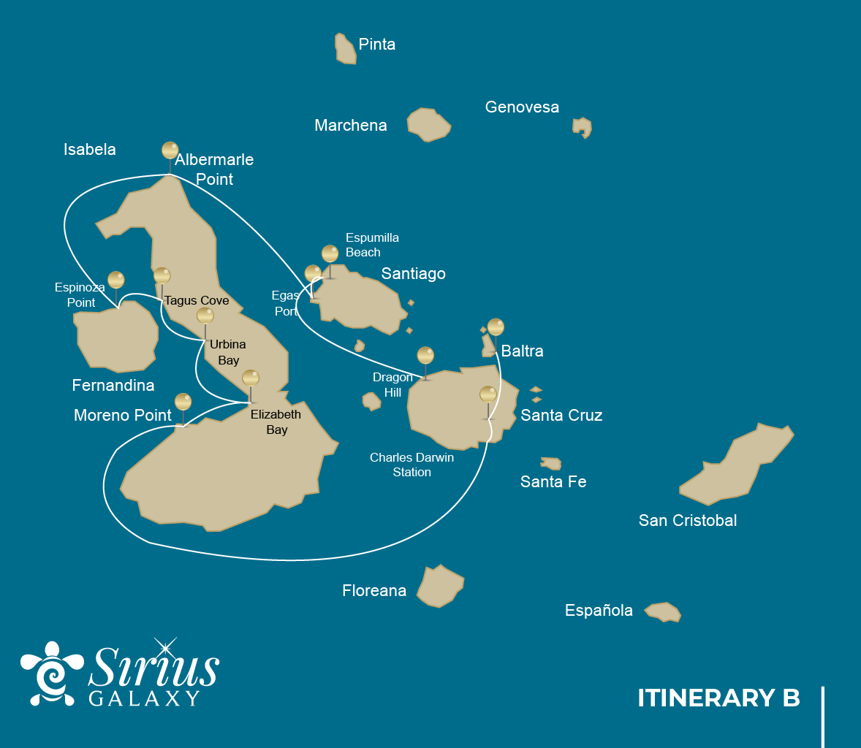

|  |  |  |  |  |  |  |  |
| --- | --- | --- | --- | --- | --- | --- | --- |
|  | | | **Hiking** | **Snorkel** | **Panga Ride** | **Paddle Board** | **Kayak** |
| SATURDAY | AM | **Santa Cruz Island :** Baltra - airport (arrival) |  |  |  |  |  |
|  | PM | **Santa Cruz Island :** Highlands | * |  |  |  |  |
| SUNDAY | AM | **Isabela Island :** Moreno Point | * | * | * |  |  |
|  | PM | **Isabela Island :** Elizabeth Bay |  |  | * | * | * |
| MONDAY | AM | **Isabela Island :** Urbina Bay | * | * |  |  |  |
|  | PM | **Isabela Island :** Tagus Cove | * | * | * | * | * |
| TUESDAY | AM | **Fernandina Island :** Espinoza Point | * | * | * |  |  |
|  | PM | **Isabela Island :** Albermarle Point | * |  | * | * | * |
| WEDNESDAY | AM | **Santiago Island :** Egas Port | * | * |  |  |  |
|  | PM | **Santiago Island :** Espumilla Beach / Buccaneer Cove | * | * | * | * | * |
| THURSDAY | AM | **Santa Cruz Island :** Dragon Hill or Daphne | * | * |  |  |  |
|  | PM | **Santa Cruz Island :** Baltra - airport (return) |  |  |  |  |  |

DAY 1

AM: TAKEOFF TO BALTRA AIRPORT

Welcome to Galapagos! Upon arrival at Baltra Airport, your naturalist guide will greet you and assist with the transfer to Itabaca Channel. This initial journey offers your first connection with the archipelago as you take a short ferry ride to Santa Cruz Island. Along the way, observe Baltra’s arid landscape and learn about its history as a former U.S. WWII airbase. This is just the beginning of the many fascinating stories awaiting you on your adventure.

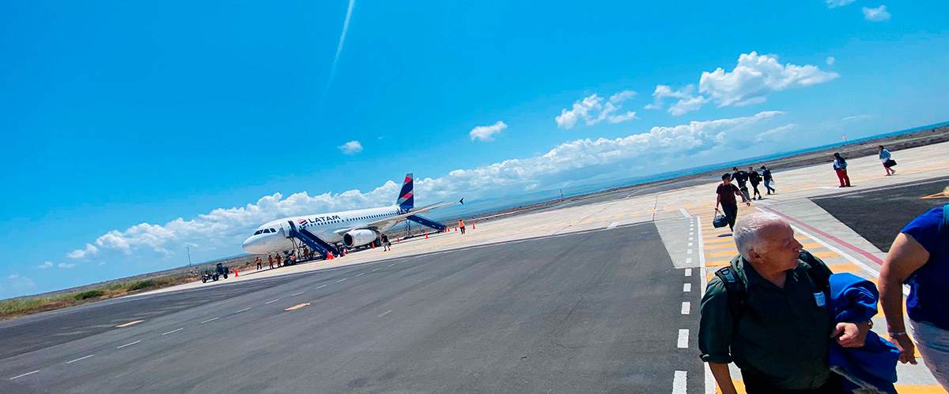

|  |  |
| --- | --- |
| **Trail:** |  |
| **Level**: | 1 |
| **Activities:** | - |

PM: EXPLORING THE HIGHLANDS

Begin your Galapagos adventure with a scenic bus ride into the lush Santa Cruz highlands. Walk through a reserve, spotting giant tortoises—some over 600 pounds—grazing peacefully. Discover endemic birds like finches and flycatchers. If included in your itinerary, explore a lava tunnel, a fascinating remnant of the volcanic forces that shaped these islands.

Lava tunnels, Darwin finches, Galapagos flycatchers, Giant tortoises, Barn owls, White-cheeked pintails

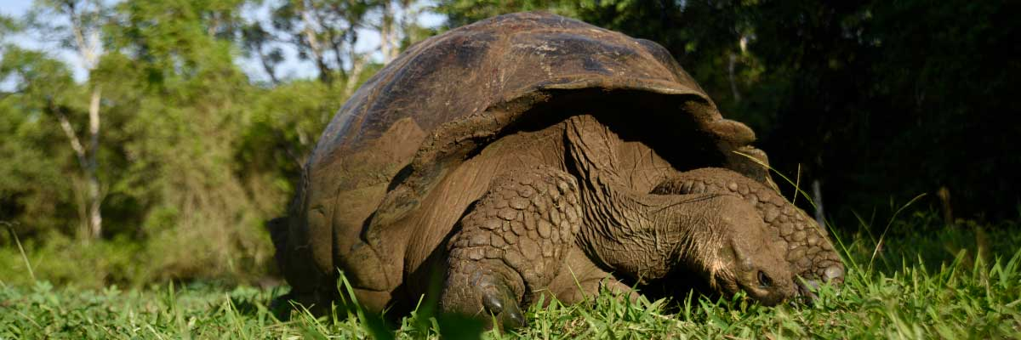

|  |  |
| --- | --- |
| **Food**: | -/L/D |
| **Trail:** | 1-1,5 km / 0,6-0,9 mi |
| **Lodging**: | M/C Galaxy Sirius |
| **Level**: | 1 |
| **Activities:** | HIKING |

DAY 2

AM: THE LAVA WILDERNESS OF MORENO POINT

Start your day exploring Moreno Point, a stunning volcanic landscape that appears barren but is brimming with life. Venture inland to discover brackish lagoons, home to flamingos, gallinules, ducks, and herons. Along the rugged coast, spot Galapagos penguins, flightless cormorants, marine iguanas, and blue-footed boobies. Sea lions and oystercatchers are also frequent visitors, making this site a remarkable showcase of how life thrives even in Galapagos’ harshest environments.

Snorkel Experience: Snorkel into the clear waters of Moreno Point and swim alongside sea turtles, cormorants, and tropical fish. If you look closely among the seaweed, you might even spot the elusive seahorse.

**Highlights:**  Stunning Views, Galapagos mockingbirds, Darwin finches, American flamingoes, Flightless cormorants, Marine iguanas, Ducks, Gallinules

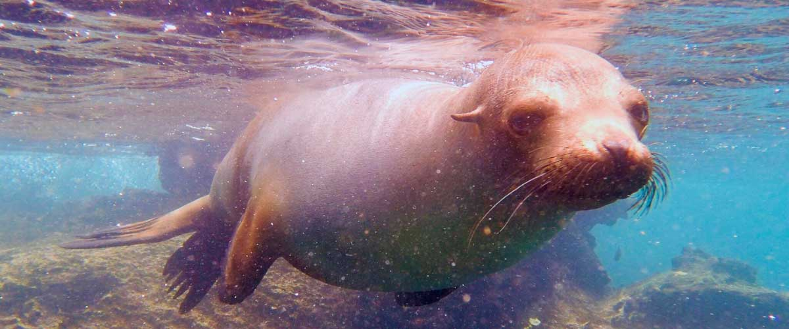

|  |  |
| --- | --- |
| **Trail:** | 1,6 km / 1 mi |
| **Level**: | 3 |
| **Activities:** | HIKING,SNORKEL,PANGA RIDE |

PM: ELIZABETH BAY

As the afternoon progresses, we venture into the stunning Elizabeth Bay, a peaceful sanctuary surrounded by towering mangroves and stark lava fields. With no trails to follow, we explore this natural wonder by dinghy, navigating through channels and coves bustling with marine life. This is one of the best places to spot the rare Galapagos penguin, with a total population of only about 3,000. The bay is also a nesting site for flightless cormorants, while blue-footed boobies and pelicans dive for fish. Watch for graceful rays and sea turtles gliding through the clear waters.

**Highlights:** Mangroves, Rays, Herons, Galapagos penguins, Galapagos hawks, Flightless cormorants, Sea turtles

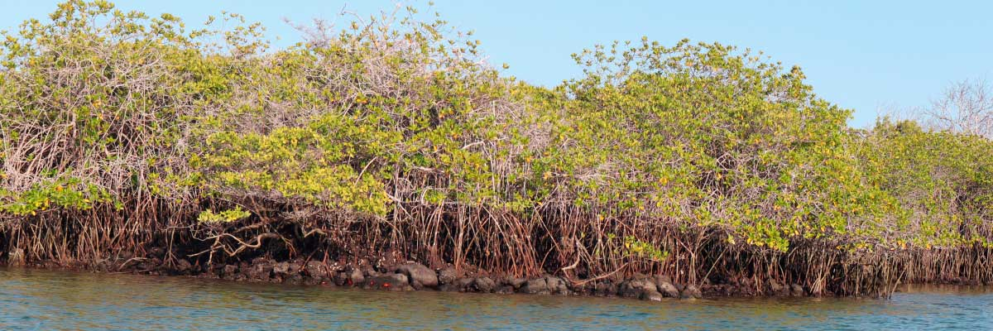

|  |  |
| --- | --- |
| **Food**: | B/L/D |
| **Trail:** | 1,4 km / 0,8 mi |
| **Lodging**: | M/C Galaxy Sirius |
| **Level**: | 1 |
| **Activities:** | PANGA RIDE,PADDLE BOARD,KAYAK |

DAY 3

AM: URBINA BAY’S DRAMATIC SEASCAPE

Our journey begins at Urbina Bay, a unique Galapagos site where a dramatic geological uplift in the 1950s exposed hectares of previously submerged land. As you walk along the trail, you’ll find fossilized shells and corals, a fascinating reminder of the area’s underwater history. The region is also home to land iguanas and, in certain seasons, giant tortoises roaming the terrain. Additionally, Galapagos hawks are often seen soaring overhead or perched on trees, surveying their surroundings with their sharp gaze.

Snorkel Experience: Swim into the clear waters of Urbina Bay alongside sea turtles, flightless cormorants, and penguins. The vibrant marine ecosystem is teeming with colorful fish, making for an unforgettable underwater experience.

**Highlights:**  Stunning Views, Galapagos mockingbirds, Galapagos hawks, Darwin finches, Galapagos flycatchers, Galapagos land iguanas

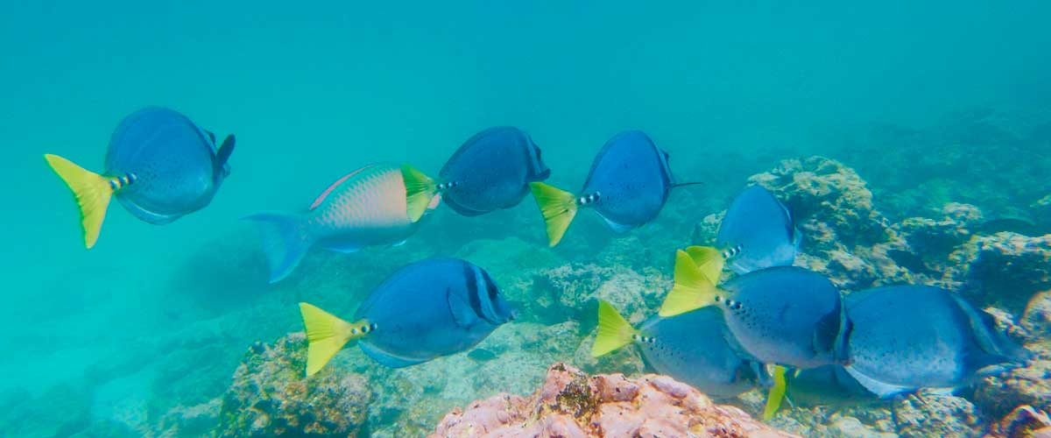

|  |  |
| --- | --- |
| **Trail:** | 1,2 km / 0,7 mi. Long trail 3,0 km / 1,8 mi |
| **Level**: | 1 |
| **Activities:** | HIKING,SNORKEL |

PM: TAGUS COVE, DARWIN’S STOMPING GROUNDS

In the afternoon, we visit the historical Tagus Cove, a site Charles Darwin once explored during his travels around the Galapagos islands. Traverse the arid Palo Santo forests, where Darwin finches and mockingbirds make their home, and take in the panoramic views of Darwin’s Lake and the towering volcanoes of northern Isabela. A boat tour along the shore offers chances to observe penguins, cormorants, marine iguanas, and the rare Galapagos martin - an endemic, petite bird considered one of the most endangered species on the island.

Snorkel Experience: The nutrient-rich waters around Tagus Cove draw in sea turtles, a rich diversity of fish species, and penguins feasting on large schools of anchovies. Watching cormorants dart underwater as they chase fish through the reef is a common sight.

**Highlights:** Stunning Views, Herons, Galapagos penguins, Galapagos hawks, Flightless cormorants, Marine iguanas, Sea turtles, Sea stars

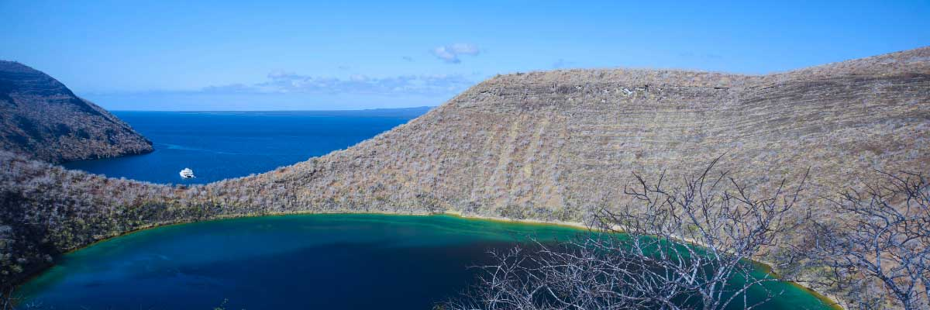

|  |  |
| --- | --- |
| **Food**: | B/L/D |
| **Trail:** | 2,6 km / 1,6 mi |
| **Lodging**: | M/C Galaxy Sirius |
| **Level**: | 3 |
| **Activities:** | HIKING,SNORKEL,PANGA RIDE,PADDLE BOARD,KAYAK |

DAY 4

AM: ESPINOZA POINT, VOLCANIC WONDERLAND

Espinoza Point is a true natural wonder, set at the base of the most active volcano in Galapagos. As you step ashore, you’ll be greeted by the largest colony of marine iguanas basking on black volcanic rocks. Sea lions lounge on the beach while their pups explore tide pools. Flightless cormorants patrol the shoreline, and in the mangroves, Galapagos hawks scan for prey. Blessed with cold, plankton-rich waters, this area teems with life—herons, oystercatchers, pelicans, and sea turtles all thrive in this untouched habitat.

Snorkel Experience: The nutrient-rich waters of Espinoza Point attract fish, sea turtles, and foraging cormorants. Watch marine iguanas feeding on algae and follow a cormorant as it chases fish through the reef—an unforgettable snorkeling experience in Galapagos.

**Highlights:**  Stunning Views, Herons, Galapagos penguins, Oystercatchers, Galapagos hawks, Marine iguanas, Sea turtles, Shorebirds

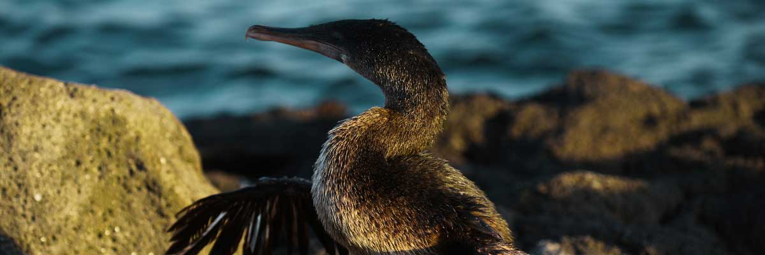

|  |  |
| --- | --- |
| **Trail:** | 1,6 km / 1 mi |
| **Level**: | 2 |
| **Activities:** | HIKING,SNORKEL,PANGA RIDE |

PM: ALBEMARLE POINT, WILDLIFE MEETS HISTORY

In the afternoon, visit Albemarle Point, where military history meets Galapagos wildlife. During WWII, the U.S. built a radar base here to monitor potential Japanese threats, and remnants of this structure remain visible today. Despite its stark, lava-covered landscape, the coastline is rich in wildlife. Some of the largest marine iguanas in the archipelago reside here, alongside Galapagos penguins, flightless cormorants, and various shorebirds, making this a fascinating blend of history and nature.

Snorkel Experience: Swim among flightless cormorants, penguins, and schools of tropical fish in crystal-clear waters, experiencing the vibrant marine life of this historic Galapagos site.

**Highlights:** Galapagos penguins, Land and marine iguanas, Flightless cormorants, Sea turtles, Sally light-foot crabs

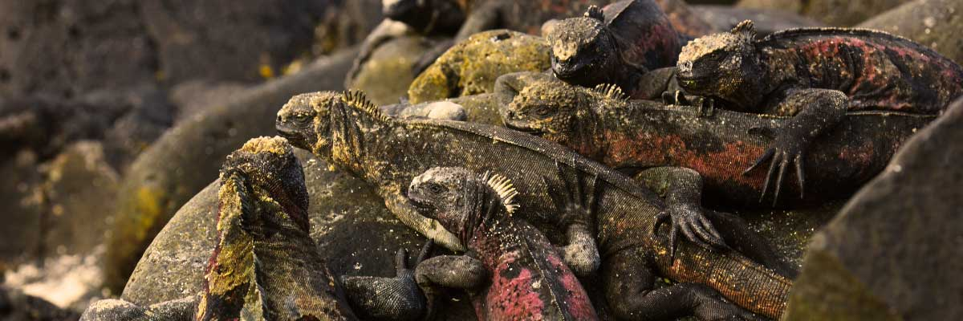

|  |  |
| --- | --- |
| **Food**: | B/L/D |
| **Trail:** | 1 km / 0,6 mi |
| **Lodging**: | M/C Galaxy Sirius |
| **Level**: | 1 |
| **Activities:** | HIKING,PANGA RIDE,PADDLE BOARD,KAYAK |

DAY 5

AM: EGAS PORT, THE WILD FRONTIER

Puerto Egas is a fascinating destination where history and wildlife intertwine. While there is no actual port, remnants of 1960s colonization attempts still stand. The coastal trail is teeming with marine iguanas basking in the sun and sea lions resting on the rocks. Herons, oystercatchers, and shorebirds complete this thriving ecosystem. Towards the end of the trail, the grottos are home to a small colony of the elusive Galapagos fur seal. Additionally, land iguanas were reintroduced to the island in 2019 after over a century of absence.

Snorkel Experience: A snorkeling session from the beach will lead you to an area of rocky bottoms, excellent for observing fish, turtles, and reef sharks. Sea lions often frequent this area and are typically open to interacting with divers.

**Highlights:**  Stunning Views, Herons, Galapagos sea lions, Galapagos fur seals, Oystercatchers, Galapagos hawks, Darwin finches, Marine and land iguanas, Galapagos doves, Shorebirds

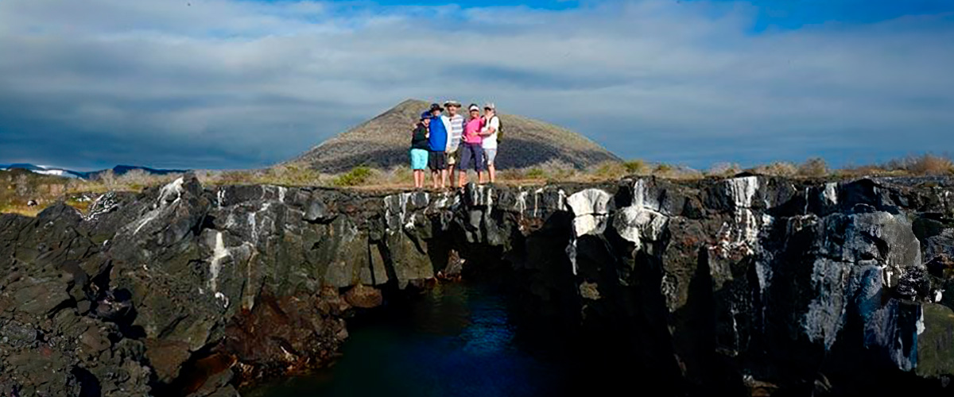

|  |  |
| --- | --- |
| **Trail:** | 2,3 km / 1,4 mi |
| **Level**: | 1 |
| **Activities:** | HIKING,SNORKEL |

PM: ESPUMILLA BEACH / BUCCANEER COVE, PIRATES’ SANCTUARY

Espumilla Beach, on Santiago’s northern coast, is a stunning one-kilometer stretch of rusty-brown sand. Surrounded by mangroves and dry forest, it hosts Galapagos hawks, finches, and mockingbirds, while flamingos and ducks may appear in the salt pan during the rainy season. Then, at Buccaneer Cove, discover a historic pirate hideout from the 17th and 18th centuries. Towering cliffs and striking rock formations create a breathtaking landscape. Although thereandamp;amp;#039;s no trail, a dinghy ride offers a unique chance to observe wildlife and delve into the archipelagoandamp;amp;#039;s history.

Snorkel Experience: Snorkel into a sheltered bay and explore a vibrant underwater world. Swim among schools of angelfish, parrotfish, and snappers while spotting reef sharks, sea turtles, and playful sea lions in their natural habitat.

**Highlights:** Herons, Boobies, Galapagos hawks

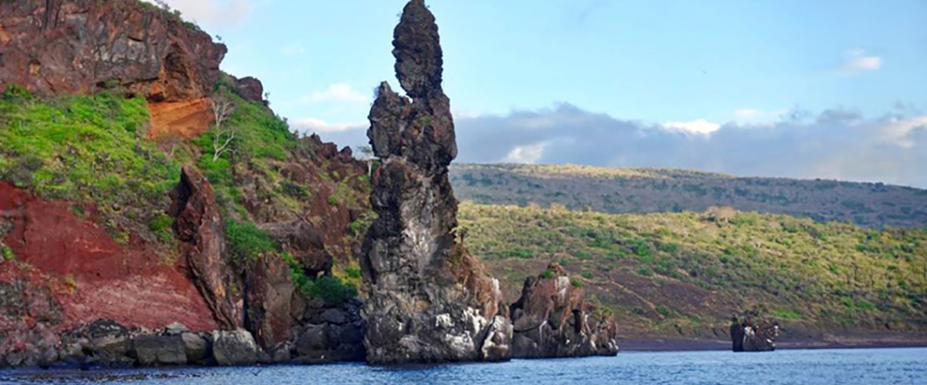

|  |  |
| --- | --- |
| **Food**: | B/L/D |
| **Trail:** | 2,3 km / 1,4 mi (plus and extra loop 1 km - 0,6 mi) |
| **Lodging**: | M/C Galaxy Sirius |
| **Level**: | 1 |
| **Activities:** | HIKING,SNORKEL,PANGA RIDE,PADDLE BOARD,KAYAK |

DAY 6

AM: DRAGON HILL OR DAPHNE

Explore one of the two remarkable sites in Galápagos: Dragon Hill on Santa Cruz, where land iguanas roam and flamingos gather at a saltwater lagoon, and Daphne Major, home to nesting seabirds and groundbreaking finch evolution research. Both offer unique, unforgettable wildlife experiences.

Herons, Darwin finches, Galapagos flycatchers, American flamingoes, Galapagos land iguanas

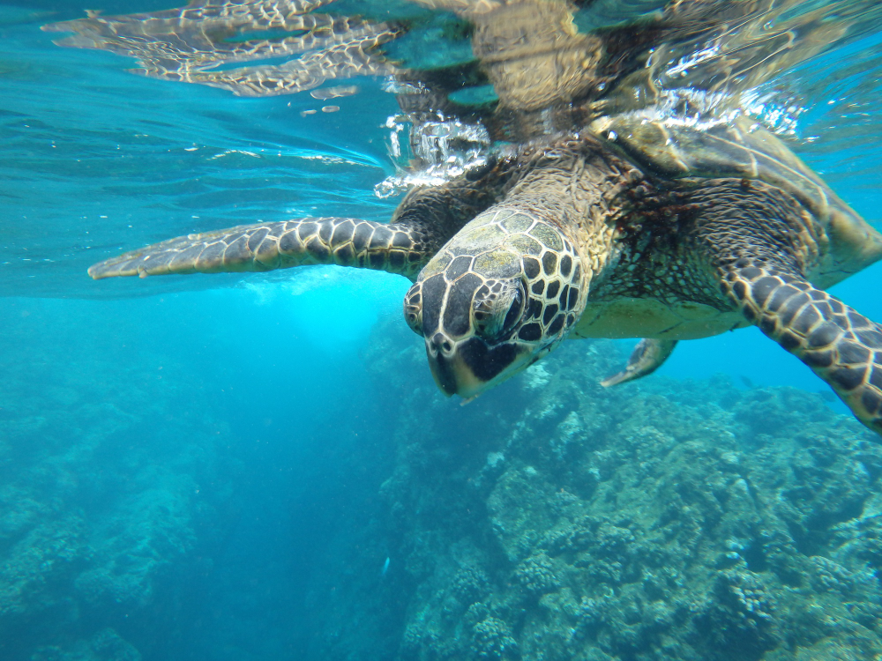

|  |  |
| --- | --- |
| **Trail:** | 2,2 km / 1,4 mi |
| **Level**: | 1 |
| **Activities:** | HIKING,SNORKEL |

PM: BALTRA (AIRPORT)

Your Galapagos adventure comes to an end. Today, you will be transferred to Baltra Airport, where your National Park naturalist guide will assist you with final details before your flight back to mainland Ecuador. As you bid farewell to this paradise, take with you the unforgettable memories of one of the world’s most extraordinary destinations.



|  |  |
| --- | --- |
| **Food**: | B/-/- |
| **Trail:** |  |
| **Lodging**: | M/C Galaxy Sirius |
| **Level**: | 1 |
| **Activities:** | - |

GLOSSARY

|  |  |  |  |
| --- | --- | --- | --- |
| **Feeding** | | **Breakfast** | B |
| **Lunch** | L |
| **Dinner** | D |
| **Difficulty of the hike** | | **Level 1** | Easy |
| **Level 2** | Moderate |
| **Level 3** | Difficult |