**The Winged Wonders Journey**

**6 Days – 5 Nights**

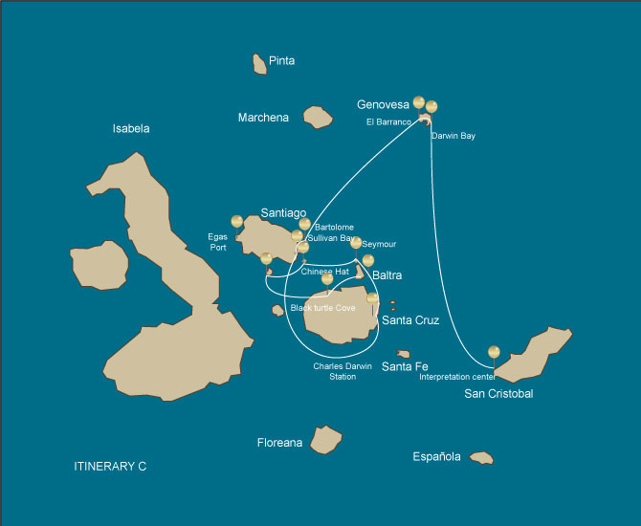

|  |  |  |  |  |  |  |  |
| --- | --- | --- | --- | --- | --- | --- | --- |
|  | | | **Hiking** | **Snorkel** | **Panga Ride** | **Paddle Board** | **Kayak** |
| THURSDAY | AM | **Santa Cruz Island :** Baltra - airport (arrival) |  |  |  |  |  |
|  | PM | **Santa Cruz Island :** Black Turtle Cove | * |  |  |  |  |
| FRIDAY | AM | **Rabida Island :** Rabida | * | * | * | * | * |
|  | PM | **Chinese Hat Island :** Chinese Hat | * | * | * | * | * |
| SATURDAY | AM | **Seymour Island :** North Seymour | * | * | * |  |  |
|  | PM | **Santa Cruz Island :** Highlands | * |  |  |  |  |
| SUNDAY | AM | **Santiago Island :** Sullivan Bay | * | * |  |  |  |
|  | PM | **Bartolome Island :** Bartolome | * | * | * |  |  |
| MONDAY | AM | **Genovesa Island :** Barranco | * | * | * | * | * |
|  | PM | **Genovesa Island :** Darwin Bay | * | * | * | * | * |
| TUESDAY | AM | **San Cristobal Island :** San Cristobal Interpretation Center | * |  |  |  |  |
|  | PM | **San Cristobal Island :** San Cristobal - airport (return) |  |  |  |  |  |

DAY 1

AM: BALTRA AIRPORT

Welcome to Galapagos! Upon arrival at Baltra Airport, your naturalist guide will greet you and assist with the transfer to Itabaca Channel. This initial journey offers your first connection with the archipelago as you take a short ferry ride to Santa Cruz Island. Along the way, observe Baltra’s arid landscape and learn about its history as a former U.S. WWII airbase. This is just the beginning of the many fascinating stories awaiting you on your adventure.

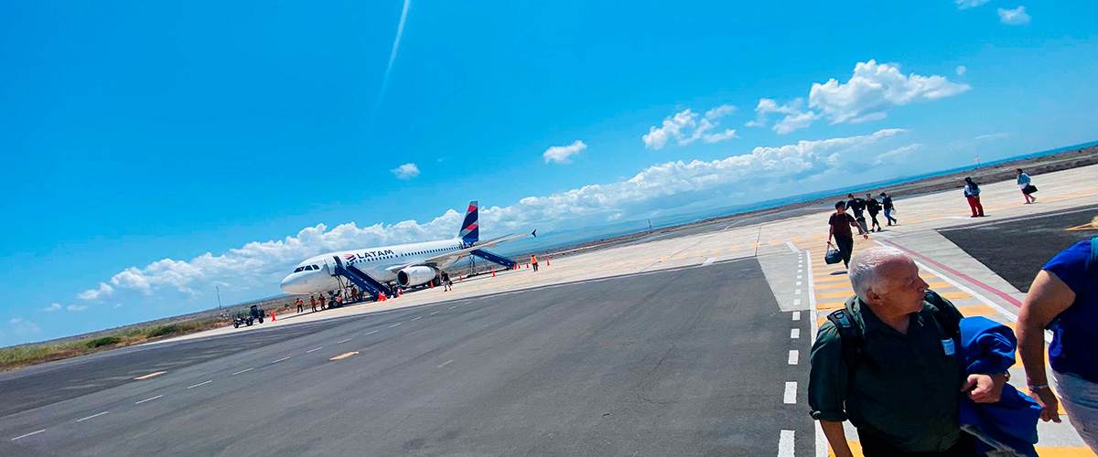

|  |  |
| --- | --- |
| **Trail:** |  |
| **Level**: | 1 |
| **Activities:** | - |

PM: BLACK TURTLE COVE

Set off on a dinghy tour through Black Turtle Cove, a shallow-water haven surrounded by lush mangroves. This sanctuary is home to sea turtles, reef sharks, and various species of rays. It also serves as a crucial breeding ground for turtles and sharks. Watch herons, boobies, and pelicans hunt among schools of anchovies. Though there’s no landing, the incredible wildlife seen from the boat offers an up-close and unforgettable experience.

Mangroves, White-tipped and black-tipped reef sharks, Green sea turtles, Rays, Herons, Blue footed boobies, Reef sharks

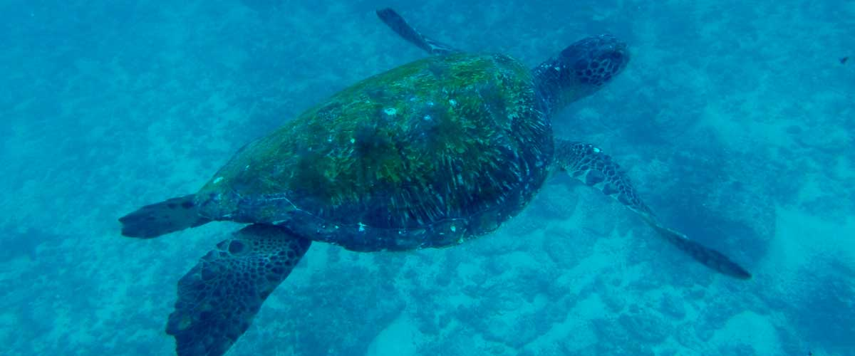

|  |  |
| --- | --- |
| **Food**: | -/L/D |
| **Trail:** |  |
| **Lodging**: | M/C Galaxy Sirius |
| **Level**: | 1 |
| **Activities:** | HIKING |

DAY 2

AM: RABIDA - A REDDISH HAVEN

Rabida Island is one of the most distinctive in the archipelago, with its red sand and iron-rich volcanic formations. On the beach, a colony of sea lions basks in the sun, while a small saltwater lagoon shelters flamingos, ducks, and stilts. The inland trail offers stunning views of the beach and lagoon, with Darwin’s finches, flycatchers, and mockingbirds along the way. Coastal cliffs provide a vantage point to spot Nazca and blue-footed boobies, brown noddies, and herons. Rabida is also one of the few places where you can see both species of sea lions: the Galapagos sea lion and the fur seal.

Snorkel Experience: From Rabida’s red beach, snorkel in protected waters teeming with tropical fish, sea lions, and reef sharks. The rocky walls shelter a stunning array of marine invertebrates.

**Highlights:**  Red-sand beach, Galapagos sea lions, Galapagos hawks, Darwin finches, Galapagos flycatchers

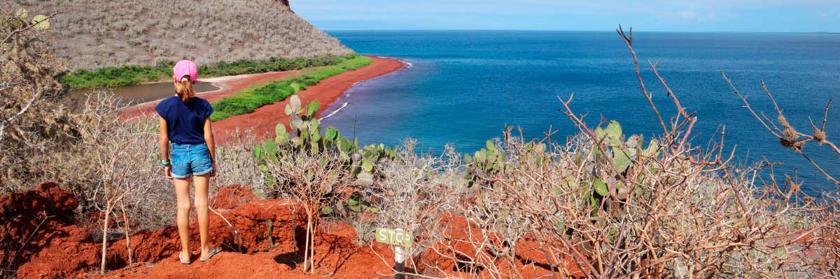

|  |  |
| --- | --- |
| **Trail:** | 2 km / 1,2 mi |
| **Level**: | 1 |
| **Activities:** | HIKING,SNORKEL,PANGA RIDE,PADDLE BOARD,KAYAK |

PM: CHINESE HAT - A PERFECT VOLCANIC CONE

Named for its distinctive cone shape, Chinese Hat is a small islet separated from Santiago by a narrow channel, forming one of Galapagos’ most picturesque bays. Its turquoise waters, coral-sand beaches, and volcanic rocks create a stunning landscape. A coastal trail leads you through a sea lion colony, while on the lava rocks, you may spot penguins resting. This site perfectly blends breathtaking scenery with Galapagos’ remarkable wildlife, making for an unforgettable experience.

Snorkel Experience: Snorkel into the crystal-clear waters of Chinese Hat and marvel at the vibrant colors of the fish. Spot sleek reef sharks and, if lucky, a penguin darting through the water like a swift underwater torpedo chasing anchovies.

**Highlights:** Lava tubes, Galapagos sea lions, Galapagos penguins, Oystercatchers, Galapagos hawks

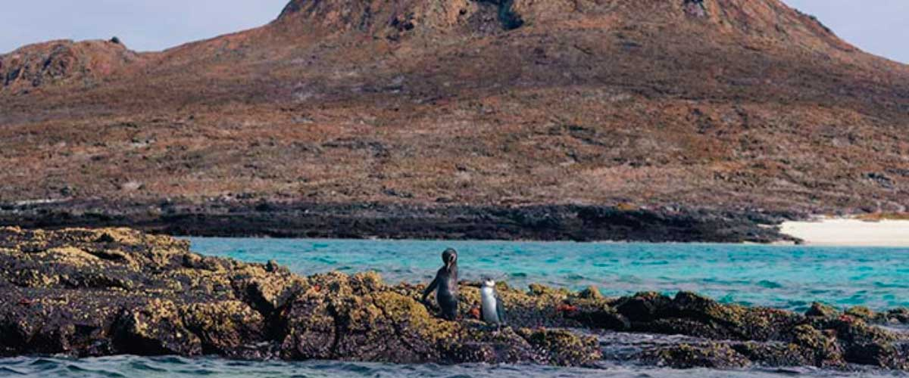

|  |  |
| --- | --- |
| **Food**: | B/L/D |
| **Trail:** | 1,3 km / 0,8 mi |
| **Lodging**: | M/C Galaxy Sirius |
| **Level**: | 1 |
| **Activities:** | HIKING,SNORKEL,PANGA RIDE,PADDLE BOARD,KAYAK |

DAY 3

AM: SEYMOUR - A BIRDWATCHER’S PARADISE

Seymour Island is a paradise for bird watchers, with large colonies of magnificent and great frigatebirds inflating their red throat pouches in an impressive courtship display. On the ground, blue-footed boobies perform their famous mating dance, while swallow-tailed gulls perch on cliffs overlooking the sea. Inland, land iguanas have thrived thanks to conservation efforts, while marine iguanas bask on the rocks near playful sea lions body surfing the waves.

Snorkel Experience: Swim alongside sea lions, sharks, turtles, rays, and tropical fish. If you're lucky, you might spot eels hiding among the rocks in this thriving marine ecosystem.

**Highlights:**  Galapagos sea lions, Magnificent and great frigatebirds, Land and marine iguanas, Darwin finches

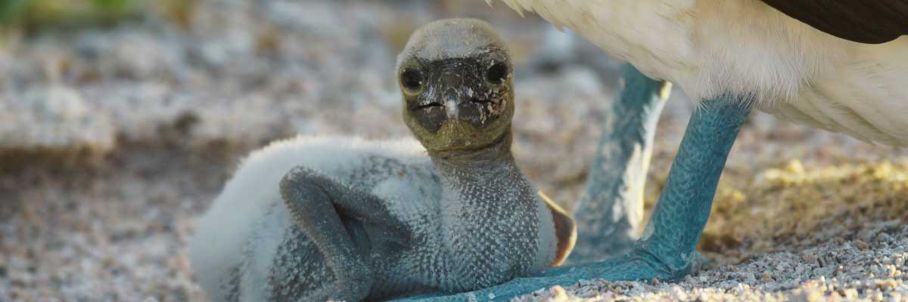

|  |  |
| --- | --- |
| **Trail:** | 1,4 km / 0,8 mi |
| **Level**: | 1 |
| **Activities:** | HIKING,SNORKEL,PANGA RIDE |

PM: HIGHLANDS

Begin your Galapagos adventure with a scenic bus ride into the lush Santa Cruz highlands. Walk through a reserve, spotting giant tortoises—some over 600 pounds—grazing peacefully. Discover endemic birds like finches and flycatchers. If included in your itinerary, explore a lava tunnel, a fascinating remnant of the volcanic forces that shaped these islands.

**Highlights:** Lava tunnels, Darwin finches, Galapagos flycatchers, Giant tortoises, Barn owls, White-cheeked pintails

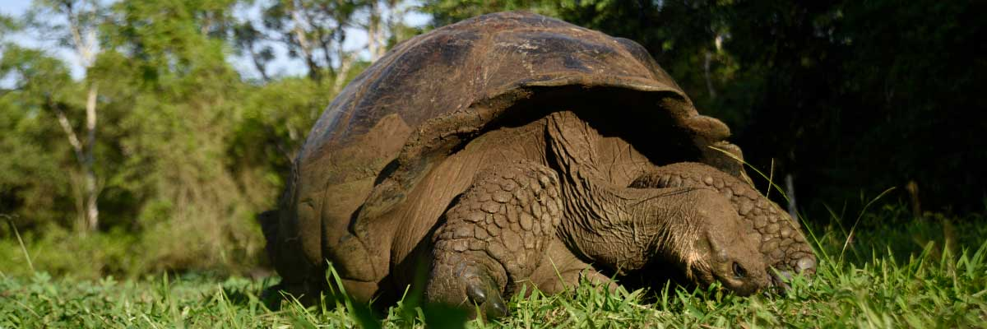

|  |  |
| --- | --- |
| **Food**: | B/L/D |
| **Trail:** | 1-1,5 km / 0,6-0,9 mi |
| **Lodging**: | M/C Galaxy Sirius |
| **Level**: | 1 |
| **Activities:** | HIKING |

DAY 4

AM: SULLIVAN BAY - A VOLCANIC WONDERLAND

Walking through Sullivan Bay is a fascinating journey into the volcanic origins of the Galapagos Islands. The trail crosses a vast Pahoehoe lava flow, showcasing unique textures that reveal the story of past eruptions. While the terrain may seem desolate at first, a closer look unveils pioneer plants, scurrying lava lizards, and small birds adapted to this extreme environment. Along the shore, the stark landscape is brightened by the presence of penguins, pelicans, and oystercatchers, adding a vibrant contrast to the stunning volcanic scenery.

Snorkel Experience: After the hike, unwind with a swim or snorkeling session from a coral-sand beach or a dinghy. The contrast with the barren land is striking—schools of fish, Galapagos penguins, reef sharks, sea turtles, and rays thrive in this vibrant marine ecosystem.

**Highlights:**  Lava tubes, Galapagos penguins, Oystercatchers, Galapagos hawks

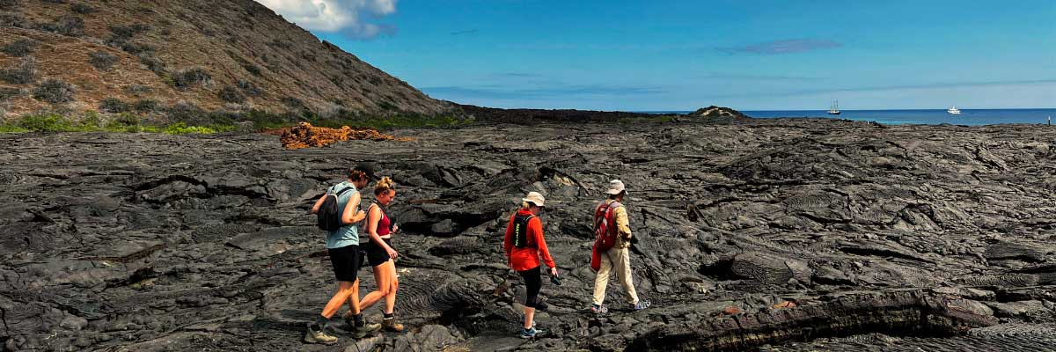

|  |  |
| --- | --- |
| **Trail:** | 2,2 km / 1,4 mi |
| **Level**: | 3 |
| **Activities:** | HIKING,SNORKEL |

PM: BARTOLOME - ICONIC VIEWS AND PENGUIN ENCOUNTERS

Bartolome Island is one of the most iconic places in the Galapagos, renowned for its accessible penguin population and the beautiful Pinnacle Rock. The beach nearby the rock is painted with peach-colored sand, adding to the surreal beauty of the landscape. A hike to the island's summit will offer you panoramic views of lunar-like landscapes dotted with volcanic cones, numerous islands, Sullivan Bay, and, of course, the towering Pinnacle Rock.

Snorkel Experience: Following the hike, you have the option to swim or snorkel from the beach. This location boasts a well-deserved reputation as one of the best snorkeling spots in the Galapagos, with its clear, calm water and diverse underwater life. This includes penguins, which are surprisingly easy to spot, along with many colorful fish, invertebrates, playful sea lions, turtles, rays, and reef sharks.

**Highlights:** Volcanic landscapes, Pinnacle rock, Herons, Bluefooted boobies, Galapagos penguins

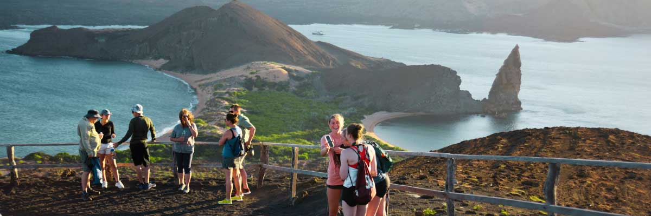

|  |  |
| --- | --- |
| **Food**: | B/L/D |
| **Trail:** | 1,5 km / 0,9 mi |
| **Lodging**: | M/C Galaxy Sirius |
| **Level**: | 2 |
| **Activities:** | HIKING,SNORKEL,PANGA RIDE |

DAY 5

AM: EL BARRANCO - BIRDWATCHER'S PARADISE

Located in the southern part of Darwin Bay on Genovesa Island, El Barranco is a wildlife sanctuary. Its fragile lava cliffs provide shelter for storm petrels and a remarkable population of short-eared owls. Along the trail, red-footed and Nazca boobies nest on the volcanic rock. At the base of the cliffs, Galapagos fur seals rest in shaded areas, while seabirds soar above this breathtaking landscape, making El Barranco an unforgettable destination for nature lovers.

Snorkel Experience: Snorkel into the waters of El Barranco and explore a vibrant underwater world. Swim among colorful fish and spot sharks, rays, and playful sea lions in their natural habitat.

**Highlights:**  Nesting great frigatebirds, Galapagos sea lions, Genovesa ground finch, Genovesa cactus finch, Galapagos mockingbirds, Galapagos fur seals

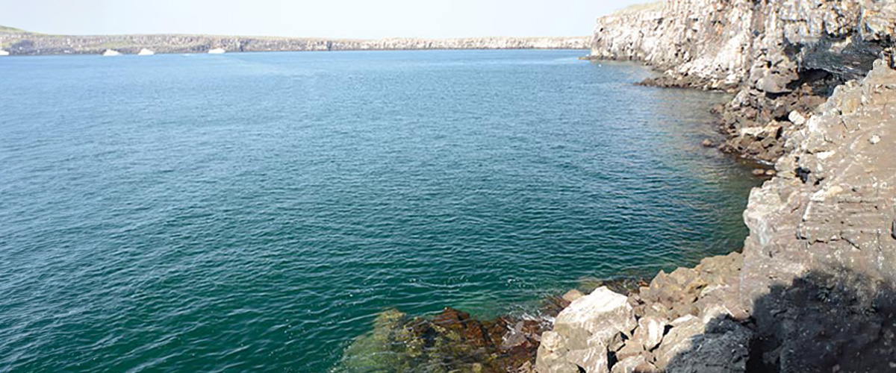

|  |  |
| --- | --- |
| **Trail:** | 1,2 km / 0,7 mi |
| **Level**: | 3 |
| **Activities:** | HIKING,SNORKEL,PANGA RIDE,PADDLE BOARD,KAYAK |

PM: DARWIN BAY - ULTIMATE WILDLIFE EXPERIENCE

Darwin Bay on Genovesa Island is a breathtaking sight for birdwatchers. As you step onto the beach, you’ll be amazed by the presence of hundreds of boobies, gulls, and frigatebirds soaring, nesting in bushes, or resting on the sand. Along the shore, sea lions and marine iguanas blend into the scenery, while inland you may spot night herons, swallow-tailed gulls, Darwin finches, Galapagos doves, and mockingbirds. This immersive experience brings you face-to-face with a thriving ecosystem.

Snorkel Experience: Darwin Bay offers incredible snorkeling spots, from deep waters along the cliffs to shallow areas near the beach. No matter where you dive, a vibrant underwater world awaits, filled with colorful fish and high chances of spotting sharks, rays, and playful sea lions

**Highlights:** Nesting great frigatebirds, Red-footed and Nazca boobies, Galapagos sea lions, Yellow-crowned night herons, Genovesa ground finch, Genovesa cactus finch, Galapagos mockingbirds

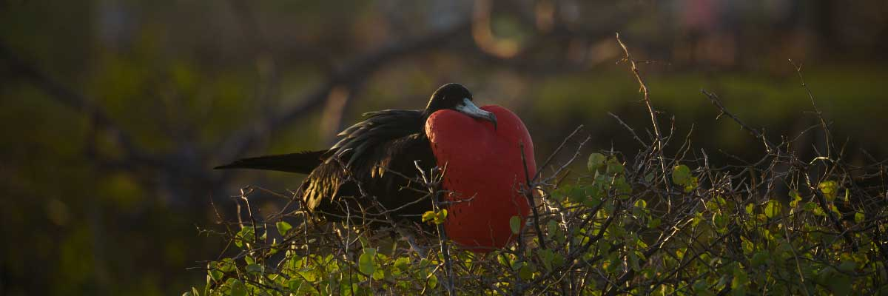

|  |  |
| --- | --- |
| **Food**: | B/L/D |
| **Trail:** | 1,2 km / 0,7 mi |
| **Lodging**: | M/C Galaxy Sirius |
| **Level**: | 3 |
| **Activities:** | HIKING,SNORKEL,PANGA RIDE,PADDLE BOARD,KAYAK |

DAY 6

AM: INTERPRETATION CENTER - A JOURNEY THROUGH HISTORY

The San Cristobal Interpretation Center provides an immersive journey through the natural and cultural history of the Galapagos. Interactive exhibits showcase the islands’ evolution, human impact, and ongoing conservation challenges. From early explorers to modern ecological restoration efforts, this center offers a comprehensive view of the past, present, and future of the archipelago. Surrounded by scenic trails and panoramic views, it’s an essential stop for those looking to understand the uniqueness and fragility of the Galapagos

Endemic plants and an exhibition on human history

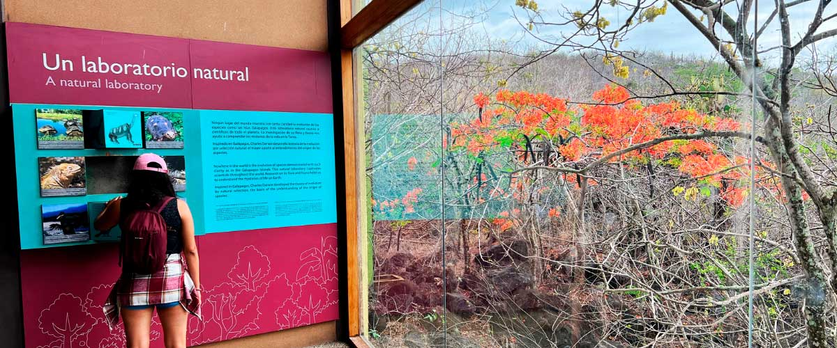

|  |  |
| --- | --- |
| **Trail:** | 0,2 km / 650 ft |
| **Level**: | 1 |
| **Activities:** | HIKING |

PM: SAN CRISTOBAL AIRPORT RETURN

After exploring the breathtaking biodiversity and unique landscapes of the Galapagos, it’s time to return to mainland Ecuador. You’ll be transferred to the airport, bringing this unforgettable journey to a close. Every encounter with giant tortoises, blue-footed boobies, and volcanic landscapes will remain etched in your memory. Galapagos is not just a destination—it’s a transformative experience that will stay with you forever. Wishing you a wonderful journey back!



|  |  |
| --- | --- |
| **Food**: | B/-/- |
| **Trail:** |  |
| **Lodging**: | M/C Galaxy Sirius |
| **Level**: | 1 |
| **Activities:** | - |

GLOSSARY

|  |  |  |  |
| --- | --- | --- | --- |
| **Feeding** | | **Breakfast** | B |
| **Lunch** | L |
| **Dinner** | D |
| **Difficulty of the hike** | | **Level 1** | Easy |
| **Level 2** | Moderate |
| **Level 3** | Difficult |