**Immerse in Nature's Grandeur: A Wildlife Expedition across the Galapagos**

**6 DAYS / 5 NIGHTS**

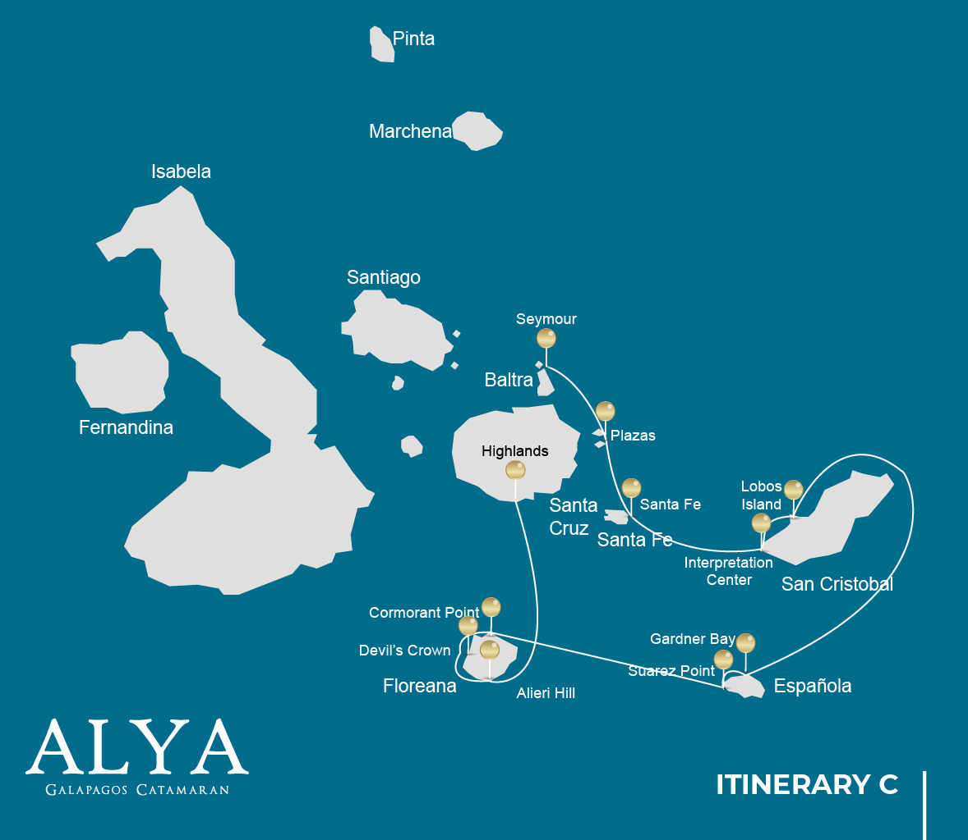

|  |  |  |  |  |  |  |  |
| --- | --- | --- | --- | --- | --- | --- | --- |
|  | | | **Hiking** | **Snorkel** | **Panga Ride** | **Paddle Board** | **Kayak** |
| SATURDAY | AM | **Santa Cruz Island :** Baltra - airport (arrival) |  |  |  |  |  |
|  | PM | **Seymour Island :** North Seymour | * |  |  |  |  |
| SUNDAY | AM | **South Plazas Island :** South Plaza | * |  | * | * | * |
|  | PM | **Santa Fe Island :** Santa Fe | * | * | * | * | * |
| MONDAY | AM | **San Cristobal Island :** San Cristobal Interpretation Center | * |  |  |  |  |
|  | PM | **San Cristobal Island :** Lobos Island | * | * | * |  |  |
| TUESDAY | AM | **Española Island :** Gardner Bay | * | * |  | * | * |
|  | PM | **Española Island :** Suarez Point | * |  |  |  |  |
| WEDNESDAY | AM | **Floreana Island :** Cormorant Point / Devil's Crown | * | * | * | * | * |
|  | PM | **Floreana Island :** Alieri Hill | * |  |  |  |  |
| THURSDAY | AM | **Santa Cruz Island :** Highlands | * |  |  |  |  |
|  | PM | **Santa Cruz Island :** Baltra - airport (return) |  |  |  |  |  |

DAY 1

AM: ARRIVAL AT BALTRA AIRPORT

Your voyage to the captivating Galapagos Islands commences! Upon your arrival at Baltra Airport, you'll be greeted by our National Park-certified naturalist guide, ready to introduce you to the unique wonders of this pristine archipelago.

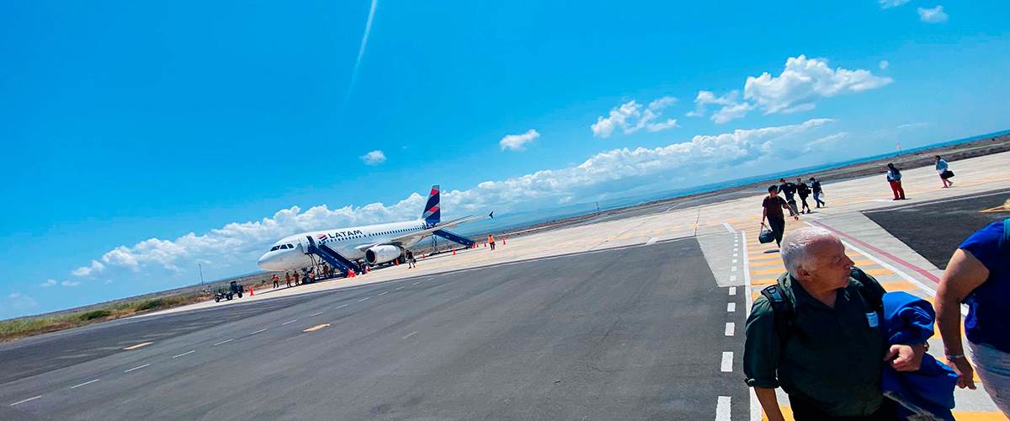

|  |  |
| --- | --- |
| **Trail:** |  |
| **Level**: | 1 |
| **Activities:** | - |

PM: SEYMOUR

Immerse in the abundant wildlife of Seymour Island. Watch out for magnificent and great frigatebirds displaying their fascinating courtship ritual. Observe blue-footed boobies in their nesting grounds and catch a glimpse of land and marine iguanas in their natural habitat. Delight in the playful activities of sea lions in the surf.

Snorkel Experience: Dive into the azure waters teeming with diverse fish species, sea lions, sharks, eels, turtles, rays, and many more. Seymour Island is a fantastic snorkeling spot not to be missed.

Galapagos sea lions, Magnificent and great frigatebirds, Land and marine iguanas, Darwin finches

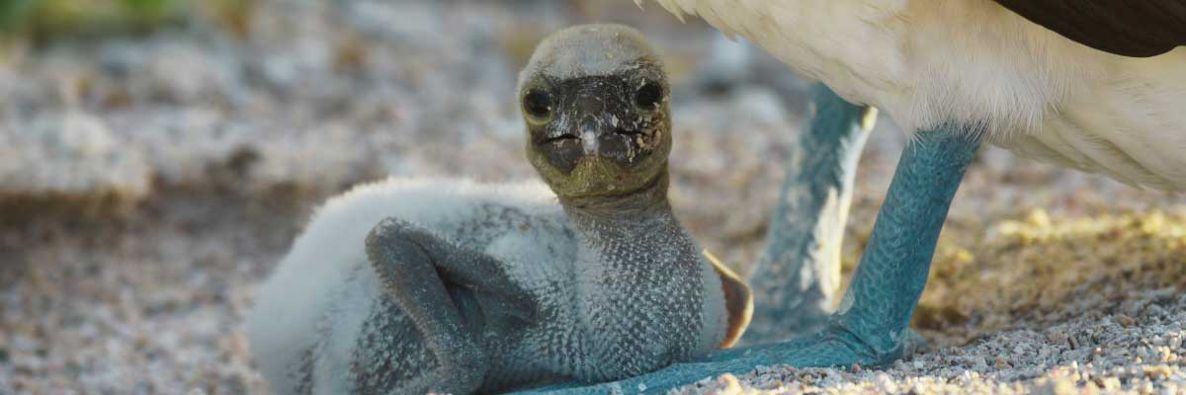

|  |  |
| --- | --- |
| **Food**: | -/L/D |
| **Trail:** | 1,4 km / 0,8 mi |
| **Lodging**: | M/C Alya |
| **Level**: | 1 |
| **Activities:** | HIKING |

DAY 2

AM: PLAZAS

Discover the richness of South Plazas, where land iguanas feed on prickly-pear cacti and playful sea lion pups frolic in tide pools. Walk along the cliff trail and witness the flurry of sea birds such as frigatebirds, red-billed tropicbirds, boobies, swallow-tailed gulls, and pelicans.

**Highlights:**  Stunning Views, Boobies, Galapagos sea lions, Galapagos shearwaters, Galapagos land iguanas, Tropicbirds, Pelicans

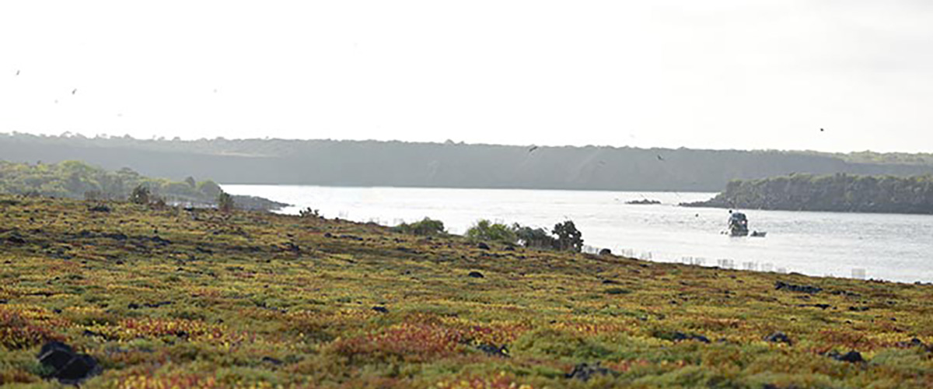

|  |  |
| --- | --- |
| **Trail:** | 1,4 km / 0,8 mi |
| **Level**: | 2 |
| **Activities:** | HIKING,PANGA RIDE,PADDLE BOARD,KAYAK |

PM: SANTA FE

Explore the cactus-strewn, lava-rock landscapes of Santa Fe. See sea lions basking in the white sand beaches, and keep an eye out for Galapagos hawks, Darwin finches, Galapagos doves, mockingbirds and lava lizards.

Snorkel Experience: Enjoy a soothing swim, kayak or snorkel in the bay's sheltered waters where sea lion pups, reef sharks, sea turtles, rays, surgeonfish and parrotfish await you.

**Highlights:** Stunning Views, Galapagos sea lions, Galapagos hawks, Galapagos doves, Santa Fe land iguanas, Reef sharks

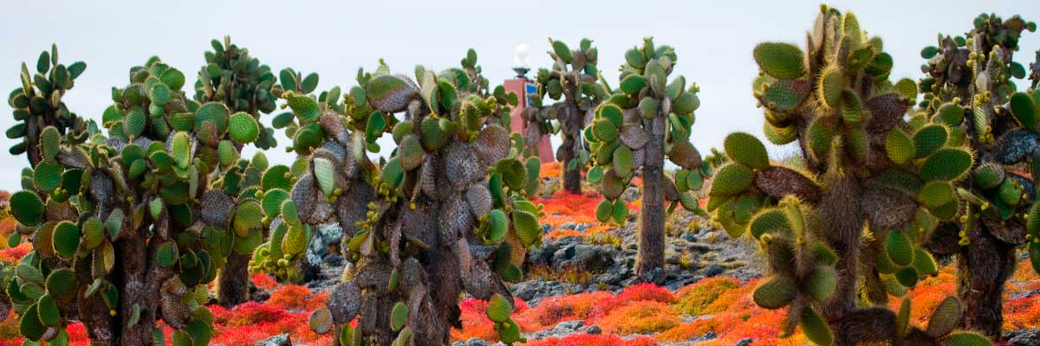

|  |  |
| --- | --- |
| **Food**: | B/L/D |
| **Trail:** | 0,8 km / 0,5 mi |
| **Lodging**: | M/C Alya |
| **Level**: | 2 |
| **Activities:** | HIKING,SNORKEL,PANGA RIDE,PADDLE BOARD,KAYAK |

DAY 3

AM: INTERPRETATION CENTER

Engage in the rich history of the Galapagos at the Interpretation Center, tracing back from the era of early Spanish explorers to the present day, and learn about the challenges faced by the initial settlers.

**Highlights:**  Endemic plants and an exhibition on human history

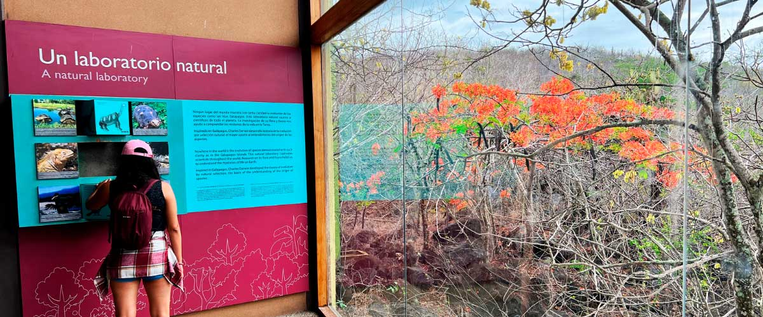

|  |  |
| --- | --- |
| **Trail:** | 0,2 km / 650 ft |
| **Level**: | 1 |
| **Activities:** | HIKING |

PM: LOBOS ISLAND

Witness the bustling wildlife of Lobos Island, home to large groups of sea lions, male frigatebirds, and blue-footed boobies.

Snorkel Experience: The calm waters of Lobos Island offer an excellent snorkeling experience. Swim with playful sea lions, or spot sea turtles and rays resting in the sandy bottoms.

**Highlights:** Stunning Views, Galapagos sea lions, Magnificent and great frigatebirds, San Cristobal Lava Lizards

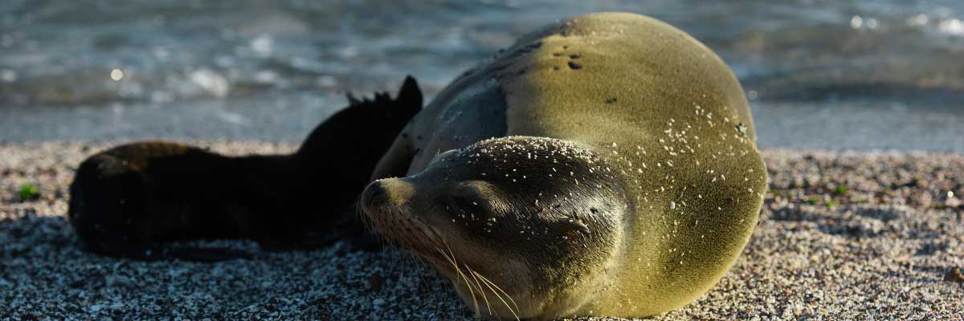

|  |  |
| --- | --- |
| **Food**: | B/L/D |
| **Trail:** | 0,6 km / 0,4 mi |
| **Lodging**: | M/C Alya |
| **Level**: | 3 |
| **Activities:** | HIKING,SNORKEL,PANGA RIDE |

DAY 4

AM: GARDNER BAY

Gardner Bay, located on Española Island, boasts one of the most stunning beaches in the Galapagos. Its soft coral sand and crystal-clear waters create a paradise-like setting, perfect for relaxation and exploration. As you stroll along the shore, spot curious Española mockingbirds, marine iguanas basking in the sun, and Galapagos hawks soaring overhead in search of prey. This natural sanctuary is also home to playful sea lions, making for an unforgettable wildlife experience in a pristine, breathtaking environment.

Snorkel Experience: Dive into the vibrant waters of Gardner Bay, where you can swim with sea lions, reef sharks, rays, and a colorful variety of tropical fish, including angelfish, parrotfish, damselfish, and surgeonfish.

**Highlights:**  Coral sand beach, Galapagos mockingbirds, Galapagos hawks, Darwin finches, Marine iguanas

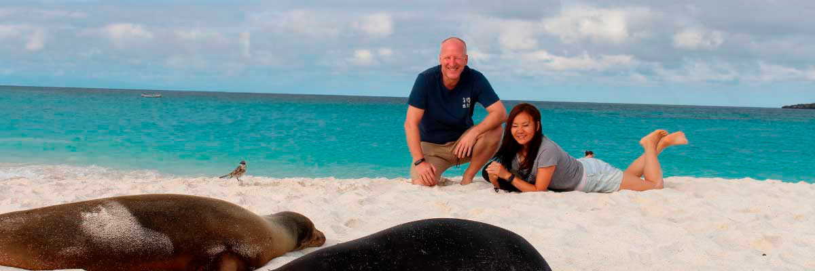

|  |  |
| --- | --- |
| **Trail:** | 0,8 km / 0,5 mi |
| **Level**: | 1 |
| **Activities:** | HIKING,SNORKEL,PADDLE BOARD,KAYAK |

PM: SUAREZ POINT

Experience an awe-inspiring nature walk at Suarez Point. Encounter sea lions, marine iguanas, and large colonies of sea birds, and from April to January, catch a sight of the waved albatross, the largest bird on the islands.

**Highlights:** Stunning Views, Herons, Galapagos mockingbirds, Galapagos hawks, Darwin finches, Marine iguanas, Waved Albatross, Lava lizards

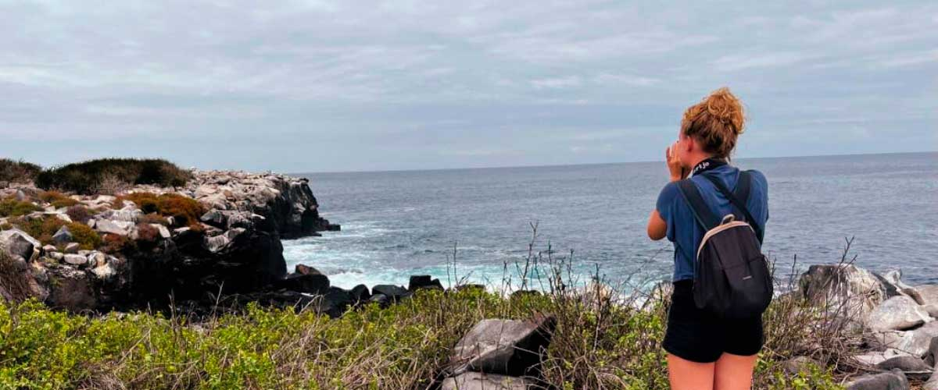

|  |  |
| --- | --- |
| **Food**: | B/L/D |
| **Trail:** | 1,7 km / 1,1 mi |
| **Lodging**: | M/C Alya |
| **Level**: | 3 |
| **Activities:** | HIKING |

DAY 5

AM: CORMORANT POINT / DEVIL´S CROWN

Venture into Punta Cormorant, famous for its large coastal lagoon inhabited by American flamingoes, white-cheeked pintails, black-necked stilts and other shorebirds.

Snorkel Experience: Prepare for an exhilarating snorkeling experience at Devil’s Crown. Be amazed by the abundant marine life, including snapper, Creole fish, parrot fish, angelfish, reef sharks, sea turtles, and rays.

**Highlights:**  Sea turtle nesting site, Galapagos shearwaters, Tropicbirds, Frigatebirds, Finches, Shorebirds

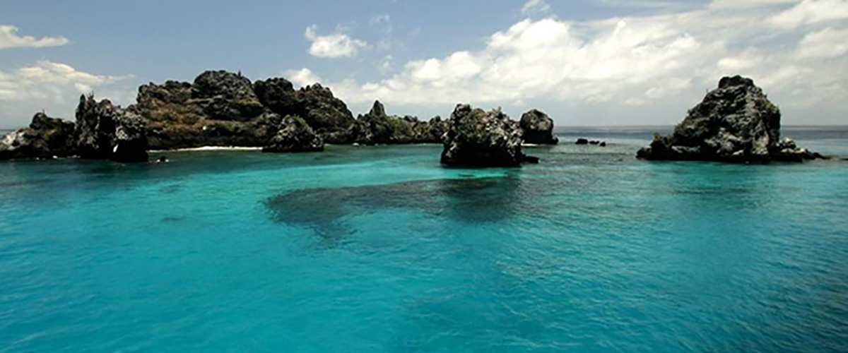

|  |  |
| --- | --- |
| **Trail:** | 1,6 km / 1 mi |
| **Level**: | 1 |
| **Activities:** | HIKING,SNORKEL,PANGA RIDE,PADDLE BOARD,KAYAK |

PM: ALIERI HILL

Alieri Hill is a haven for nature enthusiasts offering a spectacular blend of endemic plants and breathtaking views. This volcanic terrain nurtures unique flora found only in the Galapagos. As you explore the trails, keep an eye out for yellow warblers, flycatchers, and the iconic Darwin finches, whose diversity contributed to the theory of evolution. From the hilltop, take in the sweeping views of the northern coast, where the deep blue ocean meets the untouched landscapes of the island.

**Highlights:** Endemic plants and an exhibition on human history, Transition zone, Darwin finches

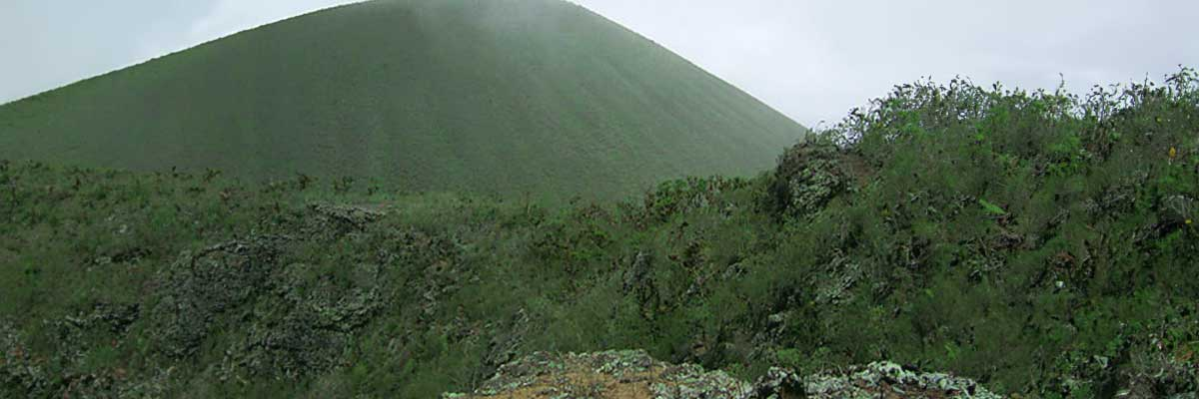

|  |  |
| --- | --- |
| **Food**: | B/L/D |
| **Trail:** | 1 km / 0,6 mi |
| **Lodging**: | M/C Alya |
| **Level**: | 3 |
| **Activities:** | HIKING |

DAY 6

AM: HIGHLANDS

Embark on a highlands adventure, either from Baltra or Puerto Ayora. A bus journey brings you to the verdant highland forests, home to Galapagos Giant tortoises. You'll find these impressive creatures, weighing up to 300 kg/600 lbs, casually grazing or lounging in freshwater ponds. The highlands also host a variety of bird species seldom seen in the lowlands. Depending on your itinerary, explore a lava tunnel and delve into the geological history of these volcanic islands.

Lava tunnels, Darwin finches, Galapagos flycatchers, Giant tortoises, Barn owls, White-cheeked pintails

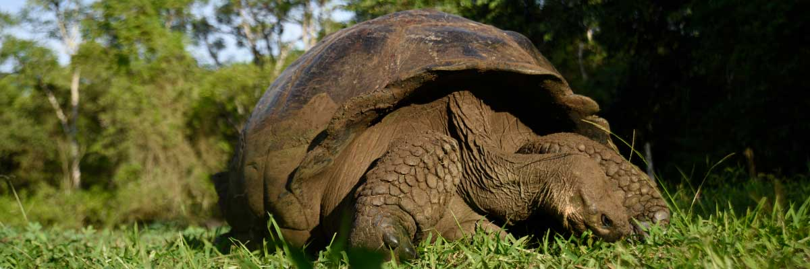

|  |  |
| --- | --- |
| **Trail:** | 1-1,5 km / 0,6-0,9 mi |
| **Level**: | 1 |
| **Activities:** | HIKING |

PM: RETURN AT BALTRA AIRPORT

Your Galapagos adventure comes to an end. Today, you will be transferred to Baltra Airport, where your National Park naturalist guide will assist you with final details before your flight back to mainland Ecuador. As you bid farewell to this paradise, take with you the unforgettable memories of one of the world’s most extraordinary destinations.



|  |  |
| --- | --- |
| **Food**: | B/-/- |
| **Trail:** |  |
| **Lodging**: | M/C Alya |
| **Level**: | 1 |
| **Activities:** | - |

GLOSSARY

|  |  |  |  |
| --- | --- | --- | --- |
| **Feeding** | | **Breakfast** | B |
| **Lunch** | L |
| **Dinner** | D |
| **Difficulty of the hike** | | **Level 1** | Easy |
| **Level 2** | Moderate |
| **Level 3** | Difficult |