**Western Galapagos Wildlife and Volcanic Wonders**

5 Days – 4 nights

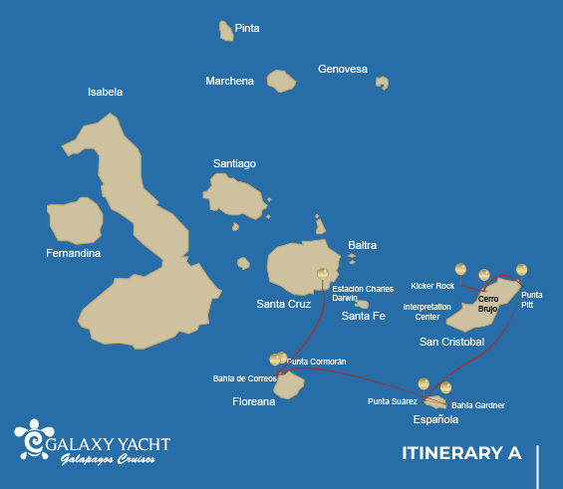

|  |  |  |  |  |  |  |  |
| --- | --- | --- | --- | --- | --- | --- | --- |
|  | | | **Hiking** | **Snorkel** | **Panga Ride** | **Paddle Board** | **Kayak** |
| SATURDAY | AM | **San Cristobal Island** : San Cristobal- Airport (arrival) |  |  |  |  |  |
|  | PM | **San Cristobal Island** : San Cristobal Interpretation Center | * |  |  |  |  |
| SUNDAY | AM | **San Cristobal Island** : Witch Hill | * | * | * | * | * |
|  | PM | **San Cristobal Island** : Pitt Point | * | * | * | * | * |
| MONDAY | AM | **Española Island** : Suarez Point | * |  |  |  |  |
|  | PM | **Española Island** : Gardner Bay | * | * |  | * | * |
| TUESDAY | AM | **Floreana Island** : Cormorant Point | * | * | * | * | * |
|  | PM | **Floreana Island** : Post Office Bay | * | * |  |  |  |
| WEDNESDAY | AM | **Santa Cruz Island** : Charles Darwin Station | * |  |  |  |  |
|  | PM | **Santa Cruz Island** : Baltra - airport (return) |  |  |  |  |  |

DAY 1 - SATURDAY

AM: EMBARKATION TO THE GALAPAGOS ISLANDS - SAN CRISTOBAL AIRPORT

Embark on an unforgettable journey to the Galapagos Islands, where nature thrives in its purest form. Your adventure begins at San Cristobal’s modest yet bustling airport, where a seasoned naturalist guide will greet you. This guardian of the ecosystem will introduce you to a world of breathtaking landscapes and unparalleled biodiversity. Feel the excitement as you step into this living sanctuary, a UNESCO World Heritage site, marking the beginning of an extraordinary exploration.



|  |  |
| --- | --- |
| **Trail:** |  |
| **Level**: | 1 |
| **Activities:** | - |

PM: SAN CRISTOBAL INTERPRETATION CENTER

The San Cristobal Interpretation Center provides an immersive journey through the natural and cultural history of the Galapagos. Interactive exhibits showcase the islands’ evolution, human impact, and ongoing conservation challenges. From early explorers to modern ecological restoration efforts, this center offers a comprehensive view of the past, present, and future of the archipelago. Surrounded by scenic trails and panoramic views, it’s an essential stop for those looking to understand the uniqueness and fragility of the Galapagos

Endemic plants and an exhibition on human history

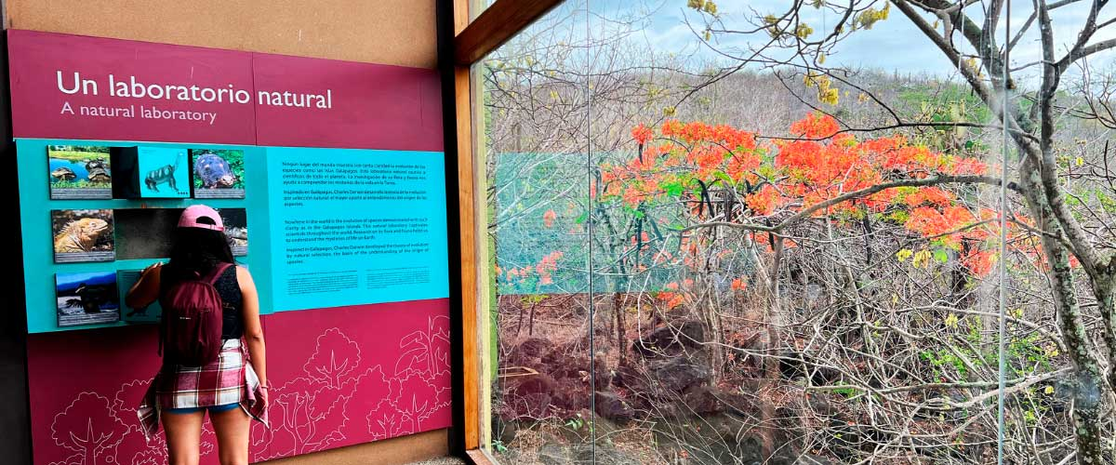

|  |  |
| --- | --- |
| **Food**: | -/L/D |
| **Trail:** | 0,2 km / 650 ft |
| **Lodging**: | M/Y Galaxy |
| **Level**: | 1 |
| **Activities:** | HIKING |

DAY 2 - SUNDAY

AM: CERRO BRUJO - SAN CRISTOBAL ISLAND

Witch Hill, on the northern coast of San Cristóbal, is one of the most stunning beaches in the Galapagos. Its powdery white sand and turquoise waters create a perfect setting for strolling and relaxing, while a large sea lion colony lounges on the shore. The nearby lagoon attracts diverse birdlife, including pelicans and blue-footed boobies. This site holds historical significance as one of Charles Darwin’s first stops in the Galapagos. Dive into the crystal-clear waters for a snorkeling experience filled with tropical fish, rays, and sea turtles.

Snorkel Experience: Stroll along Cerro Brujo’s white sands, relax near sea lions, and dive into a vibrant underwater world. Snorkeling here offers a chance to swim with tropical fish, sea turtles, and rays in crystal-clear waters.

**Highlights:**  Snorkeling opportunities, White sand beach, Blue-footed boobies, Galapagos sea lions, Pelicans

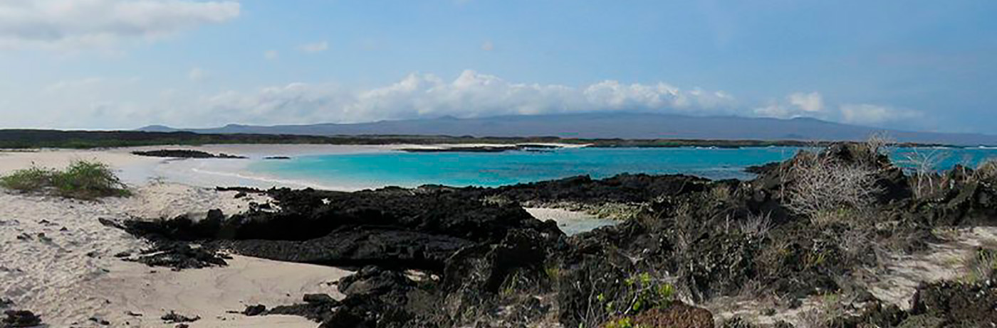

|  |  |
| --- | --- |
| **Trail:** | 0.5 km / 0.3 mi |
| **Level**: | 3 |
| **Activities:** | HIKING,SNORKEL,PANGA RIDE,PADDLE BOARD,KAYAK |

PM: PUNTA PITT - SAN CRISTOBAL ISLAND

Located on the northeastern tip of San Cristóbal, Punta Pitt is a must-visit for nature and adventure enthusiasts. Its rugged trails lead to breathtaking viewpoints, where you can observe frigatebirds and the three iconic booby species—blue-footed, red-footed, and Nazca—a rare sight in the Galapagos. The volcanic landscape, with dramatic rock formations and lush vegetation, creates a thriving habitat for diverse wildlife. This experience blends a challenging hike with the chance to witness the archipelago’s incredible biodiversity at its finest.

Hiking Experience: Explore the rugged terrain of Punta Pitt and witness the diverse birdlife, including all three booby species and frigate birds.

**Highlights:**  Stunning Views, Snorkeling opportunities, Magnificent and great frigatebirds

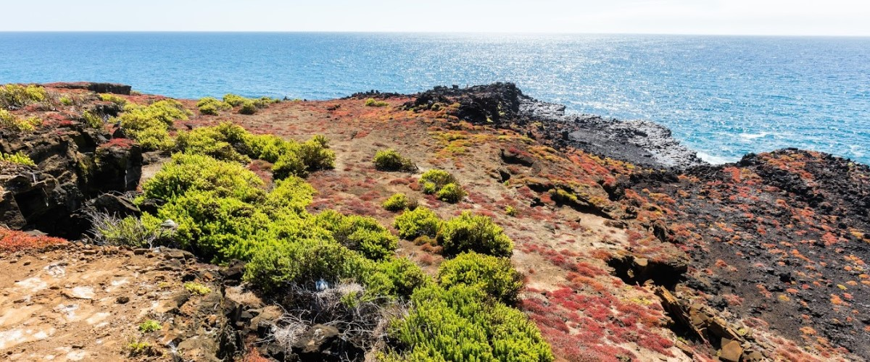

|  |  |
| --- | --- |
| **Food**: | B/L/D |
| **Trail:** | 1.5 km / 0.9 mi |
| **Lodging**: | M/Y Galaxy |
| **Level**: | 3 |
| **Activities:** | HIKING,SNORKEL,PANGA RIDE,PADDLE BOARD,KAYAK |

DAY 3 - MONDAY

AM: A WALK-THROUGH NATURE’S GALLERY - SUAREZ POINT

Embark on an adventure to Suarez Point, one of the Galapagos’ greatest natural wonders. This rocky trail is a haven for wildlife lovers, featuring an incredible array of species. Upon arrival, sea lions and marine iguanas welcome you as the first hosts of this nature spectacle. As you explore further, witness a vibrant mosaic of seabird colonies, from blue-footed and Nazca boobies to graceful frigatebirds and tropicbirds. The highlight of this journey is meeting the waved albatross, the island’s largest bird, impressing visitors with its powerful flight and intricate courtship display (present from April to January).

**Highlights:**  Stunning Views, Herons, Galapagos mockingbirds, Galapagos hawks, Darwin finches, Marine iguanas, Waved Albatross, Lava lizards

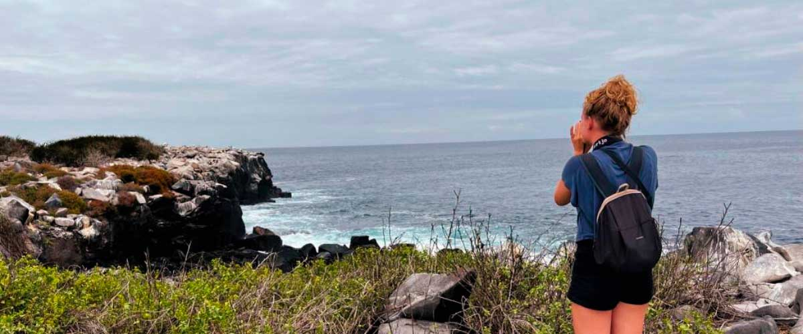

|  |  |
| --- | --- |
| **Trail:** | 1,7 km / 1,1 mi |
| **Level**: | 3 |
| **Activities:** | HIKING |

PM: A TROPICAL PARAIDSE - GARDNER BAY

Embrace the morning at Gardner Bay, a pristine piece of paradise in the Galapagos archipelago. Sugar-white coral sands merge with crystal-clear turquoise waters, creating a tropical oasis. Watch as the beach becomes a theatre, starring sun-basking sea lions in a playful performance. This idyllic setting invites you to stroll along the coast, immersing yourself in an enlightening experience as you delve into the biology of the endemic fauna - from the melodious Española mockingbird and the unique marine iguanas to the regal Galapagos hawks.

Snorkel Experience: Submerge beneath the azure waves to witness a spectacular performance choreographed by marine life. Swim alongside playful sea lions, graceful reef sharks, and gliding rays. Discover an array of fish, including vivid Angelfish, charismatic Parrotfish, dynamic Damselfish, and the ever-busy Surgeonfish coloring the underwater landscape.

**Highlights:**  Coral sand beach, Galapagos mockingbirds, Galapagos hawks, Darwin finches, Marine iguanas

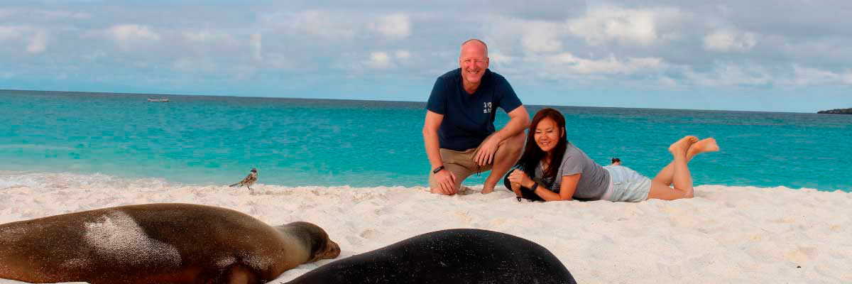

|  |  |
| --- | --- |
| **Food**: | B/L/D |
| **Trail:** | 0,8 km / 0,5 mi |
| **Lodging**: | M/Y Galaxy |
| **Level**: | 1 |
| **Activities:** | HIKING,SNORKEL,PADDLE BOARD,KAYAK |

DAY 4 - TUESDAY

AM: THE WONDER OF NATURE - CORMORANT POINT / DEVIL’S CROWN

Located in northern Floreana, Punta Cormorant is a paradise for nature lovers. Its coastal lagoon hosts flamingos, white-cheeked pintails, and black-necked stilts, while its white sand beach is a crucial nesting site for green sea turtles. In recent years, blue-footed boobies have started nesting along the trail. This is also a great site for spotting endemic plants. For snorkeling, Devil’s Crown—a heavily eroded volcanic formation—offers an unparalleled experience, attracting reef sharks, rays, sea turtles, and massive schools of tropical fish.

Snorkel Experience: Explore Devil’s Crown, one of the best snorkeling spots in the Galapagos. Its currents attract reef sharks, turtles, rays, and massive schools of fish like snappers, parrotfish, and angelfish.

**Highlights:**  Galapagos sea lions, Blue footed boobies, Galapagos shearwaters, American flamingoes, Sea turtles, Tropicbirds, Frigatebirds

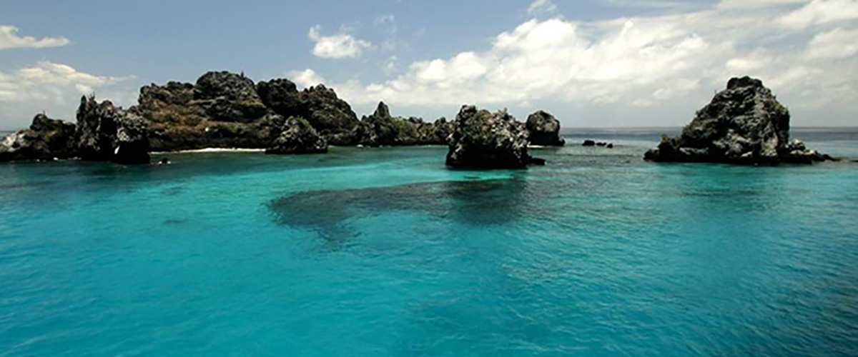

|  |  |
| --- | --- |
| **Trail:** | 1,6 km / 1 mi |
| **Level**: | 1 |
| **Activities:** | HIKING,SNORKEL,PANGA RIDE,PADDLE BOARD,KAYAK |

PM: MAIL FROM THE PAST - POST OFFICE BAY

Step into the past at Post Office Bay on Floreana, where sailors established a barrel-based mail system in the 1700s, still in use today. Beyond its historic charm, the bay was a key stop for whalers seeking freshwater and tortoises. This site also boasts a scenic beach, and incredible wildlife, including sea lions, green sea turtles, reef sharks, and, if luck is on your side, the elusive Galapagos penguin.

Snorkel Experience: Dive straight from the beach and explore a mesmerizing underwater world filled with sea turtles, rays, and schools of tropical fish. If lucky, catch a glimpse of a Galapagos penguin darting through the waves.

**Highlights:**  Galapagos penguins, Marine iguanas, Sea turtles, Finches, Shorebirds

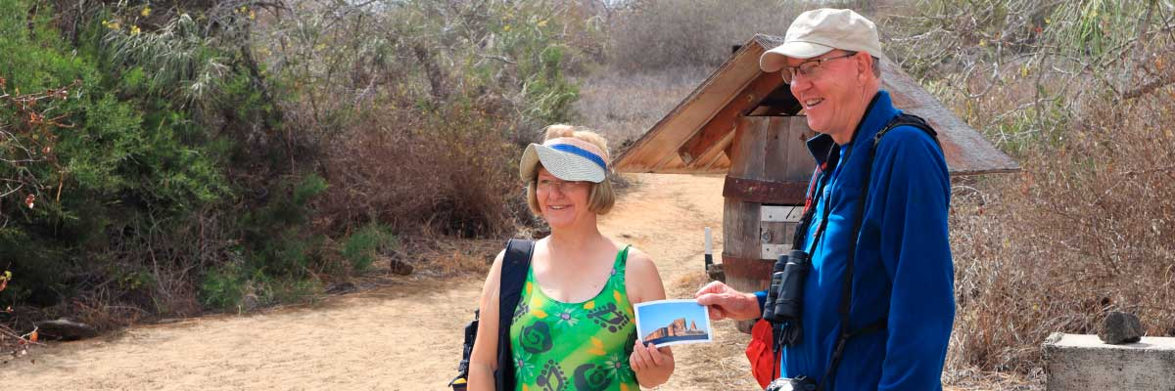

|  |  |
| --- | --- |
| **Food**: | B/L/D |
| **Trail:** | 0,7 km / 0,4 mi |
| **Lodging**: | M/Y Galaxy |
| **Level**: | 1 |
| **Activities:** | HIKING,SNORKEL |

DAY 5 - WEDNESDAY

AM: THE CRADLE OF CONSERVATION - CHARLES DARWIN STATION

Explore the Charles Darwin Research Station, a center dedicated to wildlife conservation and research. Witness breeding programs helping restore giant tortoise populations, learn about projects tackling invasive species, and see conservationists working to protect the fragile Galapagos ecosystem.

Galapagos giant tortoise and land iguanas breeding program, Galapagos mockingbirds, Darwin finches, Galapagos flycatchers

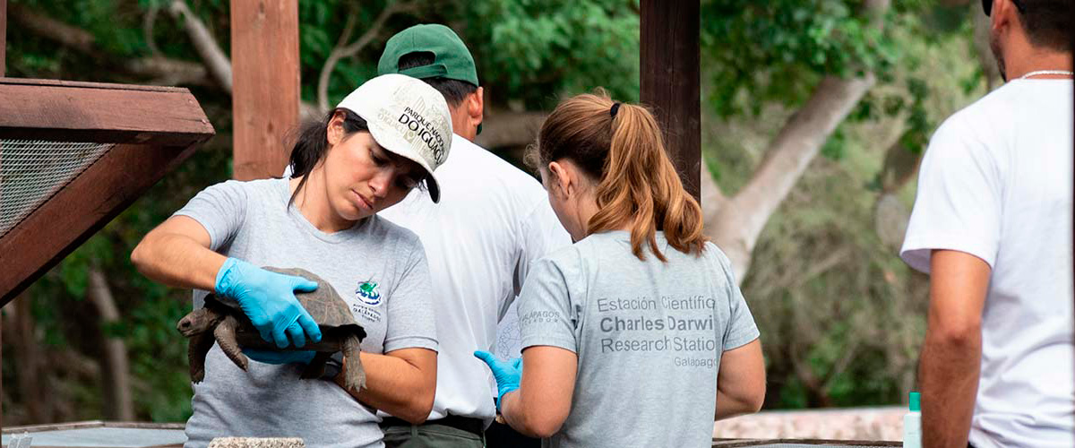

|  |  |
| --- | --- |
| **Trail:** | 2 km / 1,2 mi |
| **Level**: | 1 |
| **Activities:** | HIKING |

PM: BALTRA (AIRPORT)

Your Galapagos adventure comes to an end. Today, you will be transferred to Baltra Airport, where your National Park naturalist guide will assist you with final details before your flight back to mainland Ecuador. As you bid farewell to this paradise, take with you the unforgettable memories of one of the world’s most extraordinary destinations.

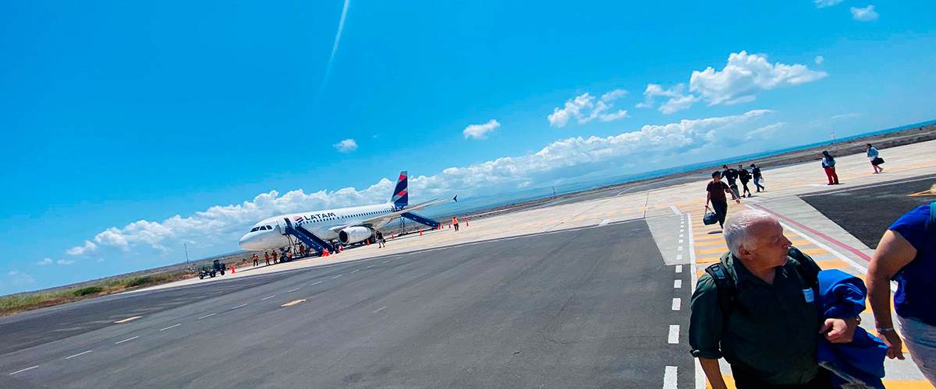

|  |  |
| --- | --- |
| **Food**: | B/-/- |
| **Trail:** |  |
| **Lodging**: | M/Y Galaxy |
| **Level**: | 1 |
| **Activities:** | - |

GLOSSARY

|  |  |  |
| --- | --- | --- |
| **Feeding** | **Breakfast** | B |
| **Lunch** | L |
| **Dinner** | D |
| **Difficulty of the hike** | **Level 1** | Easy |
| **Level 2** | Moderate |
| **Level 3** | Difficult |