Galapagos Northeast Discovery and Diversity
6 Days – 5 Nights

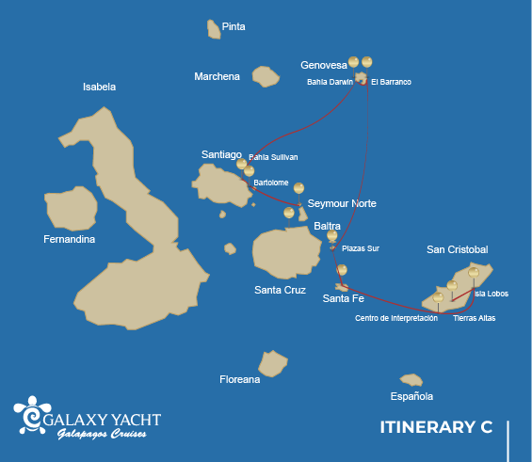
 |  |  | Hiking | Snorkel | Panga Ride | Paddle Board | Kayak
MONDAY | AM | Santa Cruz Island : Baltra - airport (arrival)
 | PM | Seymour Island : North Seymour | *
TUESDAY | AM | Bartolome Island : Bartolome | * | * | *
 | PM | Santiago Island : Sullivan Bay | * | * | *
WEDNESDAY | AM | Genovesa Island : Darwin Bay | * | * | * | * | *
 | PM | Genovesa Island : Barranco | * | * | * | * | *
THURSDAY | AM | South Plazas Island : South Plazas | * | * | *
 | PM | Santa Fe Island : Santa Fe | * | * | * | * | *
FRIDAY | AM | San Cristobal Island : Highlands | *
 | PM | San Cristobal Island : Lobos Island | * | * | *
SATURDAY | AM | San Cristobal Island : Kicker Rock
 | PM | San Cristobal Island : San Cristobal - airport (return)

DAY 1 - MONDAY

AM: BALTRA AIRPORT
Embark on an unforgettable adventure to the Galapagos Islands, starting with your arrival at Baltra airport. Our expert naturalist guide from the National Park will eagerly await your arrival to introduce you to the wonders ahead.

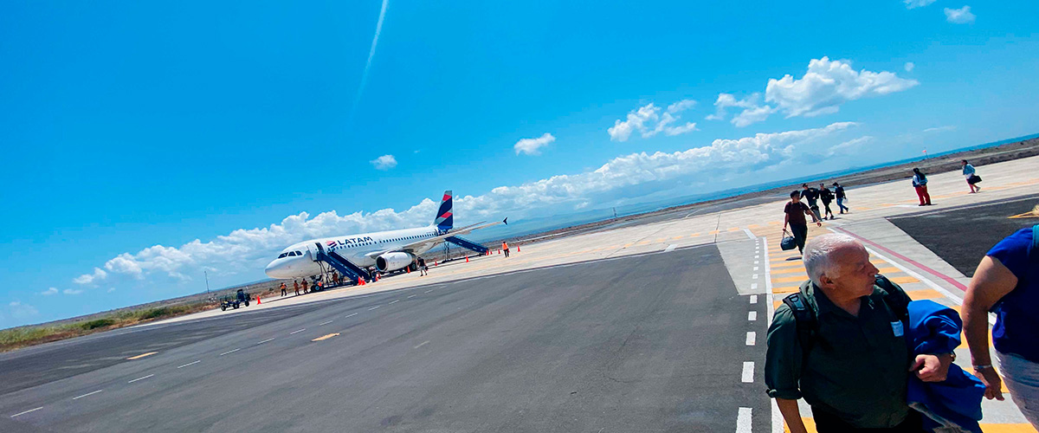
Trail:
Level: | 1
Activities: | -

PM: NORTH SEYMOUR AND TRANSFER OUT TO BALTRA’S AIRPORT
Your journey continues with a morning visit to North Seymour Island, a spectacular showcase of the Galapagos Islands' diverse wildlife. This relatively flat island is home to a thriving population of blue-footed boobies and frigate birds. The trail winds its way through a forest of low, bushy vegetation, where you'll have the opportunity to witness the fascinating courtship dance of the blue-footed boobies. The island's coastline also allows one to observe sea lions and marine iguanas basking in the sun. The large frigate bird colonies are a sight, especially when the males inflate their bright red throat pouches to attract mates.

Galapagos sea lions, Magnificent and great frigatebirds, Land and marine iguanas, Darwin finches
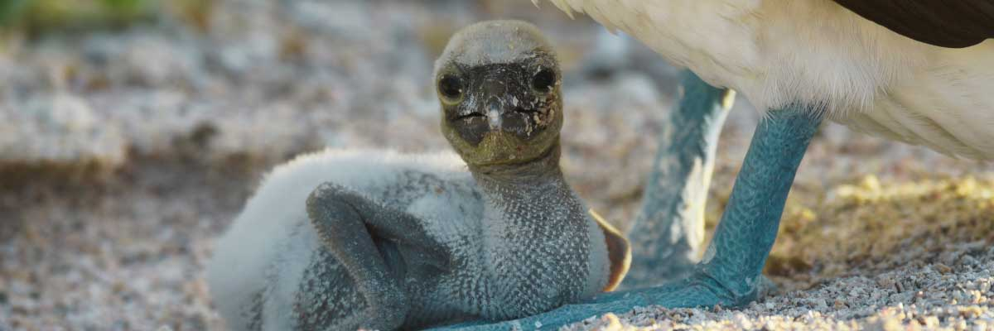
Food: | -/L/D
Trail: | 1,4 km / 0,8 mi
Lodging: | M/Y Galaxy
Level: | 2
Activities: | HIKING
DAY 2 - TUESDAY

AM: BARTOLOME
Bartolome is one of the most iconic islands in Galapagos, renowned for its dramatic volcanic landscape and the famous Pinnacle Rock. Nestled beside a peach-colored sand beach, this island is one of the few places where you can spot penguins without traveling to remote Isabela and Fernandina. The hike to the summit offers breathtaking views of a lunar-like terrain dotted with volcanic cones, with stunning panoramas of Sullivan Bay and Pinnacle Rock. From the top, the vast beauty of the archipelago unfolds before you, creating a truly unforgettable experience.

Highlights: Volcanic landscapes, Pinnacle rock, Herons, Bluefooted boobies, Galapagos penguins
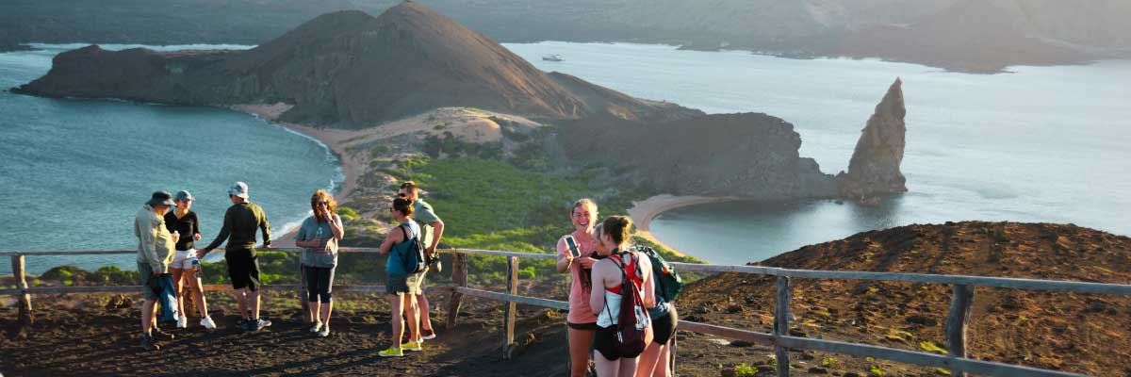
Trail: | 1,5 km / 0,9 mi
Level: | 2
Activities: | HIKING,SNORKEL,PANGA RIDE

PM: SULLIVAN BAY
Walking through Sullivan Bay is a fascinating journey into the volcanic origins of the Galapagos Islands. The trail crosses a vast Pahoehoe lava flow, showcasing unique textures that reveal the story of past eruptions. While the terrain may seem desolate at first, a closer look unveils pioneer plants, scurrying lava lizards, and small birds adapted to this extreme environment. Along the shore, the stark landscape is brightened by the presence of penguins, pelicans, and oystercatchers, adding a vibrant contrast to the stunning volcanic scenery.

Highlights: Lava tubes, Galapagos penguins, Oystercatchers, Galapagos hawks
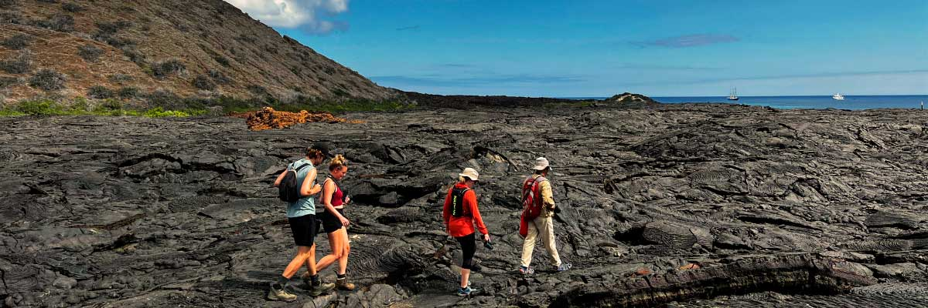
Food: | B/L/D
Trail: | 2,2 km / 1,4 mi
Lodging: | M/Y Galaxy
Level: | 3
Activities: | HIKING,SNORKEL,PANGA RIDE
DAY 3 - WEDNESDAY

AM: DARWIN BAY
Darwin Bay on Genovesa Island is a breathtaking sight for birdwatchers. As you step onto the beach, you’ll be amazed by the presence of hundreds of boobies, gulls, and frigatebirds soaring, nesting in bushes, or resting on the sand. Along the shore, sea lions and marine iguanas blend into the scenery, while inland you may spot night herons, swallow-tailed gulls, Darwin finches, Galapagos doves, and mockingbirds. This immersive experience brings you face-to-face with a thriving ecosystem.

Highlights: Nesting great frigatebirds, Red-footed and Nazca boobies, Galapagos sea lions, Yellow-crowned night herons, Genovesa ground finch, Genovesa cactus finch, Galapagos mockingbirds
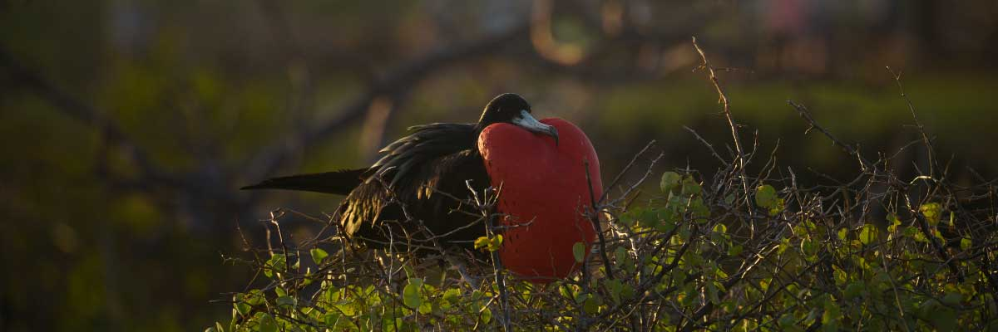
Trail: | 1,2 km / 0,7 mi
Level: | 3
Activities: | HIKING,SNORKEL,PANGA RIDE,PADDLE BOARD,KAYAK

PM: EL BARRANCO
Located in the southern part of Darwin Bay on Genovesa Island, El Barranco is a wildlife sanctuary. Its fragile lava cliffs provide shelter for storm petrels and a remarkable population of short-eared owls. Along the trail, red-footed and Nazca boobies nest on the volcanic rock. At the base of the cliffs, Galapagos fur seals rest in shaded areas, while seabirds soar above this breathtaking landscape, making El Barranco an unforgettable destination for nature lovers.

Highlights: Nesting great frigatebirds, Galapagos sea lions, Genovesa ground finch, Genovesa cactus finch, Galapagos mockingbirds, Galapagos fur seals
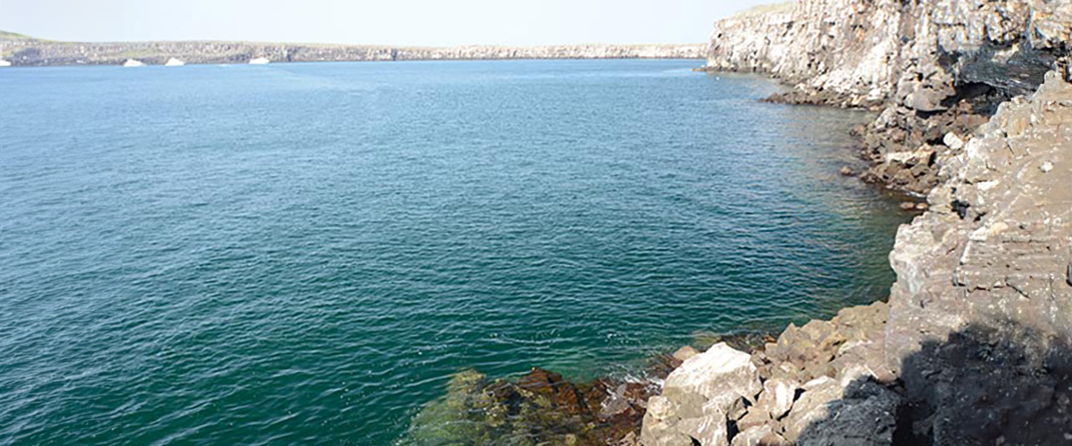
Food: | B/L/D
Trail: | 1,2 km / 0,7 mi
Lodging: | M/Y Galaxy
Level: | 3
Activities: | HIKING,SNORKEL,PANGA RIDE,PADDLE BOARD,KAYAK
DAY 4 - THURSDAY

AM: SOUTH PLAZAS ISLAND
Start your day at South Plazas Island, one of the smallest yet most vibrant in the archipelago. The landscape bursts with color, featuring towering Opuntia cacti and a carpet of *Sesuvium* that turns bright red in the dry season. A large colony of land iguanas can be seen basking under the cacti or wandering around. The island’s steep southern cliffs shelter swallow-tailed gulls, red-billed tropicbirds, and boobies. Along the coastline, sea lions splash and play in the waves, offering a fantastic wildlife spectacle.

Highlights:
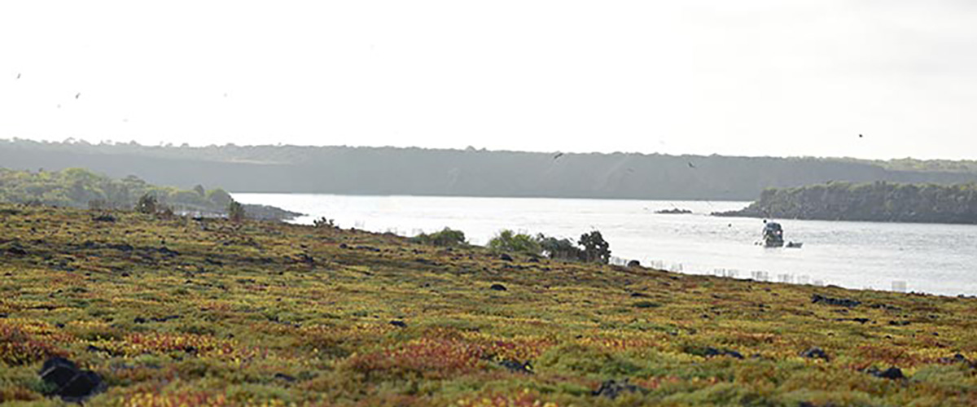
Trail: | 1,4 km / 0,8 mi
Level: | 2
Activities: | HIKING,SNORKEL,PANGA RIDE

PM: SANTA FE
Lead in the day with the stark beauty of Santa Fe, where the towering figures of giant Prickly-pear cacti strikingly contrast the rugged landscape of lava rocks. Tucked within one of the Galapagos most breathtaking bays, Santa Fe's turquoise waters, and white-sand beaches form an inviting residence for a sizable colony of sea lions you'll find lounging about. As you venture inland, remember to look down to spot the endemic Santa Fe land iguanas, but also glance upward to catch sight of the Galapagos hawks perched atop cacti, keeping a keen eye out for prey. You'll likely encounter Darwin finches, Galapagos doves, mockingbirds, and lively lava lizards along the trail.

Highlights: Stunning Views, Galapagos sea lions, Galapagos hawks, Galapagos doves, Santa Fe land iguanas, Reef sharks
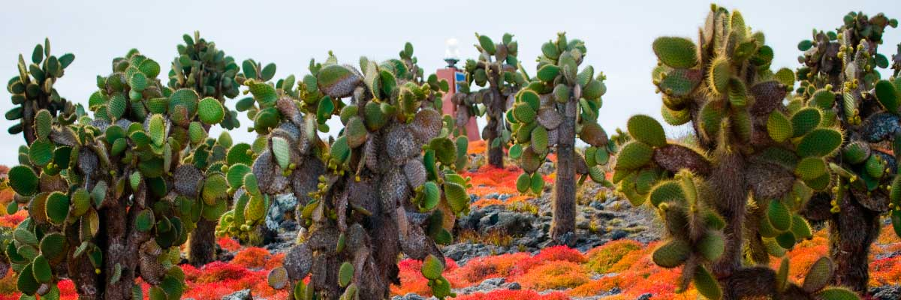
Food: | B/L/D
Trail: | 0,8 km / 0,5 mi
Lodging: | M/Y Galaxy
Level: | 2
Activities: | HIKING,SNORKEL,PANGA RIDE,PADDLE BOARD,KAYAK
DAY 5 - FRIDAY

AM: HIGHLANDS
Your day begins with a journey to the highlands of San Cristobal Island, offering a different perspectiveof the Galapagos’; unique ecosystem. This lush and verdant area contrasts sharply with the coastalzones. The highlands are home to a variety of bird species, giant tortoises in their natural habitat, anda rich array of plant life, including endemic trees and ferns. You’ll have the opportunity to walk alongpaths that meander through this lush landscape, offering a chance to observe the giant tortoises upclose and personal. The highlands also provide panoramic views of the island, showcasing its diversetopography

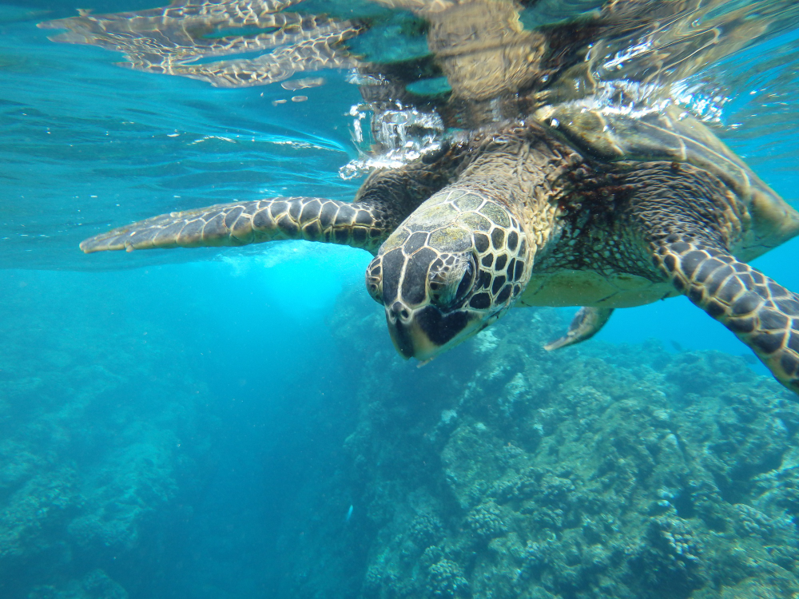
Trail: | Variable
Level: | 1
Activities: | HIKING

PM: LOBOS ISLAND
Venture to Lobos Island, a tranquil islet secluded from San Cristobal by a slim channel. This nature's cradle, amidst a serene bay, is the playground for sea lion pups frolicking in tidal pools. The island might be modest in size, but it bursts with life, particularly with “lobos marinos” or sea lions. As you step ashore, welcoming committees of sea lions would greet you, only to be outraged by the male frigatebirds inland, presenting their inflamed red balloons amidst the verdant foliage. Stay vigilant for the blue-footed boobies nesting on the trails, ready to treat you to a display of their whimsical courtship dance.

Stunning Views, Galapagos sea lions, Magnificent and great frigatebirds, San Cristobal Lava Lizards
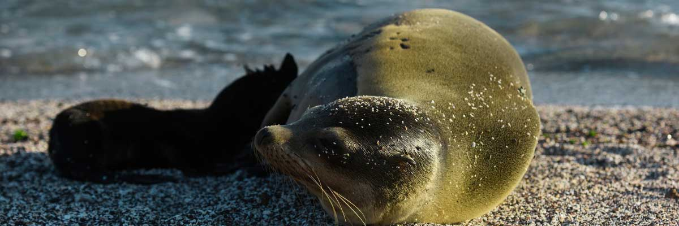
Food: | B/L/D
Trail: | 0,6 km / 0,4 mi
Lodging: | M/Y Galaxy
Level: | 3
Activities: | HIKING,SNORKEL,PANGA RIDE
DAY 6 - SATURDAY

AM: KICKER ROCK
In the afternoon, embark on an unforgettable panga (dinghy) ride around Kicker Rock, also known as León Dormido, off the coast of San Cristobal Island. This impressive rock formation, rising dramatically 500 feet above the ocean, is one of the most iconic landmarks in the Galapagos. The natural erosion of this ancient volcanic tuff cone has created a channel between two towering rock walls, providing a haven for various marine life. This peaceful and scenic panga ride around Kicker Rock provides a relaxing yet awe-inspiring conclusion to your day, allowing you to appreciate the natural wonders and rich biodiversity of the Galapagos from the sea.

Boobies, Pelicans, Frigatebirds
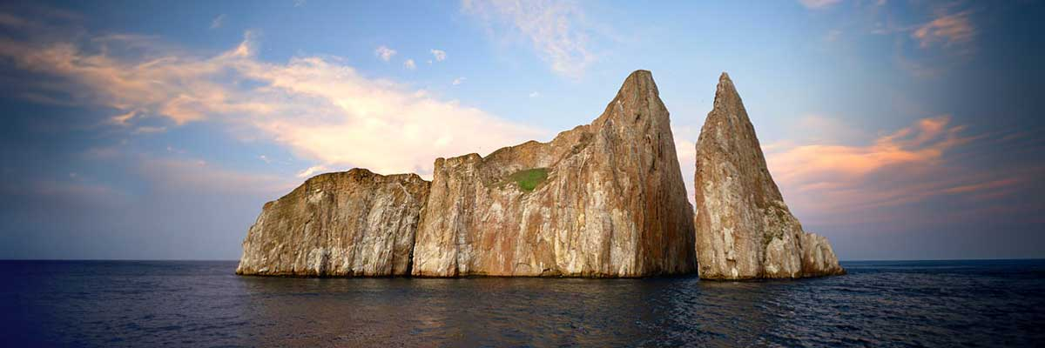
Trail:
Level: | 2
Activities: | -

PM: AIRPORT (SAN CRISTOBAL)
After exploring the breathtaking biodiversity and unique landscapes of the Galapagos, it’s time to return to mainland Ecuador. You’ll be transferred to the airport, bringing this unforgettable journey to a close. Every encounter with giant tortoises, blue-footed boobies, and volcanic landscapes will remain etched in your memory. Galapagos is not just a destination—it’s a transformative experience that will stay with you forever. Wishing you a wonderful journey back!

Food: | B/-/-
Trail:
Lodging: | M/Y Galaxy
Level: | 1
Activities: | -
GLOSSARY
Feeding | Breakfast | B
Feeding | Lunch | L
Feeding | Dinner | D
Difficulty of the hike | Level 1 | Easy
Difficulty of the hike | Level 2 | Moderate
Difficulty of the hike | Level 3 | Difficult

