**Galapagos Western Hidden Jewels Cruise**

**8 days – 7 nights**

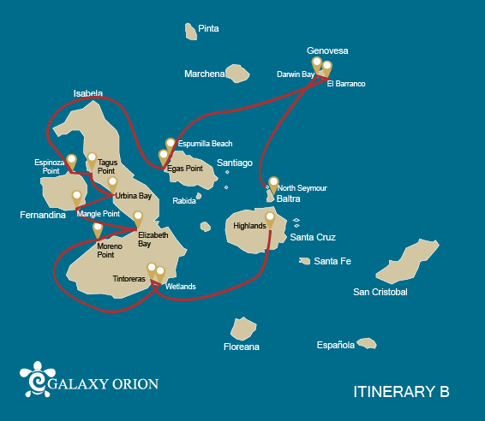

|  |  |  |  |  |  |  |  |
| --- | --- | --- | --- | --- | --- | --- | --- |
|  | | | **Hiking** | **Snorkel** | **Panga Ride** | **Paddle Board** | **Kayak** |
| SATURDAY | AM | **Santa Cruz Island :** Baltra - airport (arrival) |  |  |  |  |  |
|  | PM | **Santa Cruz Island :** Highlands | * |  |  |  |  |
| SUNDAY | AM | **Isabela Island :** Tintoreras | * | * | * |  |  |
|  | PM | **San Cristobal Island :** Isabela's Wetlands and Interpretation Center | * |  |  |  |  |
| MONDAY | AM | **Isabela Island :** Moreno Point | * | * | * |  |  |
|  | PM | **Isabela Island :** Elizabeth Bay |  |  | * | * | * |
| TUESDAY | AM | **Fernandina Island :** Mangle Point |  | * | * | * | * |
|  | PM | **Isabela Island :** Urbina Bay | * | * |  |  |  |
| WEDNESDAY | AM | **Isabela Island :** Tagus Cove | * | * | * | * | * |
|  | PM | **Fernandina Island :** Espinoza Point | * | * | * |  |  |
| THURSDAY | AM | **Santiago Island :** Egas Port | * | * |  |  |  |
|  | PM | **Santiago Island :** Espumilla Beach / Buccaneer Cove | * | * | * | * | * |
| FRIDAY | AM | **Genovesa Island :** Barranco | * | * | * | * | * |
|  | PM | **Genovesa Island :** Darwin Bay | * | * | * | * | * |
| SATURDAY | AM | **Seymour Island :** North Seymour | * |  |  |  |  |
|  | PM | **Santa Cruz Island :** Baltra - airport (return) |  |  |  |  |  |

DAY 1

AM: ARRIVAL AT BALTRA AIRPORT

Welcome to Galapagos! Upon arrival at Baltra Airport, your naturalist guide will greet you and assist with the transfer to Itabaca Channel. This initial journey offers your first connection with the archipelago as you take a short ferry ride to Santa Cruz Island. Along the way, observe Baltra’s arid landscape and learn about its history as a former U.S. WWII airbase. This is just the beginning of the many fascinating stories awaiting you on your adventure.

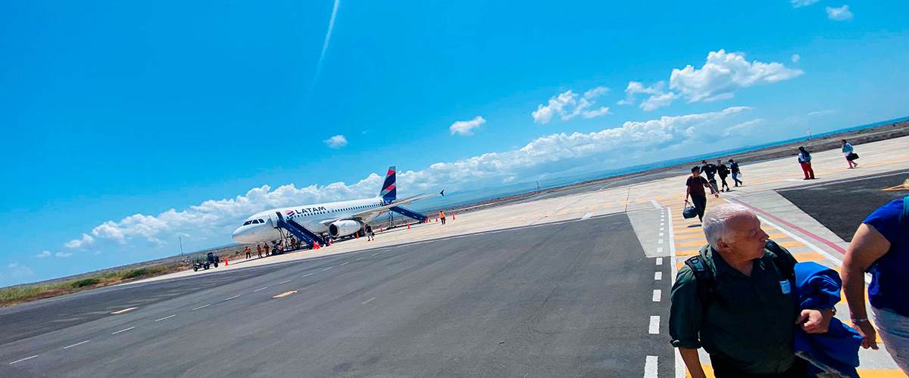

|  |  |
| --- | --- |
| **Trail:** |  |
| **Level**: | 1 |
| **Activities:** | - |

PM: HIGHLANDS

Embark on a highlands adventure, either from Baltra or Puerto Ayora. A bus journey brings you to the verdant highland forests, home to Galapagos Giant tortoises. You'll find these impressive creatures, weighing up to 300 kg/600 lbs, casually grazing or lounging in freshwater ponds. The highlands also host a variety of bird species seldom seen in the lowlands. Depending on your itinerary, explore a lava tunnel and delve into the geological history of these volcanic islands.

Lava tunnels, Darwin finches, Galapagos flycatchers, Giant tortoises, Barn owls, White-cheeked pintails

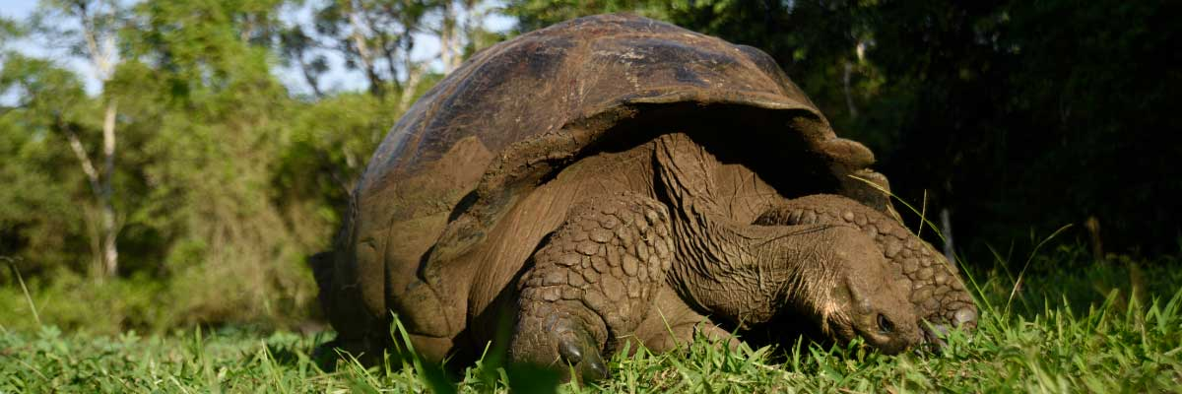

|  |  |
| --- | --- |
| **Food**: | -/L/D |
| **Trail:** | 1-1,5 km / 0,6-0,9 mi |
| **Lodging**: | M/Y Galaxy Orion |
| **Level**: | 1 |
| **Activities:** | HIKING |

DAY 2

AM: TINTORERAS

Start your morning on Isabela Island, embarking on a unique adventure at Tintoreras, a cluster of small isles teeming with wildlife. Sail through crystal-clear waters and discover a vibrant underwater world inhabited by white-tipped sharks, colorful tropical fish, and starfish. Continue excursing to Sierra Negra Volcano, one of the world's largest and most active craters. The hike will take you through lunar landscapes and breathtaking views, where you’ll learn about volcanic geology and the endemic flora and fauna.

**Highlights:**  White-tipped and black-tipped reef sharks, Sea turtles, Manta rays

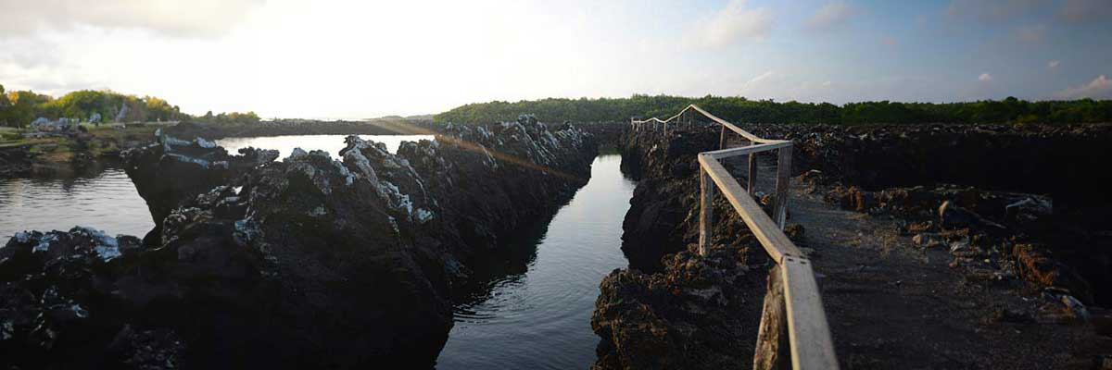

|  |  |
| --- | --- |
| **Trail:** | 1,1 km / 0,7 mi |
| **Level**: | 2 |
| **Activities:** | HIKING,SNORKEL,PANGA RIDE |

PM: ISABELA ISLAND WETLANDS AND INTERPRETATION CENTER

In the afternoon, immerse yourself in Isabela’s wetlands, a crucial ecosystem for Galapagos’ biodiversity. Walk along trails through mangroves and saline lagoons, where pink flamingos, blue-billed ducks, and other aquatic birds thrive. This natural sanctuary showcases the island’s remarkable wildlife. Conclude your day at the Interpretation Center, where you’ll gain insight into Galapagos’ natural and human history, its conservation challenges, and the ongoing efforts to protect this UNESCO World Heritage Site.

**Highlights:** Mangroves, Flamingoes, Ducks

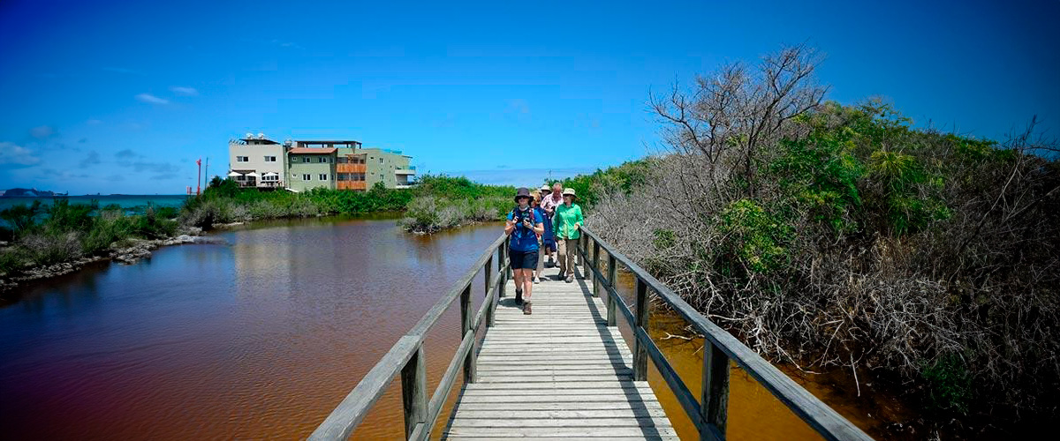

|  |  |
| --- | --- |
| **Food**: | B/L/D |
| **Trail:** | 3 km / 1.86 mi |
| **Lodging**: | M/Y Galaxy Orion |
| **Level**: | 1 |
| **Activities:** | HIKING |

DAY 3

AM: MORENO POINT

Commence your day at the enchanted Moreno Point. The extensive lava fields may appear lifeless, but scattered brackish lagoons teeming with life, such as flamingos, gallinules, ducks, and herons lie within its borders. Along the coast, keep an eye out for penguins, marine iguanas, flightless cormorants, blue-footed boobies, sea lions, oystercatchers, and other shore birds.

Snorkel Experience: Dip into the refreshing water and explore a mesmerizing underwater world populated by sea turtles, cormorants, and a myriad of fish species. Look carefully within the long seaweeds; you might discover a charming sea horse.

**Highlights:**  Stunning Views, Galapagos mockingbirds, Darwin finches, American flamingoes, Flightless cormorants, Marine iguanas, Ducks, Gallinules

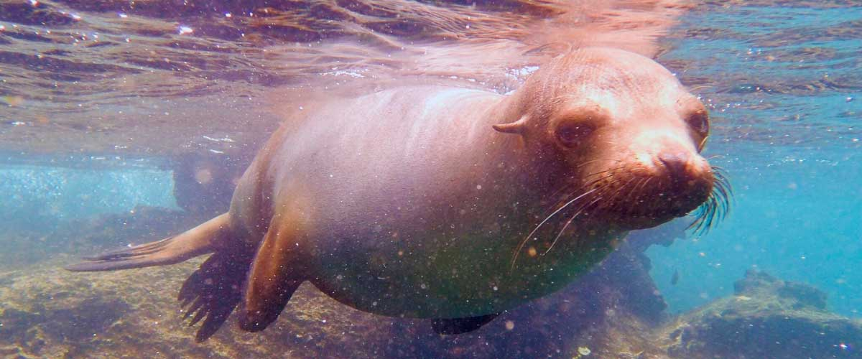

|  |  |
| --- | --- |
| **Trail:** | 1,6 km / 1 mi |
| **Level**: | 3 |
| **Activities:** | HIKING,SNORKEL,PANGA RIDE |

PM: ELIZABETH BAY

As the afternoon progresses, we venture into the stunning Elizabeth Bay, a peaceful sanctuary surrounded by towering mangroves and stark lava fields. With no trails to follow, we explore this natural wonder by dinghy, navigating through channels and coves bustling with marine life. This is one of the best places to spot the rare Galapagos penguin, with a total population of only about 3,000. The bay is also a nesting site for flightless cormorants, while blue-footed boobies and pelicans dive for fish. Watch for graceful rays and sea turtles gliding through the clear waters.

**Highlights:** Mangroves, Rays, Herons, Galapagos penguins, Galapagos hawks, Flightless cormorants, Sea turtles

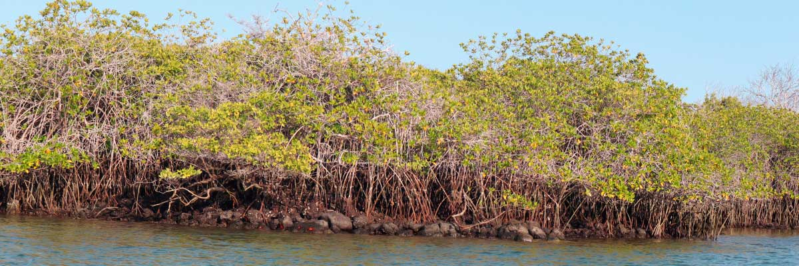

|  |  |
| --- | --- |
| **Food**: | B/L/D |
| **Trail:** | 1,4 km / 0,8 mi |
| **Lodging**: | M/Y Galaxy Orion |
| **Level**: | 1 |
| **Activities:** | PANGA RIDE,PADDLE BOARD,KAYAK |

DAY 4

AM: MANGLE POINT

Start your day at Mangle Point, an ecological paradise on the untouched Fernandina Island. This site is a biodiversity haven where mangrove forests provide a crucial habitat for many marine species. As your boat glides through crystal-clear waters, observe sea turtles weaving through the mangrove roots and rays resting on the sandy bottom. This location offers a rare opportunity to connect with nature, experiencing firsthand the intricate symbiosis between the mangrove ecosystem and marine life.

Snorkel Experience: Immerse yourself in the calm waters of Mangle Point and swim among sea turtles, rays, and tropical fish. This underwater sanctuary offers a unique experience, exploring the biodiversity thriving between the mangroves and coral reefs.

**Highlights:**  Mangroves, Rays, Sea turtles

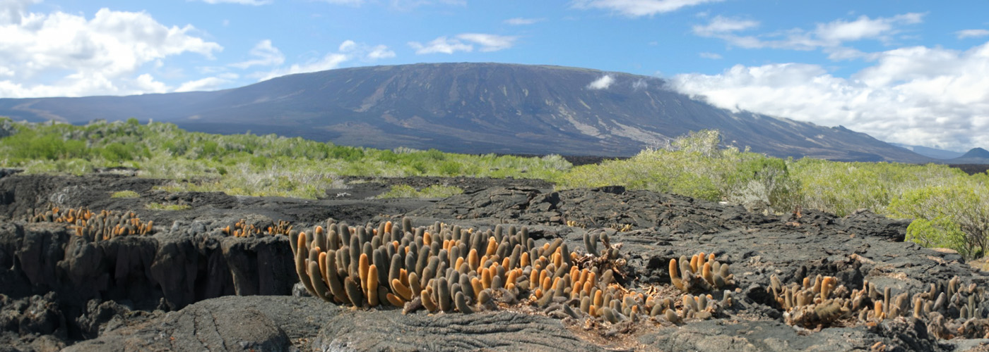

|  |  |
| --- | --- |
| **Trail:** | N/A (mainly a water-based activity) |
| **Level**: | 1 |
| **Activities:** | SNORKEL,PANGA RIDE,PADDLE BOARD,KAYAK |

PM: URBINA BAY

Urbina Bay, known for its dramatic uplift during the 1950s, awaits your visit in the morning. As you traverse the trail, observe small shells and corals, indicators that this area was submerged just over sixty years ago. Here, you can encounter land iguanas and, during certain seasons, giant tortoises. Galapagos hawks nest in the area, often seen soaring or perched on trees.

Snorkel Experience: Snorkel from the beach to spot sea turtles, flightless cormorants, and penguins. The area also boasts an abundance of fish.

**Highlights:** Stunning Views, Galapagos mockingbirds, Galapagos hawks, Darwin finches, Galapagos flycatchers, Galapagos land iguanas

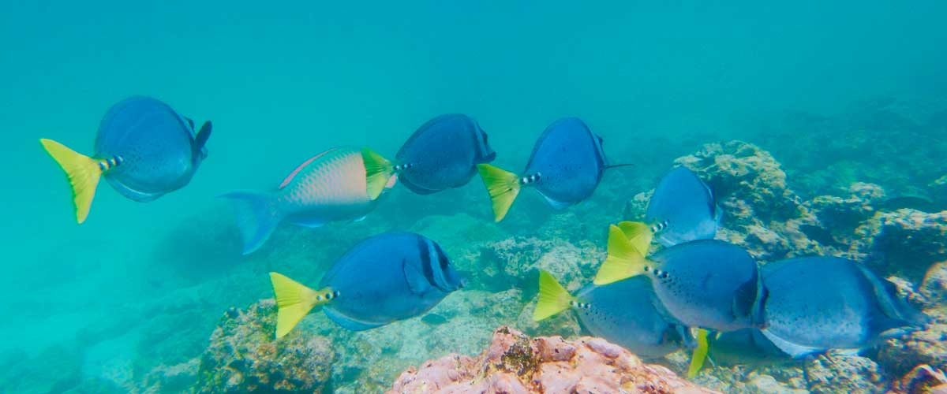

|  |  |
| --- | --- |
| **Food**: | B/L/D |
| **Trail:** | 1,2 km / 0,7 mi. Long trail 3,0 km / 1,8 mi |
| **Lodging**: | M/Y Galaxy Orion |
| **Level**: | 1 |
| **Activities:** | HIKING,SNORKEL |

DAY 5

AM: TAGUS COVE

Tagus Cove is steeped in history, once visited by Charles Darwin during his Galapagos exploration. A scenic trail winds through dry Palo Santo forests, where Darwin’s finches and mockingbirds can be spotted. At the top, breathtaking views of Lake Darwin and Isabela’s towering volcanoes await. A boat tour along the shore provides a chance to observe Galapagos penguins, flightless cormorants, marine iguanas, and the elusive Galapagos martin, one of the rarest and most endangered birds in the archipelago.

Snorkel Experience: The nutrient-rich waters of Tagus Cove attract sea turtles, tropical fish, and penguins feasting on anchovies. Flightless cormorants can often be seen chasing fish underwater, creating a truly unique snorkeling experience.

**Highlights:**  Stunning Views, Herons, Galapagos penguins, Galapagos hawks, Flightless cormorants, Marine iguanas, Sea turtles, Sea stars

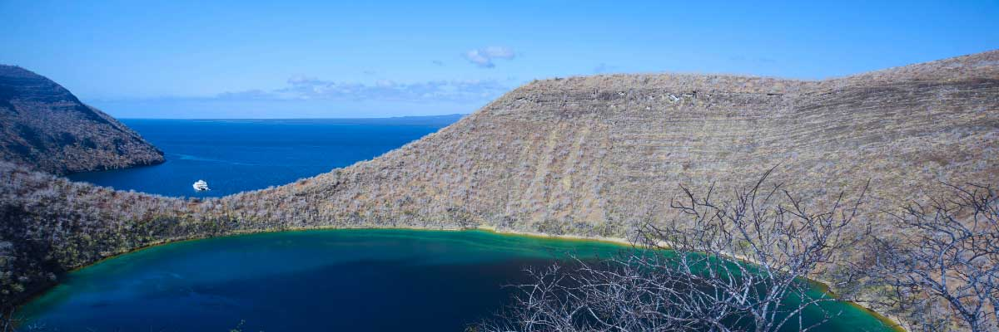

|  |  |
| --- | --- |
| **Trail:** | 2,6 km / 1,6 mi |
| **Level**: | 3 |
| **Activities:** | HIKING,SNORKEL,PANGA RIDE,PADDLE BOARD,KAYAK |

PM: ESPINOZA POINT

Espinoza Point is a true natural wonder, set at the base of the most active volcano in Galapagos. As you step ashore, you’ll be greeted by the largest colony of marine iguanas basking on black volcanic rocks. Sea lions lounge on the beach while their pups explore tide pools. Flightless cormorants patrol the shoreline, and in the mangroves, Galapagos hawks scan for prey. Blessed with cold, plankton-rich waters, this area teems with life—herons, oystercatchers, pelicans, and sea turtles all thrive in this untouched habitat.

Snorkel Experience: The nutrient-rich waters of Espinoza Point attract fish, sea turtles, and foraging cormorants. Watch marine iguanas feeding on algae and follow a cormorant as it chases fish through the reef—an unforgettable snorkeling experience in Galapagos.

**Highlights:** Stunning Views, Herons, Galapagos penguins, Oystercatchers, Galapagos hawks, Marine iguanas, Sea turtles, Shorebirds

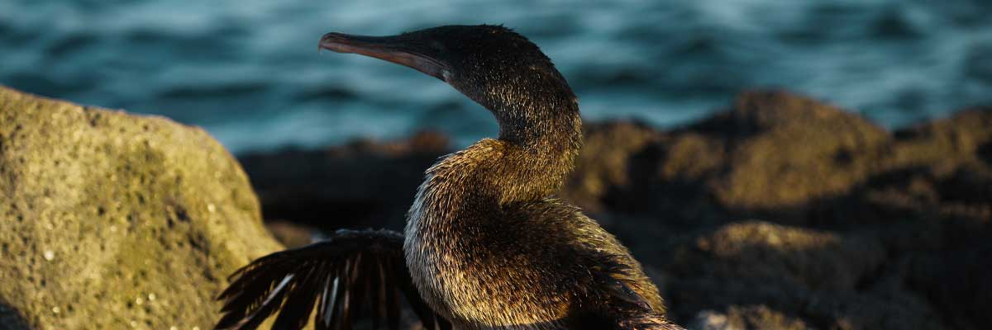

|  |  |
| --- | --- |
| **Food**: | B/L/D |
| **Trail:** | 1,6 km / 1 mi |
| **Lodging**: | M/Y Galaxy Orion |
| **Level**: | 2 |
| **Activities:** | HIKING,SNORKEL,PANGA RIDE |

DAY 6

AM: EGAS PORT

Puerto Egas is a fascinating destination where history and wildlife intertwine. While there is no actual port, remnants of 1960s colonization attempts still stand. The coastal trail is teeming with marine iguanas basking in the sun and sea lions resting on the rocks. Herons, oystercatchers, and shorebirds complete this thriving ecosystem. Towards the end of the trail, the grottos are home to a small colony of the elusive Galapagos fur seal. Additionally, land iguanas were reintroduced to the island in 2019 after over a century of absence.

Snorkel Experience: A snorkeling session from the beach will lead you to an area of rocky bottoms, excellent for observing fish, turtles, and reef sharks. Sea lions often frequent this area and are typically open to interacting with divers.

**Highlights:**  Stunning Views, Herons, Galapagos sea lions, Galapagos fur seals, Oystercatchers, Galapagos hawks, Darwin finches, Marine and land iguanas, Galapagos doves, Shorebirds

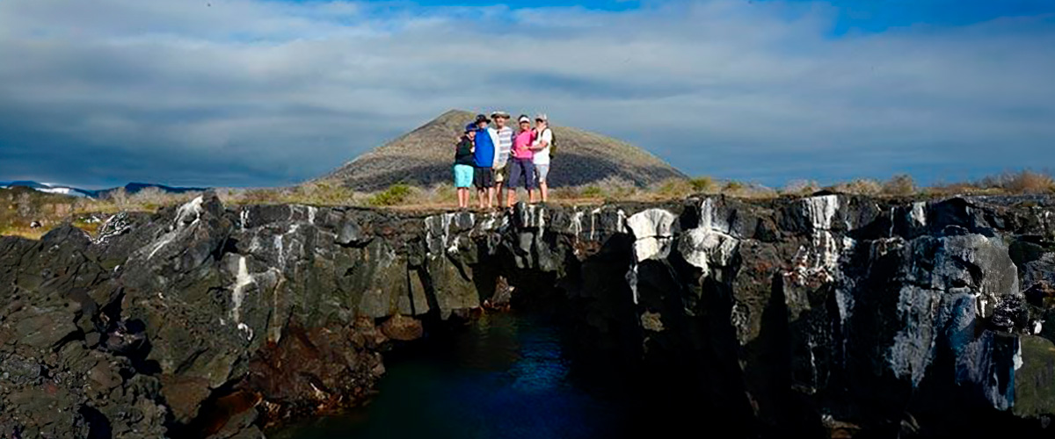

|  |  |
| --- | --- |
| **Trail:** | 2,3 km / 1,4 mi |
| **Level**: | 1 |
| **Activities:** | HIKING,SNORKEL |

PM: ESPUMILLA BEACH AND BUCANEER COVE

Espumilla Beach, on Santiago’s northern coast, is a stunning one-kilometer stretch of rusty-brown sand. Surrounded by mangroves and dry forest, it hosts Galapagos hawks, finches, and mockingbirds, while flamingos and ducks may appear in the salt pan during the rainy season. Then, at Buccaneer Cove, discover a historic pirate hideout from the 17th and 18th centuries. Towering cliffs and striking rock formations create a breathtaking landscape. Although thereandamp;amp;#039;s no trail, a dinghy ride offers a unique chance to observe wildlife and delve into the archipelagoandamp;amp;#039;s history.

Snorkel Experience: Snorkel into a sheltered bay and explore a vibrant underwater world. Swim among schools of angelfish, parrotfish, and snappers while spotting reef sharks, sea turtles, and playful sea lions in their natural habitat.

**Highlights:** Herons, Boobies, Galapagos hawks

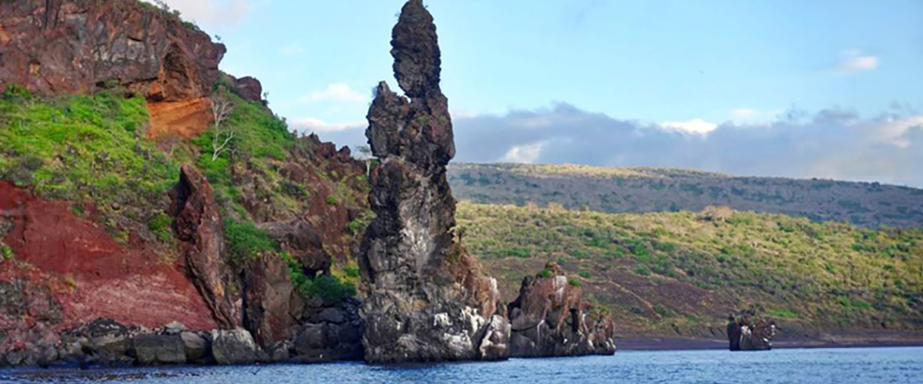

|  |  |
| --- | --- |
| **Food**: | B/L/D |
| **Trail:** | 2,3 km / 1,4 mi (plus and extra loop 1 km - 0,6 mi) |
| **Lodging**: | M/Y Galaxy Orion |
| **Level**: | 2 |
| **Activities:** | HIKING,SNORKEL,PANGA RIDE,PADDLE BOARD,KAYAK |

DAY 7

AM: EL BARRANCO

Located in the southern part of Darwin Bay on Genovesa Island, El Barranco is a wildlife sanctuary. Its fragile lava cliffs provide shelter for storm petrels and a remarkable population of short-eared owls. Along the trail, red-footed and Nazca boobies nest on the volcanic rock. At the base of the cliffs, Galapagos fur seals rest in shaded areas, while seabirds soar above this breathtaking landscape, making El Barranco an unforgettable destination for nature lovers.

Snorkel Experience: Snorkel into the waters of El Barranco and explore a vibrant underwater world. Swim among colorful fish and spot sharks, rays, and playful sea lions in their natural habitat.

**Highlights:**  Nesting great frigatebirds, Galapagos sea lions, Genovesa ground finch, Genovesa cactus finch, Galapagos mockingbirds, Galapagos fur seals

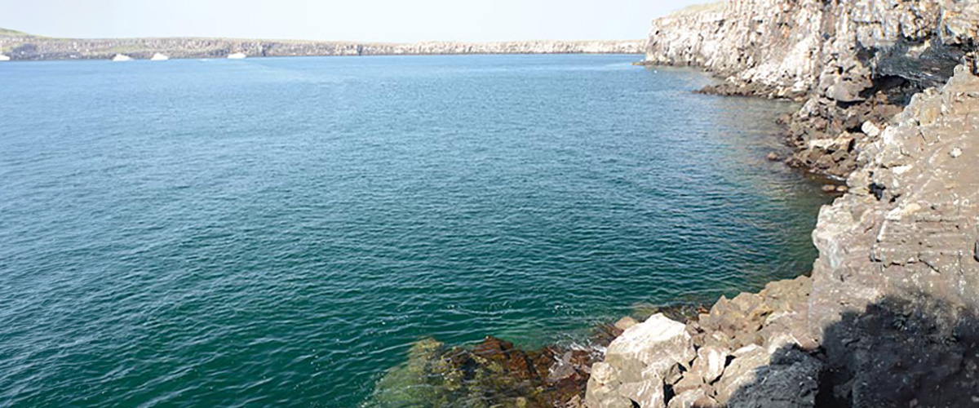

|  |  |
| --- | --- |
| **Trail:** | 1,2 km / 0,7 mi |
| **Level**: | 3 |
| **Activities:** | HIKING,SNORKEL,PANGA RIDE,PADDLE BOARD,KAYAK |

PM: DARWIN BAY

Darwin Bay on Genovesa Island is a breathtaking sight for birdwatchers. As you step onto the beach, you’ll be amazed by the presence of hundreds of boobies, gulls, and frigatebirds soaring, nesting in bushes, or resting on the sand. Along the shore, sea lions and marine iguanas blend into the scenery, while inland you may spot night herons, swallow-tailed gulls, Darwin finches, Galapagos doves, and mockingbirds. This immersive experience brings you face-to-face with a thriving ecosystem.

Snorkel Experience: Darwin Bay offers incredible snorkeling spots, from deep waters along the cliffs to shallow areas near the beach. No matter where you dive, a vibrant underwater world awaits, filled with colorful fish and high chances of spotting sharks, rays, and playful sea lions

**Highlights:** Nesting great frigatebirds, Red-footed and Nazca boobies, Galapagos sea lions, Yellow-crowned night herons, Genovesa ground finch, Genovesa cactus finch, Galapagos mockingbirds

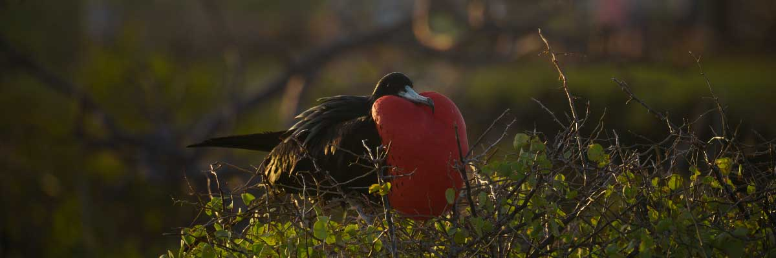

|  |  |
| --- | --- |
| **Food**: | B/L/D |
| **Trail:** | 1,2 km / 0,7 mi |
| **Lodging**: | M/Y Galaxy Orion |
| **Level**: | 3 |
| **Activities:** | HIKING,SNORKEL,PANGA RIDE,PADDLE BOARD,KAYAK |

DAY 8

AM – NORTH SEYMOUR AND TRANSFER OUT TO BALTRA’S AIRPORT

North Seymour Island is a paradise for bird watchers, with large colonies of magnificent and great frigatebirds inflating their red throat pouches in an impressive courtship display. On the ground, blue-footed boobies perform their famous mating dance, while swallow-tailed gulls perch on cliffs overlooking the sea. Inland, land iguanas have thrived thanks to conservation efforts, while marine iguanas bask on the rocks near playful sea lions body surfing the waves.

Snorkel Experience: Explore Seymour’s underwater world, home to incredible biodiversity. Swim alongside sea lions, sharks, turtles, rays, and tropical fish. If you're lucky, you might spot eels hiding among the rocks in this thriving marine ecosystem.

Galapagos sea lions, Magnificent and great frigatebirds, Land and marine iguanas, Darwin finches

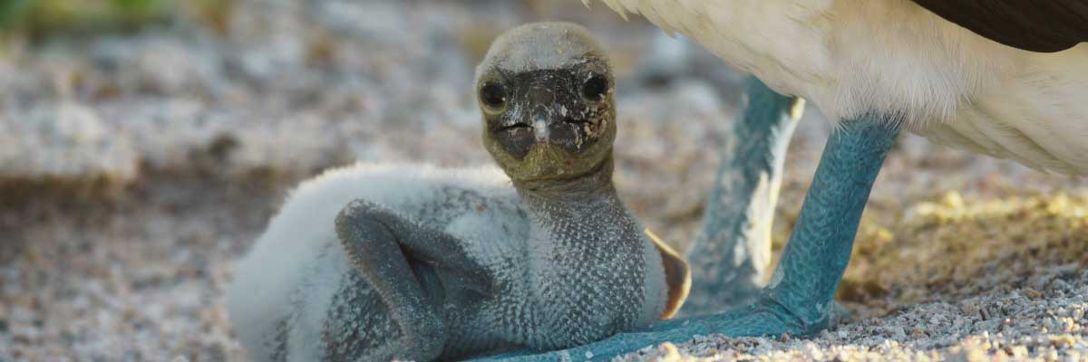

|  |  |
| --- | --- |
| **Trail:** | 1,4 km / 0,8 mi |
| **Level**: | 2 |
| **Activities:** | HIKING |

PM: BALTRA (AIRPORT)

Your Galapagos adventure comes to an end. Today, you will be transferred to Baltra Airport, where your National Park naturalist guide will assist you with final details before your flight back to mainland Ecuador. As you bid farewell to this paradise, take with you the unforgettable memories of one of the world’s most extraordinary destinations.



|  |  |
| --- | --- |
| **Food**: | B/-/- |
| **Trail:** |  |
| **Lodging**: | M/Y Galaxy Orion |
| **Level**: | 1 |
| **Activities:** | - |

GLOSSARY

|  |  |  |
| --- | --- | --- |
| **Feeding** | **Breakfast** | B |
| **Lunch** | L |
| **Dinner** | D |
| **Difficulty of the hike** | **Level 1** | Easy |
| **Level 2** | Moderate |
| **Level 3** | Difficult |