**Galapagos Central Wonders Cruise**

**5 Days – 4 Nights**

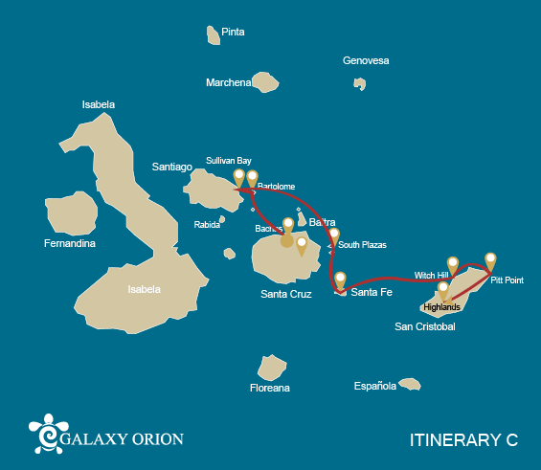

|  |  |  |  |  |  |  |  |
| --- | --- | --- | --- | --- | --- | --- | --- |
|  | | | **Hiking** | **Snorkel** | **Panga Ride** | **Paddle Board** | **Kayak** |
| SATURDAY | AM | **Santa Cruz Island :** Baltra - airport (arrival) |  |  |  |  |  |
|  | PM | **Santa Cruz Island :** Bachas Beach | * |  |  |  |  |
| SUNDAY | AM | **Bartolome Island :** Bartolome | * | * | * |  |  |
|  | PM | **Santiago Island :** Sullivan Bay | * | * | * |  |  |
| MONDAY | AM | **South Plazas Island :** South Plaza | * |  | * | * | * |
|  | PM | **Santa Fe Island :** Santa Fe | * | * | * | * | * |
| TUESDAY | AM | **San Cristobal Island :** Witch Hill | * | * | * | * | * |
|  | PM | **San Cristobal Island :** Pitt Point | * | * |  |  |  |
| WEDNESDAY | AM | **Santa Cruz Island :** Highlands | * |  |  |  |  |
|  | PM | **Santa Cruz Island :** Baltra - airport (return) |  |  |  |  |  |

DAY 1

AM: ARRIVAL AT BALTRA AIRPORT

Welcome to Galapagos! Upon arrival at Baltra Airport, your naturalist guide will greet you and assist with the transfer to Itabaca Channel. This initial journey offers your first connection with the archipelago as you take a short ferry ride to Santa Cruz Island. Along the way, observe Baltra’s arid landscape and learn about its history as a former U.S. WWII airbase. This is just the beginning of the many fascinating stories awaiting you on your adventure.

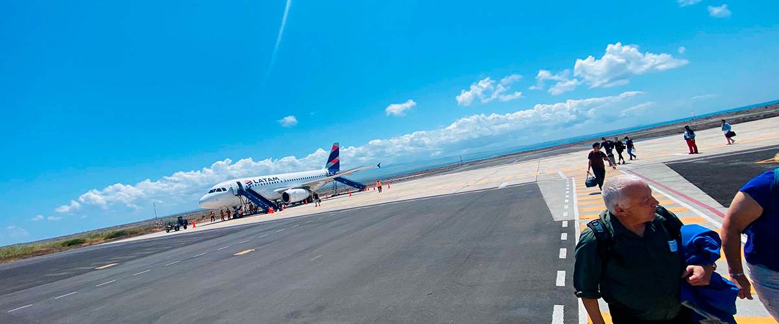

|  |  |
| --- | --- |
| **Trail:** |  |
| **Level**: | 1 |
| **Activities:** | - |

PM: BACHAS

End your Galapagos adventure at Bachas Beach, a key sea turtle nesting site from November to May. At low tide, remnants of WWII barges emerge from the white sand. Explore its saltwater lagoons, home to flamingos, herons, and aquatic birds. After this final stop, transfer to the airport for your flight back to the mainland, concluding an unforgettable journey.

Stunning Views, Blue footed boobies, White-cheeked pintails, American flamingoes, Sandpipers, Lava gulls

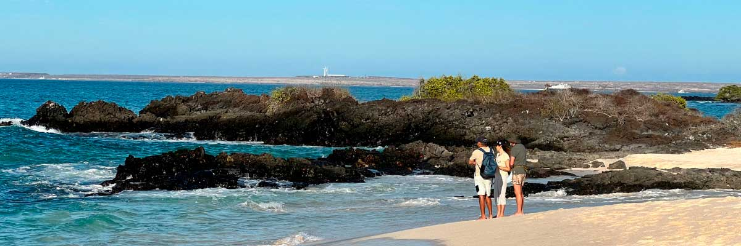

|  |  |
| --- | --- |
| **Food**: | -/L/D |
| **Trail:** | 1,6 km / 1 mi |
| **Lodging**: | M/Y Galaxy Orion |
| **Level**: | 1 |
| **Activities:** | HIKING |

DAY 2

AM: BARTOLOME

Bartolome is one of the most iconic islands in Galapagos, renowned for its dramatic volcanic landscape and the famous Pinnacle Rock. Nestled beside a peach-colored sand beach, this island is one of the few places where you can spot penguins without traveling to remote Isabela and Fernandina. The hike to the summit offers breathtaking views of a lunar-like terrain dotted with volcanic cones, with stunning panoramas of Sullivan Bay and Pinnacle Rock. From the top, the vast beauty of the archipelago unfolds before you, creating a truly unforgettable experience.

Snorkel Experience: Enjoy an unforgettable snorkeling experience in Bartolome, one of Galapagos’ top spots. Swim in calm, clear waters alongside penguins, colorful fish, sea turtles, sea lions, rays, and reef sharks in a thriving marine ecosystem.

**Highlights:**  Volcanic landscapes, Pinnacle rock, Herons, Bluefooted boobies, Galapagos penguins

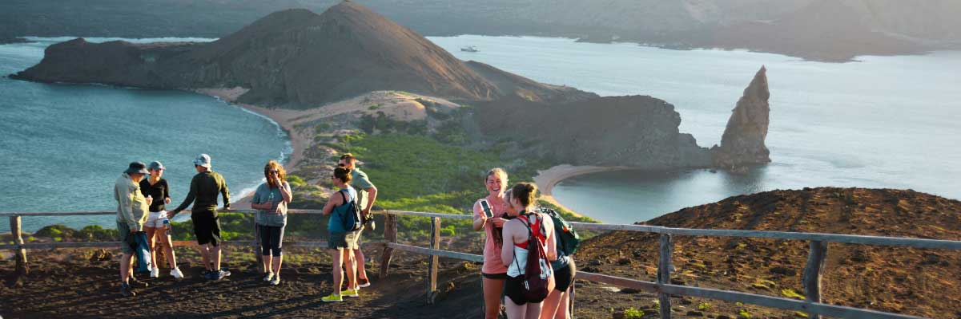

|  |  |
| --- | --- |
| **Trail:** | 1,5 km / 0,9 mi |
| **Level**: | 2 |
| **Activities:** | HIKING,SNORKEL,PANGA RIDE |

PM: SULLIVAN BAY

Walking through Sullivan Bay is a fascinating journey into the volcanic origins of the Galapagos Islands. The trail crosses a vast Pahoehoe lava flow, showcasing unique textures that reveal the story of past eruptions. While the terrain may seem desolate at first, a closer look unveils pioneer plants, scurrying lava lizards, and small birds adapted to this extreme environment. Along the shore, the stark landscape is brightened by the presence of penguins, pelicans, and oystercatchers, adding a vibrant contrast to the stunning volcanic scenery.

Snorkel Experience: After the hike, unwind with a swim or snorkeling session from a coral-sand beach or a dinghy. The contrast with the barren land is striking—schools of fish, Galapagos penguins, reef sharks, sea turtles, and rays thrive in this vibrant marine ecosystem.

**Highlights:** Lava tubes, Galapagos penguins, Oystercatchers, Galapagos hawks

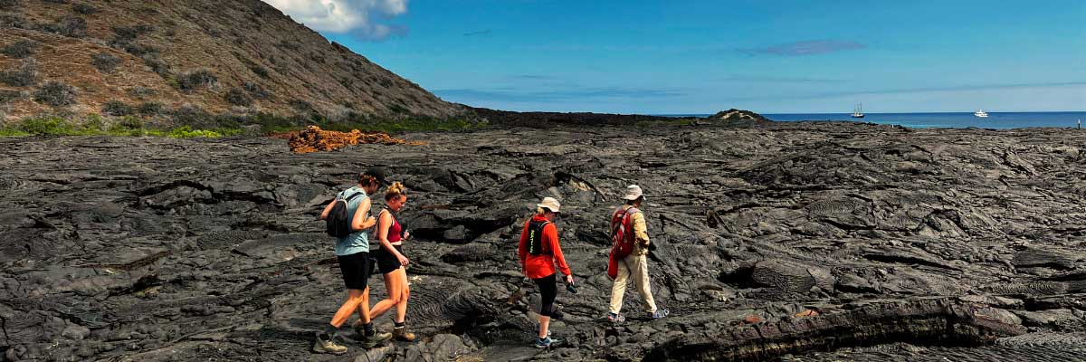

|  |  |
| --- | --- |
| **Food**: | B/L/D |
| **Trail:** | 2,2 km / 1,4 mi |
| **Lodging**: | M/Y Galaxy Orion |
| **Level**: | 3 |
| **Activities:** | HIKING,SNORKEL,PANGA RIDE |

DAY 3

AM: SOUTH PLAZAS ISLAND

Of the two twin islands, only South Plazas is open to visitors, while North Plazas remains a scientific research site. Despite its small size, South Plazas is teeming with wildlife. Upon landing, ll find land iguanas lounging beneath Opuntia cacti, waiting for fallen fruit. A large sea lion colony dominates the shore, where playful pups explore tide pools while massive bulls defend their territory. The trail leads to a dramatic cliffside, offering breathtaking ocean views where frigatebirds, blue-footed boobies, red-billed tropicbirds, and swallow-tailed gulls soar. A blanket of reddish succulents covering the island adds to its striking beauty.

**Highlights:**  Stunning Views, Boobies, Galapagos sea lions, Galapagos shearwaters, Galapagos land iguanas, Tropicbirds, Pelicans

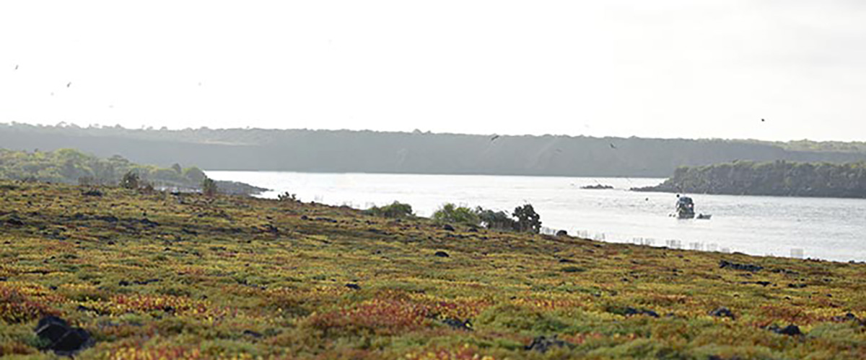

|  |  |
| --- | --- |
| **Trail:** | 1,4 km / 0,8 mi |
| **Level**: | 2 |
| **Activities:** | HIKING,PANGA RIDE,PADDLE BOARD,KAYAK |

PM: SANTA FE ISLAND

Santa Fe Island, nestled in one of the most stunning bays in the Galapagos, boasts towering prickly-pear cacti and ancient lava formations. Its white-sand beach and turquoise waters are home to a large sea lion colony basking under the sun. As you follow the trail, look for the endemic Santa Fe land iguana and, if lucky, a Galapagos hawk perched atop a cactus scanning for prey. Along the way, Darwin’s finches, Galapagos doves, mockingbirds, and lava lizards are commonly seen, making this hike a true wildlife experience.

Snorkel Experience: After the hike, snorkel in the bay’s sheltered waters. Swim alongside playful sea lions, reef sharks, and sea turtles. Spot rays and schools of tropical fish, including surgeonfish and parrotfish, for an unforgettable underwater experience.

**Highlights:** Stunning Views, Galapagos sea lions, Galapagos hawks, Galapagos doves, Santa Fe land iguanas, Reef sharks

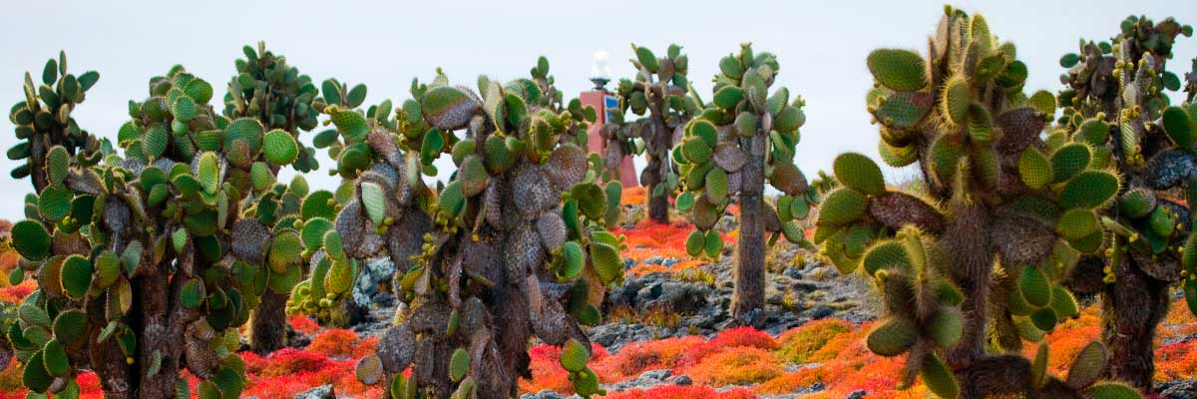

|  |  |
| --- | --- |
| **Food**: | B/L/D |
| **Trail:** | 0,8 km / 0,5 mi |
| **Lodging**: | M/Y Galaxy Orion |
| **Level**: | 2 |
| **Activities:** | HIKING,SNORKEL,PANGA RIDE,PADDLE BOARD,KAYAK |

DAY 4

AM: WITCH HILL

Witch Hill, on the northern coast of San Cristóbal, is one of the most stunning beaches in the Galapagos. Its powdery white sand and turquoise waters create a perfect setting for strolling and relaxing, while a large sea lion colony lounges on the shore. The nearby lagoon attracts diverse birdlife, including pelicans and blue-footed boobies. This site holds historical significance as one of Charles Darwin’s first stops in the Galapagos. Dive into the crystal-clear waters for a snorkeling experience filled with tropical fish, rays, and sea turtles.

Snorkel Experience: Stroll along Cerro Brujo’s white sands, relax near sea lions, and dive into a vibrant underwater world. Snorkeling here offers a chance to swim with tropical fish, sea turtles, and rays in crystal-clear waters.

**Highlights:**  Snorkeling opportunities, White sand beach, Blue-footed boobies, Galapagos sea lions, Pelicans

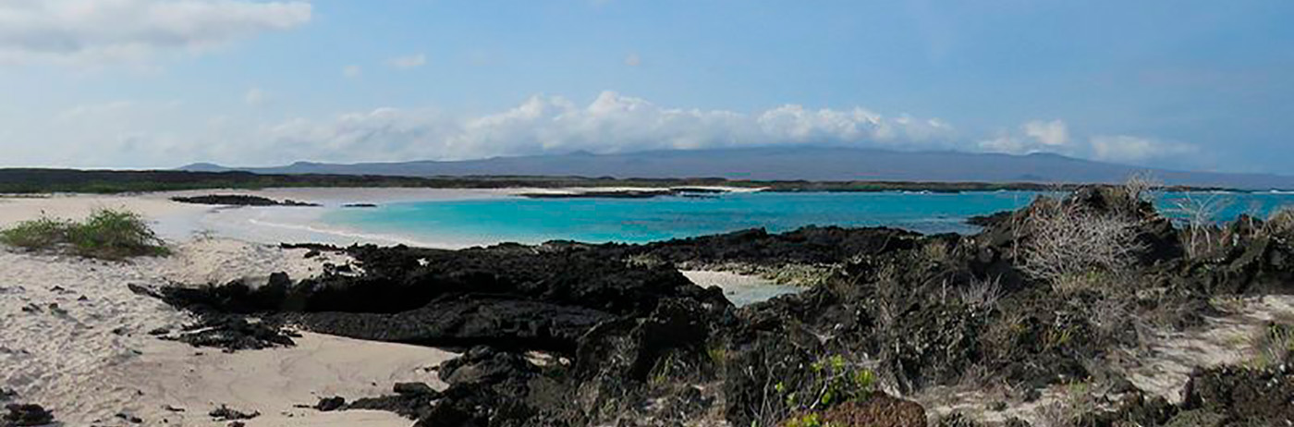

|  |  |
| --- | --- |
| **Trail:** | 0.5 km / 0.3 mi |
| **Level**: | 1 |
| **Activities:** | HIKING,SNORKEL,PANGA RIDE,PADDLE BOARD,KAYAK |

PM: PITT POINT

Located on the northeastern tip of San Cristóbal, Punta Pitt is a must-visit for nature and adventure enthusiasts. Its rugged trails lead to breathtaking viewpoints, where you can observe frigatebirds and the three iconic booby species—blue-footed, red-footed, and Nazca—a rare sight in the Galapagos. The volcanic landscape, with dramatic rock formations and lush vegetation, creates a thriving habitat for diverse wildlife. This experience blends a challenging hike with the chance to witness the archipelago’s incredible biodiversity at its finest.

Hiking Experience: Explore the rugged terrain of Punta Pitt and witness the diverse birdlife, including all three booby species and frigate birds.

**Highlights:** Stunning Views, Snorkeling opportunities, Magnificent and great frigatebirds

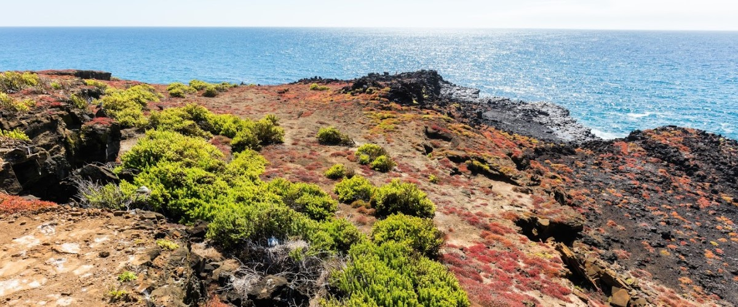

|  |  |
| --- | --- |
| **Food**: | B/L/D |
| **Trail:** | 1.5 km / 0.9 mi |
| **Lodging**: | M/Y Galaxy Orion |
| **Level**: | 3 |
| **Activities:** | HIKING,SNORKEL |

DAY 5

AM: HIGHLANDS

Embark on a highlands adventure, either from Baltra or Puerto Ayora. A bus journey brings you to the verdant highland forests, home to Galapagos Giant tortoises. You'll find these impressive creatures, weighing up to 300 kg/600 lbs, casually grazing or lounging in freshwater ponds. The highlands also host a variety of bird species seldom seen in the lowlands. Depending on your itinerary, explore a lava tunnel and delve into the geological history of these volcanic islands.

Lava tunnels, Darwin finches, Galapagos flycatchers, Giant tortoises, Barn owls, White-cheeked pintails

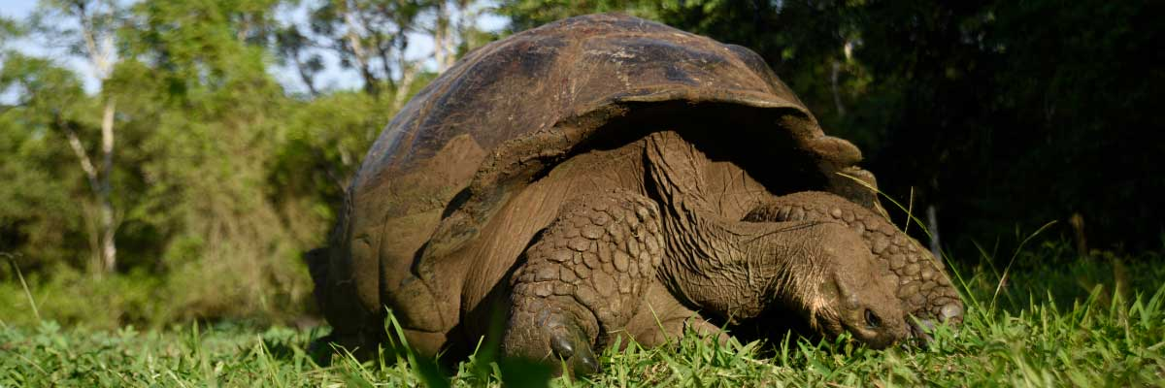

|  |  |
| --- | --- |
| **Trail:** | 1-1,5 km / 0,6-0,9 mi |
| **Level**: | 1 |
| **Activities:** | HIKING |

PM: BALTRA AIPORT

Your Galapagos adventure comes to an end. Today, you will be transferred to Baltra Airport, where your National Park naturalist guide will assist you with final details before your flight back to mainland Ecuador. As you bid farewell to this paradise, take with you the unforgettable memories of one of the world’s most extraordinary destinations.



|  |  |
| --- | --- |
| **Food**: | B/-/- |
| **Trail:** |  |
| **Lodging**: | M/Y Galaxy Orion |
| **Level**: | 1 |
| **Activities:** | - |

GLOSSARY

|  |  |  |
| --- | --- | --- |
| **Feeding** | **Breakfast** | B |
| **Lunch** | L |
| **Dinner** | D |
| **Difficulty of the hike** | **Level 1** | Easy |
| **Level 2** | Moderate |
| **Level 3** | Difficult |