**Galapagos Central Wonders Cruise**

**8 Days – 7 Nights**

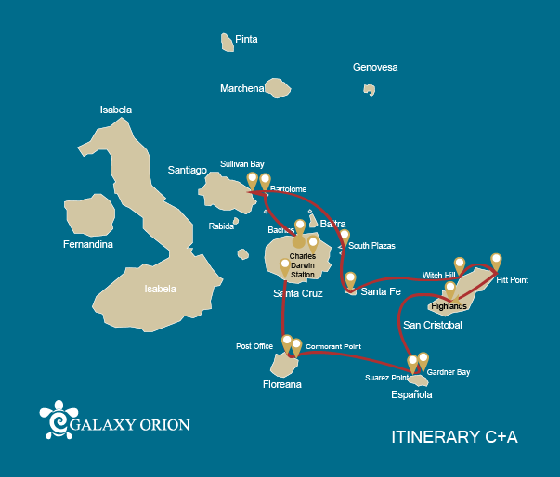

|  |  |  |  |  |  |  |  |
| --- | --- | --- | --- | --- | --- | --- | --- |
|  | | | **Hiking** | **Snorkel** | **Panga Ride** | **Paddle Board** | **Kayak** |
| SATURDAY | AM | **Santa Cruz Island :** Baltra - airport (arrival) |  |  |  |  |  |
|  | PM | **Santa Cruz Island :** Bachas Beach | * | * |  |  |  |
| SUNDAY | AM | **Bartolome Island :** Bartolome | * | * | * |  |  |
|  | PM | **Santiago Island :** Sullivan Bay | * | * | * | * |  |
| MONDAY | AM | **South Plazas Island :** South Plaza | * |  |  |  |  |
|  | PM | **Santa Fe Island :** Santa Fe | * | * | * | * | * |
| TUESDAY | AM | **San Cristobal Island :** Witch Hill | * | * | * |  |  |
|  | PM | **San Cristobal Island :** Pitt Point | * | * |  |  |  |
| WEDNESDAY | AM | **Santa Cruz Island :** Highlands | * |  | * | * | * |
|  | PM | **San Cristobal Island :** Lobos Island | * | * | * |  |  |
| THURSDAY | AM | **Española Island :** Suarez Point | * |  |  |  |  |
|  | PM | **Española Island :** Gardner Bay | * | * | * | * |  |
| FRIDAY | AM | **Floreana Island :** Post Office Bay | * | * |  |  |  |
|  | PM | **Floreana Island :** Cormorant Point | * | * | * | * | * |
| SATURDAY | AM | **Santa Cruz Island :** Charles Darwin Station | * |  |  |  |  |
|  | PM | **Santa Cruz Island :** Baltra - airport (return) |  |  |  |  |  |

DAY 1

AM: ARRIVAL AT BALTRA AIRPORT

Welcome to Galapagos! Upon arrival at Baltra Airport, your naturalist guide will greet you and assist with the transfer to Itabaca Channel. This initial journey offers your first connection with the archipelago as you take a short ferry ride to Santa Cruz Island. Along the way, observe Baltra’s arid landscape and learn about its history as a former U.S. WWII airbase. This is just the beginning of the many fascinating stories awaiting you on your adventure.

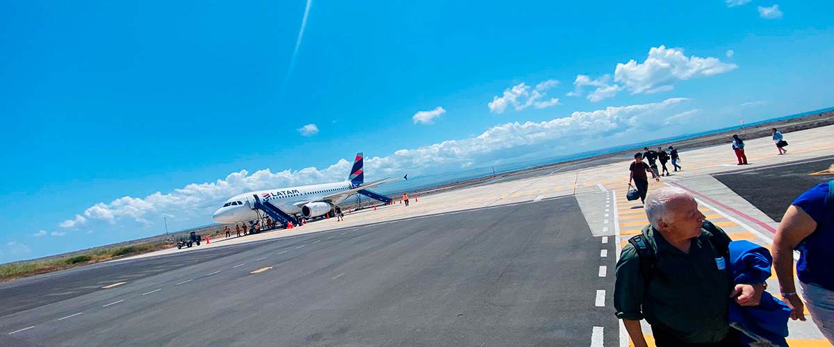

|  |  |
| --- | --- |
| **Trail:** |  |
| **Level**: | 1 |
| **Activities:** | - |

PM: BACHAS

End your Galapagos adventure at Bachas Beach, a key sea turtle nesting site from November to May. At low tide, remnants of WWII barges emerge from the white sand. Explore its saltwater lagoons, home to flamingos, herons, and aquatic birds. After this final stop, transfer to the airport for your flight back to the mainland, concluding an unforgettable journey.

Stunning Views, Blue footed boobies, White-cheeked pintails, American flamingoes, Sandpipers, Lava gulls

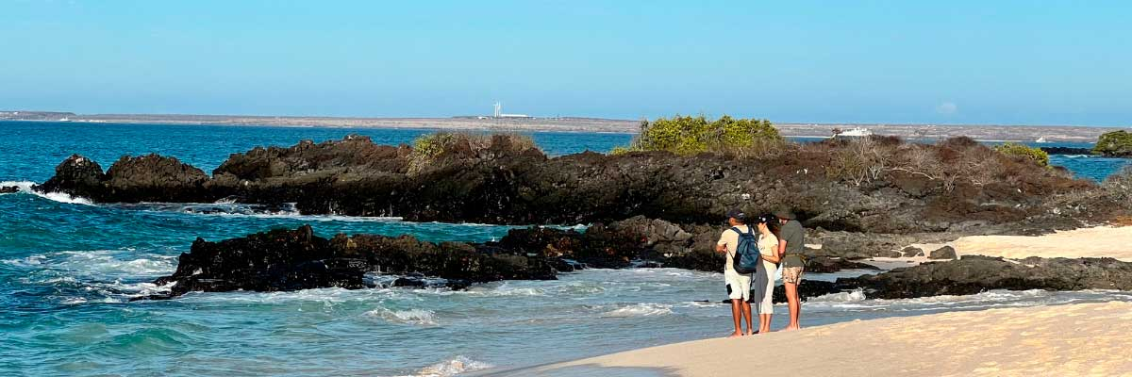

|  |  |
| --- | --- |
| **Food**: | -/L/D |
| **Trail:** | 1,6 km / 1 mi |
| **Lodging**: | M/Y Galaxy Orion |
| **Level**: | 1 |
| **Activities:** | HIKING, SNORKEL |

DAY 2

AM: BARTOLOME

Bartolome is one of the most iconic islands in Galapagos, renowned for its dramatic volcanic landscape and the famous Pinnacle Rock. Nestled beside a peach-colored sand beach, this island is one of the few places where you can spot penguins without traveling to remote Isabela and Fernandina. The hike to the summit offers breathtaking views of a lunar-like terrain dotted with volcanic cones, with stunning panoramas of Sullivan Bay and Pinnacle Rock. From the top, the vast beauty of the archipelago unfolds before you, creating a truly unforgettable experience.

Snorkel Experience: Enjoy an unforgettable snorkeling experience in Bartolome, one of Galapagos’ top spots. Swim in calm, clear waters alongside penguins, colorful fish, sea turtles, sea lions, rays, and reef sharks in a thriving marine ecosystem.

**Highlights:**  Volcanic landscapes, Pinnacle rock, Herons, Bluefooted boobies, Galapagos penguins

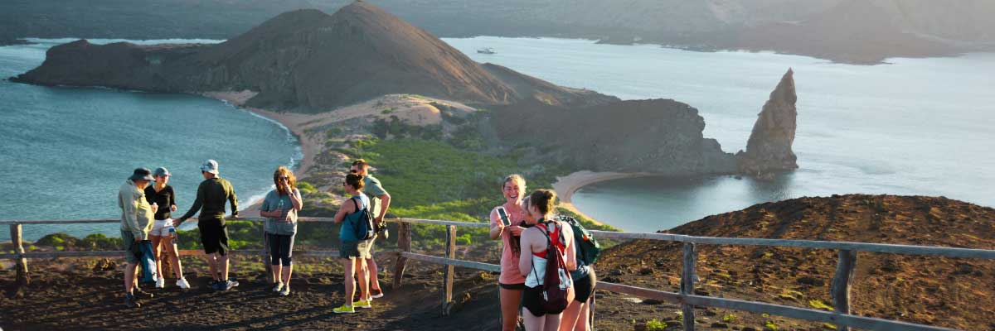

|  |  |
| --- | --- |
| **Trail:** | 1,5 km / 0,9 mi |
| **Level**: | 2 |
| **Activities:** | HIKING,SNORKEL,PANGA RIDE |

PM: SULLIVAN BAY

Walking through Sullivan Bay is a fascinating journey into the volcanic origins of the Galapagos Islands. The trail crosses a vast Pahoehoe lava flow, showcasing unique textures that reveal the story of past eruptions. While the terrain may seem desolate at first, a closer look unveils pioneer plants, scurrying lava lizards, and small birds adapted to this extreme environment. Along the shore, the stark landscape is brightened by the presence of penguins, pelicans, and oystercatchers, adding a vibrant contrast to the stunning volcanic scenery.

Snorkel Experience: After the hike, unwind with a swim or snorkeling session from a coral-sand beach or a dinghy. The contrast with the barren land is striking—schools of fish, Galapagos penguins, reef sharks, sea turtles, and rays thrive in this vibrant marine ecosystem.

**Highlights:** Lava tubes, Galapagos penguins, Oystercatchers, Galapagos hawks

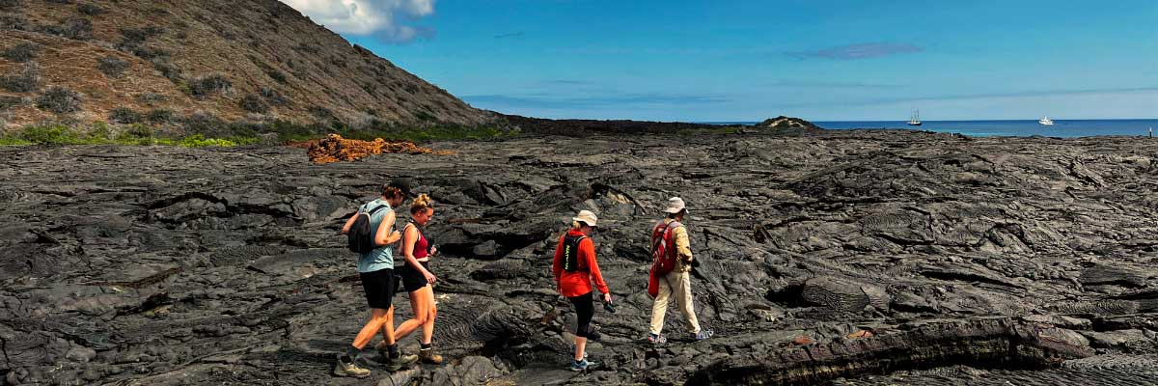

|  |  |
| --- | --- |
| **Food**: | B/L/D |
| **Trail:** | 2,2 km / 1,4 mi |
| **Lodging**: | M/Y Galaxy Orion |
| **Level**: | 3 |
| **Activities:** | HIKING,SNORKEL,PANGA RIDE,PADDLE BOARD |

DAY 3

AM: SOUTH PLAZAS ISLAND

Of the two twin islands, only South Plazas is open to visitors, while North Plazas remains a scientific research site. Despite its small size, South Plazas is teeming with wildlife. Upon landing, ll find land iguanas lounging beneath Opuntia cacti, waiting for fallen fruit. A large sea lion colony dominates the shore, where playful pups explore tide pools while massive bulls defend their territory. The trail leads to a dramatic cliffside, offering breathtaking ocean views where frigatebirds, blue-footed boobies, red-billed tropicbirds, and swallow-tailed gulls soar. A blanket of reddish succulents covering the island adds to its striking beauty.

**Highlights:**  Stunning Views, Boobies, Galapagos sea lions, Galapagos shearwaters, Galapagos land iguanas, Tropicbirds, Pelicans

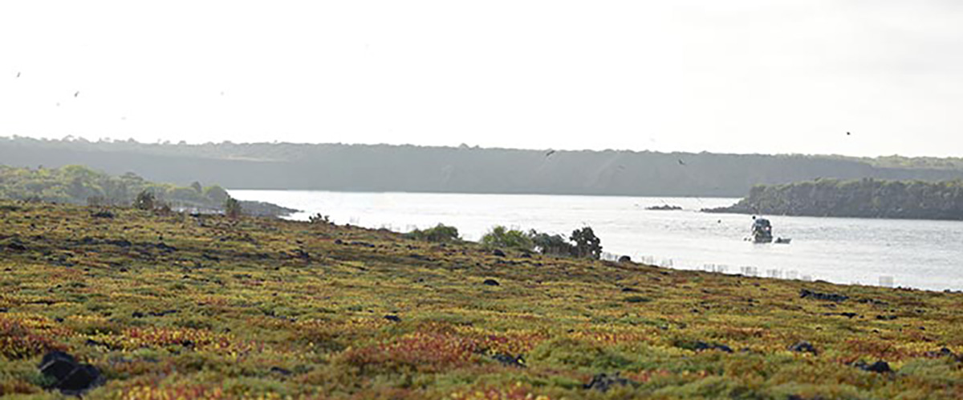

|  |  |
| --- | --- |
| **Trail:** | 1,4 km / 0,8 mi |
| **Level**: | 2 |
| **Activities:** | HIKING |

PM: SANTA FE ISLAND

Santa Fe Island, nestled in one of the most stunning bays in the Galapagos, boasts towering prickly-pear cacti and ancient lava formations. Its white-sand beach and turquoise waters are home to a large sea lion colony basking under the sun. As you follow the trail, look for the endemic Santa Fe land iguana and, if lucky, a Galapagos hawk perched atop a cactus scanning for prey. Along the way, Darwin’s finches, Galapagos doves, mockingbirds, and lava lizards are commonly seen, making this hike a true wildlife experience.

Snorkel Experience: After the hike, snorkel in the bay’s sheltered waters. Swim alongside playful sea lions, reef sharks, and sea turtles. Spot rays and schools of tropical fish, including surgeonfish and parrotfish, for an unforgettable underwater experience.

**Highlights:** Stunning Views, Galapagos sea lions, Galapagos hawks, Galapagos doves, Santa Fe land iguanas, Reef sharks

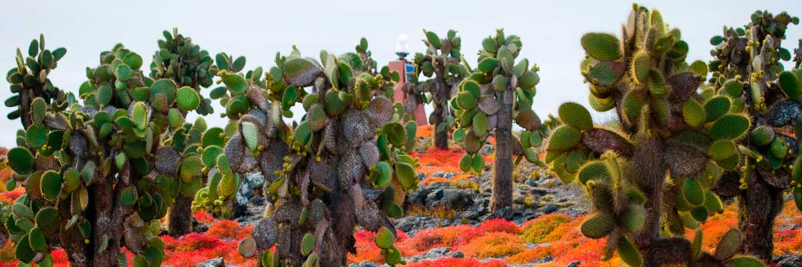

|  |  |
| --- | --- |
| **Food**: | B/L/D |
| **Trail:** | 0,8 km / 0,5 mi |
| **Lodging**: | M/Y Galaxy Orion |
| **Level**: | 2 |
| **Activities:** | HIKING,SNORKEL,PANGA RIDE,PADDLE BOARD,KAYAK |

DAY 4

AM: WITCH HILL

Witch Hill, on the northern coast of San Cristóbal, is one of the most stunning beaches in the Galapagos. Its powdery white sand and turquoise waters create a perfect setting for strolling and relaxing, while a large sea lion colony lounges on the shore. The nearby lagoon attracts diverse birdlife, including pelicans and blue-footed boobies. This site holds historical significance as one of Charles Darwin’s first stops in the Galapagos. Dive into the crystal-clear waters for a snorkeling experience filled with tropical fish, rays, and sea turtles.

Snorkel Experience: Stroll along Cerro Brujo’s white sands, relax near sea lions, and dive into a vibrant underwater world. Snorkeling here offers a chance to swim with tropical fish, sea turtles, and rays in crystal-clear waters.

**Highlights:**  Snorkeling opportunities, White sand beach, Blue-footed boobies, Galapagos sea lions, Pelicans

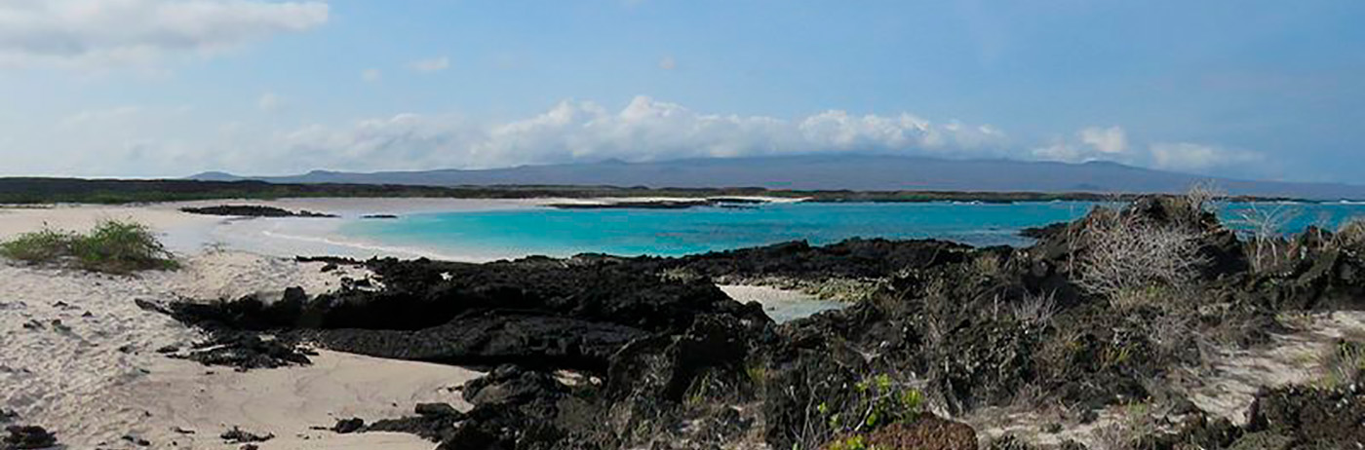

|  |  |
| --- | --- |
| **Trail:** | 0.5 km / 0.3 mi |
| **Level**: | 1 |
| **Activities:** | HIKING,SNORKEL,PANGA RIDE |

PM: PITT POINT

Located on the northeastern tip of San Cristóbal, Punta Pitt is a must-visit for nature and adventure enthusiasts. Its rugged trails lead to breathtaking viewpoints, where you can observe frigatebirds and the three iconic booby species—blue-footed, red-footed, and Nazca—a rare sight in the Galapagos. The volcanic landscape, with dramatic rock formations and lush vegetation, creates a thriving habitat for diverse wildlife. This experience blends a challenging hike with the chance to witness the archipelago’s incredible biodiversity at its finest.

Hiking Experience: Explore the rugged terrain of Punta Pitt and witness the diverse birdlife, including all three booby species and frigate birds.

**Highlights:** Stunning Views, Snorkeling opportunities, Magnificent and great frigatebirds

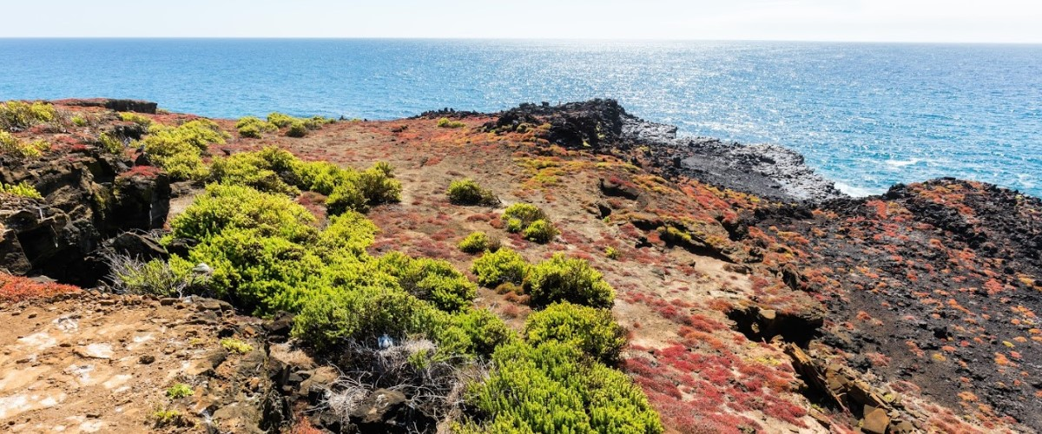

|  |  |
| --- | --- |
| **Food**: | B/L/D |
| **Trail:** | 1.5 km / 0.9 mi |
| **Lodging**: | M/Y Galaxy Orion |
| **Level**: | 3 |
| **Activities:** | HIKING,SNORKEL |

DAY 5

AM: HIGHLANDS

Embark on a highlands adventure, either from Baltra or Puerto Ayora. A bus journey brings you to the verdant highland forests, home to Galapagos Giant tortoises. You'll find these impressive creatures, weighing up to 300 kg/600 lbs, casually grazing or lounging in freshwater ponds. The highlands also host a variety of bird species seldom seen in the lowlands. Depending on your itinerary, explore a lava tunnel and delve into the geological history of these volcanic islands.

**Highlights:**  Lava tunnels, Darwin finches, Galapagos flycatchers, Giant tortoises, Barn owls, White-cheeked pintails

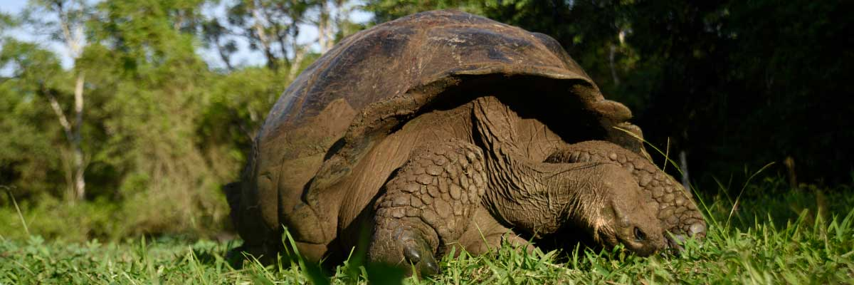

|  |  |
| --- | --- |
| **Trail:** | 1-1,5 km / 0,6-0,9 mi |
| **Level**: | 1 |
| **Activities:** | HIKING,PANGA RIDE,PADDLE BOARD,KAYAK |

PM: LOBOS ISLAND

Venture to Lobos Island, a tranquil islet secluded from San Cristobal by a slim channel. This nature's cradle, amidst a serene bay, is the playground for sea lion pups frolicking in tidal pools. The island might be modest but bursts with life, particularly with “lobos marinos” or sea lions. As you step ashore, welcoming committees of sea lions would greet you, only to be outraged by the male frigatebirds inland, presenting their inflamed red balloons amidst the verdant foliage. Stay vigilant for the blue-footed boobies nesting on the trails, ready to treat you to a display of their whimsical courtship dance.

Snorkel Experience: Dive into an underwater ballet at this renowned snorkeling spot, sheltered by the calm waves. Playful sea lions would eagerly display their acrobatic prowess. In contrast, sea turtles and rays find solace resting on the sandy seabed, giving you a glimpse into the harmonious marine life that thrives beneath the surface.

**Highlights:** Stunning Views, Galapagos sea lions, Magnificent and great frigatebirds, San Cristobal Lava Lizards

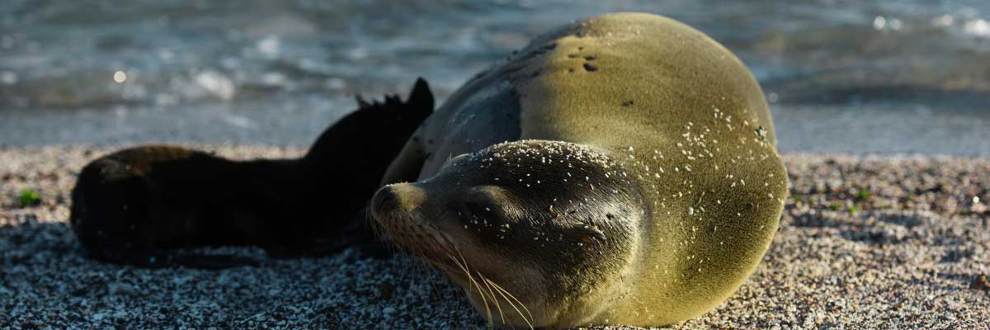

|  |  |
| --- | --- |
| **Food**: | B/L/D |
| **Trail:** | 0,6 km / 0,4 mi |
| **Lodging**: | M/Y Galaxy Orion |
| **Level**: | 3 |
| **Activities:** | HIKING,SNORKEL,PANGA RIDE |

DAY 6

AM: SUAREZ POINT

Embark on an adventure to Suarez Point, one of the Galapagos’ greatest natural wonders. This rocky trail is a haven for wildlife lovers, featuring an incredible array of species. Upon arrival, sea lions and marine iguanas welcome you as the first hosts of this nature spectacle. As you explore further, witness a vibrant mosaic of seabird colonies, from blue-footed and Nazca boobies to graceful frigatebirds and tropicbirds. The highlight of this journey is meeting the waved albatross, the island’s largest bird, impressing visitors with its powerful flight and intricate courtship display (present from April to January).

**Highlights:**  Stunning Views, Herons, Galapagos mockingbirds, Galapagos hawks, Darwin finches, Marine iguanas, Waved Albatross, Lava lizards

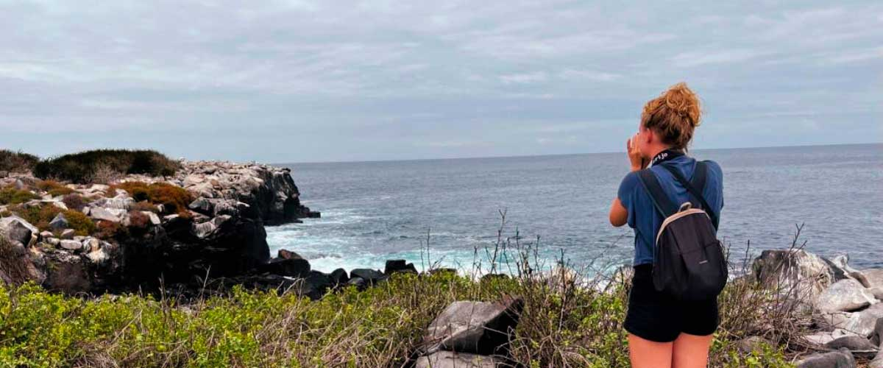

|  |  |
| --- | --- |
| **Trail:** | 1,7 km / 1,1 mi |
| **Level**: | 3 |
| **Activities:** | HIKING |

PM: GARDNER BAY

Embrace the morning at Gardner Bay, a pristine piece of paradise in the Galapagos archipelago. Sugar-white coral sands merge with crystal-clear turquoise waters, creating a tropical oasis. Watch as the beach becomes a theatre, starring sun-basking sea lions in a playful performance. This idyllic setting invites you to stroll along the coast, immersing yourself in an enlightening experience as you delve into the biology of the endemic fauna - from the melodious Española mockingbird and the unique marine iguanas to the regal Galapagos hawks.

Snorkel Experience: Submerge beneath the azure waves to witness a spectacular performance choreographed by marine life. Swim alongside playful sea lions, graceful reef sharks, and gliding rays. Discover an array of fish, including vivid Angelfish, charismatic Parrotfish, dynamic Damselfish, and the ever-busy Surgeonfish coloring the underwater landscape.

**Highlights:** Coral sand beach, Galapagos mockingbirds, Galapagos hawks, Darwin finches, Marine iguanas

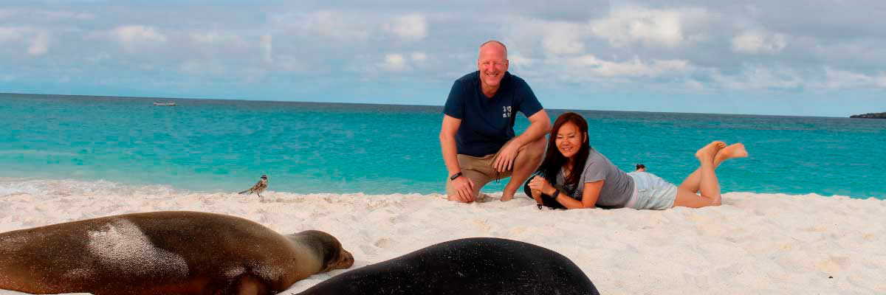

|  |  |
| --- | --- |
| **Food**: | B/L/D |
| **Trail:** | 0,8 km / 0,5 mi |
| **Lodging**: | M/Y Galaxy Orion |
| **Level**: | 1 |
| **Activities:** | HIKING,SNORKEL,PANGA RIDE,PADDLE BOARD |

DAY 7

AM: POST OFFICE BAY

Step into the past at Post Office Bay on Floreana, where sailors established a barrel-based mail system in the 1700s, still in use today. Beyond its historic charm, the bay was a key stop for whalers seeking freshwater and tortoises. This site also boasts a scenic beach, and incredible wildlife, including sea lions, green sea turtles, reef sharks, and, if luck is on your side, the elusive Galapagos penguin.

Snorkel Experience: Dive straight from the beach and explore a mesmerizing underwater world filled with sea turtles, rays, and schools of tropical fish. If lucky, catch a glimpse of a Galapagos penguin darting through the waves.

**Highlights:**  Galapagos penguins, Marine iguanas, Sea turtles, Finches, Shorebirds

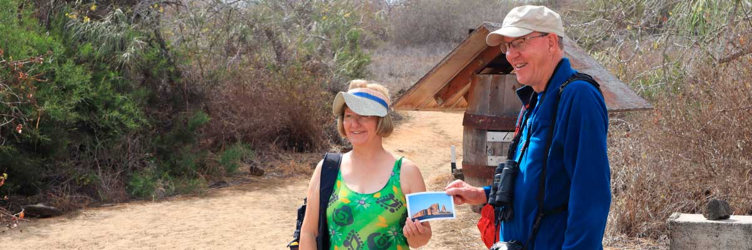

|  |  |
| --- | --- |
| **Trail:** | 0,7 km / 0,4 mi |
| **Level**: | 1 |
| **Activities:** | HIKING,SNORKEL |

PM: CORMORANT POINT

Located in northern Floreana, Punta Cormorant is a paradise for nature lovers. Its coastal lagoon hosts flamingos, white-cheeked pintails, and black-necked stilts, while its white sand beach is a crucial nesting site for green sea turtles. In recent years, blue-footed boobies have started nesting along the trail. This is also a great site for spotting endemic plants. For snorkeling, Devil’s Crown—a heavily eroded volcanic formation—offers an unparalleled experience, attracting reef sharks, rays, sea turtles, and massive schools of tropical fish.

Snorkel Experience: Explore Devil’s Crown, one of the best snorkeling spots in the Galapagos. Its currents attract reef sharks, turtles, rays, and massive schools of fish like snappers, parrotfish, and angelfish.

**Highlights:** Galapagos sea lions, Blue footed boobies, Galapagos shearwaters, American flamingoes, Sea turtles, Tropicbirds, Frigatebirds

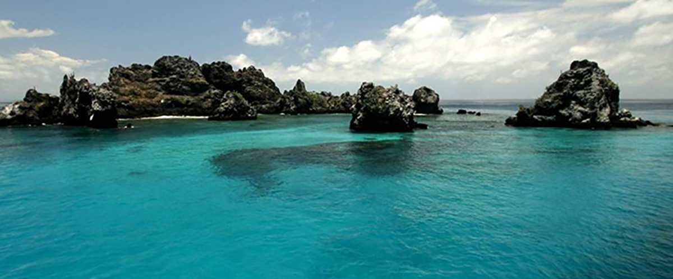

|  |  |
| --- | --- |
| **Food**: | B/L/D |
| **Trail:** | 1,6 km / 1 mi |
| **Lodging**: | M/Y Galaxy Orion |
| **Level**: | 1 |
| **Activities:** | HIKING,SNORKEL,PANGA RIDE,PADDLE BOARD,KAYAK |

DAY 8

AM: CHARLES DARWIN STATION

Explore the Charles Darwin Research Station, a center dedicated to wildlife conservation and research. Witness breeding programs helping restore giant tortoise populations, learn about projects tackling invasive species, and see conservationists working to protect the fragile Galapagos ecosystem.

Galapagos giant tortoise and land iguanas breeding program, Galapagos mockingbirds, Darwin finches, Galapagos flycatchers

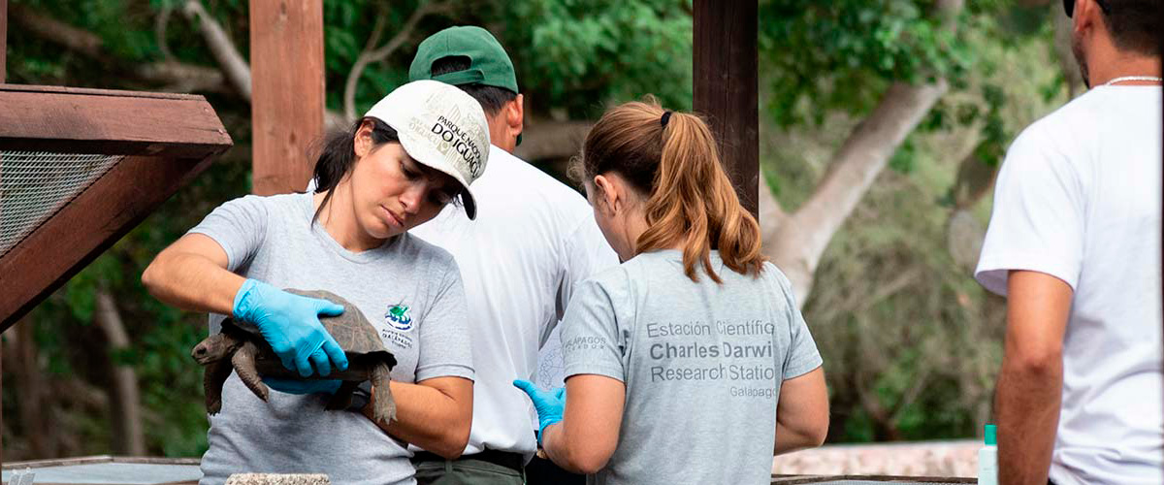

|  |  |
| --- | --- |
| **Trail:** | 2 km / 1,2 mi |
| **Level**: | 1 |
| **Activities:** | HIKING |

PM: BALTRA AIRPORT

Your Galapagos adventure comes to an end. Today, you will be transferred to Baltra Airport, where your National Park naturalist guide will assist you with final details before your flight back to mainland Ecuador. As you bid farewell to this paradise, take with you the unforgettable memories of one of the world’s most extraordinary destinations.



|  |  |
| --- | --- |
| **Food**: | B/-/- |
| **Trail:** |  |
| **Lodging**: | M/Y Galaxy Orion |
| **Level**: | 1 |
| **Activities:** | - |

GLOSSARY

|  |  |  |
| --- | --- | --- |
| **Feeding** | **Breakfast** | B |
| **Lunch** | L |
| **Dinner** | D |
| **Difficulty of the hike** | **Level 1** | Easy |
| **Level 2** | Moderate |
| **Level 3** | Difficult |