**Galapagos Southeastern Splendor And Secrets**

4 Days - 3 Nights

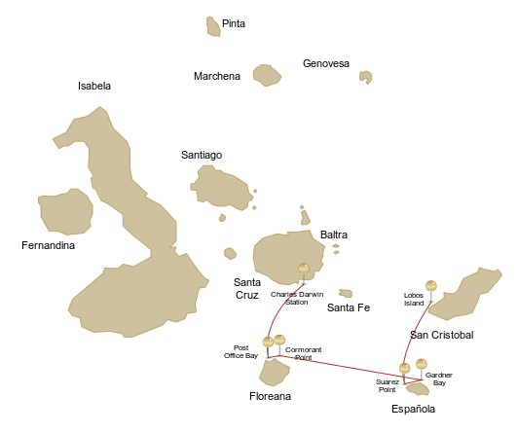

|  |  |  |  |  |  |  |  |
| --- | --- | --- | --- | --- | --- | --- | --- |
|  | | | **Hiking** | **Snorkel** | **Panga Ride** | **Paddle Board** | **Kayak** |
| SUNDAY | AM | **San Cristobal Island** : San Cristobal- Airport (arrival) |  |  |  |  |  |
|  | PM | **San Cristobal Island** : Lobos Island | * | * | * |  |  |
| MONDAY | AM | **Española Island** : Suarez Point | * |  |  |  |  |
|  | PM | **Española Island** : Gardner Bay | * | * |  | * | * |
| TUESDAY | AM | **Floreana Island** : Cormorant Point | * | * | * | * | * |
|  | PM | **Floreana Island** : Post Office Bay | * | * |  |  |  |
| WEDNESDAY | AM | **Santa Cruz Island** : Charles Darwin Station | * |  |  |  |  |
|  | PM | **Santa Cruz Island** : Baltra - airport (return) |  |  |  |  |  |

DAY 1 - SUNDAY

AM: SAN CRISTOBAL AIRPORT (ARRIVAL)

Embark on an unforgettable journey to the Galapagos Islands, where nature thrives in its purest form. Your adventure begins at San Cristobal’s modest yet bustling airport, where a seasoned naturalist guide will greet you. This guardian of the ecosystem will introduce you to a world of breathtaking landscapes and unparalleled biodiversity. Feel the excitement as you step into this living sanctuary, a UNESCO World Heritage site, marking the beginning of an extraordinary exploration.

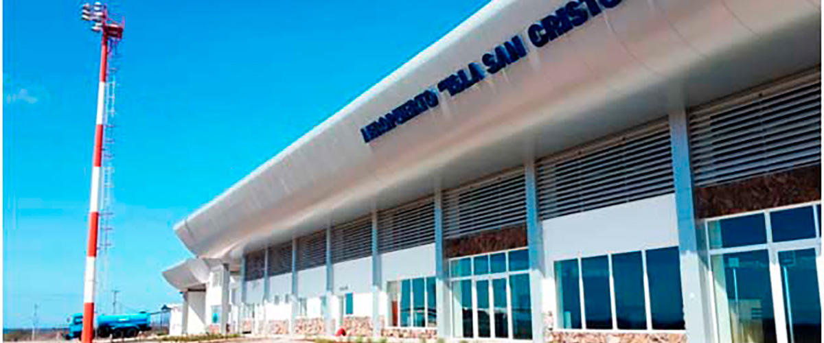

|  |  |
| --- | --- |
| **Trail:** |  |
| **Level**: | 1 |
| **Activities:** | - |

PM: LOBOS ISLAND

Venture to Lobos Island, a tranquil islet secluded from San Cristobal by a slim channel. This nature's cradle, amidst a serene bay, is the playground for sea lion pups frolicking in tidal pools. The island might be modest in size, but it bursts with life, particularly with “lobos marinos” or sea lions. As you step ashore, welcoming committees of sea lions would greet you, only to be outraged by the male frigatebirds inland, presenting their inflamed red balloons amidst the verdant foliage. Stay vigilant for the blue-footed boobies nesting on the trails, ready to treat you to a display of their whimsical courtship dance.

Snorkel Experience: Dive into an underwater ballet at this renowned snorkeling spot, sheltered by the calm waves. Playful sea lions would eagerly display their acrobatic prowess. In contrast, sea turtles and rays find solace resting on the sandy seabed, giving you a glimpse into the harmonious marine life that thrives beneath the surface.

Stunning Views, Galapagos sea lions, Magnificent and great frigatebirds, San Cristobal Lava Lizards

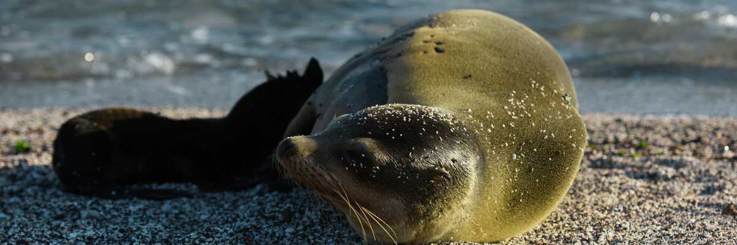

|  |  |
| --- | --- |
| **Food**: | -/L/D |
| **Trail:** | 0,6 km / 0,4 mi |
| **Lodging**: | M/Y Galaxy |
| **Level**: | 2 |
| **Activities:** | HIKING,SNORKEL,PANGA RIDE |

DAY 2 - MONDAY

AM: SUAREZ POINT

Embark on an adventure to Suarez Point, one of the Galapagos’ greatest natural wonders. This rocky trail is a haven for wildlife lovers, featuring an incredible array of species. Upon arrival, sea lions and marine iguanas welcome you as the first hosts of this nature spectacle. As you explore further, witness a vibrant mosaic of seabird colonies, from blue-footed and Nazca boobies to graceful frigatebirds and tropicbirds. The highlight of this journey is meeting the waved albatross, the island’s largest bird, impressing visitors with its powerful flight and intricate courtship display (present from April to January).

**Highlights:**  Stunning Views, Herons, Galapagos mockingbirds, Galapagos hawks, Darwin finches, Marine iguanas, Waved Albatross, Lava lizards

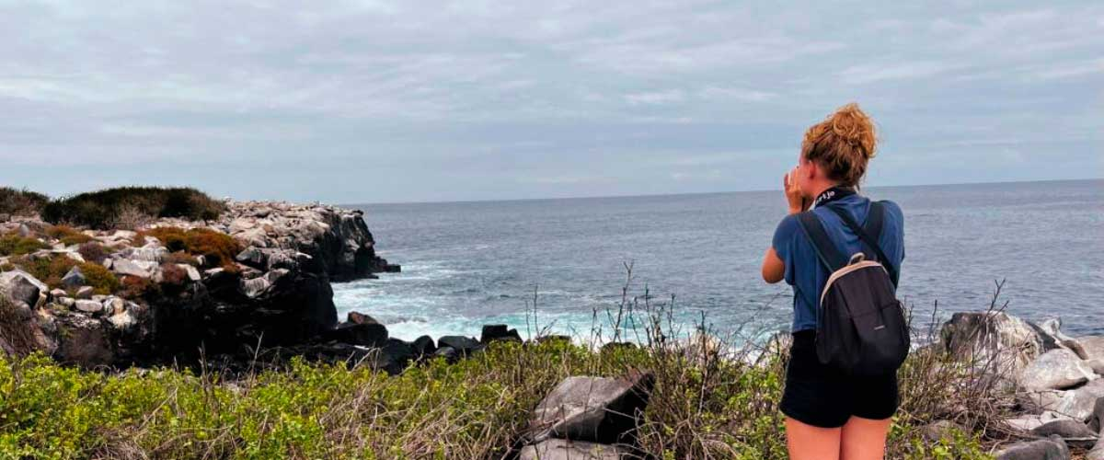

|  |  |
| --- | --- |
| **Trail:** | 1,7 km / 1,1 mi |
| **Level**: | 1 |
| **Activities:** | HIKING |

PM: GARDNER BAY

Embrace the morning at Gardner Bay, a pristine piece of paradise in the Galapagos archipelago. Sugar-white coral sands merge with crystal-clear turquoise waters, creating a tropical oasis. Watch as the beach becomes a theatre, starring sun-basking sea lions in a playful performance. This idyllic setting invites you to stroll along the coast, immersing yourself in an enlightening experience as you delve into the biology of the endemic fauna - from the melodious Española mockingbird and the unique marine iguanas to the regal Galapagos hawks.

Snorkel Experience: Submerge beneath the azure waves to witness a spectacular performance choreographed by marine life. Swim alongside playful sea lions, graceful reef sharks, and gliding rays. Discover an array of fish, including vivid Angelfish, charismatic Parrotfish, dynamic Damselfish, and the ever-busy Surgeonfish coloring the underwater landscape.

**Highlights:**  Coral sand beach, Galapagos mockingbirds, Galapagos hawks, Darwin finches, Marine iguanas

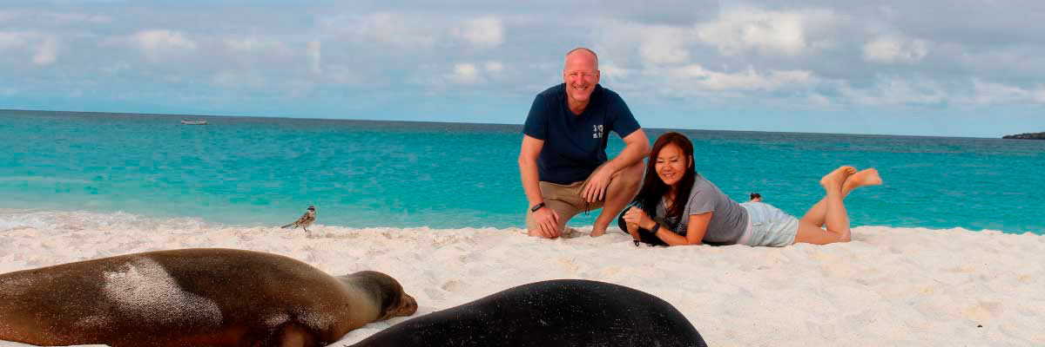

|  |  |
| --- | --- |
| **Food**: | B/L/D |
| **Trail:** | 0,8 km / 0,5 mi |
| **Lodging**: | M/Y Galaxy |
| **Level**: | 3 |
| **Activities:** | HIKING,SNORKEL,PADDLE BOARD,KAYAK |

DAY 3 - TUESDAY

AM: CORMORANT POINT

Located in northern Floreana, Punta Cormorant is a paradise for nature lovers. Its coastal lagoon hosts flamingos, white-cheeked pintails, and black-necked stilts, while its white sand beach is a crucial nesting site for green sea turtles. In recent years, blue-footed boobies have started nesting along the trail. This is also a great site for spotting endemic plants. For snorkeling, Devil’s Crown—a heavily eroded volcanic formation—offers an unparalleled experience, attracting reef sharks, rays, sea turtles, and massive schools of tropical fish.

Snorkel Experience: Explore Devil’s Crown, one of the best snorkeling spots in the Galapagos. Its currents attract reef sharks, turtles, rays, and massive schools of fish like snappers, parrotfish, and angelfish.

**Highlights:**  Galapagos sea lions, Blue footed boobies, Galapagos shearwaters, American flamingoes, Sea turtles, Tropicbirds, Frigatebirds

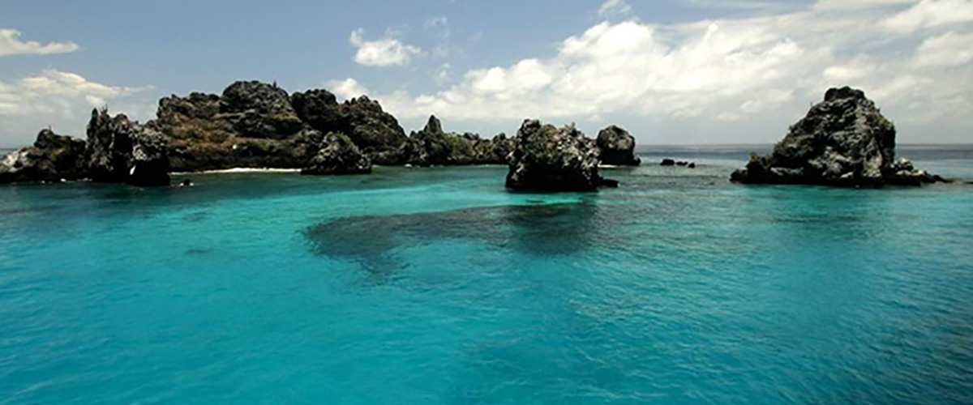

|  |  |
| --- | --- |
| **Trail:** | 1,6 km / 1 mi |
| **Level**: | 3 |
| **Activities:** | HIKING,SNORKEL,PANGA RIDE,PADDLE BOARD,KAYAK |

PM: POST OFFICE BAY

Step into the past at Post Office Bay on Floreana, where sailors established a barrel-based mail system in the 1700s, still in use today. Beyond its historic charm, the bay was a key stop for whalers seeking freshwater and tortoises. This site also boasts a scenic beach, and incredible wildlife, including sea lions, green sea turtles, reef sharks, and, if luck is on your side, the elusive Galapagos penguin.

Snorkel Experience: Dive straight from the beach and explore a mesmerizing underwater world filled with sea turtles, rays, and schools of tropical fish. If lucky, catch a glimpse of a Galapagos penguin darting through the waves.

**Highlights:**  Galapagos penguins, Marine iguanas, Sea turtles, Finches, Shorebirds

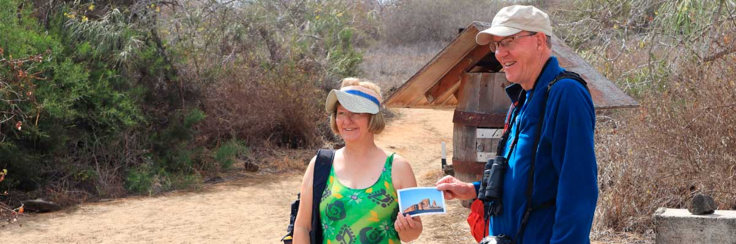

|  |  |
| --- | --- |
| **Food**: | B/L/D |
| **Trail:** | 0,7 km / 0,4 mi |
| **Lodging**: | M/Y Galaxy |
| **Level**: | 2 |
| **Activities:** | HIKING,SNORKEL |

DAY 4 - WEDNESDAY

AM: CHARLES DARWIN STATION

Explore the Charles Darwin Research Station, a center dedicated to wildlife conservation and research. Witness breeding programs helping restore giant tortoise populations, learn about projects tackling invasive species, and see conservationists working to protect the fragile Galapagos ecosystem.

Galapagos giant tortoise and land iguanas breeding program, Galapagos mockingbirds, Darwin finches, Galapagos flycatchers

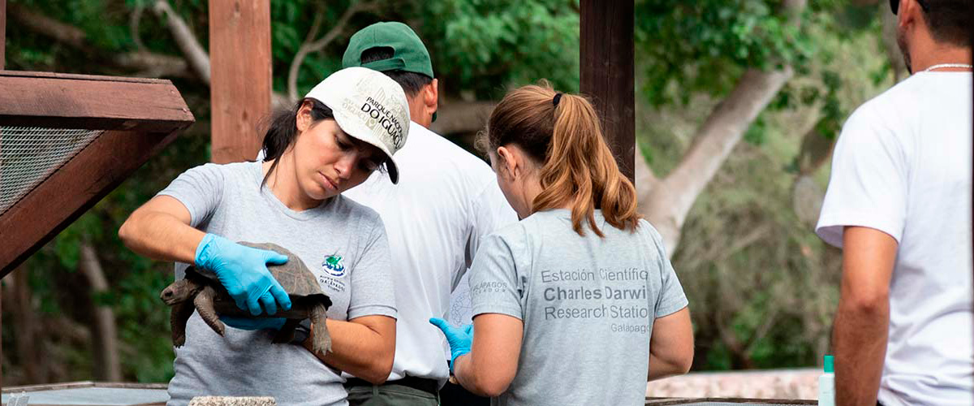

|  |  |
| --- | --- |
| **Trail:** | 2 km / 1,2 mi |
| **Level**: | 1 |
| **Activities:** | HIKING |

PM: BALTRA AIRPORT (RETURN)

Your Galapagos adventure comes to an end. Today, you will be transferred to Baltra Airport, where your National Park naturalist guide will assist you with final details before your flight back to mainland Ecuador. As you bid farewell to this paradise, take with you the unforgettable memories of one of the world’s most extraordinary destinations.

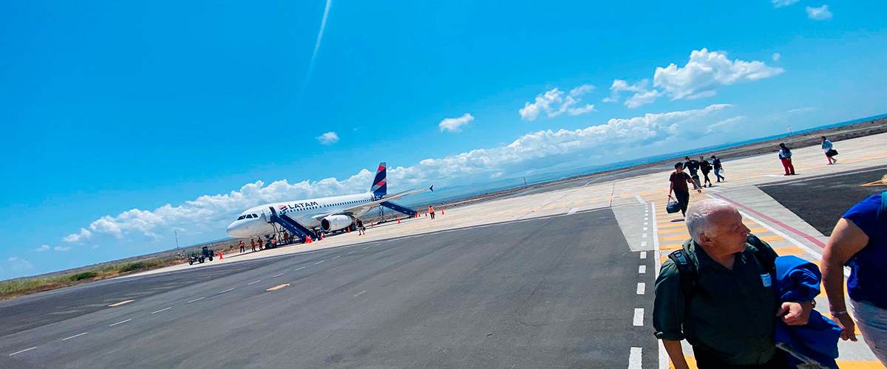

|  |  |
| --- | --- |
| **Food**: | B/-/- |
| **Trail:** |  |
| **Lodging**: | M/Y Galaxy |
| **Level**: | 1 |
| **Activities:** | - |

GLOSSARY

|  |  |  |
| --- | --- | --- |
| **Feeding** | **Breakfast** | B |
| **Lunch** | L |
| **Dinner** | D |
| **Difficulty of the hike** | **Level 1** | Easy |
| **Level 2** | Moderate |
| **Level 3** | Difficult |