**GALAPAGOS ONBOARD A CRUISE**

**7 DAYS / 6 NIGHTS**

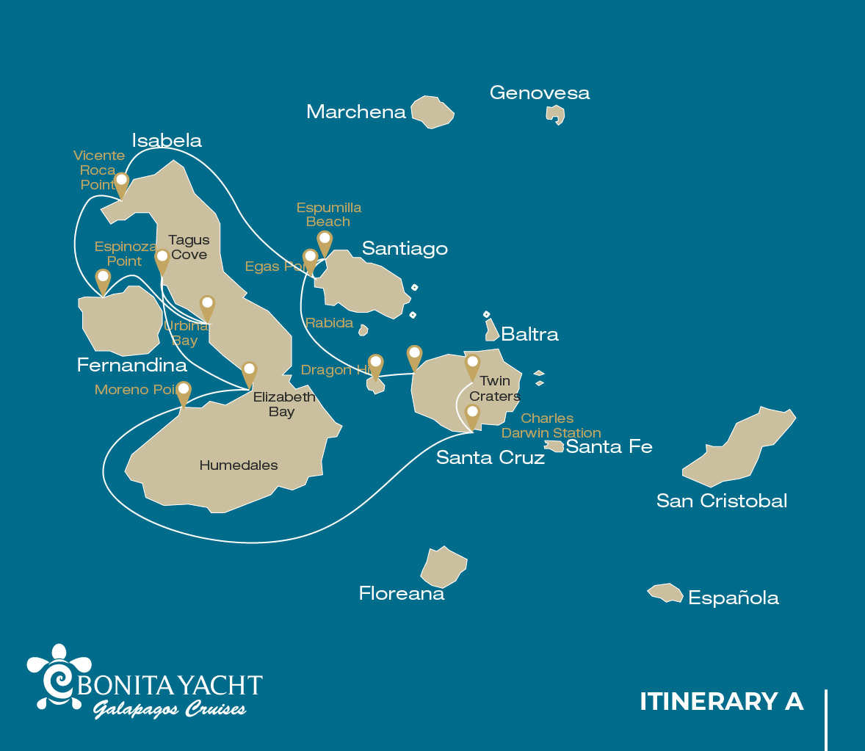

|  |  |  |  |  |  |  |  |
| --- | --- | --- | --- | --- | --- | --- | --- |
|  | | | **Hiking** | **Snorkel** | **Panga Ride** | **Paddle Board** | **Kayak** |
| SUNDAY | AM | Santa Cruz Island : Baltra - airport (arrival) |  |  |  |  |  |
|  | PM | Santa Cruz Island : Dragon Hill | * |  |  |  |  |
| MONDAY | AM | Santiago Island : Espumilla Beach / Buccaneer Cove | * | * | * | * | * |
|  | PM | Santiago Island : Egas Port | * | * |  |  |  |
| TUESDAY | AM | Isabela Island : Vicente Roca Point |  | * | * |  |  |
|  | PM | Fernandina Island : Espinoza Point | * | * | * |  |  |
| WEDNESDAY | AM | Isabela Island : Urbina Bay | * | * |  |  |  |
|  | PM | Isabela Island : Tagus Cove | * | * | * | * | * |
| THURSDAY | AM | Isabela Island : Elizabeth Bay |  |  | * | * | * |
|  | PM | Isabela Island : Moreno Point | * | * | * |  |  |
| FRIDAY | AM | Santa Cruz Island : Charles Darwin Station | * |  |  |  |  |
|  | PM | Santa Cruz Island : Highlands | * |  |  |  |  |
| SATURDAY | AM | Santa Cruz Island : Twin Craters | * |  |  |  |  |
|  | PM | Santa Cruz Island : Baltra - airport (return) |  |  |  |  |  |

DAY 1

AM: BALTRA AIRPORT

Welcome to Galapagos! Upon arrival at Baltra Airport, your naturalist guide will greet you and assist with the transfer to Itabaca Channel. This initial journey offers your first connection with the archipelago as you take a short ferry ride to Santa Cruz Island. Along the way, observe Baltra’s arid landscape and learn about its history as a former U.S. WWII airbase. This is just the beginning of the many fascinating stories awaiting you on your adventure.

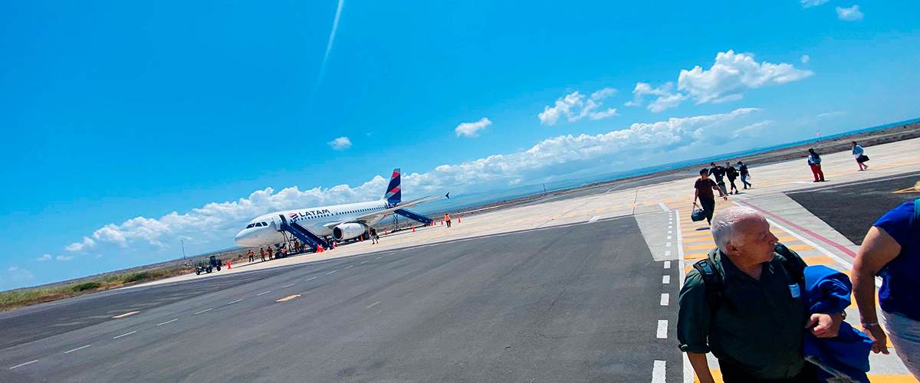

|  |  |
| --- | --- |
| **Trail:** |  |
| **Level**: | 1 |
| **Activities:** | - |

PM: DRAGON HILL

Located on Santa Cruz’s northern coast, Dragon Hill is the only place on the island where land iguanas roam freely. Once near extinction in the 70s and 80s, their population has successfully rebounded. As you explore this unique ecosystem, you’ll also spot a saltwater lagoon where flamingos, ducks, and shorebirds often gather.

Snorkel Experience: After the hike, dive into calm, shallow waters for an unforgettable snorkeling experience. Swim among schools of surgeonfish and parrotfish, and spot reef sharks, rays, and vibrant tropical fish.

Herons, Darwin finches, Galapagos flycatchers, White-cheeked pintails, American flamingoes, Galapagos land iguanas

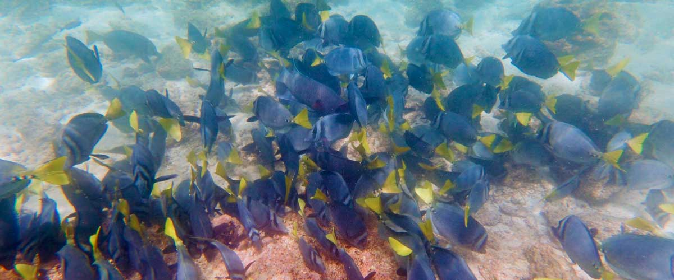

|  |  |
| --- | --- |
| **Food**: | -/L/D |
| **Trail:** | 2,2 km / 1,4 mi |
| **Lodging**: | M/Y Bonita |
| **Level**: | 1 |
| **Activities:** | HIKING |

DAY 2

AM: BUCCANEER COVE / ESPUMILLA BEACH

This site gets its name because it was used by pirates and buccaneers during the XVII and XVIII centuries as a place to hide and get freshwater and tortoises. The place is very scenic with beautiful cliffs and interesting rock formations. There is no trail, but here you will take a dinghy to look at wildlife from the small boats.

Snorkel Experience: You can snorkel in a sheltered bay which is teaming with underwater wildlife including large schools of fish (angelfish, puffers, parrotfish, snappers, grunts…) but also reek sharks, sea lions and sea turtles.

**Highlights:**  Herons, Boobies, Galapagos hawks

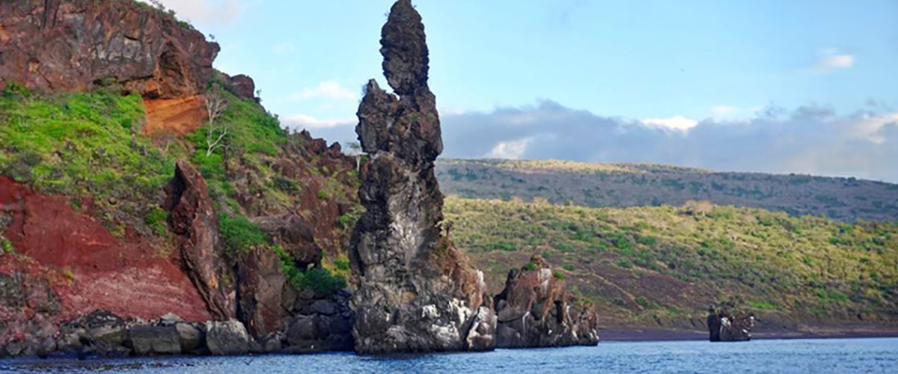

|  |  |
| --- | --- |
| **Trail:** | 2,3 km / 1,4 mi (plus and extra loop 1 km - 0,6 mi) |
| **Level**: | 1 |
| **Activities:** | HIKING,SNORKEL,PANGA RIDE,PADDLE BOARD,KAYAK |

PM: EGAS PORT

Despite its name, there is no “port” at Puerto Egas, but you might see a few remains of the last attempts to colonize the island during the 60’s. The trail goes along the coastline which is rich in wildlife, with marine iguanas basking in the sun everywhere, Galapagos sea lions, herons, oystercatchers and many shorebirds. At the end of the trail an area called “the grottos” is home for a small colony of the endemic Galapagos fur seal, much more difficult to see at close range than its cousin. As recently as 2019, land iguanas were reintroduced to the area, so look around for these impressive reptiles which were extinct from Santiago for over a century.

Snorkel Experience: You can snorkel from the beach and explore an area of rocky bottoms which is excellent for fish, turtles and reef sharks. Often, sea lions are also present and are happy to interact with divers.

**Highlights:** Stunning Views, Herons, Galapagos sea lions, Galapagos fur seals, Oystercatchers, Galapagos hawks, Darwin finches, Marine and land iguanas, Galapagos doves, Shorebirds

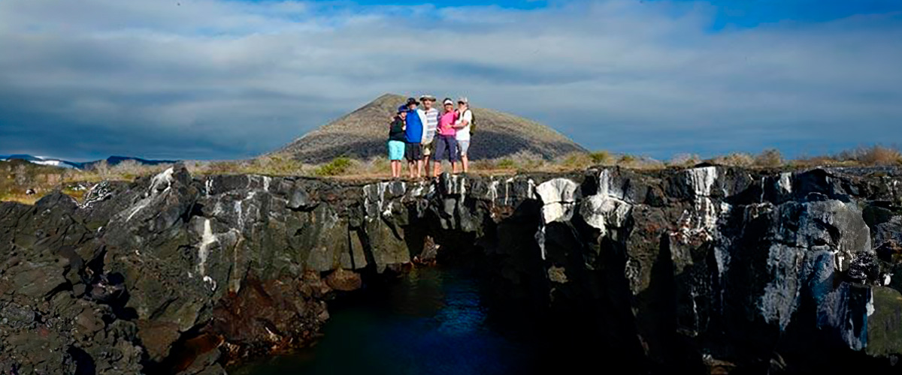

|  |  |
| --- | --- |
| **Food**: | B/L/D |
| **Trail:** | 2,3 km / 1,4 mi |
| **Lodging**: | M/Y Bonita |
| **Level**: | 1 |
| **Activities:** | HIKING,SNORKEL |

DAY 3

AM: VICENTE ROCA POINT

Vicente Roca Point offers a breathtaking natural spectacle, featuring some of the tallest cliffs in Galapagos and intriguing volcanic formations. While there are no trails, a dinghy tour along the shore provides an up-close look at the areaand#039;s rich wildlife. Highlights include flightless cormorants, blue-footed boobies, pelicans, and sea turtles. The site is also home to Galapagos fur seals and marine iguanas basking on the rocks. Moreover, the deep waters surrounding the area make it an excellent spot for dolphin and whale sightings.

Snorkel Experience: Snorkel in the cove to look for sea turtles, penguins, sea lions, cormorants, rays and many different species of fish. Look for fan corals, sponges and other invertebrates growing on the walls.

**Highlights:**  Stunning Views, Galapagos penguins, Flightless cormorants, Marine iguanas, Sea turtles

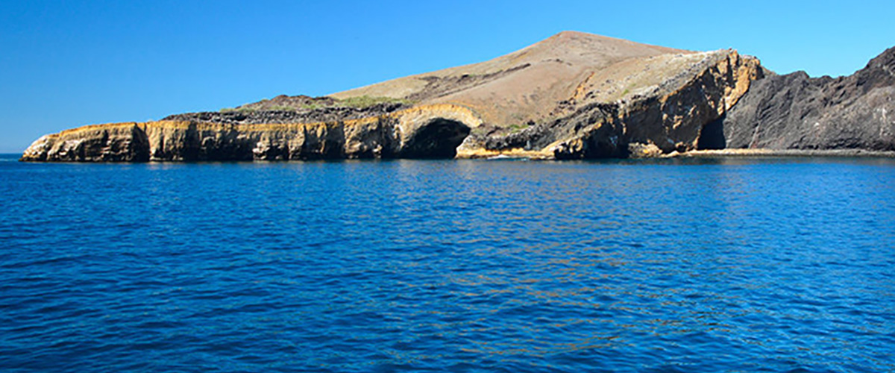

|  |  |
| --- | --- |
| **Trail:** | 1,4 km / 0,8 mi |
| **Level**: | 1 |
| **Activities:** | SNORKEL,PANGA RIDE |

AM: ESPINOZA POINT

Fernandina is the most active volcano of the islands, with regular eruptions every 3-5 years. This island is also one of the jewels of Galapagos because of the large number of animals on its shores. As soon as you disembark you will see hundreds of marine iguanas lounging in the sun, while the tide pools are a favorite playground for sea lions. Further along, Galapagos cormorants build their nests near the shore, not far from other species such as herons, oystercatchers and other shorebirds, while hawks often perch in the mangroves in search of prey.

Snorkel Experience: The nutrient-rich waters are the reason for the great diversity of species in this area, including penguins, cormorants, sea lions and many sea turtles. The abundance of algae makes this place the best place to see marine iguanas feeding underwater.

**Highlights:** Stunning Views, Herons, Galapagos penguins, Oystercatchers, Galapagos hawks, Marine iguanas, Sea turtles, Shorebirds

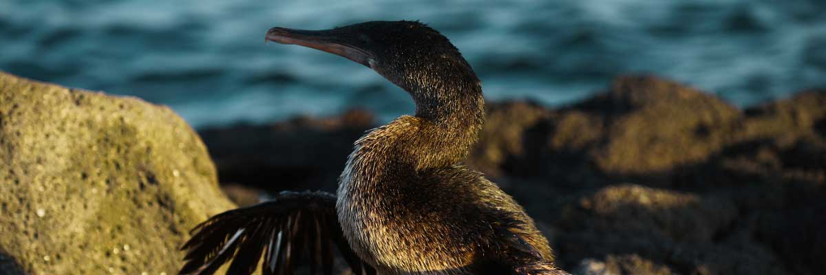

|  |  |
| --- | --- |
| **Food**: | B/L/D |
| **Trail:** | 1,6 km / 1 mi |
| **Lodging**: | M/Y Bonita |
| **Level**: | 2 |
| **Activities:** | HIKING,SNORKEL,PANGA RIDE |

DAY 4

AM: URBINA BAY

This place is known for the dramatic uplifting that happened here during the 1950’s. A large portion of the coast was pushed up, exposing many hectares of previously submerged land. Look carefully along the trail and you will find small shells and corals, a proof that the area was underwater more than sixty years ago. The trail will give the opportunity to see land iguanas and, during certain seasons, giant tortoises. Galapagos hawks nest in the area and are often seen flying or perched on the trees.

Snorkel Experience: You can snorkel from the beach to see sea turtles, cormorants and penguins. Fish are also abundant in the area.

**Highlights:**  Stunning Views, Galapagos mockingbirds, Galapagos hawks, Darwin finches, Galapagos flycatchers, Galapagos land iguanas

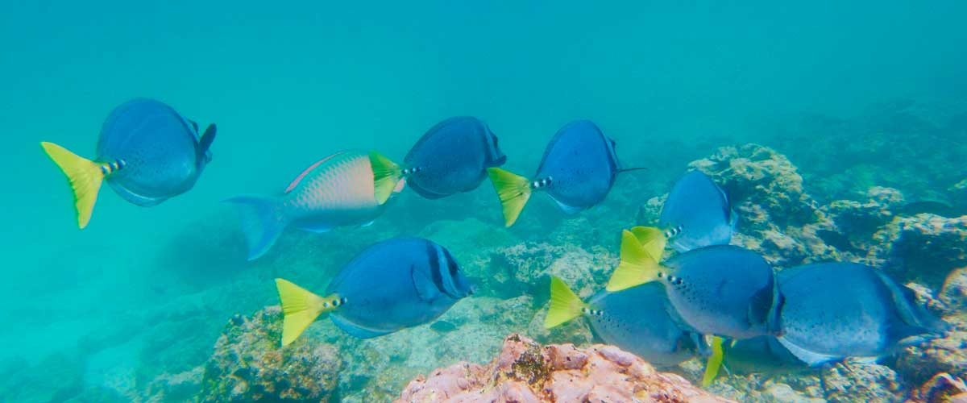

|  |  |
| --- | --- |
| **Trail:** | 1,2 km / 0,7 mi. Long trail 3,0 km / 1,8 mi |
| **Level**: | 1 |
| **Activities:** | HIKING,SNORKEL |

PM: TAGUS COVE

Tagus Cove is steeped in history, once visited by Charles Darwin during his Galapagos exploration. A scenic trail winds through dry Palo Santo forests, where Darwin’s finches and mockingbirds can be spotted. At the top, breathtaking views of Lake Darwin and Isabela’s towering volcanoes await. A boat tour along the shore provides a chance to observe Galapagos penguins, flightless cormorants, marine iguanas, and the elusive Galapagos martin, one of the rarest and most endangered birds in the archipelago.

Snorkel Experience: The nutrient-rich waters of Tagus Cove attract sea turtles, tropical fish, and penguins feasting on anchovies. Flightless cormorants can often be seen chasing fish underwater, creating a truly unique snorkeling experience.

**Highlights:** Stunning Views, Herons, Galapagos penguins, Galapagos hawks, Flightless cormorants, Marine iguanas, Sea turtles, Sea stars

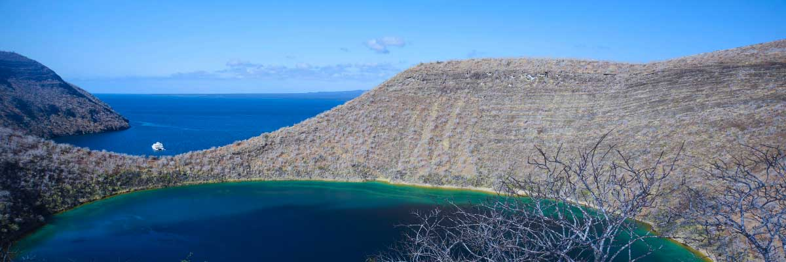

|  |  |
| --- | --- |
| **Food**: | B/L/D |
| **Trail:** | 2,6 km / 1,6 mi |
| **Lodging**: | M/Y Bonita |
| **Level**: | 3 |
| **Activities:** | HIKING,SNORKEL,PANGA RIDE,PADDLE BOARD,KAYAK |

DAY 5

AM: ELIZABETH BAY

Elizabeth Bay is a beautiful sheltered bay surrounded by large mangroves and barren lava fields. There is no trail here so you will take a dinghy tour to explore many channels, pools and coves teeming with life. This is one of the best locations in the islands to see Galapagos penguins, but don’t expect to see thousands of them, as the entire population of the islands is only about 3.000 of them. Flightless cormorants also nest in the area and blue-footed boobies and pelicans often fish in these shallow and rich waters. Rays and sea turtles are also very abundant.

**Highlights:**  Mangroves, Rays, Herons, Galapagos penguins, Galapagos hawks, Flightless cormorants, Sea turtles

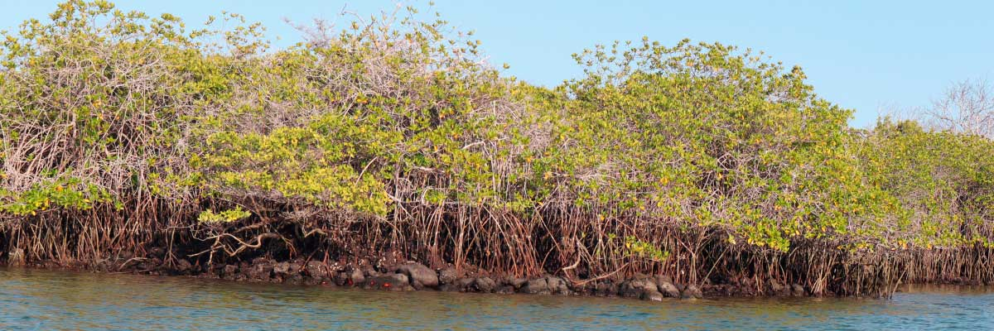

|  |  |
| --- | --- |
| **Trail:** | 1,4 km / 0,8 mi |
| **Level**: | 1 |
| **Activities:** | PANGA RIDE,PADDLE BOARD,KAYAK |

PM: MORENO POINT

Moreno Point is a magical place with extensive lava fields which look lifeless at first sight. Once inland, scattered brackish lagoons form an oasis of life where you can find flamingos, gallinules, ducks and herons. Along the shore we will look for penguins, marine iguanas, flightless cormorants, blue-footed boobies, sea lions, oystercatchers and other shore birds.

Snorkel Experience: We will snorkel to see sea turtles, cormorants and many species of fish. Look carefully in the long seaweeds and you might find a seahorse.

**Highlights:** Stunning Views, Galapagos mockingbirds, Darwin finches, American flamingoes, Flightless cormorants, Marine iguanas, Ducks, Gallinules

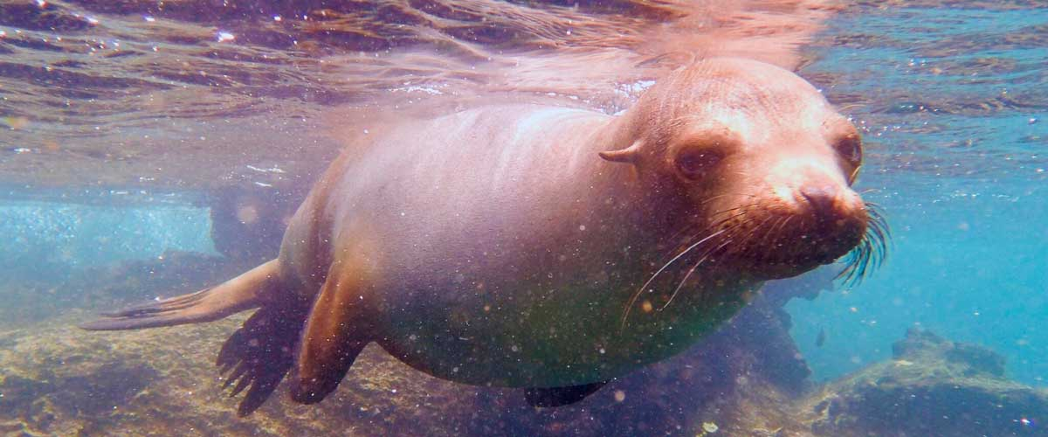

|  |  |
| --- | --- |
| **Food**: | B/L/D |
| **Trail:** | 1,6 km / 1 mi |
| **Lodging**: | M/Y Bonita |
| **Level**: | 3 |
| **Activities:** | HIKING,SNORKEL,PANGA RIDE |

DAY 6

AM: CHARLES DARWIN STATION

The Charles Darwin Station is a nonprofit organization which has been working for decades together with the Galapagos National Park to preserve the biodiversity of these unique islands. During this visit you will learn about the projects that both institutions carry together to protect the native species and eradicate the invasive ones which are threatening the Galapagos environment. One of the most important and emblematic projects has been reproducing giant tortoises in captivity. The visit is mostly outdoors in a beautiful dry native forest with giant cactus and many other interesting native plants. It is also a fantastic place to find several endemic Darwin finches, as well as flycatchers and mockingbirds.

**Highlights:**  Galapagos giant tortoise and land iguanas breeding program, Galapagos mockingbirds, Darwin finches, Galapagos flycatchers

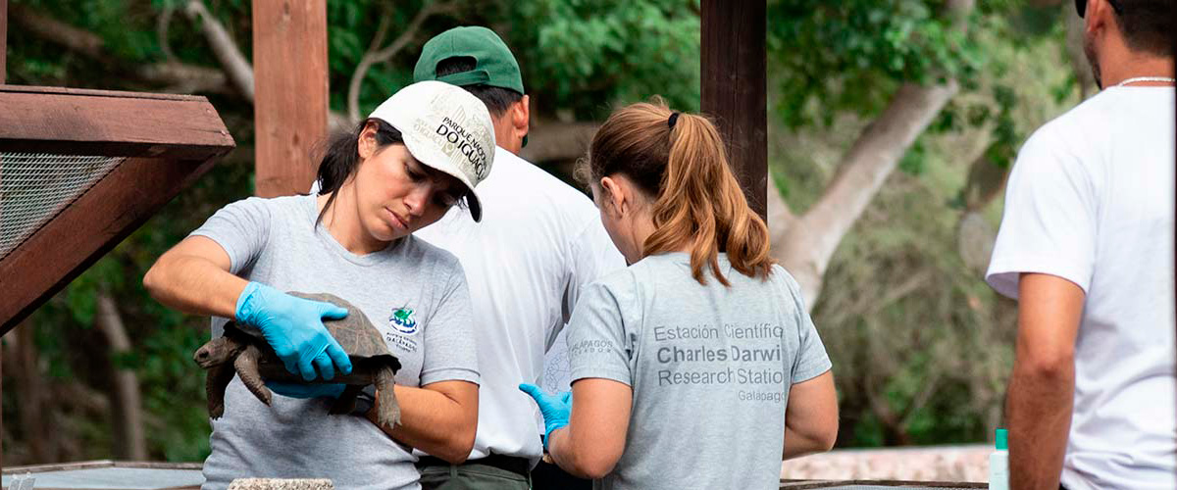

|  |  |
| --- | --- |
| **Trail:** | 2 km / 1,2 mi |
| **Level**: | 1 |
| **Activities:** | HIKING |

PM: HIGHLANDS

Either if you do this visit starting from Baltra or from Puerto Ayora, a bus will take you to the highlands stopping along the way at one of the reserves to visit the lush highland forests where you will look for Galapagos Giant tortoises in their natural environment. This is the best place in the Galapagos to see these gentle giants (reaching over 300 kg / 600 pounds!) casually grazing and resting in freshwater ponds. This is also home for a great diversity of birds rarely found at the lowlands, including finches (tree, woodpecker and vegetarian finches), flycatchers and several species of water birds. You will visit a lava tunnel (depending on the itinerary) and learn how these extraordinary formations were created by ancient volcanic eruptions.

**Highlights:** Lava tunnels, Darwin finches, Galapagos flycatchers, Giant tortoises, Barn owls, White-cheeked pintails

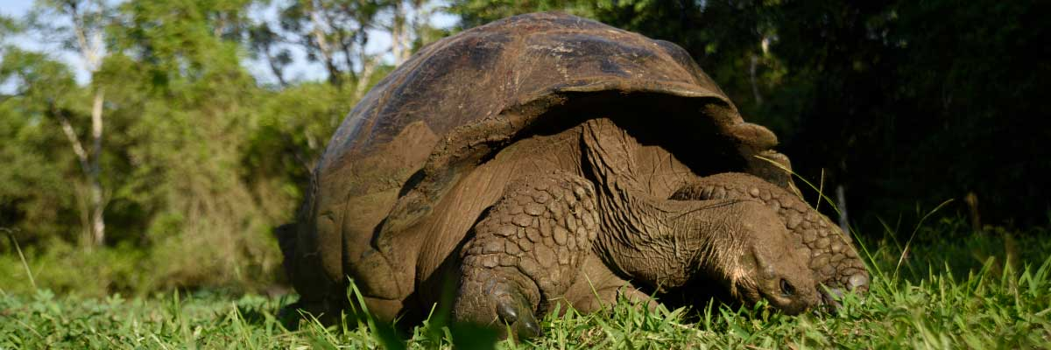

|  |  |
| --- | --- |
| **Food**: | B/L/D |
| **Trail:** | 1-1,5 km / 0,6-0,9 mi |
| **Lodging**: | M/Y Bonita |
| **Level**: | 1 |
| **Activities:** | HIKING |

DAY 7

AM: TWIN CRATERS

Discover Los Gemelos, two massive sinkholes formed by the collapse of underground chambers on Santa Cruz Island. Located along the road between Puerto Ayora and Baltra, these craters provide stunning views of lush Scalesia forests and a chance to spot the endemic short-eared owl. This breathtaking site is a perfect farewell before your airport transfer.

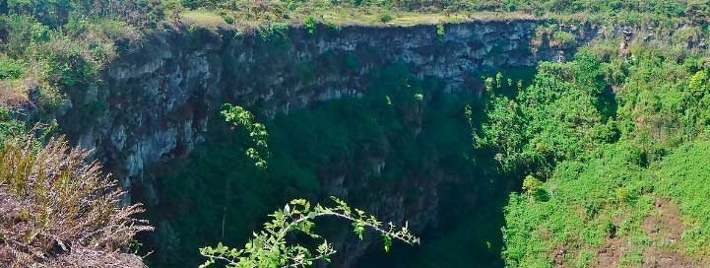

|  |  |
| --- | --- |
| **Trail:** |  |
| **Level**: | 1 |
| **Activities:** | HIKING |

PM: BALTRA (AIRPORT)

Your Galapagos adventure comes to an end. Today, you will be transferred to Baltra Airport, where your National Park naturalist guide will assist you with final details before your flight back to mainland Ecuador. As you bid farewell to this paradise, take with you the unforgettable memories of one of the world’s most extraordinary destinations.



|  |  |
| --- | --- |
| **Food**: | B/-/- |
| **Trail:** |  |
| **Lodging**: | M/Y Bonita |
| **Level**: | 1 |
| **Activities:** | - |

GLOSSARY

|  |  |  |
| --- | --- | --- |
| **Feeding** | **Breakfast** | B |
| **Lunch** | L |
| **Dinner** | D |
| **Difficulty of the hike** | **Level 1** | Easy |
| **Level 2** | Moderate |
| **Level 3** | Difficult |