**Western Galapagos Wildlife And Volcanic Wonders**

8 Days – 7 nights

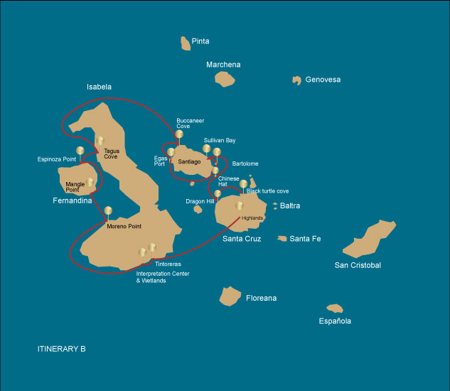

|  |  |  |  |  |  |  |  |
| --- | --- | --- | --- | --- | --- | --- | --- |
|  | | | **Hiking** | **Snorkel** | **Panga Ride** | **Paddle Board** | **Kayak** |
| WEDNESDAY | AM | **Santa Cruz Island** : Baltra - airport (arrival) |  |  |  |  |  |
|  | PM | **Santa Cruz Island** : Highlands | * |  |  |  |  |
| THURSDAY | AM | **Isabela Island** : Tintoreras |  | * | * |  |  |
|  | PM | **Isabela Island** : Isabela's Wetlands and Interpretation Center | * |  |  |  |  |
| FRIDAY | AM | **Isabela Island** : Moreno Point | * | * | * |  |  |
|  | PM | **Fernandina Island** : Mangle Point |  | * | * | * | * |
| SATURDAY | AM | **Fernandina Island** : Espinoza Point | * | * | * |  |  |
|  | PM | **Isabela Island** : Tagus Cove | * | * | * | * | * |
| SUNDAY | AM | **Santiago Island** : Buccaneer Cove | * | * |  |  |  |
|  | PM | **Santiago Island** : Egas Port | * | * | * | * | * |
| MONDAY | AM | **Bartolome Island** : Bartolome |  |  | * |  |  |
|  | PM | **Santiago Island** : Sullivan Bay | * | * |  |  |  |
| TUESDAY | AM | **Chinese Hat Island** : Chinese Hat | * | * | * | * | * |
|  | PM | **Santa Cruz Island** : Dragon Hill | * |  | * | * |  |
| WEDNESDAY | AM | **Santa Cruz Island** : Black Turtle Cove | * | * |  |  |  |
|  | PM | **Santa Cruz Island** : Baltra - airport (return) |  |  |  |  |  |

DAY 1 - WEDNESDAY

AM: BALTRA AIRPORT (ARRIVAL)

Embark on an unforgettable adventure to the Galapagos Islands, starting with your arrival at Baltra airport. Our expert naturalist guide from the National Park will eagerly await your arrival to introduce you to the wonders ahead.

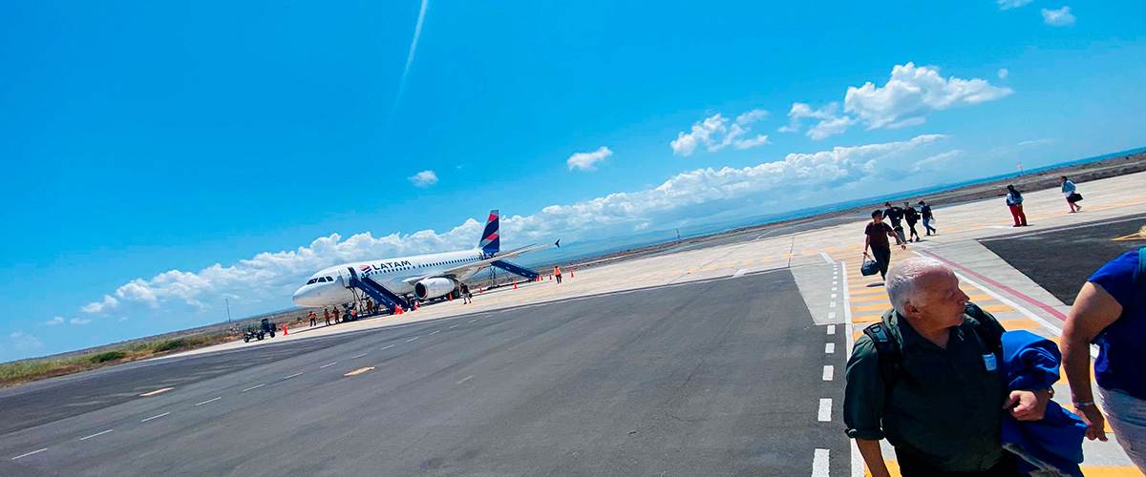

|  |  |
| --- | --- |
| **Trail:** |  |
| **Level**: | 1 |
| **Activities:** | - |

PM: HIGHLANDS

Your day begins with a journey to the highlands of San Cristobal Island, offering a different perspective of the Galapagos' unique ecosystem. This lush and verdant area contrasts sharply with the coastal zones. The highlands are home to a variety of bird species, giant tortoises in their natural habitat, and a rich array of plant life, including endemic trees and ferns. You'll have the opportunity to walk along paths that meander through this lush landscape, offering a chance to observe the giant tortoises up close and personal. The highlands also provide panoramic views of the island, showcasing its diverse topography.

Lava tunnels, Darwin finches, Galapagos flycatchers, Giant tortoises, Barn owls, White-cheeked pintails

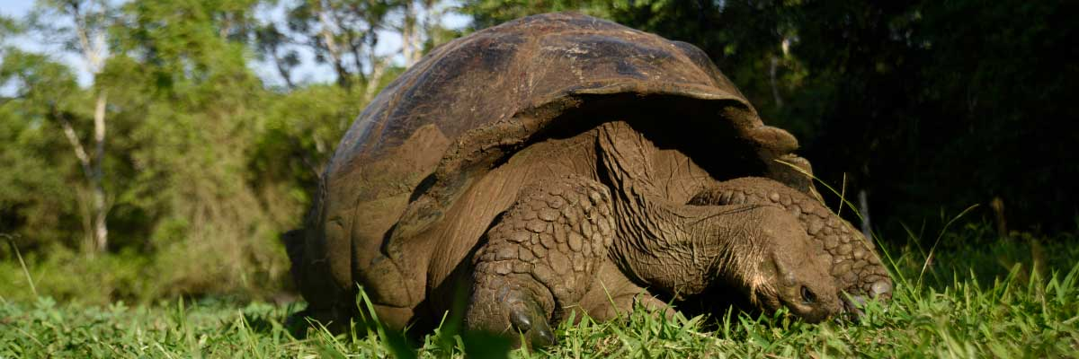

|  |  |
| --- | --- |
| **Food**: | -/L/D |
| **Trail:** | 1-1,5 km / 0,6-0,9 mi |
| **Lodging**: | M/Y Galaxy |
| **Level**: | 1 |
| **Activities:** | HIKING |

DAY 2 - THURSDAY

AM: TINTORERAS

Start your morning on Isabela Island, embarking on a unique adventure at Tintoreras, a cluster of small isles teeming with wildlife. Sail through crystal-clear waters and discover a vibrant underwater world inhabited by white-tipped sharks, colorful tropical fish, and starfish.

Snorkel Experience: Dive into the marvelous marine world of Isabela. Swim alongside sea turtles, manta rays, and, if you’re lucky, Galapagos penguins.

**Highlights:**  White-tipped and black-tipped reef sharks, Sea turtles, Manta rays

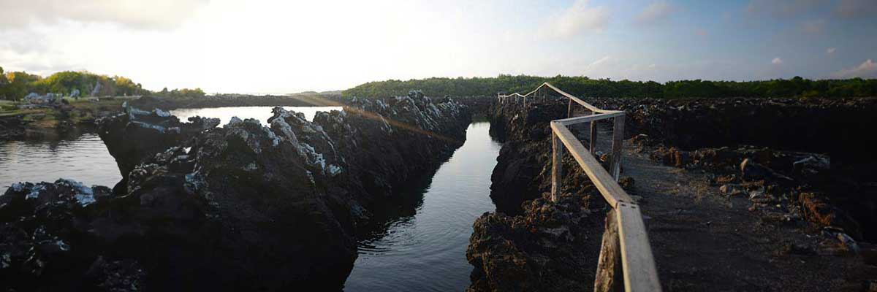

|  |  |
| --- | --- |
| **Trail:** | 1,1 km / 0,7 mi |
| **Level**: | 2 |
| **Activities:** | SNORKEL,PANGA RIDE |

PM: ISABELA'S WETLANDS AND INTERPRETATION CENTER

In the afternoon, immerse yourself in Isabela’s wetlands, a crucial ecosystem for Galapagos’ biodiversity. Walk along trails through mangroves and saline lagoons, where pink flamingos, blue-billed ducks, and other aquatic birds thrive. This natural sanctuary showcases the island’s remarkable wildlife. Conclude your day at the Interpretation Center, where you’ll gain insight into Galapagos’ natural and human history, its conservation challenges, and the ongoing efforts to protect this UNESCO World Heritage Site.

**Highlights:**  Mangroves, Flamingoes, Ducks

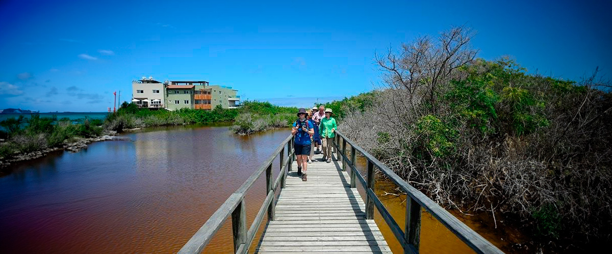

|  |  |
| --- | --- |
| **Food**: | B/L/D |
| **Trail:** | 3 km / 1.86 mi |
| **Lodging**: | M/Y Galaxy |
| **Level**: | 1 |
| **Activities:** | HIKING |

DAY 3 - FRIDAY

AM: MORENO POINT

Start your day exploring Moreno Point, a stunning volcanic landscape that appears barren but is brimming with life. Venture inland to discover brackish lagoons, home to flamingos, gallinules, ducks, and herons. Along the rugged coast, spot Galapagos penguins, flightless cormorants, marine iguanas, and blue-footed boobies. Sea lions and oystercatchers are also frequent visitors, making this site a remarkable showcase of how life thrives even in Galapagos’ harshest environments.

Snorkel Experience: Snorkel into the clear waters of Moreno Point and swim alongside sea turtles, cormorants, and tropical fish. If you look closely among the seaweed, you might even spot the elusive seahorse.

**Highlights:**  Stunning Views, Galapagos mockingbirds, Darwin finches, American flamingoes, Flightless cormorants, Marine iguanas, Ducks, Gallinules

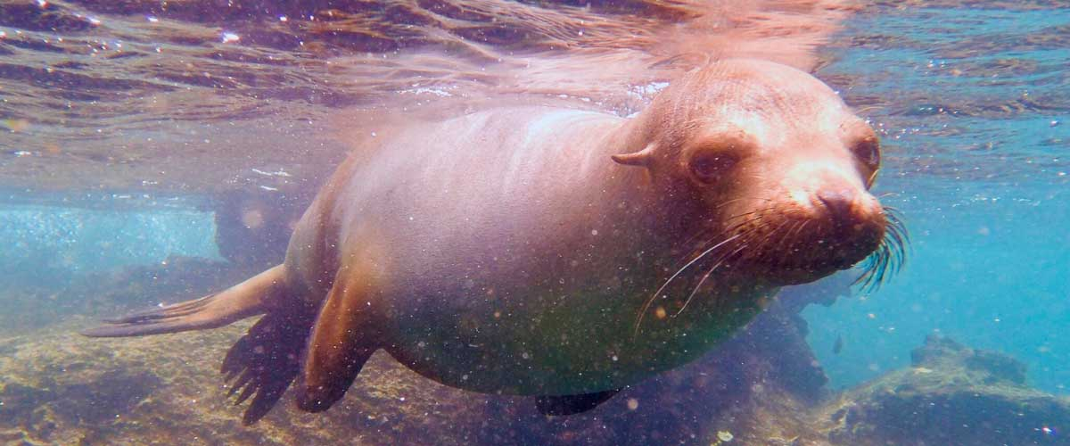

|  |  |
| --- | --- |
| **Trail:** | 1,6 km / 1 mi |
| **Level**: | 3 |
| **Activities:** | HIKING,SNORKEL,PANGA RIDE |

PM: MANGLE POINT

Start your day at Mangle Point, an ecological paradise on the untouched Fernandina Island. This site is a biodiversity haven where mangrove forests provide a crucial habitat for many marine species. As your boat glides through crystal-clear waters, observe sea turtles weaving through the mangrove roots and rays resting on the sandy bottom. This location offers a rare opportunity to connect with nature, experiencing firsthand the intricate symbiosis between the mangrove ecosystem and marine life.

Snorkel Experience: Immerse yourself in the calm waters of Mangle Point and swim among sea turtles, rays, and tropical fish. This underwater sanctuary offers a unique experience, exploring the biodiversity thriving between the mangroves and coral reefs.

**Highlights:**  Mangroves, Rays, Sea turtles

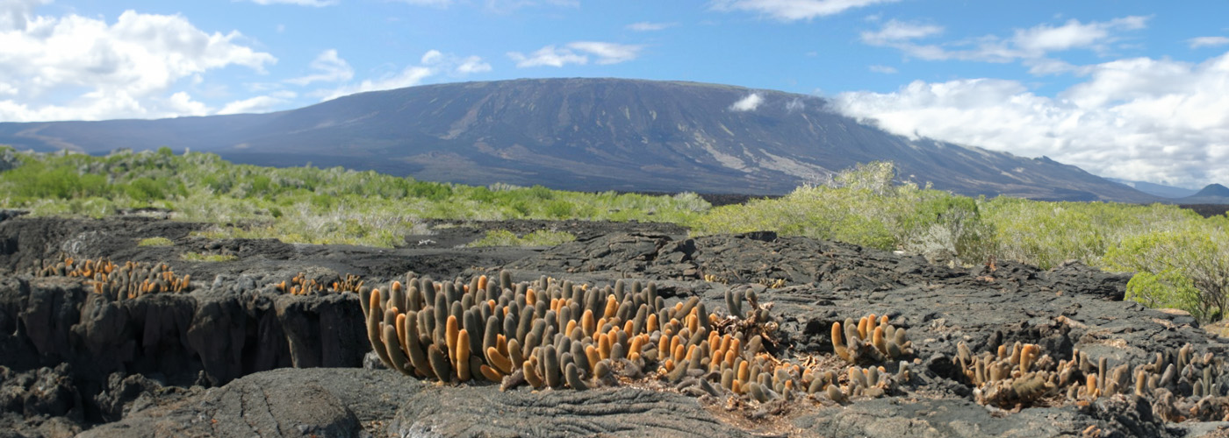

|  |  |
| --- | --- |
| **Food**: | B/L/D |
| **Trail:** | N/A (mainly a water-based activity) |
| **Lodging**: | M/Y Galaxy |
| **Level**: | 1 |
| **Activities:** | SNORKEL,PANGA RIDE,PADDLE BOARD,KAYAK |

DAY 4 - SATURDAY

AM: ESPINOZA POINT

Espinoza Point is a true natural wonder, set at the base of the most active volcano in Galapagos. As you step ashore, you’ll be greeted by the largest colony of marine iguanas basking on black volcanic rocks. Sea lions lounge on the beach while their pups explore tide pools. Flightless cormorants patrol the shoreline, and in the mangroves, Galapagos hawks scan for prey. Blessed with cold, plankton-rich waters, this area teems with life—herons, oystercatchers, pelicans, and sea turtles all thrive in this untouched habitat.

Snorkel Experience: The nutrient-rich waters of Espinoza Point attract fish, sea turtles, and foraging cormorants. Watch marine iguanas feeding on algae and follow a cormorant as it chases fish through the reef—an unforgettable snorkeling experience in Galapagos.

**Highlights:**  Stunning Views, Herons, Galapagos penguins, Oystercatchers, Galapagos hawks, Marine iguanas, Sea turtles, Shorebirds

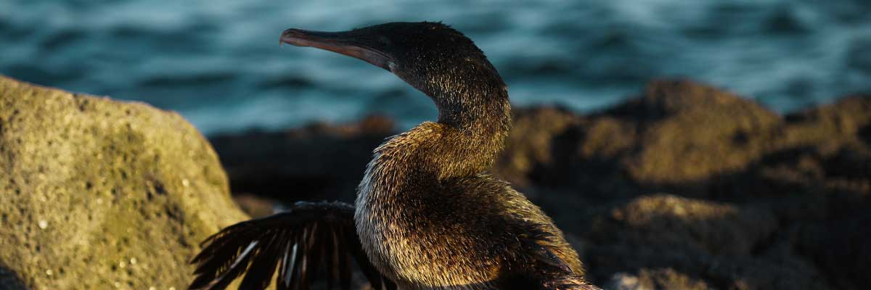

|  |  |
| --- | --- |
| **Trail:** | 1,6 km / 1 mi |
| **Level**: | 2 |
| **Activities:** | HIKING,SNORKEL,PANGA RIDE |

PM: TAGUS COVE

In the afternoon, we visit the historical Tagus Cove, a site Charles Darwin once explored during his travels around the Galapagos islands. Traverse the arid Palo Santo forests, where Darwin finches and mockingbirds make their home, and take in the panoramic views of Darwin’s Lake and the towering volcanoes of northern Isabela. A boat tour along the shore offers chances to observe penguins, cormorants, marine iguanas, and the rare Galapagos martin - an endemic, petite bird considered one of the most endangered species on the island.

Snorkel Experience: The nutrient-rich waters around Tagus Cove draw in sea turtles, a rich diversity of fish species, and penguins feasting on large schools of anchovies. Watching cormorants dart underwater as they chase fish through the reef is a common sight.

**Highlights:**  Stunning Views, Herons, Galapagos penguins, Galapagos hawks, Flightless cormorants, Marine iguanas, Sea turtles, Sea stars

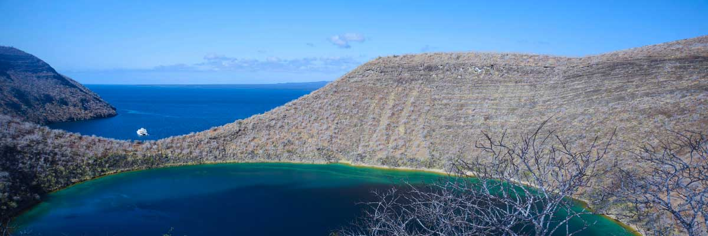

|  |  |
| --- | --- |
| **Food**: | B/L/D |
| **Trail:** | 2,6 km / 1,6 mi |
| **Lodging**: | M/Y Galaxy |
| **Level**: | 3 |
| **Activities:** | HIKING,SNORKEL,PANGA RIDE,PADDLE BOARD,KAYAK |

DAY 5 - SUNDAY

AM: BUCCANEER COVE

Known as a hideout for pirates and buccaneers in the 17th and 18th centuries, Buccaneer Cove is a site steeped in history and natural beauty. Here, sailors hid their treasures and gathered fresh water and tortoises for long voyages. Today, this stunning landscape of cliffs and rock formations is home to diverse wildlife. While there is no trail, a dinghy ride allows you to explore the cove, admire its dramatic scenery, and observe seabirds and other species that inhabit this legendary Galapagos site.

Snorkel Experience: Snorkel in the sheltered waters of Buccaneer Cove, surrounded by vibrant marine life. Swim among schools of angelfish, parrotfish, and snappers, as well as reef sharks, sea turtles, and playful sea lions.

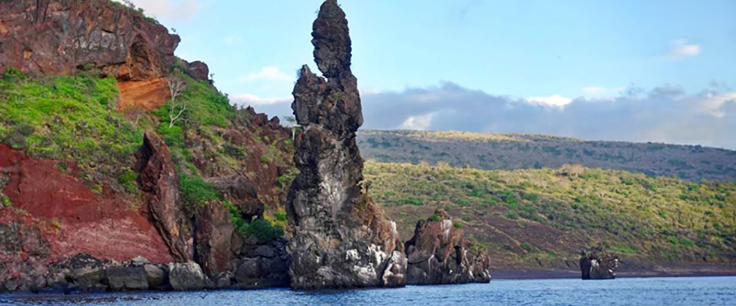

|  |  |
| --- | --- |
| **Trail:** | 2,3 km / 1,4 mi (plus an extra loop 1 km - 0,6 mi) |
| **Level**: | 1 |
| **Activities:** | HIKING,SNORKEL |

PM: EGAS PORT

Puerto Egas is a fascinating destination where history and wildlife intertwine. While there is no actual port, remnants of 1960s colonization attempts still stand. The coastal trail is teeming with marine iguanas basking in the sun and sea lions resting on the rocks. Herons, oystercatchers, and shorebirds complete this thriving ecosystem. Towards the end of the trail, the grottos are home to a small colony of the elusive Galapagos fur seal. Additionally, land iguanas were reintroduced to the island in 2019 after over a century of absence.

Snorkel Experience: A snorkeling session from the beach will lead you to an area of rocky bottoms, excellent for observing fish, turtles, and reef sharks. Sea lions often frequent this area and are typically open to interacting with divers.

Stunning Views, Herons, Galapagos sea lions, Galapagos fur seals, Oystercatchers, Galapagos hawks, Darwin finches, Marine and land iguanas, Galapagos doves, Shorebirds

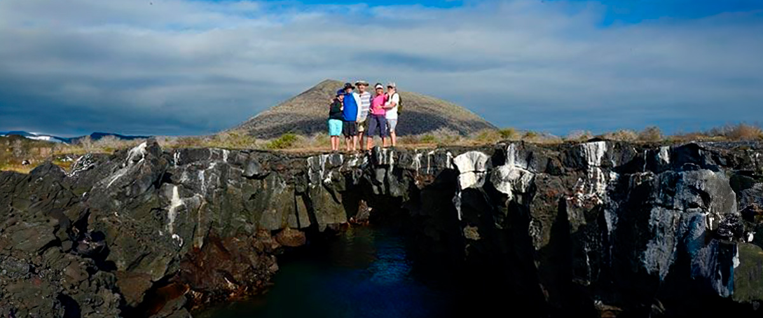

|  |  |
| --- | --- |
| **Food**: | B/L/D |
| **Trail:** | 2,3 km / 1,4 mi |
| **Lodging**: | M/Y Galaxy |
| **Level**: | 3 |
| **Activities:** | HIKING,SNORKEL,PANGA RIDE,PADDLE BOARD,KAYAK |

DAY 6 - MONDAY

AM: BARTOLOME

Bartolome is one of the most iconic islands in Galapagos, renowned for its dramatic volcanic landscape and the famous Pinnacle Rock. Nestled beside a peach-colored sand beach, this island is one of the few places where you can spot penguins without traveling to remote Isabela and Fernandina. The hike to the summit offers breathtaking views of a lunar-like terrain dotted with volcanic cones, with stunning panoramas of Sullivan Bay and Pinnacle Rock. From the top, the vast beauty of the archipelago unfolds before you, creating a truly unforgettable experience.

Snorkel Experience: Enjoy an unforgettable snorkeling experience in Bartolome, one of Galapagos’ top spots. Swim in calm, clear waters alongside penguins, colorful fish, sea turtles, sea lions, rays, and reef sharks in a thriving marine ecosystem.

**Highlights:**  Volcanic landscapes, Pinnacle rock, Herons, Bluefooted boobies, Galapagos penguins

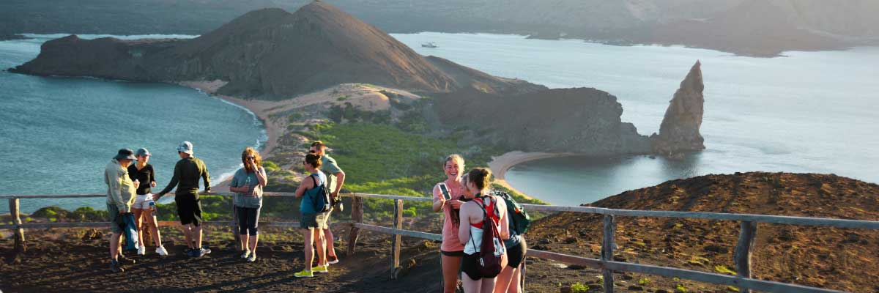

|  |  |
| --- | --- |
| **Trail:** | 1,5 km / 0,9 mi |
| **Level**: | 1 |
| **Activities:** | PANGA RIDE |

PM: SULLIVAN BAY

Walking through Sullivan Bay is a fascinating journey into the volcanic origins of the Galapagos Islands. The trail crosses a vast Pahoehoe lava flow, showcasing unique textures that reveal the story of past eruptions. While the terrain may seem desolate at first, a closer look unveils pioneer plants, scurrying lava lizards, and small birds adapted to this extreme environment. Along the shore, the stark landscape is brightened by the presence of penguins, pelicans, and oystercatchers, adding a vibrant contrast to the stunning volcanic scenery.

Snorkel Experience: After the hike, unwind with a swim or snorkeling session from a coral-sand beach or a dinghy. The contrast with the barren land is striking—schools of fish, Galapagos penguins, reef sharks, sea turtles, and rays thrive in this vibrant marine ecosystem.

**Highlights:**  Lava tubes, Galapagos penguins, Oystercatchers, Galapagos hawks

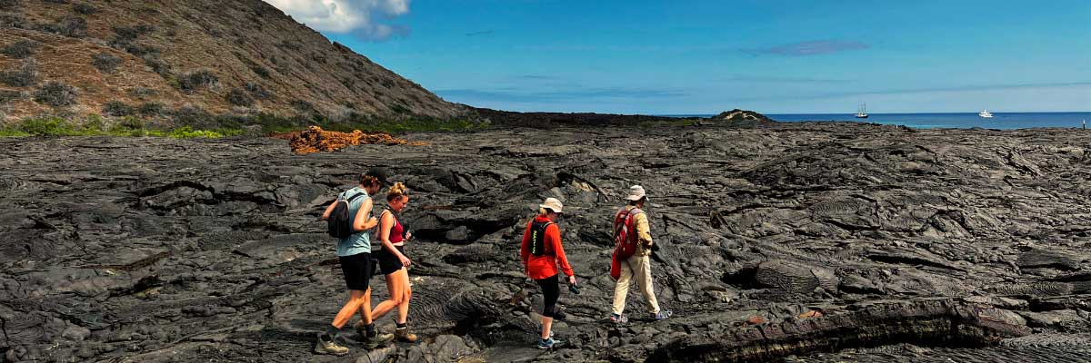

|  |  |
| --- | --- |
| **Food**: | B/L/D |
| **Trail:** | 2,2 km / 1,4 mi |
| **Lodging**: | M/Y Galaxy |
| **Level**: | 1 |
| **Activities:** | HIKING,SNORKEL |

DAY 7 - TUESDAY

AM: CHINESE HAT

Named for its distinctive cone shape, Chinese Hat is a small islet separated from Santiago by a narrow channel, forming one of Galapagos’ most picturesque bays. Its turquoise waters, coral-sand beaches, and volcanic rocks create a stunning landscape. A coastal trail leads you through a sea lion colony, while on the lava rocks, you may spot penguins resting. This site perfectly blends breathtaking scenery with Galapagos’ remarkable wildlife, making for an unforgettable experience.

Snorkel Experience: Snorkel into the crystal-clear waters of Chinese Hat and marvel at the vibrant colors of the fish. Spot sleek reef sharks and, if lucky, a penguin darting through the water like a swift underwater torpedo chasing anchovies.

**Highlights:**  Lava tubes, Galapagos sea lions, Galapagos penguins, Oystercatchers, Galapagos hawks

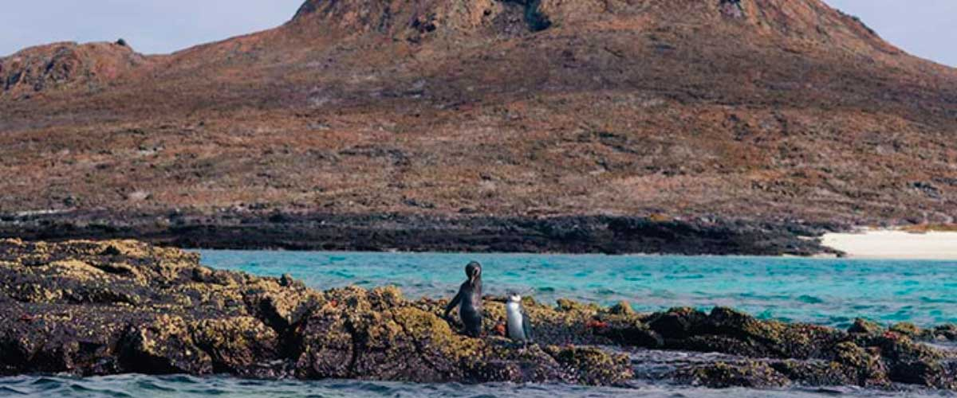

|  |  |
| --- | --- |
| **Trail:** | 1,3 km / 0,8 mi |
| **Level**: | 2 |
| **Activities:** | HIKING,SNORKEL,PANGA RIDE,PADDLE BOARD,KAYAK |

PM: DRAGON HILL

Located on Santa Cruz’s northern coast, Dragon Hill is the only place on the island where land iguanas roam freely. Once near extinction in the 70s and 80s, their population has successfully rebounded. As you explore this unique ecosystem, you’ll also spot a saltwater lagoon where flamingos, ducks, and shorebirds often gather.

Snorkel Experience: After the hike, dive into calm, shallow waters for an unforgettable snorkeling experience. Swim among schools of surgeonfish and parrotfish, and spot reef sharks, rays, and vibrant tropical fish.

**Highlights:**  Herons, Darwin finches, Galapagos flycatchers, White-cheeked pintails, American flamingoes, Galapagos land iguanas

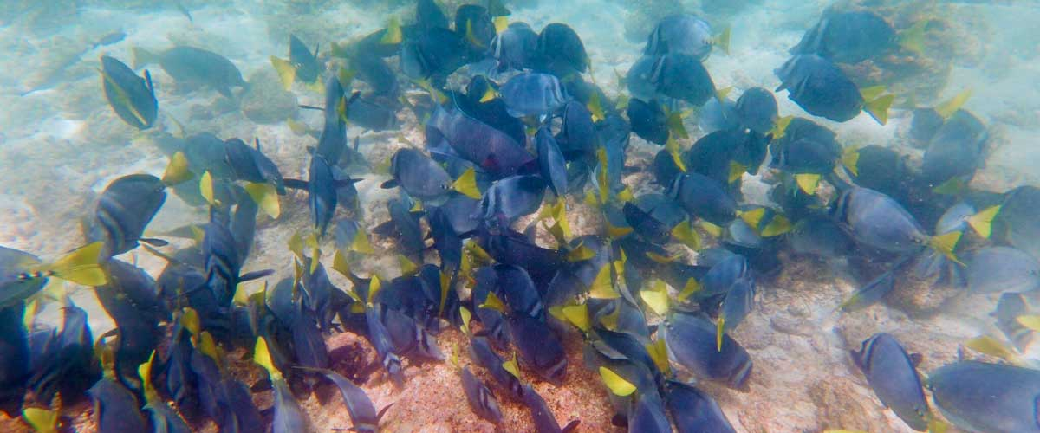

|  |  |
| --- | --- |
| **Food**: | B/L/D |
| **Trail:** | 2,2 km / 1,4 mi |
| **Lodging**: | M/Y Galaxy |
| **Level**: | 2 |
| **Activities:** | HIKING,PANGA RIDE,PADDLE BOARD |

DAY 8 - WEDNESDAY

AM: BLACK TURTLE COVE

Set off on a dinghy tour through Black Turtle Cove, a shallow-water haven surrounded by lush mangroves. This sanctuary is home to sea turtles, reef sharks, and various species of rays. It also serves as a crucial breeding ground for turtles and sharks. Watch herons, boobies, and pelicans hunt among schools of anchovies. Though there’s no landing, the incredible wildlife seen from the boat offers an up-close and unforgettable experience.

Mangroves, White-tipped and black-tipped reef sharks, Green sea turtles, Rays, Herons, Blue footed boobies, Reef sharks

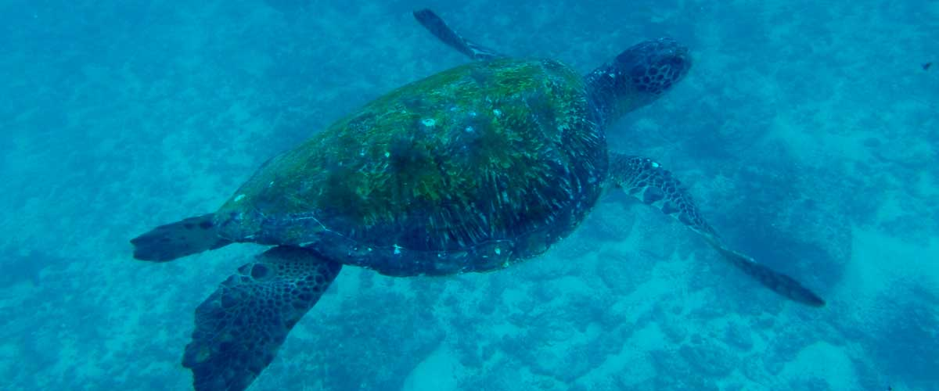

|  |  |
| --- | --- |
| **Trail:** |  |
| **Level**: | 1 |
| **Activities:** | HIKING,SNORKEL |

PM: BALTRA AIRPORT (RETURN)

Your Galapagos adventure comes to an end. Today, you will be transferred to Baltra Airport, where your National Park naturalist guide will assist you with final details before your flight back to mainland Ecuador. As you bid farewell to this paradise, take with you the unforgettable memories of one of the world’s most extraordinary destinations.



|  |  |
| --- | --- |
| **Food**: | B/-/- |
| **Trail:** |  |
| **Lodging**: | M/Y Galaxy |
| **Level**: | 1 |
| **Activities:** | - |

GLOSSARY

|  |  |  |
| --- | --- | --- |
| **Feeding** | **Breakfast** | B |
| **Lunch** | L |
| **Dinner** | D |
| **Difficulty of the hike** | **Level 1** | Easy |
| **Level 2** | Moderate |
| **Level 3** | Difficult |