**Galapagos Northeast Discovery andDiversity**

5 Days – 4 nights

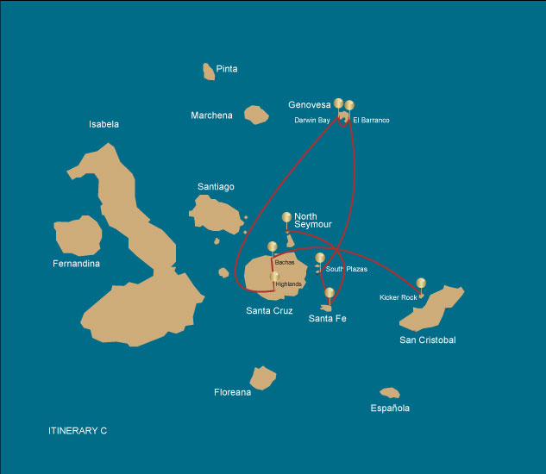

|  |  |  |  |  |  |  |  |
| --- | --- | --- | --- | --- | --- | --- | --- |
|  | | | **Hiking** | **Snorkel** | **Panga Ride** | **Paddle Board** | **Kayak** |
| WEDNESDAY | AM | **Santa Cruz Island** : Baltra - airport (arrival) |  |  |  |  |  |
|  | PM | **Seymour Island** : North Seymour | * | * | * |  |  |
| THURSDAY | AM | **Santa Fe Island** : Santa Fe | * | * | * |  |  |
|  | PM | **South Plazas Island** : South Plaza | * | * |  |  |  |
| FRIDAY | AM | **Genovesa Island** : Barranco | * | * | * | * | * |
|  | PM | **Genovesa Island** : Darwin Bay | * | * | * | * | * |
| SATURDAY | AM | **Santa Cruz Island** : Highlands | * |  |  |  |  |
|  | PM | **Santa Cruz Island** : Bachas Beach | * | * | * | * | * |
| SUNDAY | AM | **San Cristobal Island** : Kicker Rock |  |  |  |  |  |
|  | PM | **San Cristobal Island** : San Cristobal - airport (return) |  |  |  |  |  |

DAY 1 - WEDNESDAY

AM: BALTRA AIRPORT (ARRIVAL)

Embark on an unforgettable adventure to the Galapagos Islands, starting with your arrival at Baltra airport. Our expert naturalist guide from the National Park will eagerly await your arrival to introduce you to the wonders ahead.

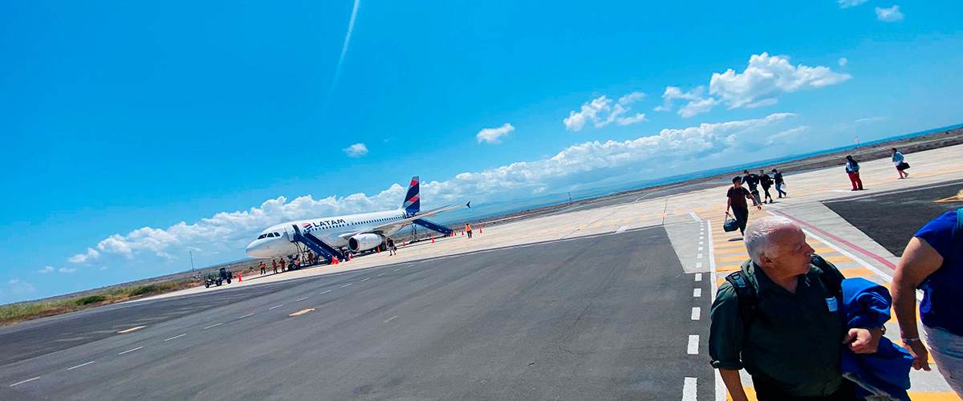

|  |  |
| --- | --- |
| **Trail:** |  |
| **Level**: | 1 |
| **Activities:** | - |

PM: NORTH SEYMOUR

Your journey continues with a morning visit to North Seymour Island, a spectacular showcase of the Galapagos Islands' diverse wildlife. This relatively flat island is home to a thriving population of blue-footed boobies and frigate birds. The trail winds its way through a forest of low, bushy vegetation, where you'll have the opportunity to witness the fascinating courtship dance of the blue-footed boobies. The island's coastline also allows one to observe sea lions and marine iguanas basking in the sun. The large frigate bird colonies are a sight, especially when the males inflate their bright red throat pouches to attract mates.

Birdwatching Experience: Encounter the majestic frigate birds and charming blue-footed boobies in their natural habitat. This is an ideal spot for birdwatching and photography

Galapagos sea lions, Magnificent and great frigatebirds, Land and marine iguanas, Darwin finches

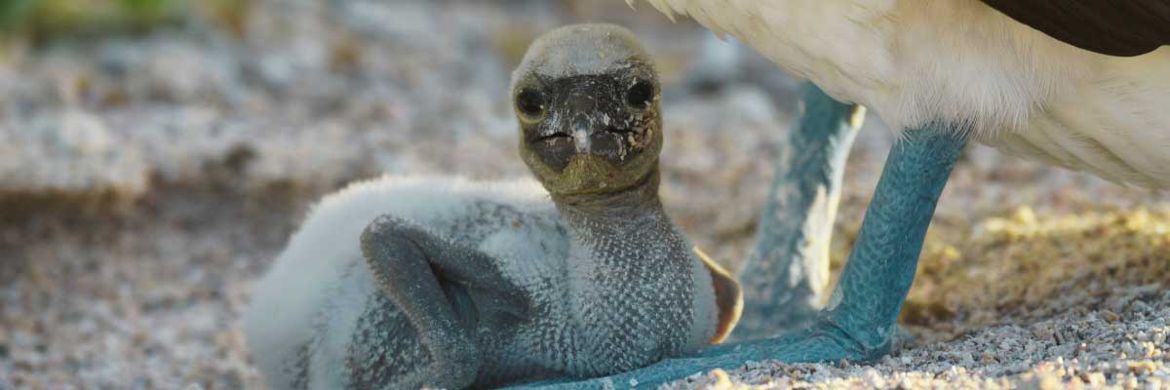

|  |  |
| --- | --- |
| **Food**: | -/L/D |
| **Trail:** | 1,4 km / 0,8 mi |
| **Lodging**: | M/Y Galaxy |
| **Level**: | 2 |
| **Activities:** | HIKING,SNORKEL,PANGA RIDE |

DAY 2 - THURSDAY

AM: SANTA FE

Lead in the day with the stark beauty of Santa Fe, where the towering figures of giant Prickly-pear cacti strikingly contrast the rugged landscape of lava rocks. Tucked within one of the Galapagos most breathtaking bays, Santa Fe's turquoise waters, and white-sand beaches form an inviting residence for a sizable colony of sea lions you'll find lounging about. As you venture inland, remember to look down to spot the endemic Santa Fe land iguanas, but also glance upward to catch sight of the Galapagos hawks perched atop cacti, keeping a keen eye out for prey. You'll likely encounter Darwin finches, Galapagos doves, mockingbirds, and lively lava lizards along the trail.

Snorkel Experience: After your exploratory hike, the sheltered bay offers you a choice paddle through serene waters on a kayak or plunge beneath the surface to snorkel with playful sea lion pups and reef sharks. Also, keep an eye out for graceful sea turtles, gliding rays, and the swirling colors of tropical fish, including large schools of Surgeonfish and Parrotfish.

**Highlights:**  Stunning Views, Galapagos sea lions, Galapagos hawks, Galapagos doves, Santa Fe land iguanas, Reef sharks

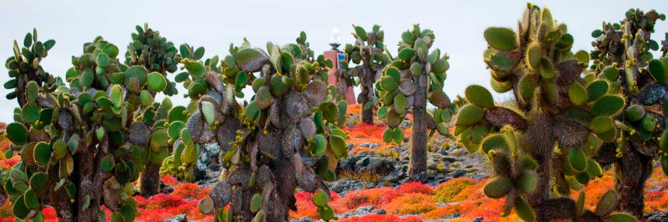

|  |  |
| --- | --- |
| **Trail:** | 0,8 km / 0,5 mi |
| **Level**: | 2 |
| **Activities:** | HIKING,SNORKEL,PANGA RIDE |

PM: PLAZAS

Your afternoon destination is South Plazas, one of a twin pair of islands where the northern sibling is reserved exclusively for scientific research. Though petite in size, this islet brims with a fantastic array of wildlife. Upon landing, Galapagos land iguanas will welcome you from beneath prickly-pear cacti, eagerly awaiting their fruit. Sea lions populate the island in large numbers, allowing you to observe their fascinating social dynamics, from playful pups splashing in tide pools to formidable males protecting their territories. Your trail eventually leads you to a cliff, a vantage point to observe a myriad of seabirds, including frigatebirds, red-billed tropicbirds, boobies, swallow-tailed gulls, and pelicans. A verdant carpet of reddish succulent vegetation dotted with scattered cacti blankets the island, giving South Plazas a genuinely unique personality.

**Highlights:**  Stunning Views, Boobies, Galapagos sea lions, Galapagos shearwaters, Galapagos land iguanas, Tropicbirds, Pelicans

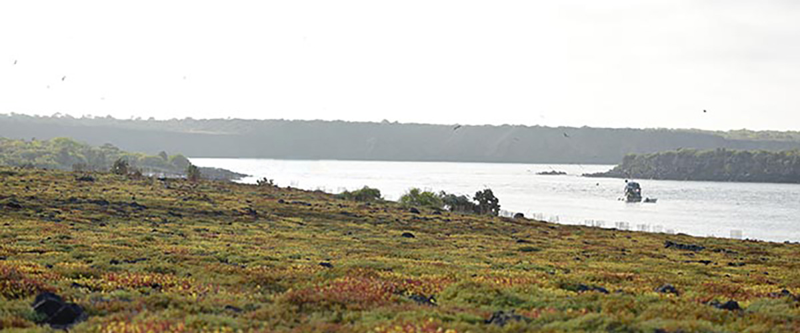

|  |  |
| --- | --- |
| **Food**: | B/L/D |
| **Trail:** | 1,4 km / 0,8 mi |
| **Lodging**: | M/Y Galaxy |
| **Level**: | 3 |
| **Activities:** | HIKING,SNORKEL |

DAY 3 - FRIDAY

AM: BARRANCO

Located in the southern part of Darwin Bay on Genovesa Island, El Barranco is a wildlife sanctuary. Its fragile lava cliffs provide shelter for storm petrels and a remarkable population of short-eared owls. Along the trail, red-footed and Nazca boobies nest on the volcanic rock. At the base of the cliffs, Galapagos fur seals rest in shaded areas, while seabirds soar above this breathtaking landscape, making El Barranco an unforgettable destination for nature lovers.

Snorkel Experience: Snorkel into the waters of El Barranco and explore a vibrant underwater world. Swim among colorful fish and spot sharks, rays, and playful sea lions in their natural habitat.

**Highlights:**  Nesting great frigatebirds, Galapagos sea lions, Genovesa ground finch, Genovesa cactus finch, Galapagos mockingbirds, Galapagos fur seals

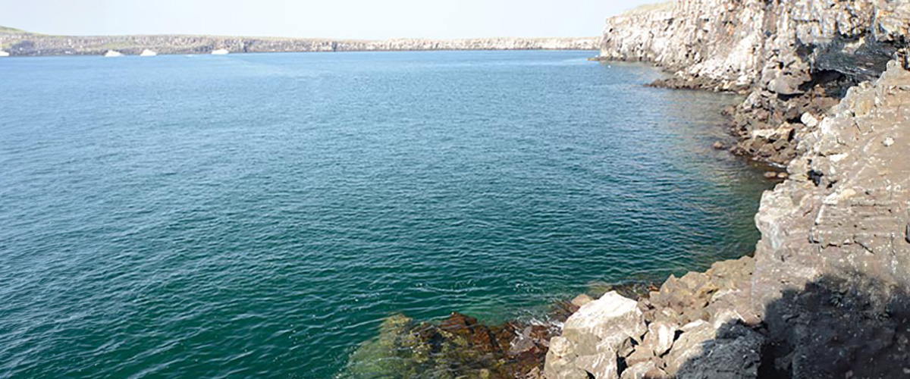

|  |  |
| --- | --- |
| **Trail:** | 1,2 km / 0,7 mi |
| **Level**: | 3 |
| **Activities:** | HIKING,SNORKEL,PANGA RIDE,PADDLE BOARD,KAYAK |

PM: DARWIN BAY

Darwin Bay on Genovesa Island is a breathtaking sight for birdwatchers. As you step onto the beach, you’ll be amazed by the presence of hundreds of boobies, gulls, and frigatebirds soaring, nesting in bushes, or resting on the sand. Along the shore, sea lions and marine iguanas blend into the scenery, while inland you may spot night herons, swallow-tailed gulls, Darwin finches, Galapagos doves, and mockingbirds. This immersive experience brings you face-to-face with a thriving ecosystem.

Snorkel Experience: Darwin Bay offers incredible snorkeling spots, from deep waters along the cliffs to shallow areas near the beach. No matter where you dive, a vibrant underwater world awaits, filled with colorful fish and high chances of spotting sharks, rays, and playful sea lions

**Highlights:**  Nesting great frigatebirds, Red-footed and Nazca boobies, Galapagos sea lions, Yellow-crowned night herons, Genovesa ground finch, Genovesa cactus finch, Galapagos mockingbirds

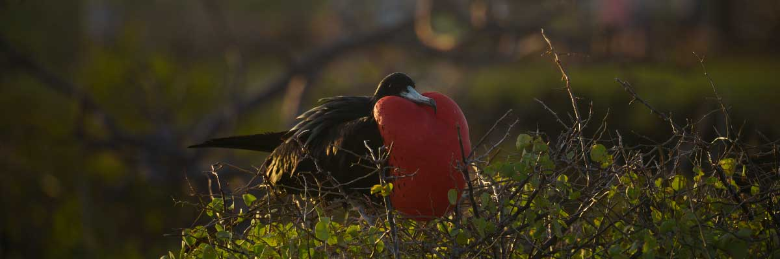

|  |  |
| --- | --- |
| **Food**: | B/L/D |
| **Trail:** | 1,2 km / 0,7 mi |
| **Lodging**: | M/Y Galaxy |
| **Level**: | 3 |
| **Activities:** | HIKING,SNORKEL,PANGA RIDE,PADDLE BOARD,KAYAK |

DAY 4 - SATURDAY

AM: HIGHLANDS

Your day begins with a journey to the highlands of San Cristobal Island, offering a different perspective of the Galapagos' unique ecosystem. This lush and verdant area contrasts sharply with the coastal zones. The highlands are home to a variety of bird species, giant tortoises in their natural habitat, and a rich array of plant life, including endemic trees and ferns. You'll have the opportunity to walk along paths that meander through this lush landscape, offering a chance to observe the giant tortoises up close and personal. The highlands also provide panoramic views of the island, showcasing its diverse topography.

**Highlights:**  Lava tunnels, Darwin finches, Galapagos flycatchers, Giant tortoises, Barn owls, White-cheeked pintails

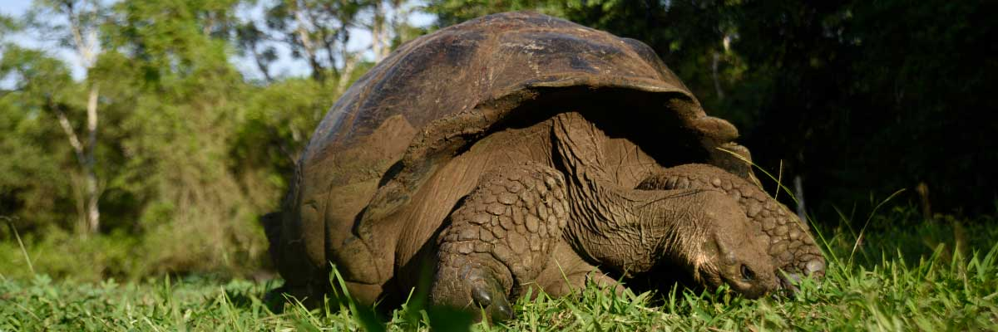

|  |  |
| --- | --- |
| **Trail:** | 1-1,5 km / 0,6-0,9 mi |
| **Level**: | 1 |
| **Activities:** | HIKING |

PM: BACHAS BEACH

End your Galapagos adventure at Bachas Beach, a key sea turtle nesting site from November to May. At low tide, remnants of WWII barges emerge from the white sand. Explore its saltwater lagoons, home to flamingos, herons, and aquatic birds. After this final stop, transfer to the airport for your flight back to the mainland, concluding an unforgettable journey.

**Highlights:**  Stunning Views, Blue footed boobies, White-cheeked pintails, American flamingoes, Sandpipers, Lava gulls

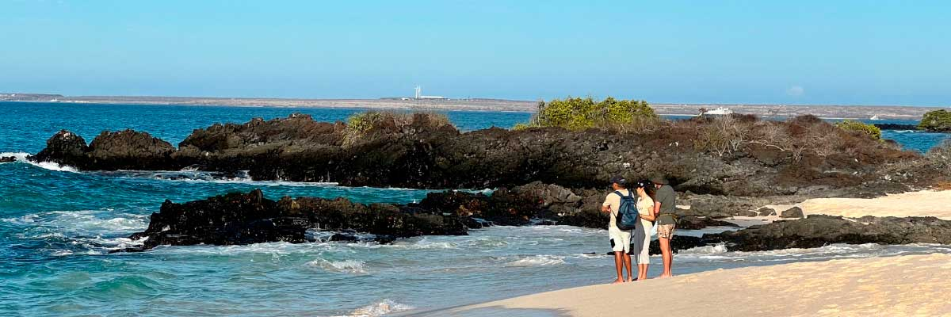

|  |  |
| --- | --- |
| **Food**: | B/L/D |
| **Trail:** | 1,6 km / 1 mi |
| **Lodging**: | M/Y Galaxy |
| **Level**: | 3 |
| **Activities:** | HIKING,SNORKEL,PANGA RIDE,PADDLE BOARD,KAYAK |

DAY 5 - SUNDAY

AM: KICKER ROCK

In the afternoon, embark on an unforgettable panga (dinghy) ride around Kicker Rock, also known as León Dormido, off the coast of San Cristobal Island. This impressive rock formation, rising dramatically 500 feet above the ocean, is one of the most iconic landmarks in the Galapagos. The natural erosion of this ancient volcanic tuff cone has created a channel between two towering rock walls, providing a haven for various marine life. This peaceful and scenic panga ride around Kicker Rock provides a relaxing yet awe-inspiring conclusion to your day, allowing you to appreciate the natural wonders and rich biodiversity of the Galapagos from the sea.

Panga Experience: Navigate the waters around Kicker Rock, marveling at the sheer size and beauty of the formation. The ride offers a unique perspective of the rock, with opportunities to observe seabirds such as frigate birds, boobies, and occasionally, pelicans nesting or resting on its cliffs. Keep an eye out for marine life in the surrounding waters, including sea turtles, rays, and even sharks that frequent the area.

Boobies, Pelicans, Frigatebirds

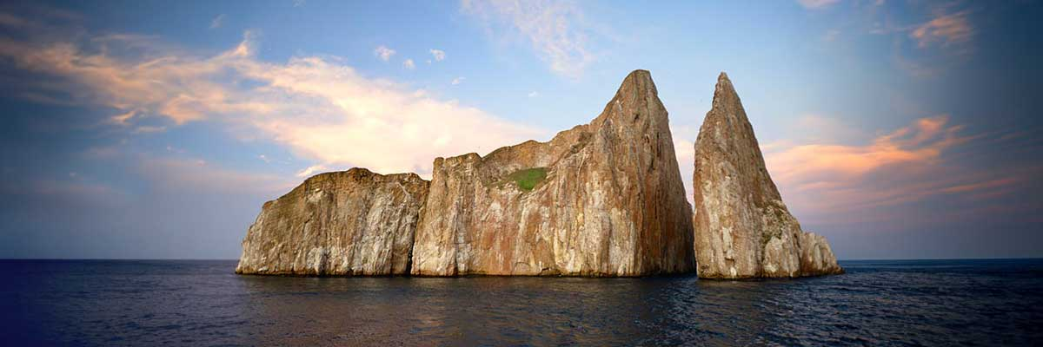

|  |  |
| --- | --- |
| **Trail:** |  |
| **Level**: | 1 |
| **Activities:** | - |

PM: SAN CRISTOBAL AIRPORT (RETURN)

After exploring the breathtaking biodiversity and unique landscapes of the Galapagos, it’s time to return to mainland Ecuador. You’ll be transferred to the airport, bringing this unforgettable journey to a close. Every encounter with giant tortoises, blue-footed boobies, and volcanic landscapes will remain etched in your memory. Galapagos is not just a destination—it’s a transformative experience that will stay with you forever. Wishing you a wonderful journey back!



|  |  |
| --- | --- |
| **Food**: | B/-/- |
| **Trail:** |  |
| **Lodging**: | M/Y Galaxy |
| **Level**: | 1 |
| **Activities:** | - |

GLOSSARY

|  |  |  |
| --- | --- | --- |
| **Feeding** | **Breakfast** | B |
| **Lunch** | L |
| **Dinner** | D |
| **Difficulty of the hike** | **Level 1** | Easy |
| **Level 2** | Moderate |
| **Level 3** | Difficult |