**Galapagos Northeast Discovery and Diversity**

8 Days – 7 nights

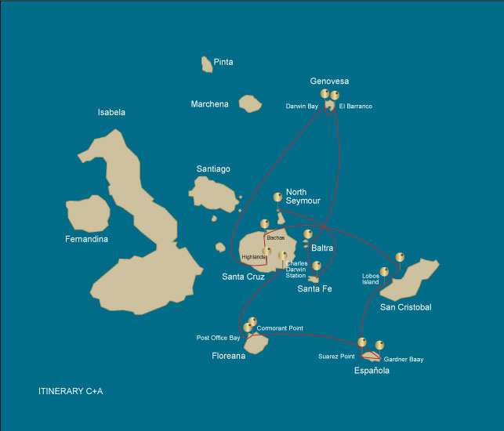

|  |  |  |  |  |  |  |  |
| --- | --- | --- | --- | --- | --- | --- | --- |
|  | | | **Hiking** | **Snorkel** | **Panga Ride** | **Paddle Board** | **Kayak** |
| WEDNESDAY | AM | **Santa Cruz Island** : Baltra - airport (arrival) |  |  |  |  |  |
|  | PM | **Seymour Island** : North Seymour | * | * | * |  |  |
| THURSDAY | AM | **Santa Fe Island** : Santa Fe | * | * | * |  |  |
|  | PM | **South Plazas Island** : South Plaza | * | * |  |  |  |
| FRIDAY | AM | **Genovesa Island** : Barranco | * | * | * | * | * |
|  | PM | **Genovesa Island** : Darwin Bay | * | * | * | * | * |
| SATURDAY | AM | **Santa Cruz Island** : Highlands | * |  |  |  |  |
|  | PM | **Santa Cruz Island** : Bachas Beach | * | * | * | * | * |
| SUNDAY | AM | **San Cristobal Island** : Kicker Rock |  |  |  |  |  |
|  | PM | **San Cristobal Island** : Lobos Island | * | * | * |  |  |
| MONDAY | AM | **Española Island** : Suarez Point | * |  |  |  |  |
|  | PM | **Española Island** : Gardner Bay | * | * |  | * | * |
| TUESDAY | AM | **Floreana Island** : Cormorant Point | * | * | * | * | * |
|  | PM | **Floreana Island** : Post Office Bay | * | * |  |  |  |
| WEDNESDAY | AM | **Santa Cruz Island** : Charles Darwin Station |  |  |  |  |  |
|  | PM | **Santa Cruz Island** : Baltra - airport (return) |  |  |  |  |  |

DAY 1 - WEDNESDAY

AM: AIRPORT (ARRIVAL)

Embark on an unforgettable adventure to the Galapagos Islands, starting with your arrival at Baltra airport. Our expert naturalist guide from the National Park will eagerly await your arrival to introduce you to the wonders ahead.

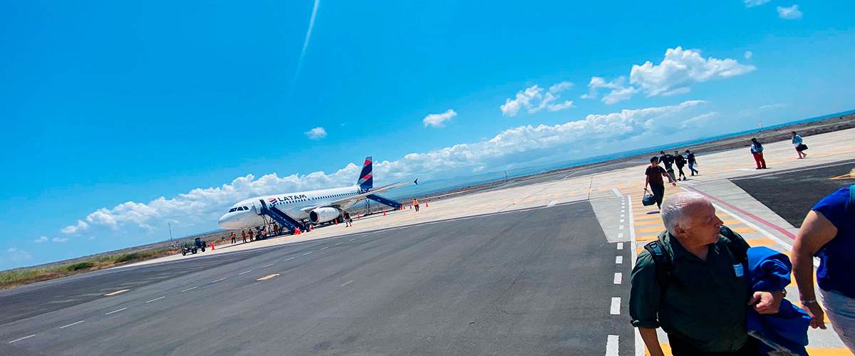

|  |  |
| --- | --- |
| **Trail:** |  |
| **Level**: | 1 |
| **Activities:** | - |

PM: NORTH SEYMOUR

Your journey continues with a morning visit to North Seymour Island, a spectacular showcase of the Galapagos Islands' diverse wildlife. This relatively flat island is home to a thriving population of blue-footed boobies and frigate birds. The trail winds its way through a forest of low, bushy vegetation, where you'll have the opportunity to witness the fascinating courtship dance of the blue-footed boobies. The island's coastline also allows one to observe sea lions and marine iguanas basking in the sun. The large frigate bird colonies are a sight, especially when the males inflate their bright red throat pouches to attract mates.

Birdwatching Experience: Encounter the majestic frigate birds and charming blue-footed boobies in their natural habitat. This is an ideal spot for birdwatching and photography

Galapagos sea lions, Magnificent and great frigatebirds, Land and marine iguanas, Darwin finches

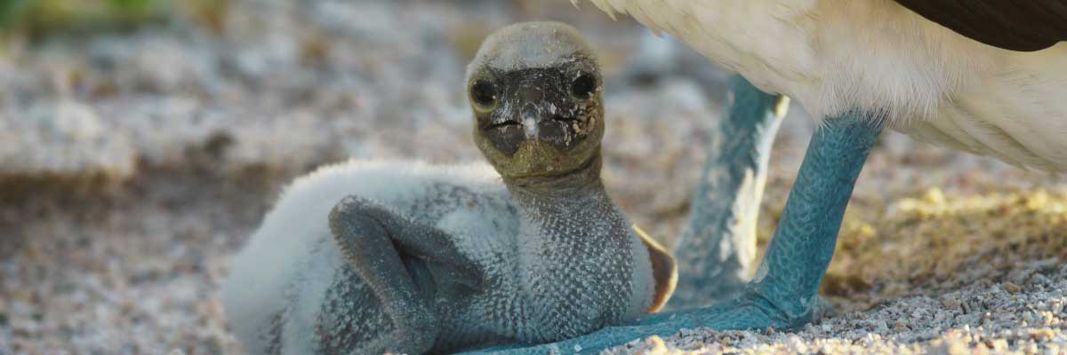

|  |  |
| --- | --- |
| **Food**: | -/L/D |
| **Trail:** | 1,4 km / 0,8 mi |
| **Lodging**: | M/Y Galaxy |
| **Level**: | 2 |
| **Activities:** | HIKING,SNORKEL,PANGA RIDE |

DAY 2 - THURSDAY

AM: SANTA FE

Lead in the day with the stark beauty of Santa Fe, where the towering figures of giant Prickly-pear cacti strikingly contrast the rugged landscape of lava rocks. Tucked within one of the Galapagos most breathtaking bays, Santa Fe's turquoise waters, and white-sand beaches form an inviting residence for a sizable colony of sea lions you'll find lounging about. As you venture inland, remember to look down to spot the endemic Santa Fe land iguanas, but also glance upward to catch sight of the Galapagos hawks perched atop cacti, keeping a keen eye out for prey. You'll likely encounter Darwin finches, Galapagos doves, mockingbirds, and lively lava lizards along the trail.

Snorkel Experience: After your exploratory hike, the sheltered bay offers you a choice paddle through serene waters on a kayak or plunge beneath the surface to snorkel with playful sea lion pups and reef sharks. Also, keep an eye out for graceful sea turtles, gliding rays, and the swirling colors of tropical fish, including large schools of Surgeonfish and Parrotfish.

**Highlights:**  Stunning Views, Galapagos sea lions, Galapagos hawks, Galapagos doves, Santa Fe land iguanas, Reef sharks

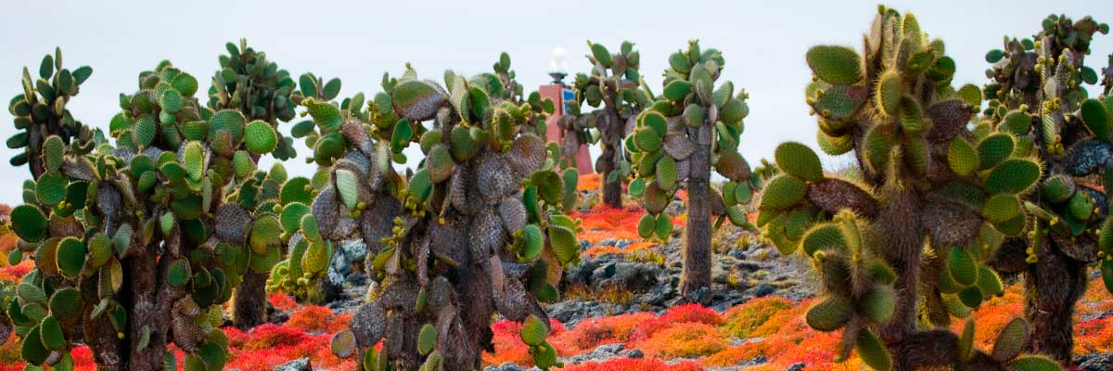

|  |  |
| --- | --- |
| **Trail:** | 0,8 km / 0,5 mi |
| **Level**: | 2 |
| **Activities:** | HIKING,SNORKEL,PANGA RIDE |

PM: SOUTH PLAZA

Your afternoon destination is South Plazas, one of a twin pair of islands where the northern sibling is reserved exclusively for scientific research. Though petite in size, this islet brims with a fantastic array of wildlife. Upon landing, Galapagos land iguanas will welcome you from beneath prickly-pear cacti, eagerly awaiting their fruit. Sea lions populate the island in large numbers, allowing you to observe their fascinating social dynamics, from playful pups splashing in tide pools to formidable males protecting their territories. Your trail eventually leads you to a cliff, a vantage point to observe a myriad of seabirds, including frigatebirds, red-billed tropicbirds, boobies, swallow-tailed gulls, and pelicans. A verdant carpet of reddish succulent vegetation dotted with scattered cacti blankets the island, giving South Plazas a genuinely unique personality.

**Highlights:**  Stunning Views, Boobies, Galapagos sea lions, Galapagos shearwaters, Galapagos land iguanas, Tropicbirds, Pelicans

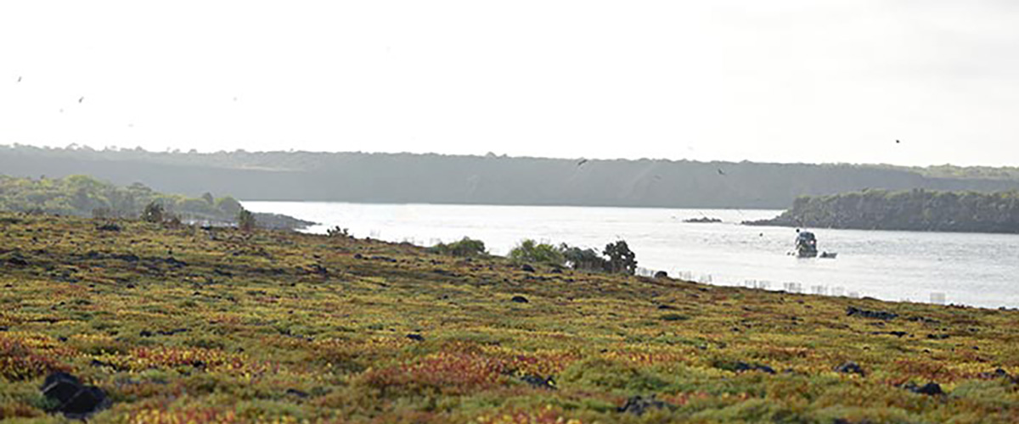

|  |  |
| --- | --- |
| **Food**: | B/L/D |
| **Trail:** | 1,4 km / 0,8 mi |
| **Lodging**: | M/Y Galaxy |
| **Level**: | 3 |
| **Activities:** | HIKING,SNORKEL |

DAY 3 - FRIDAY

AM: BARRANCO

Located in the southern part of Darwin Bay on Genovesa Island, El Barranco is a wildlife sanctuary. Its fragile lava cliffs provide shelter for storm petrels and a remarkable population of short-eared owls. Along the trail, red-footed and Nazca boobies nest on the volcanic rock. At the base of the cliffs, Galapagos fur seals rest in shaded areas, while seabirds soar above this breathtaking landscape, making El Barranco an unforgettable destination for nature lovers.

Snorkel Experience: Snorkel into the waters of El Barranco and explore a vibrant underwater world. Swim among colorful fish and spot sharks, rays, and playful sea lions in their natural habitat.

**Highlights:**  Nesting great frigatebirds, Galapagos sea lions, Genovesa ground finch, Genovesa cactus finch, Galapagos mockingbirds, Galapagos fur seals

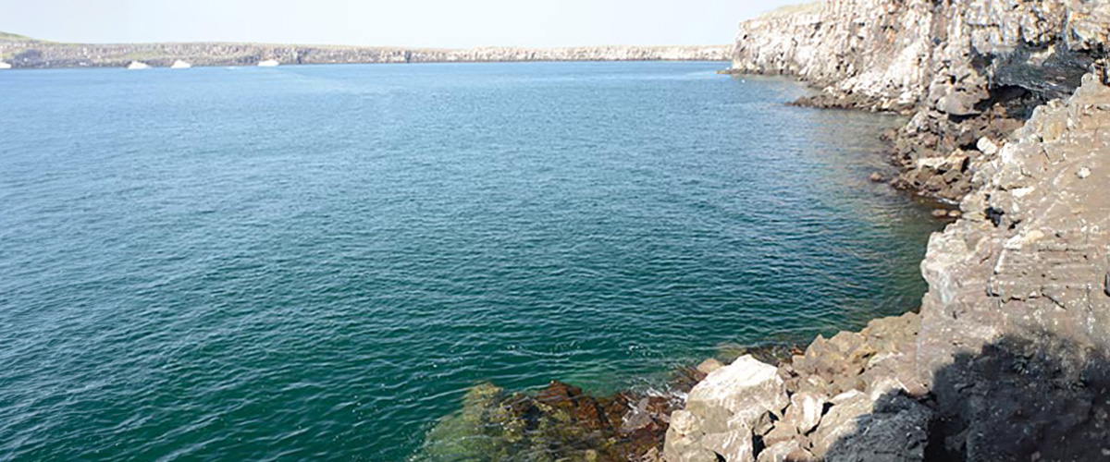

|  |  |
| --- | --- |
| **Trail:** | 1,2 km / 0,7 mi |
| **Level**: | 3 |
| **Activities:** | HIKING,SNORKEL,PANGA RIDE,PADDLE BOARD,KAYAK |

PM: DARWIN BAY

Darwin Bay on Genovesa Island is a breathtaking sight for birdwatchers. As you step onto the beach, you’ll be amazed by the presence of hundreds of boobies, gulls, and frigatebirds soaring, nesting in bushes, or resting on the sand. Along the shore, sea lions and marine iguanas blend into the scenery, while inland you may spot night herons, swallow-tailed gulls, Darwin finches, Galapagos doves, and mockingbirds. This immersive experience brings you face-to-face with a thriving ecosystem.

Snorkel Experience: Darwin Bay offers incredible snorkeling spots, from deep waters along the cliffs to shallow areas near the beach. No matter where you dive, a vibrant underwater world awaits, filled with colorful fish and high chances of spotting sharks, rays, and playful sea lions

**Highlights:**  Nesting great frigatebirds, Red-footed and Nazca boobies, Galapagos sea lions, Yellow-crowned night herons, Genovesa ground finch, Genovesa cactus finch, Galapagos mockingbirds

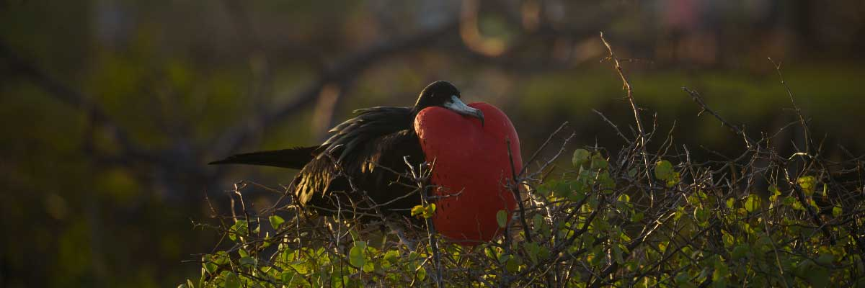

|  |  |
| --- | --- |
| **Food**: | B/L/D |
| **Trail:** | 1,2 km / 0,7 mi |
| **Lodging**: | M/Y Galaxy |
| **Level**: | 3 |
| **Activities:** | HIKING,SNORKEL,PANGA RIDE,PADDLE BOARD,KAYAK |

DAY 4 - SATURDAY

AM: HIGHLANDS

Your day begins with a journey to the highlands of San Cristobal Island, offering a different perspective of the Galapagos' unique ecosystem. This lush and verdant area contrasts sharply with the coastal zones. The highlands are home to a variety of bird species, giant tortoises in their natural habitat, and a rich array of plant life, including endemic trees and ferns. You'll have the opportunity to walk along paths that meander through this lush landscape, offering a chance to observe the giant tortoises up close and personal. The highlands also provide panoramic views of the island, showcasing its diverse topography.

**Highlights:**  Lava tunnels, Darwin finches, Galapagos flycatchers, Giant tortoises, Barn owls, White-cheeked pintails

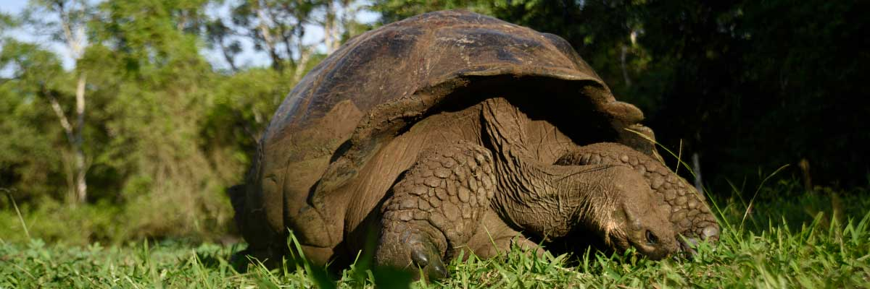

|  |  |
| --- | --- |
| **Trail:** | 1-1,5 km / 0,6-0,9 mi |
| **Level**: | 1 |
| **Activities:** | HIKING |

PM: BACHAS BEACH

End your Galapagos adventure at Bachas Beach, a key sea turtle nesting site from November to May. At low tide, remnants of WWII barges emerge from the white sand. Explore its saltwater lagoons, home to flamingos, herons, and aquatic birds. After this final stop, transfer to the airport for your flight back to the mainland, concluding an unforgettable journey.

**Highlights:**  Stunning Views, Blue footed boobies, White-cheeked pintails, American flamingoes, Sandpipers, Lava gulls

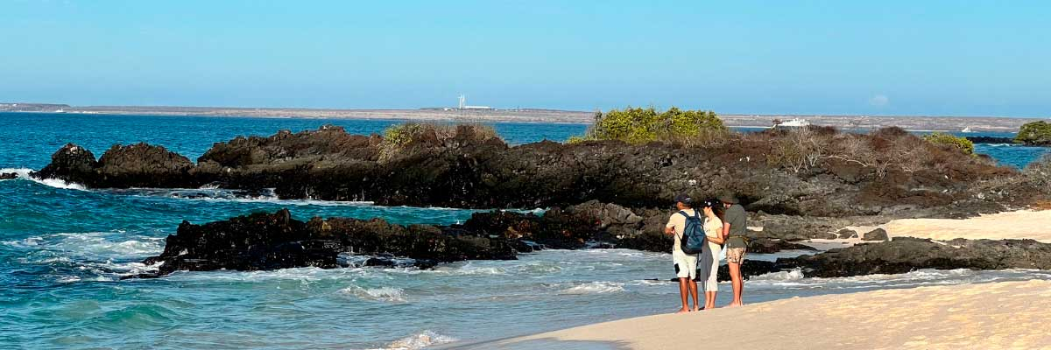

|  |  |
| --- | --- |
| **Food**: | B/L/D |
| **Trail:** | 1,6 km / 1 mi |
| **Lodging**: | M/Y Galaxy |
| **Level**: | 3 |
| **Activities:** | HIKING,SNORKEL,PANGA RIDE,PADDLE BOARD,KAYAK |

DAY 5 - SUNDAY

AM: KICKER ROCK

In the afternoon, embark on an unforgettable panga (dinghy) ride around Kicker Rock, also known as León Dormido, off the coast of San Cristobal Island. This impressive rock formation, rising dramatically 500 feet above the ocean, is one of the most iconic landmarks in the Galapagos. The natural erosion of this ancient volcanic tuff cone has created a channel between two towering rock walls, providing a haven for various marine life. This peaceful and scenic panga ride around Kicker Rock provides a relaxing yet awe-inspiring conclusion to your day, allowing you to appreciate the natural wonders and rich biodiversity of the Galapagos from the sea.

Panga Experience: Navigate the waters around Kicker Rock, marveling at the sheer size and beauty of the formation. The ride offers a unique perspective of the rock, with opportunities to observe seabirds such as frigate birds, boobies, and occasionally, pelicans nesting or resting on its cliffs. Keep an eye out for marine life in the surrounding waters, including sea turtles, rays, and even sharks that frequent the area.

**Highlights:**  Boobies, Pelicans, Frigatebirds

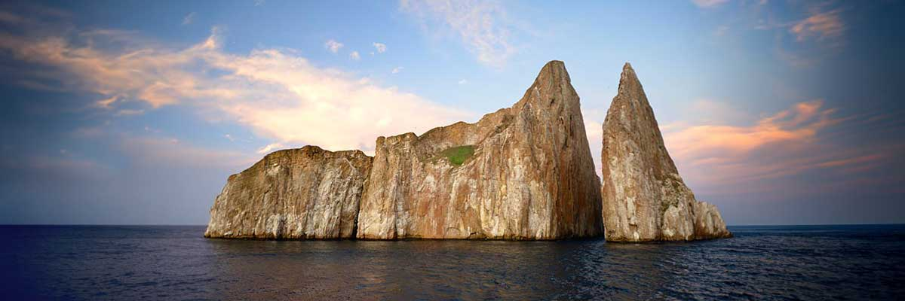

|  |  |
| --- | --- |
| **Trail:** |  |
| **Level**: | 1 |
| **Activities:** | - |

PM: LOBOS ISLAND

Venture to Lobos Island, a tranquil islet secluded from San Cristobal by a slim channel. This nature's cradle, amidst a serene bay, is the playground for sea lion pups frolicking in tidal pools. The island might be modest in size, but it bursts with life, particularly with “lobos marinos” or sea lions. As you step ashore, welcoming committees of sea lions would greet you, only to be outraged by the male frigatebirds inland, presenting their inflamed red balloons amidst the verdant foliage. Stay vigilant for the blue-footed boobies nesting on the trails, ready to treat you to a display of their whimsical courtship dance.

Snorkel Experience: Dive into an underwater ballet at this renowned snorkeling spot, sheltered by the calm waves. Playful sea lions would eagerly display their acrobatic prowess. In contrast, sea turtles and rays find solace resting on the sandy seabed, giving you a glimpse into the harmonious marine life that thrives beneath the surface.

**Highlights:**  Stunning Views, Galapagos sea lions, Magnificent and great frigatebirds, San Cristobal Lava Lizards

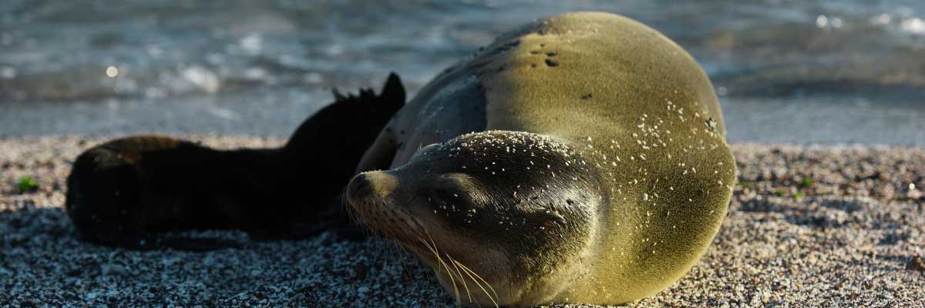

|  |  |
| --- | --- |
| **Food**: | -/L/D |
| **Trail:** | 0,6 km / 0,4 mi |
| **Lodging**: | M/Y Galaxy |
| **Level**: | 2 |
| **Activities:** | HIKING,SNORKEL,PANGA RIDE |

DAY 6 - MONDAY

AM: SUAREZ POINT

Embark on an adventure to Suarez Point, one of the Galapagos’ greatest natural wonders. This rocky trail is a haven for wildlife lovers, featuring an incredible array of species. Upon arrival, sea lions and marine iguanas welcome you as the first hosts of this nature spectacle. As you explore further, witness a vibrant mosaic of seabird colonies, from blue-footed and Nazca boobies to graceful frigatebirds and tropicbirds. The highlight of this journey is meeting the waved albatross, the island’s largest bird, impressing visitors with its powerful flight and intricate courtship display (present from April to January).

**Highlights:**  Stunning Views, Herons, Galapagos mockingbirds, Galapagos hawks, Darwin finches, Marine iguanas, Waved Albatross, Lava lizards

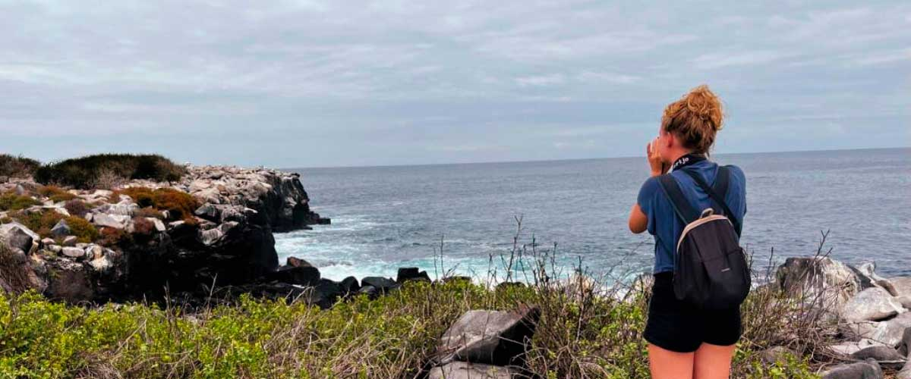

|  |  |
| --- | --- |
| **Trail:** | 1,7 km / 1,1 mi |
| **Level**: | 3 |
| **Activities:** | HIKING |

PM: GARDNER BAY

Embrace the morning at Gardner Bay, a pristine piece of paradise in the Galapagos archipelago. Sugar-white coral sands merge with crystal-clear turquoise waters, creating a tropical oasis. Watch as the beach becomes a theatre, starring sun-basking sea lions in a playful performance. This idyllic setting invites you to stroll along the coast, immersing yourself in an enlightening experience as you delve into the biology of the endemic fauna - from the melodious Española mockingbird and the unique marine iguanas to the regal Galapagos hawks.

Snorkel Experience: Submerge beneath the azure waves to witness a spectacular performance choreographed by marine life. Swim alongside playful sea lions, graceful reef sharks, and gliding rays. Discover an array of fish, including vivid Angelfish, charismatic Parrotfish, dynamic Damselfish, and the ever-busy Surgeonfish coloring the underwater landscape.

**Highlights:**  Coral sand beach, Galapagos mockingbirds, Galapagos hawks, Darwin finches, Marine iguanas

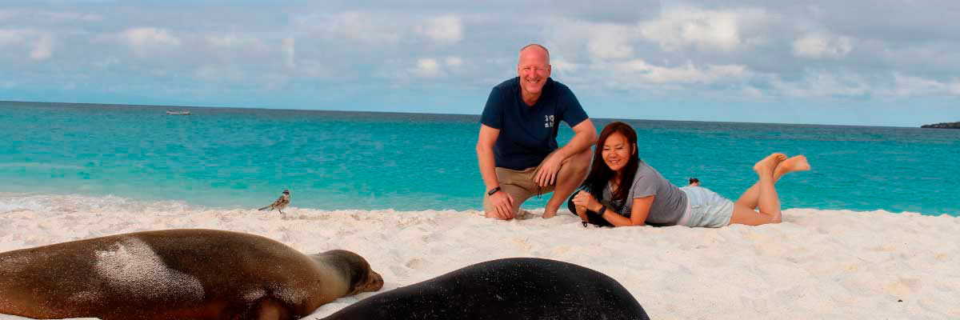

|  |  |
| --- | --- |
| **Food**: | B/L/D |
| **Trail:** | 0,8 km / 0,5 mi |
| **Lodging**: | M/Y Galaxy |
| **Level**: | 2 |
| **Activities:** | HIKING,SNORKEL,PADDLE BOARD,KAYAK |

DAY 7 - TUESDAY

AM: CORMORANT POINT

Located in northern Floreana, Punta Cormorant is a paradise for nature lovers. Its coastal lagoon hosts flamingos, white-cheeked pintails, and black-necked stilts, while its white sand beach is a crucial nesting site for green sea turtles. In recent years, blue-footed boobies have started nesting along the trail. This is also a great site for spotting endemic plants. For snorkeling, Devil’s Crown—a heavily eroded volcanic formation—offers an unparalleled experience, attracting reef sharks, rays, sea turtles, and massive schools of tropical fish.

Snorkel Experience: Explore Devil’s Crown, one of the best snorkeling spots in the Galapagos. Its currents attract reef sharks, turtles, rays, and massive schools of fish like snappers, parrotfish, and angelfish.

**Highlights:**  Galapagos sea lions, Blue footed boobies, Galapagos shearwaters, American flamingoes, Sea turtles, Tropicbirds, Frigatebirds

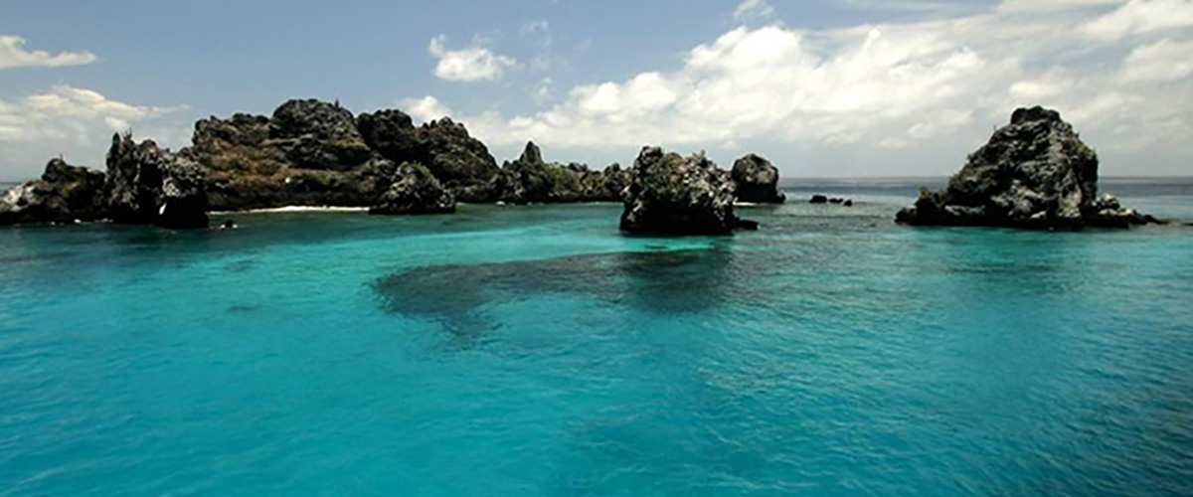

|  |  |
| --- | --- |
| **Trail:** | 1,6 km / 1 mi |
| **Level**: | 2 |
| **Activities:** | HIKING,SNORKEL,PANGA RIDE,PADDLE BOARD,KAYAK |

PM: POST OFFICE BAY

Step into the past at Post Office Bay on Floreana, where sailors established a barrel-based mail system in the 1700s, still in use today. Beyond its historic charm, the bay was a key stop for whalers seeking freshwater and tortoises. This site also boasts a scenic beach, and incredible wildlife, including sea lions, green sea turtles, reef sharks, and, if luck is on your side, the elusive Galapagos penguin.

Snorkel Experience: Dive straight from the beach and explore a mesmerizing underwater world filled with sea turtles, rays, and schools of tropical fish. If lucky, catch a glimpse of a Galapagos penguin darting through the waves.

**Highlights:**  Galapagos penguins, Marine iguanas, Sea turtles, Finches, Shorebirds

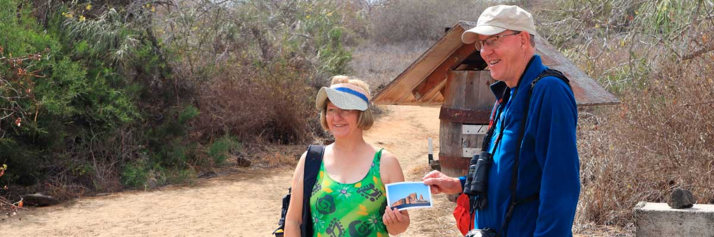

|  |  |
| --- | --- |
| **Food**: | B/L/D |
| **Trail:** | 0,7 km / 0,4 mi |
| **Lodging**: | M/Y Galaxy |
| **Level**: | 1 |
| **Activities:** | HIKING,SNORKEL |

DAY 8 - WEDNESDAY

AM: CHARLES DARWIN STATION

Explore the Charles Darwin Research Station, a center dedicated to wildlife conservation and research. Witness breeding programs helping restore giant tortoise populations, learn about projects tackling invasive species, and see conservationists working to protect the fragile Galapagos ecosystem.

Galapagos giant tortoise and land iguanas breeding program, Galapagos mockingbirds, Darwin finches, Galapagos flycatchers

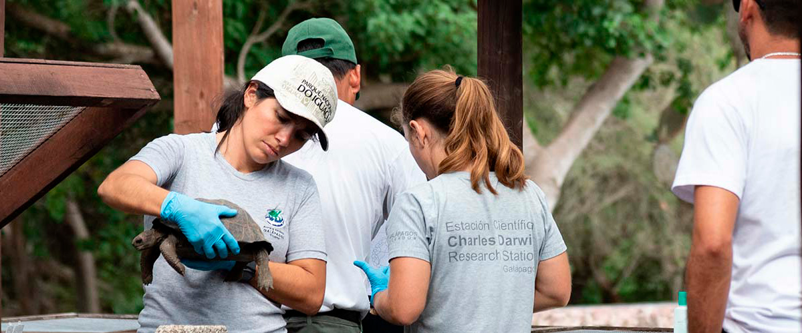

|  |  |
| --- | --- |
| **Trail:** | 2 km / 1,2 mi |
| **Level**: | 1 |
| **Activities:** | - |

PM: BALTRA AIRPORT (RETURN)

Your Galapagos adventure comes to an end. Today, you will be transferred to Baltra Airport, where your National Park naturalist guide will assist you with final details before your flight back to mainland Ecuador. As you bid farewell to this paradise, take with you the unforgettable memories of one of the world’s most extraordinary destinations.



|  |  |
| --- | --- |
| **Food**: | B/-/- |
| **Trail:** |  |
| **Lodging**: | M/Y Galaxy |
| **Level**: | 1 |
| **Activities:** | - |

GLOSSARY

|  |  |  |
| --- | --- | --- |
| **Feeding** | **Breakfast** | B |
| **Lunch** | L |
| **Dinner** | D |
| **Difficulty of the hike** | **Level 1** | Easy |
| **Level 2** | Moderate |
| **Level 3** | Difficult |