**GALAPAGOS ONBOARD A CRUISE**

**5 Days - 4 Nights**

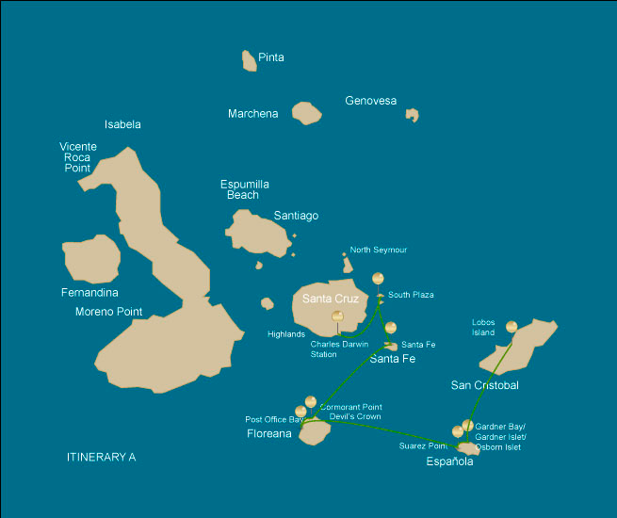

|  |  |  |  |  |  |  |  |
| --- | --- | --- | --- | --- | --- | --- | --- |
|  | | | **Hiking** | **Snorkel** | **Panga Ride** | **Paddle Board** | **Kayak** |
| TUESDAY | AM | **San Cristobal Island :** San Cristobal- Airport (arrival) |  |  |  |  |  |
|  | PM | **San Cristobal Island :** Lobos Island | * |  |  |  |  |
| WEDNESDAY | AM | **Española Island :** Gardner Bay / Islote Gardner / Osborn Islote | * | * | * | * | * |
|  | PM | **Española Island :** Suarez Point | * |  |  |  |  |
| THURSDAY | AM | **Floreana Island :** Post Office Bay | * | * |  |  |  |
|  | PM | **Floreana Island :** Cormorant Point / Devil's Crown | * | * | * |  |  |
| FRIDAY | AM | **Santa Fe Island :** Santa Fe | * | * | * | * | * |
|  | PM | **South Plazas Island :** South Plaza | * |  |  |  |  |
| SATURDAY | AM | **Santa Cruz Island :** Charles Darwin Station | * |  |  |  |  |
|  | PM | **Santa Cruz Island :** Baltra - airport (return) | * |  |  |  |  |

DAY 1

AM: SAN CRISTOBAL AIRPORT ARRIVAL

Embark on an unforgettable journey to the Galapagos Islands, where nature thrives in its purest form. Your adventure begins at San Cristobal’s modest yet bustling airport, where a seasoned naturalist guide will greet you. This guardian of the ecosystem will introduce you to a world of breathtaking landscapes and unparalleled biodiversity. Feel the excitement as you step into this living sanctuary, a UNESCO World Heritage site, marking the beginning of an extraordinary exploration.



|  |  |
| --- | --- |
| **Trail:** |  |
| **Level**: | 1 |
| **Activities:** | - |

PM: LOBOS ISLAND

Lobos Island, a small islet near San Cristóbal, offers an unforgettable wildlife experience. Upon landing, groups of sea lions will greet you as they play in tidal pools. Walking inland, you’ll spot frigatebirds perched in bushes, displaying their inflated red pouches, while blue-footed boobies nest along the trail, performing their iconic courtship dance. In the calm waters, snorkeling provides an incredible opportunity to swim with playful sea lions, while sea turtles and rays rest on the sandy bottom.

Snorkel Experience: The calm waters of Lobos Island are perfect for swimming with playful sea lions. Sea turtles and rays are often seen resting on the sandy bottom, while tropical fish add vibrant colors to the scene.

Stunning Views, Galapagos sea lions, Magnificent and great frigatebirds, San Cristobal Lava Lizards

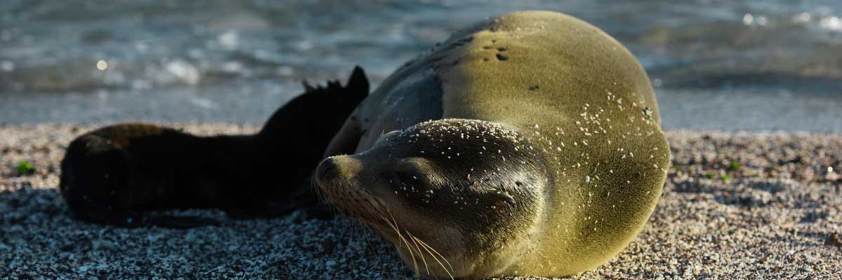

|  |  |
| --- | --- |
| **Food**: | -/L/D |
| **Trail:** | 0,6 km / 0,4 mi |
| **Lodging**: | M/C EcoGalaxy |
| **Level**: | 1 |
| **Activities:** | HIKING |

DAY 2

AM: GARDNER BAY / ISLOTE GARDNER / OSBORN ISLET

Gardner beach is undoubtedly one of the most beautiful and interesting beaches to visit in the Galapagos. Its fine coral sand and turquoise water give it a totally tropical appearance, which contrasts with the presence of sea lions basking in the beach. You will have the opportunity to walk along the beach and learn about the biology of sea lions and other endemic species, such as the Española mockingbird, marine iguanas and Galapagos hawks.

Snorkel Experience: There are several great snorkeling places at Gardner bay. It is a fantastic site to swim with sea lions, reef sharks, rays and many species of fish, including; Angelfish, Parrotfish, Damselfish, Surgeonfish and many others.

**Highlights:**  Herons, Galapagos mockingbirds, Galapagos hawks, Darwin finches, Marine iguanas, Waved Albatross, Lava lizards

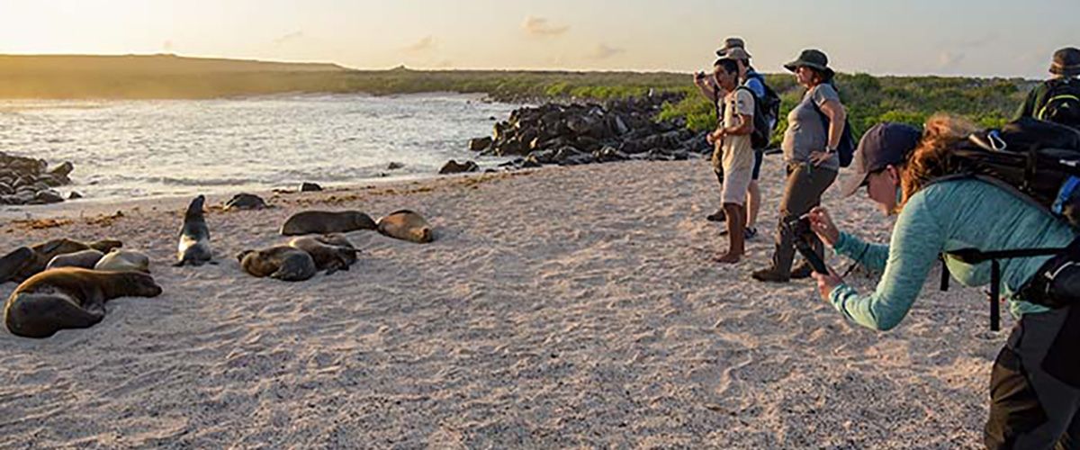

|  |  |
| --- | --- |
| **Trail:** | 0,8 km / 0,5 mi |
| **Level**: | 3 |
| **Activities:** | HIKING,SNORKEL,PANGA RIDE,PADDLE BOARD,KAYAK |

PM: SUAREZ POINT

This rocky trail is one the most amazing nature walks you can do in the Galapagos islands. From the moment you set foot on the island and all the way along the trail the amount and diversity of fauna is truly amazing. Sea lions and marine iguanas will be the first ones welcoming us, followed by large colonies of sea birds, including Nazca and Blue-footed boobies, gulls and tropicbirds. At the end of the trail we will visit a colony of waved albatross (April to January), the largest bird in the islands and one of the most interesting because of its powerful flight and elaborate courtship. Waved albatross only nest at Española, so this is the only place where you will see them at close range.

**Highlights:** Stunning Views, Herons, Galapagos mockingbirds, Galapagos hawks, Darwin finches, Marine iguanas, Waved Albatross, Lava lizards

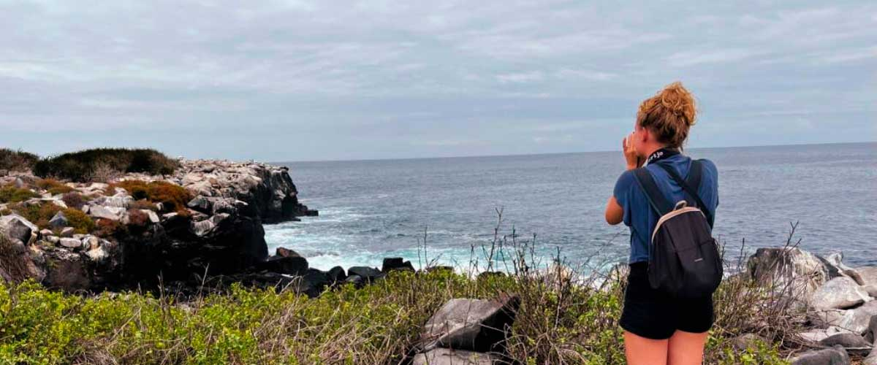

|  |  |
| --- | --- |
| **Food**: | B/L/D |
| **Trail:** | 1,7 km / 1,1 mi |
| **Lodging**: | M/C EcoGalaxy |
| **Level**: | 1 |
| **Activities:** | HIKING |

DAY 3

AM: POST OFFICE BAY

Floreana is famous for the tales of German settlers and the baroness during the late 1920’s and 30 ‘s. Assassinations, disappearances and other unsolved mysteries are the ingredients of this fascinating story. Post office bay was often used by whalers to anchor their ships and go up to the highlands to get freshwater and tortoises. Most boats visiting the Galapagos had to came to this place sooner or later, so a system of mail was established more than 200 years ago: a barrel near the beach became the way to leave messages to other ships and also to the outside world. This mail system is still in use and will allow you to send postcards from the Galapagos to the outside world. Aside from a small beautiful beach, the area is great for dinghy tours to look for sea lions, green sea turtles, shorebirds, small sharks and, with some luck, Galapagos penguins.

Snorkel Experience: There is great snorkel from the beach, as you can see lots of sea turtles, rays, great diversity of fish and, if you are really lucky, Galapagos penguin

**Highlights:**  Galapagos penguins, Marine iguanas, Sea turtles, Finches, Shorebirds

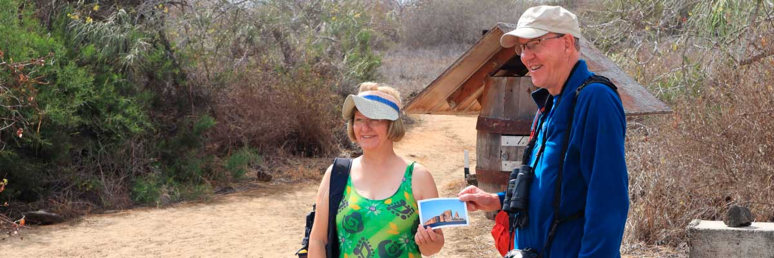

|  |  |
| --- | --- |
| **Trail:** | 0,7 km / 0,4 mi |
| **Level**: | 1 |
| **Activities:** | HIKING,SNORKEL |

PM: CORMORANT POINT / DEVIL'S CROW

Punta Cormorant is located in the north of Floreana and it is known for its large coastal lagoon with American flamingos, white-cheeked pintails, black-necked stilts and other shorebirds. There is a beautiful white sand beach which is an important nesting ground for green sea turtles where we can also see rays and reef sharks. In recent years, a small group of blue footed boobies have started to breed right by the trail. This is also a great trail dayto look at endemic plants.

Snorkel Experience: It will be done at Devil’s Crown, a heavily eroded little volcano right by Floreana island. This is considered by many as one of the best snorkeling sites in the entire archipelago as the current funnels plankton through the Crown, attracting huge schools of snapper, Creole fish parrot fish, angelfish, reef sharks, sea turtles, rays and a phenomenal amount of marine life.

**Highlights:** Sea turtle nesting site, Galapagos shearwaters, Tropicbirds, Frigatebirds, Finches, Shorebirds

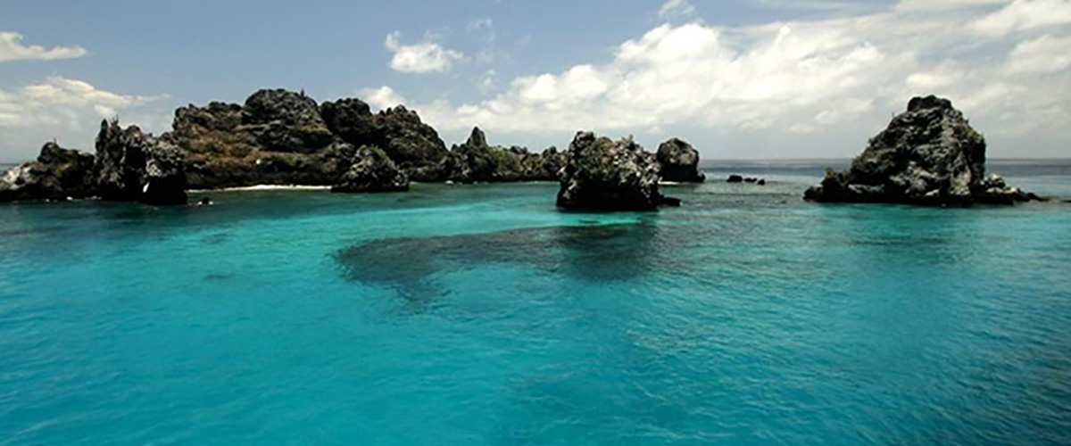

|  |  |
| --- | --- |
| **Food**: | B/L/D |
| **Trail:** | 1,6 km / 1 mi |
| **Lodging**: | M/C EcoGalaxy |
| **Level**: | 1 |
| **Activities:** | HIKING,SNORKEL,PANGA RIDE |

DAY 4

AM: SANTA FE

Santa Fe Island, nestled in one of the most stunning bays in the Galapagos, boasts towering prickly-pear cacti and ancient lava formations. Its white-sand beach and turquoise waters are home to a large sea lion colony basking under the sun. As you follow the trail, look for the endemic Santa Fe land iguana and, if lucky, a Galapagos hawk perched atop a cactus scanning for prey. Along the way, Darwin’s finches, Galapagos doves, mockingbirds, and lava lizards are commonly seen, making this hike a true wildlife experience.

Snorkel Experience: After the hike, snorkel in the bay’s sheltered waters. Swim alongside playful sea lions, reef sharks, and sea turtles. Spot rays and schools of tropical fish, including surgeonfish and parrotfish, for an unforgettable underwater experience.

**Highlights:**  Stunning Views, Galapagos sea lions, Galapagos hawks, Galapagos doves, Santa Fe land iguanas, Reef sharks

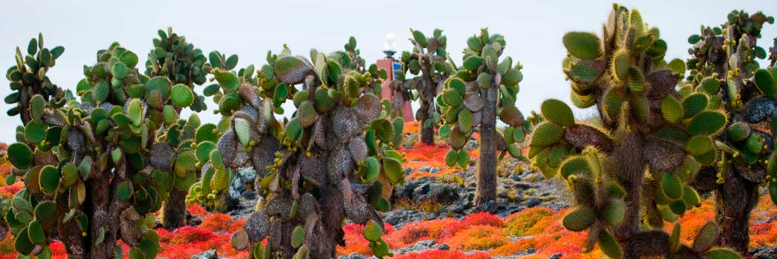

|  |  |
| --- | --- |
| **Trail:** | 0,8 km / 0,5 mi |
| **Level**: | 2 |
| **Activities:** | HIKING,SNORKEL,PANGA RIDE,PADDLE BOARD,KAYAK |

Of the two twin islands, only South Plazas is open to visitors, while North Plazas remains a scientific research site. Despite its small size, South Plazas is teeming with wildlife. Upon landing, ll find land iguanas lounging beneath Opuntia cacti, waiting for fallen fruit. A large sea lion colony dominates the shore, where playful pups explore tide pools while massive bulls defend their territory. The trail leads to a dramatic cliffside, offering breathtaking ocean views where frigatebirds, blue-footed boobies, red-billed tropicbirds, and swallow-tailed gulls soar. A blanket of reddish succulents covering the island adds to its striking beauty.

**Highlights:** Stunning Views, Boobies, Galapagos sea lions, Galapagos shearwaters, Galapagos land iguanas, Tropicbirds, Pelicans

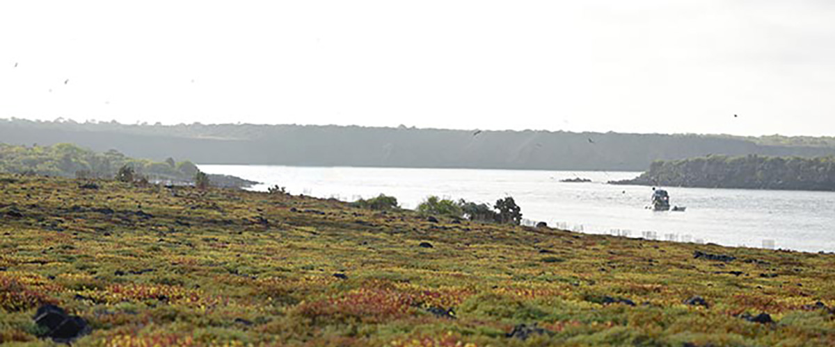

|  |  |
| --- | --- |
| **Food**: | B/L/D |
| **Trail:** | 1,4 km / 0,8 mi |
| **Lodging**: | M/C EcoGalaxy |
| **Level**: | 2 |
| **Activities:** | HIKING |

DAY 5

AM: CHARLES DARWIN STATION

The Charles Darwin Station is a nonprofit organization which has been working for decades together with the Galapagos National Park to preserve the biodiversity of these unique islands. During this visit you will learn about the projects that both institutions carry together to protect the native species and eradicate the invasive ones which are threatening the Galapagos environment. One of the most important and emblematic projects has been reproducing giant tortoises in captivity. The visit is mostly outdoors in a beautiful dry native forest with giant cactus and many other interesting native plants. It is also a fantastic place to find several endemic Darwin finches, as well as flycatchers and mockingbirds.

Galapagos giant tortoise and land iguanas breeding program, Galapagos mockingbirds, Darwin finches, Galapagos flycatchers

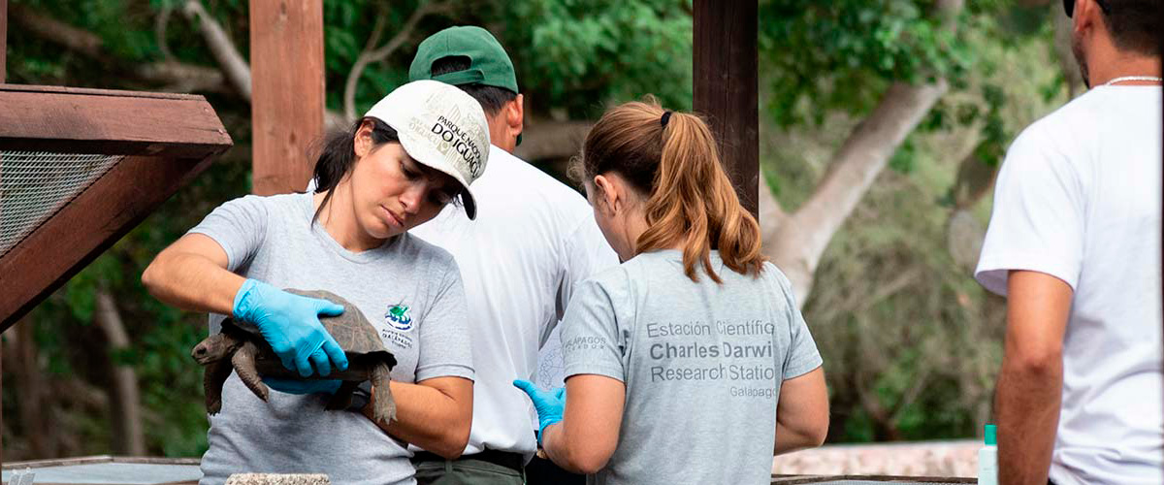

|  |  |
| --- | --- |
| **Trail:** | 2 km / 1,2 mi |
| **Level**: | 1 |
| **Activities:** | HIKING |

PM: BALTRA AIRPORT RETURN

Your Galapagos adventure comes to an end. Today, you will be transferred to Baltra Airport, where your National Park naturalist guide will assist you with final details before your flight back to mainland Ecuador. As you bid farewell to this paradise, take with you the unforgettable memories of one of the world’s most extraordinary destinations.

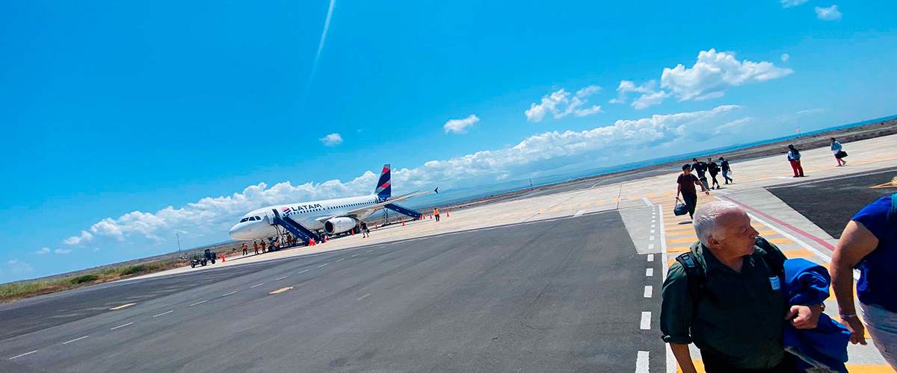

|  |  |
| --- | --- |
| **Food**: | B/-/- |
| **Trail:** |  |
| **Lodging**: | M/C EcoGalaxy |
| **Level**: | 1 |
| **Activities:** | HIKING |

GLOSSARY

|  |  |  |
| --- | --- | --- |
| **Feeding** | **Breakfast** | B |
| **Lunch** | L |
| **Dinner** | D |
| **Difficulty of the hike** | **Level 1** | Easy |
| **Level 2** | Moderate |
| **Level 3** | Difficult |