**GALAPAGOS ONBOARD A CRUISE**

**6 Days - 5 Nights**

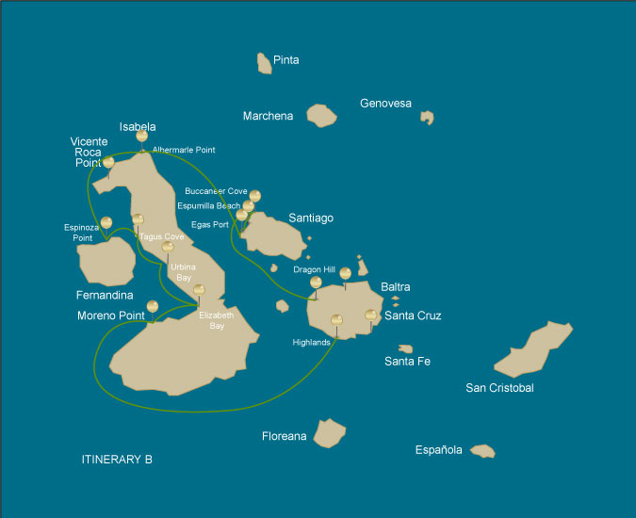

|  |  |  |  |  |  |  |  |
| --- | --- | --- | --- | --- | --- | --- | --- |
|  | | | **Hiking** | **Snorkel** | **Panga Ride** | **Paddle Board** | **Kayak** |
| SATURDAY | AM | **Santa Cruz Island :** Baltra - airport (arrival) | * |  |  |  |  |
|  | PM | **Santa Cruz Island :** Highlands | * |  |  |  |  |
| SUNDAY | AM | **Isabela Island :** Moreno Point | * | * | * |  |  |
|  | PM | **Isabela Island :** Elizabeth Bay |  |  | * | * | * |
| MONDAY | AM | **Isabela Island :** Urbina Bay | * | * |  |  |  |
|  | PM | **Isabela Island :** Tagus Cove | * | * | * | * | * |
| TUESDAY | AM | **Fernandina Island :** Espinoza Point | * | * | * |  |  |
|  | PM | **Isabela Island :** Albermarle Point | * |  | * | * | * |
| WEDNESDAY | AM | **Santiago Island :** Egas Port | * | * |  |  |  |
|  | PM | **Santiago Island :** Espumilla Beach / Buccaneer Cove | * | * | * | * | * |
| THURSDAY | AM | **Santa Cruz Island :** Dragon Hill or Daphne | * | * |  |  |  |
|  | PM | **Santa Cruz Island :** Baltra - airport (return) | * |  |  |  |  |

DAY 1

AM: SANTA CRUZ - BALTRA AIRPORT ARRIVAL

Welcome to Galapagos! Upon arrival at Baltra Airport, your naturalist guide will greet you and assist with the transfer to Itabaca Channel. This initial journey offers your first connection with the archipelago as you take a short ferry ride to Santa Cruz Island. Along the way, observe Baltra’s arid landscape and learn about its history as a former U.S. WWII airbase. This is just the beginning of the many fascinating stories awaiting you on your adventure.

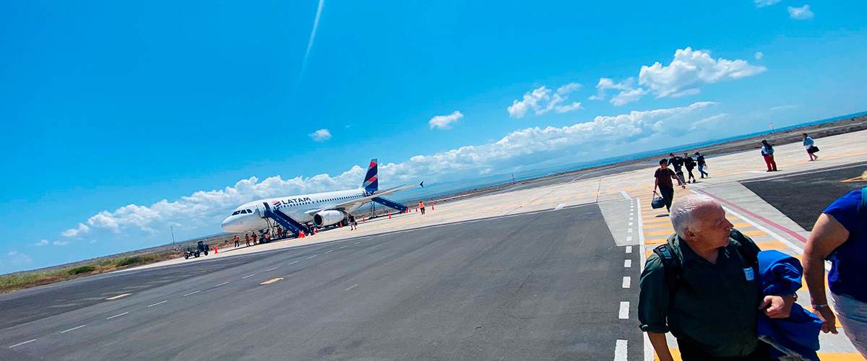

|  |  |
| --- | --- |
| **Trail:** |  |
| **Level**: | 1 |
| **Activities:** | HIKING |

PM: HIGHLANDS

Either if you do this visit starting from Baltra or from Puerto Ayora, a bus will take you to the highlands stopping along the way at one of the reserves to visit the lush highland forests where you will look for Galapagos Giant tortoises in their natural environment. This is the best place in the Galapagos to see these gentle giants (reaching over 300 kg / 600 pounds!) casually grazing and resting in freshwater ponds. This is also home for a great diversity of birds rarely found at the lowlands, including finches (tree, woodpecker and vegetarian finches), flycatchers and several species of water birds. You will visit a lava tunnel (depending on the itinerary) and learn how these extraordinary formations were created by ancient volcanic eruptions.

Lava tunnels, Darwin finches, Galapagos flycatchers, Giant tortoises, Barn owls, White-cheeked pintails

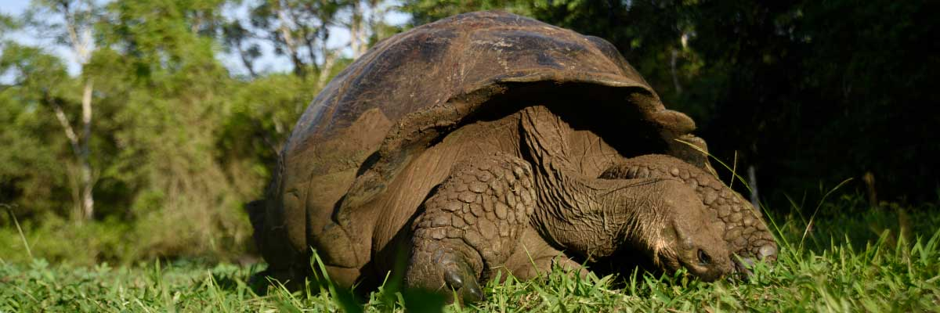

|  |  |
| --- | --- |
| **Food**: | -/L/D |
| **Trail:** | 1-1,5 km / 0,6-0,9 mi |
| **Lodging**: | M/C EcoGalaxy |
| **Level**: | 1 |
| **Activities:** | HIKING |

DAY 2

AM: MORENO POINT

Moreno Point is a magical place with extensive lava fields which look lifeless at first sight. Once inland, scattered brackish lagoons form an oasis of life where you can find flamingos, gallinules, ducks and herons. Along the shore we will look for penguins, marine iguanas, flightless cormorants, blue-footed boobies, sea lions, oystercatchers and other shore birds.

Snorkel Experience: We will snorkel to see sea turtles, cormorants and many species of fish. Look carefully in the long seaweeds and you might find a seahorse.

**Highlights:**  Stunning Views, Galapagos mockingbirds, Darwin finches, American flamingoes, Flightless cormorants, Marine iguanas, Ducks, Gallinules

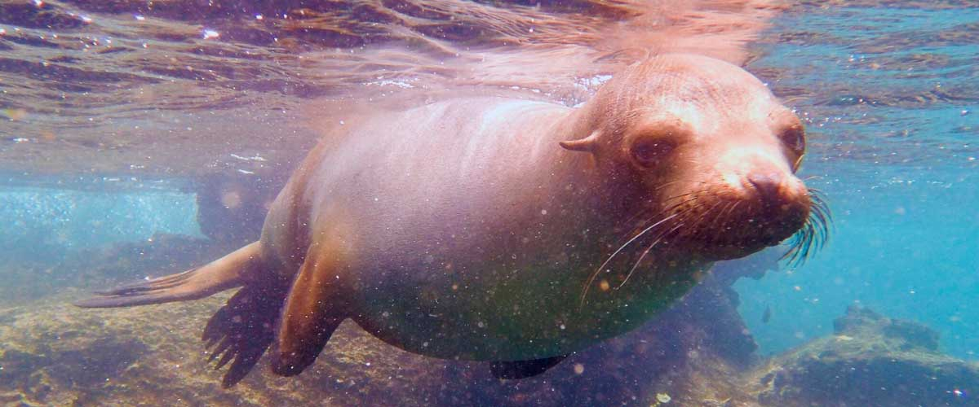

|  |  |
| --- | --- |
| **Trail:** | 1,6 km / 1 mi |
| **Level**: | 3 |
| **Activities:** | HIKING,SNORKEL,PANGA RIDE |

PM: ELIZABETH BAY

Elizabeth Bay is a beautiful sheltered bay surrounded by large mangroves and barren lava fields. There is no trail here so you will take a dinghy tour to explore many channels, pools and coves teeming with life. This is one of the best locations in the islands to see Galapagos penguins, but don’t expect to see thousands of them, as the entire population of the islands is only about 3.000 of them. Flightless cormorants also nest in the area and blue-footed boobies and pelicans often fish in these shallow and rich waters. Rays and sea turtles are also very abundant.

**Highlights:** Mangroves, Rays, Herons, Galapagos penguins, Galapagos hawks, Flightless cormorants, Sea turtles

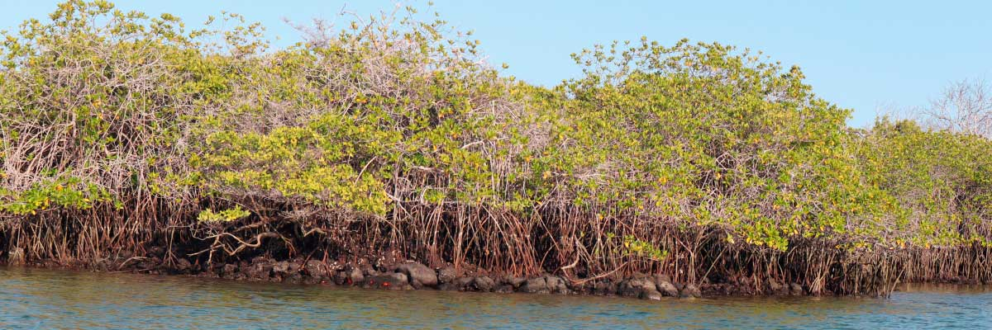

|  |  |
| --- | --- |
| **Food**: | B/L/D |
| **Trail:** | 1,4 km / 0,8 mi |
| **Lodging**: | M/C EcoGalaxy |
| **Level**: | 1 |
| **Activities:** | PANGA RIDE,PADDLE BOARD,KAYAK |

DAY 3

AM: URBINA BAY

This place is known for the dramatic uplifting that happened here during the 1950’s. A large portion of the coast was pushed up, exposing many hectares of previously submerged land. Look carefully along the trail and you will find small shells and corals, a proof that the area was underwater more than sixty years ago. The trail will give the opportunity to see land iguanas and, during certain seasons, giant tortoises. Galapagos hawks nest in the area and are often seen flying or perched on the trees.

Snorkel Experience: You can snorkel from the beach to see sea turtles, cormorants and penguins. Fish are also abundant in the area.

**Highlights:**  Stunning Views, Galapagos mockingbirds, Galapagos hawks, Darwin finches, Galapagos flycatchers, Galapagos land iguanas

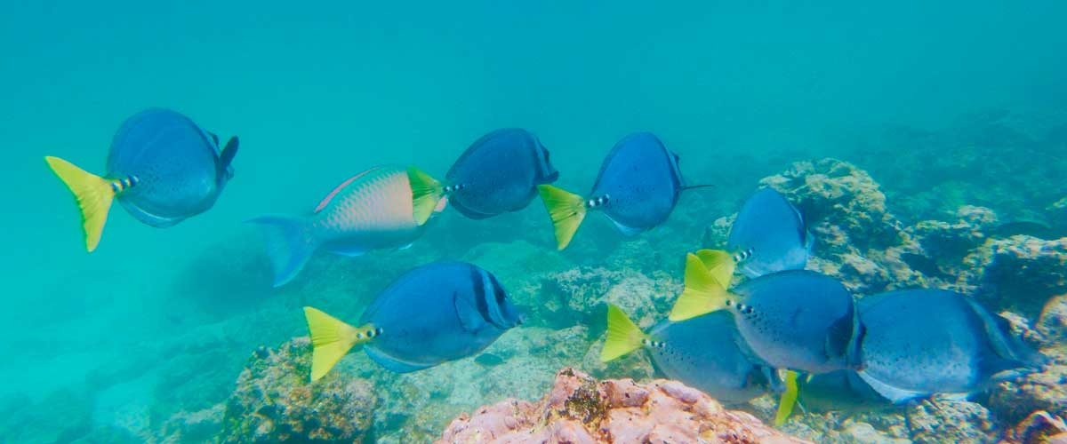

|  |  |
| --- | --- |
| **Trail:** | 1,2 km / 0,7 mi. Long trail 3,0 km / 1,8 mi |
| **Level**: | 1 |
| **Activities:** | HIKING,SNORKEL |

PM: TAGUS COVE

Tagus Cove is steeped in history, once visited by Charles Darwin during his Galapagos exploration. A scenic trail winds through dry Palo Santo forests, where Darwin’s finches and mockingbirds can be spotted. At the top, breathtaking views of Lake Darwin and Isabela’s towering volcanoes await. A boat tour along the shore provides a chance to observe Galapagos penguins, flightless cormorants, marine iguanas, and the elusive Galapagos martin, one of the rarest and most endangered birds in the archipelago.

Snorkel Experience: The nutrient-rich waters of Tagus Cove attract sea turtles, tropical fish, and penguins feasting on anchovies. Flightless cormorants can often be seen chasing fish underwater, creating a truly unique snorkeling experience.

**Highlights:** Stunning Views, Herons, Galapagos penguins, Galapagos hawks, Flightless cormorants, Marine iguanas, Sea turtles, Sea stars

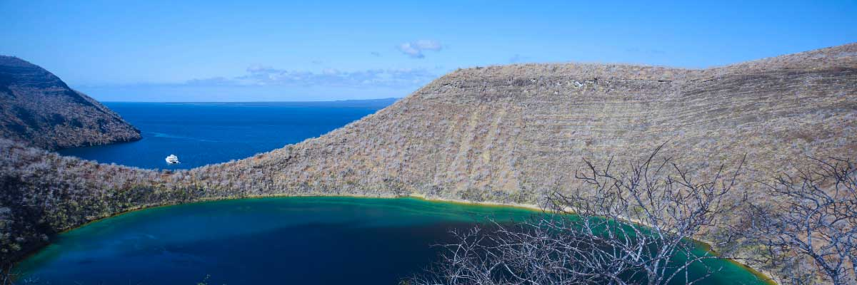

|  |  |
| --- | --- |
| **Food**: | B/L/D |
| **Trail:** | 2,6 km / 1,6 mi |
| **Lodging**: | M/C EcoGalaxy |
| **Level**: | 1 |
| **Activities:** | HIKING,SNORKEL,PANGA RIDE,PADDLE BOARD,KAYAK |

DAY 4

AM: ESPINOZA POINT

Located at the base of an imposing volcano (the most active in the Galapagos islands) this site is one of the jewels of the Galapagos National Park. As soon as you disembark you will be surrounded by hundreds of marine iguanas, as this is the largest colony for the species. Sea lions bask in the beaches while their pups play in tide pools. Along the shore you will see flightless cormorants, which are restricted to the western areas of the archipelago. Surrounded by cold plankton-rich waters, Punta Espinosa is home for an array of species, including herons, pelicans, oystercatchers, sea turtles, shorebird and many more. Look up in the mangroves as Galapagos hawks often perch to look for their prey.

Snorkel Experience: The nutrient-rich waters around Punta Espinosa attracts great numbers and diversity of fish and sea turtles. Seaweeds are also abundant, making this place the best for seeing marine iguanas feeding underwater. Following a cormorant underwater as it chases fish through the reef is one on the most amazing snorkel experiences you may have on your trip.

**Highlights:**  Stunning Views, Herons, Galapagos penguins, Oystercatchers, Galapagos hawks, Marine iguanas, Sea turtles, Shorebirds

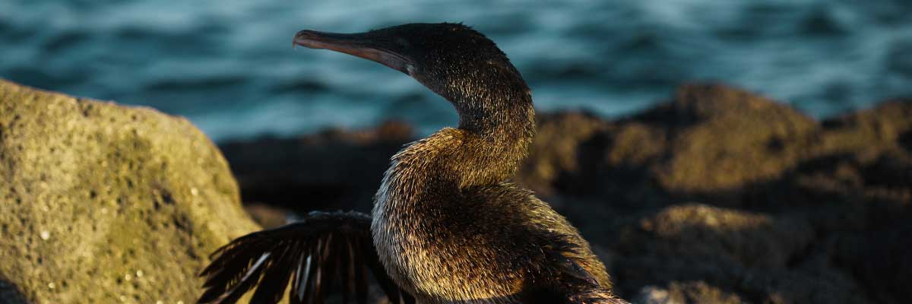

|  |  |
| --- | --- |
| **Trail:** | 1,6 km / 1 mi |
| **Level**: | 2 |
| **Activities:** | HIKING,SNORKEL,PANGA RIDE |

PM: ALBERMARLE POINT

In the afternoon, visit Albemarle Point, where military history meets Galapagos wildlife. During WWII, the U.S. built a radar base here to monitor potential Japanese threats, and remnants of this structure remain visible today. Despite its stark, lava-covered landscape, the coastline is rich in wildlife. Some of the largest marine iguanas in the archipelago reside here, alongside Galapagos penguins, flightless cormorants, and various shorebirds, making this a fascinating blend of history and nature.

Snorkel Experience: Swim among flightless cormorants, penguins, and schools of tropical fish in crystal-clear waters, experiencing the vibrant marine life of this historic Galapagos site.

**Highlights:** Galapagos penguins, Land and marine iguanas, Flightless cormorants, Sea turtles, Sally light-foot crabs

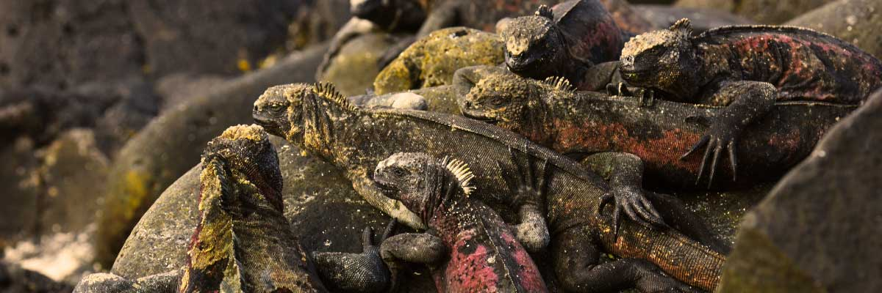

|  |  |
| --- | --- |
| **Food**: | B/L/D |
| **Trail:** | 1 km / 0,6 mi |
| **Lodging**: | M/C EcoGalaxy |
| **Level**: | 1 |
| **Activities:** | HIKING,PANGA RIDE,PADDLE BOARD,KAYAK |

DAY 5

AM: EGAS PORT

Puerto Egas is a fascinating destination where history and wildlife intertwine. While there is no actual port, remnants of 1960s colonization attempts still stand. The coastal trail is teeming with marine iguanas basking in the sun and sea lions resting on the rocks. Herons, oystercatchers, and shorebirds complete this thriving ecosystem. Towards the end of the trail, the grottos are home to a small colony of the elusive Galapagos fur seal. Additionally, land iguanas were reintroduced to the island in 2019 after over a century of absence.

Snorkel Experience: A snorkeling session from the beach will lead you to an area of rocky bottoms, excellent for observing fish, turtles, and reef sharks. Sea lions often frequent this area and are typically open to interacting with divers.

**Highlights:**  Stunning Views, Herons, Galapagos sea lions, Galapagos fur seals, Oystercatchers, Galapagos hawks, Darwin finches, Marine and land iguanas, Galapagos doves, Shorebirds

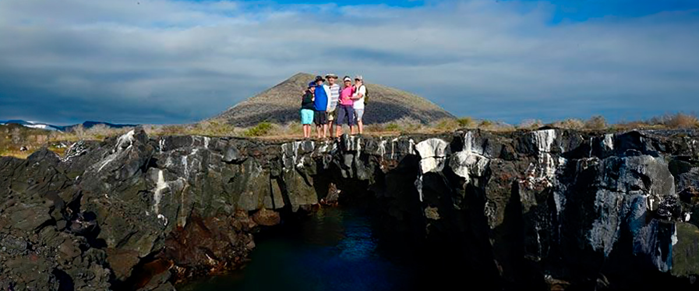

|  |  |
| --- | --- |
| **Trail:** | 2,3 km / 1,4 mi |
| **Level**: | 1 |
| **Activities:** | HIKING,SNORKEL |

PM: ESPUMILLA BEACH / BUCCANEER COVE

Espumilla Beach, on Santiago’s northern coast, is a stunning one-kilometer stretch of rusty-brown sand. Surrounded by mangroves and dry forest, it hosts Galapagos hawks, finches, and mockingbirds, while flamingos and ducks may appear in the salt pan during the rainy season. Then, at Buccaneer Cove, discover a historic pirate hideout from the 17th and 18th centuries. Towering cliffs and striking rock formations create a breathtaking landscape. Although thereandamp;amp;#039;s no trail, a dinghy ride offers a unique chance to observe wildlife and delve into the archipelagoandamp;amp;#039;s history.

Snorkel Experience: Snorkel into a sheltered bay and explore a vibrant underwater world. Swim among schools of angelfish, parrotfish, and snappers while spotting reef sharks, sea turtles, and playful sea lions in their natural habitat.

**Highlights:** Herons, Boobies, Galapagos hawks

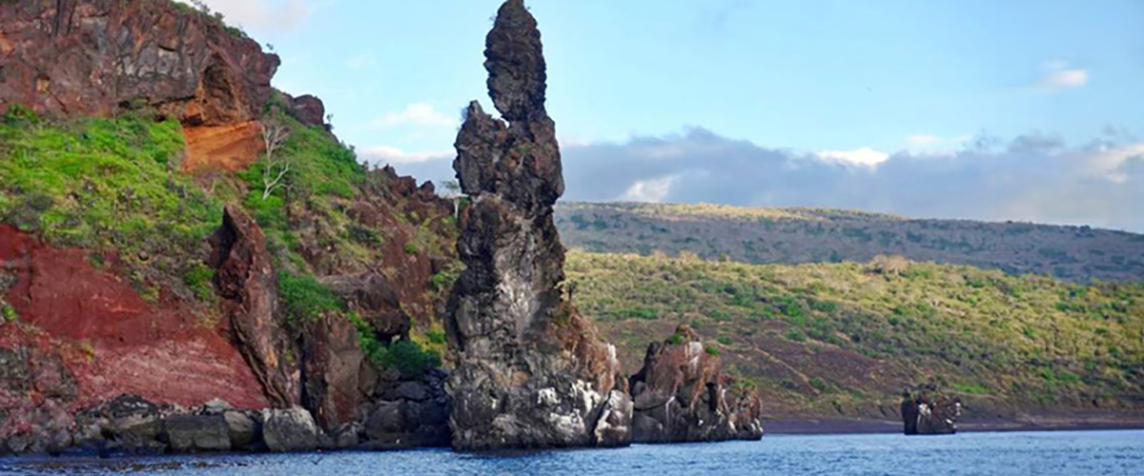

|  |  |
| --- | --- |
| **Food**: | B/L/D |
| **Trail:** | 2,3 km / 1,4 mi (plus and extra loop 1 km - 0,6 mi) |
| **Lodging**: | M/C EcoGalaxy |
| **Level**: | 1 |
| **Activities:** | HIKING,SNORKEL,PANGA RIDE,PADDLE BOARD,KAYAK |

DAY 6

AM: DRAGON HILL OR DAPHNE

Explore one of the two remarkable sites in Galápagos: Dragon Hill on Santa Cruz, where land iguanas roam and flamingos gather at a saltwater lagoon, and Daphne Major, home to nesting seabirds and groundbreaking finch evolution research. Both offer unique, unforgettable wildlife experiences.

Herons, Darwin finches, Galapagos flycatchers, American flamingoes, Galapagos land iguanas

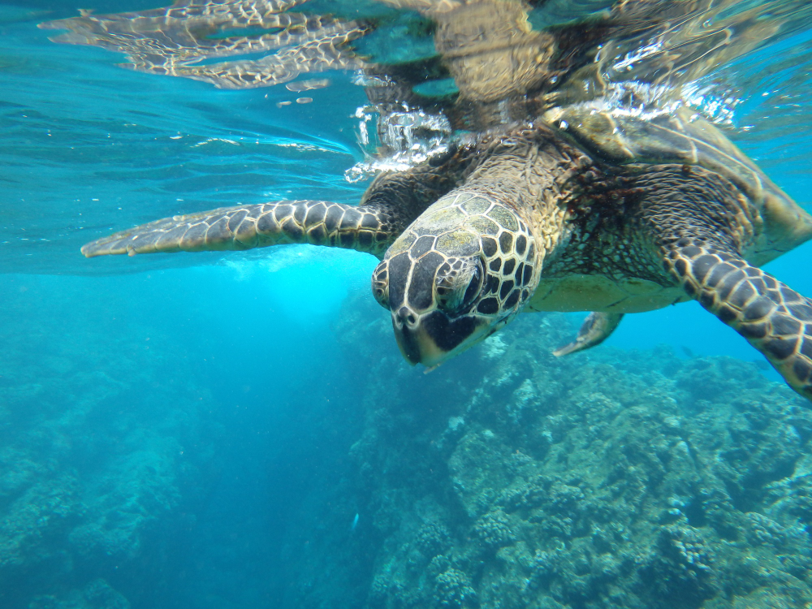

|  |  |
| --- | --- |
| **Trail:** | 2,2 km / 1,4 mi |
| **Level**: | 1 |
| **Activities:** | HIKING,SNORKEL |

PM: BALTRA AIRPORT (RETURN)

Your Galapagos adventure comes to an end. Today, you will be transferred to Baltra Airport, where your National Park naturalist guide will assist you with final details before your flight back to mainland Ecuador. As you bid farewell to this paradise, take with you the unforgettable memories of one of the world’s most extraordinary destinations.



|  |  |
| --- | --- |
| **Food**: | B/-/- |
| **Trail:** |  |
| **Lodging**: | M/C EcoGalaxy |
| **Level**: | 1 |
| **Activities:** | HIKING |

GLOSSARY

|  |  |  |
| --- | --- | --- |
| **Feeding** | **Breakfast** | B |
| **Lunch** | L |
| **Dinner** | D |
| **Difficulty of the hike** | **Level 1** | Easy |
| **Level 2** | Moderate |
| **Level 3** | Difficult |