**GALAPAGOS ONBOARD A CRUISE**

**6 Days - 5 Nights**

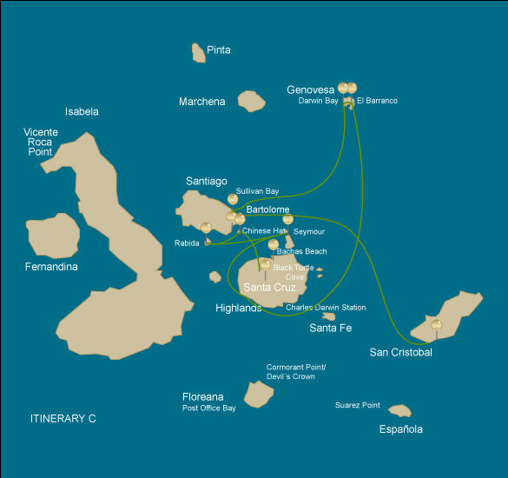

|  |  |  |  |  |  |  |  |
| --- | --- | --- | --- | --- | --- | --- | --- |
|  | | | **Hiking** | **Snorkel** | **Panga Ride** | **Paddle Board** | **Kayak** |
| THURSDAY | AM | **Santa Cruz Island :** Baltra - airport (arrival) | * |  |  |  |  |
|  | PM | **Santa Cruz Island :** Black Turtle Cove |  |  | * |  |  |
| FRIDAY | AM | **Chinese Hat Island :** Chinese Hat | * | * | * | * | * |
|  | PM | **Rabida Island :** Rabida | * | * | * |  |  |
| SATURDAY | AM | **Seymour Island :** North Seymour | * |  |  |  |  |
|  | PM | **Santa Cruz Island :** Highlands | * |  |  |  |  |
| SUNDAY | AM | **Genovesa Island :** Barranco | * | * | * | * | * |
|  | PM | **Genovesa Island :** Darwin Bay | * | * | * | * | * |
| MONDAY | AM | **Santiago Island :** Sullivan Bay | * | * | * |  |  |
|  | PM | **Bartolome Island :** Bartolome | * | * | * |  |  |
| TUESDAY | AM | **San Cristobal Island :** San Cristobal Interpretation Center | * |  |  |  |  |
|  | PM | **San Cristobal Island :** San Cristobal - airport (return) | * |  |  |  |  |

DAY 1

AM: BALTRA AIRPORT (ARRIVAL)

Welcome to Galapagos! Upon arrival at Baltra Airport, your naturalist guide will greet you and assist with the transfer to Itabaca Channel. This initial journey offers your first connection with the archipelago as you take a short ferry ride to Santa Cruz Island. Along the way, observe Baltra’s arid landscape and learn about its history as a former U.S. WWII airbase. This is just the beginning of the many fascinating stories awaiting you on your adventure.

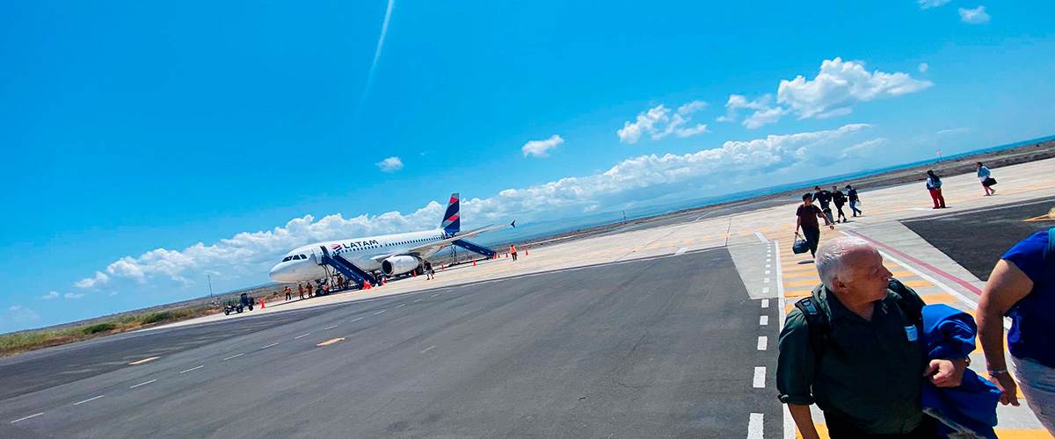

|  |  |
| --- | --- |
| **Trail:** |  |
| **Level**: | 1 |
| **Activities:** | HIKING |

PM: BLACK TURTLE COVE

Black Turtle Cove gets its name from the abundance of green sea turtles, locally known as: “tortugas negras”. There is no landing here so you will be doing a boat tour on the dinghies, exploring shallow channels and small coves surrounded by beautiful mangrove forests. Reef sharks, sea turtles and several species of rays inhabit this beautiful area which is considered an important mating area for turtles and a nursery for several species of sharks. Herons, pelicans and boobies are also common here as they pray in schools of anchovies.

Mangroves, White-tipped and black-tipped reef sharks, Green sea turtles, Rays, Herons, Blue footed boobies, Reef sharks

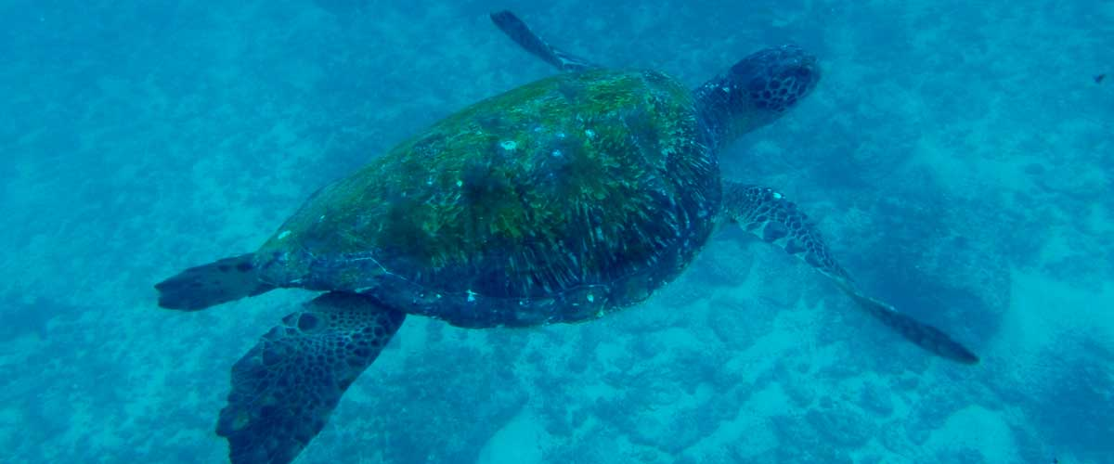

|  |  |
| --- | --- |
| **Food**: | -/L/D |
| **Trail:** |  |
| **Lodging**: | M/C EcoGalaxy |
| **Level**: | 1 |
| **Activities:** | PANGA RIDE |

DAY 2

AM: CHINESE HAT

Named for its distinctive cone shape, Chinese Hat is a small islet separated from Santiago by a narrow channel, forming one of Galapagos’ most picturesque bays. Its turquoise waters, coral-sand beaches, and volcanic rocks create a stunning landscape. A coastal trail leads you through a sea lion colony, while on the lava rocks, you may spot penguins resting. This site perfectly blends breathtaking scenery with Galapagos’ remarkable wildlife, making for an unforgettable experience.

Snorkel Experience: Snorkel into the crystal-clear waters of Chinese Hat and marvel at the vibrant colors of the fish. Spot sleek reef sharks and, if lucky, a penguin darting through the water like a swift underwater torpedo chasing anchovies.

**Highlights:**  Lava tubes, Galapagos sea lions, Galapagos penguins, Oystercatchers, Galapagos hawks

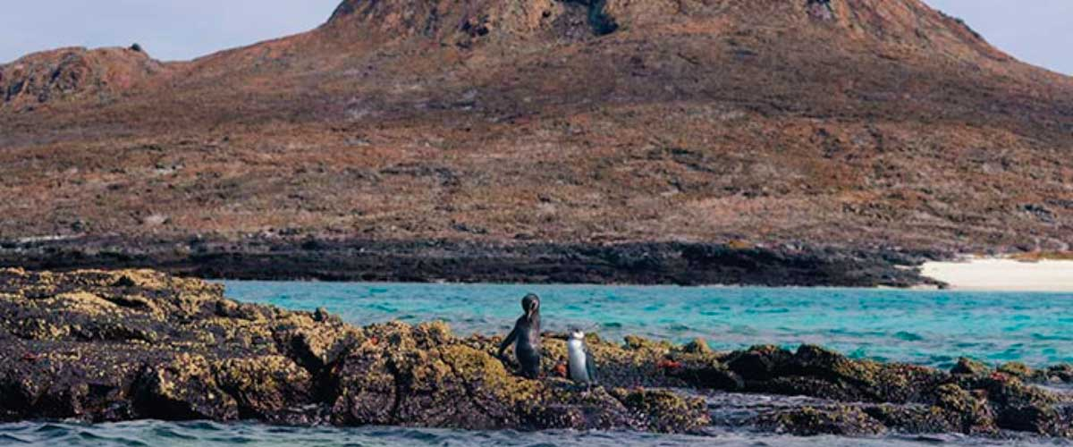

|  |  |
| --- | --- |
| **Trail:** | 1,3 km / 0,8 mi |
| **Level**: | 1 |
| **Activities:** | HIKING,SNORKEL,PANGA RIDE,PADDLE BOARD,KAYAK |

PM: RABIDA

Rabida is a small island famous for its reddish lava rocks (rich in iron) which gives it a unique look. The beach is also red and hosts a small colony of sea lions. There is a small salt water lagoon where we will see ducks and stilts and sometimes flamingoes. The trail will take you inland to get beautiful views of the beach and the lagoon. Look for Darwin finches, flycatchers and mockingbirds. In the cliffs along the coast you can find Nazca and blue-footed boobies, brown noddy, herons and the two species of sea lions: Galapagos and fur seals.

Snorkel Experience: You can snorkel from the beach and explore a sheltered rocky area, which is excellent for fish, sea lions and reef sharks. Look at the high diversity of small invertebrates attached to the vertical walls.

**Highlights:** Red-sand beach, Galapagos sea lions, Galapagos hawks, Darwin finches, Galapagos flycatchers

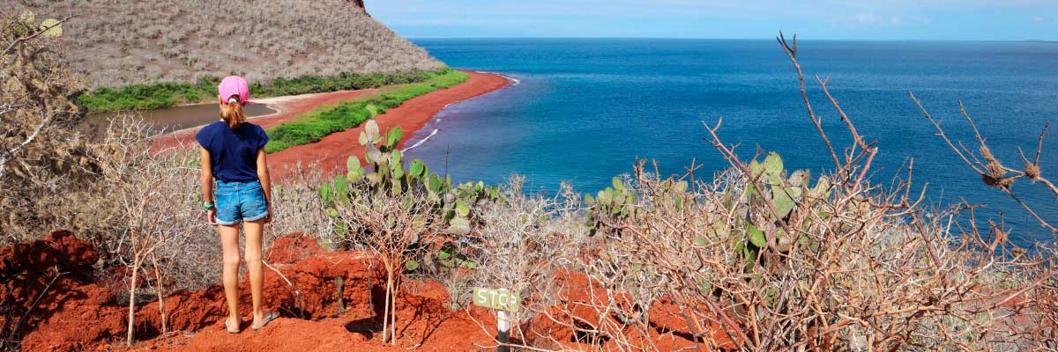

|  |  |
| --- | --- |
| **Food**: | B/L/D |
| **Trail:** | 2 km / 1,2 mi |
| **Lodging**: | M/C EcoGalaxy |
| **Level**: | 1 |
| **Activities:** | HIKING,SNORKEL,PANGA RIDE |

DAY 3

AM: NORTH SEYMOUR

This island is home for large colonies of both magnificent and great frigatebirds and you can see them displaying their red balloons to attract a female. Blue-footed boobies nest in the ground and perform their famous dance in the open areas, while swallow-tailed gulls perch on the cliff edges. Land iguanas are common inland while their marine cousins bask in the rocks by the sea, close to sea lions, which often like to body surf in the waves.

Snorkel Experience: This place is a really great snorkeling location, as it has tremendous diversity and amount of fish, but also sea lions, sharks, eels, turtles, rays and many more.

**Highlights:**  Galapagos sea lions, Magnificent and great frigatebirds, Land and marine iguanas, Darwin finches

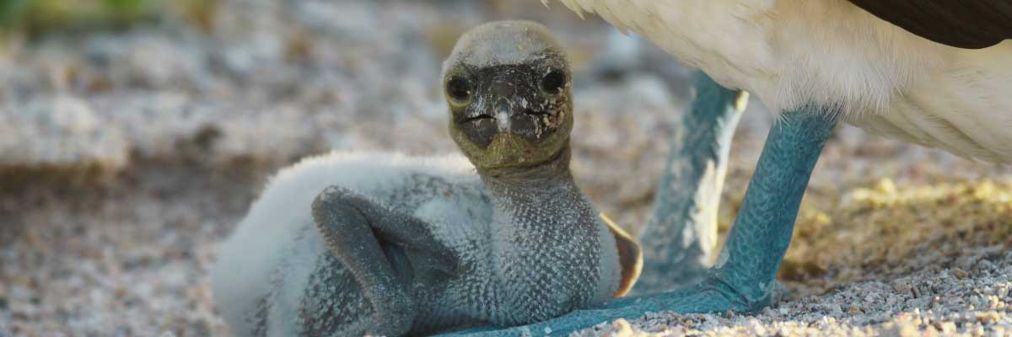

|  |  |
| --- | --- |
| **Trail:** | 1,4 km / 0,8 mi |
| **Level**: | 1 |
| **Activities:** | HIKING |

PM: HIGHLANDS

Either if you do this visit starting from Baltra or from Puerto Ayora, a bus will take you to the highlands stopping along the way at one of the reserves to visit the lush highland forests where you will look for Galapagos Giant tortoises in their natural environment. This is the best place in the Galapagos to see these gentle giants (reaching over 300 kg / 600 pounds!) casually grazing and resting in freshwater ponds. This is also home for a great diversity of birds rarely found at the lowlands, including finches (tree, woodpecker and vegetarian finches), flycatchers and several species of water birds. You will visit a lava tunnel (depending on the itinerary) and learn how these extraordinary formations were created by ancient volcanic eruptions.

**Highlights:** Lava tunnels, Darwin finches, Galapagos flycatchers, Giant tortoises, Barn owls, White-cheeked pintails

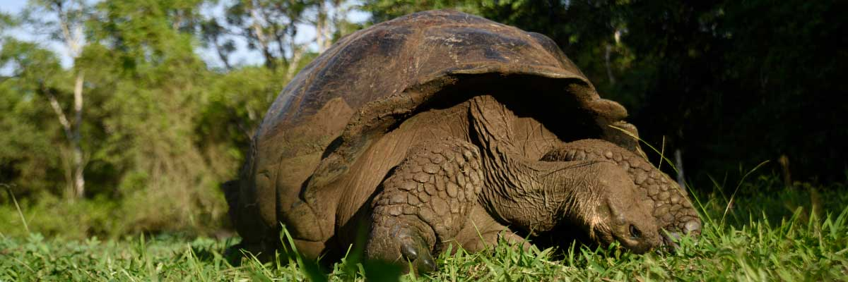

|  |  |
| --- | --- |
| **Food**: | B/L/D |
| **Trail:** | 1-1,5 km / 0,6-0,9 mi |
| **Lodging**: | M/C EcoGalaxy |
| **Level**: | 1 |
| **Activities:** | HIKING |

DAY 4

AM: EL BARRANCO

El Barranco is located in the southern part of Darwin Bay at Genovesa Island. The cliffs facing the sea are made of very fragile fractured lava, making it the ideal place for storm petrels to build their colonies, which attracts an important population of short-eared owls preying on the nesting birds. Red footed and Nazca boobies are abundant along the trail. At the base of the cliffs you can see Galapagos fur seals resting in shaded areas, as well as several species of seabirds.

Snorkel Experience: You can snorkel along the cliffs where there are many fish and great chances of seeing sharks, rays and sea lions.

**Highlights:**  Nesting great frigatebirds, Galapagos sea lions, Genovesa ground finch, Genovesa cactus finch, Galapagos mockingbirds, Galapagos fur seals

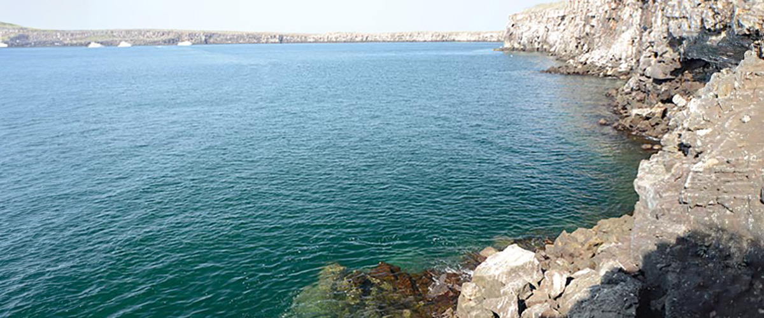

|  |  |
| --- | --- |
| **Trail:** | 1,2 km / 0,7 mi |
| **Level**: | 3 |
| **Activities:** | HIKING,SNORKEL,PANGA RIDE,PADDLE BOARD,KAYAK |

PM: DARWIN BAY

Genovesa is a favorite island for birdwatchers as it is home for very large colonies of seabirds. From the minute you set foot at the beach you will be amazed by the noise of hundreds of boobies, gulls and frigatebirds flying over your heads, perched in the bushes or nesting on the sandy terrain. The trail is an ultimate wildlife experience as there are animals everywhere; sea lions and marine iguanas near the sea; night herons, lava and swallow tailed gulls, Darwin finches, Galapagos doves, mockingbirds and many more species inland.

Snorkel Experience: The bay offers several places to snorkel; from deep waters along the cliffs across the bay, to shallow waters by the beach. In either case, there are many fish to see and great chances of seeing sharks, rays and sea lions.

**Highlights:** Nesting great frigatebirds, Red-footed and Nazca boobies, Galapagos sea lions, Yellow-crowned night herons, Genovesa ground finch, Genovesa cactus finch, Galapagos mockingbirds

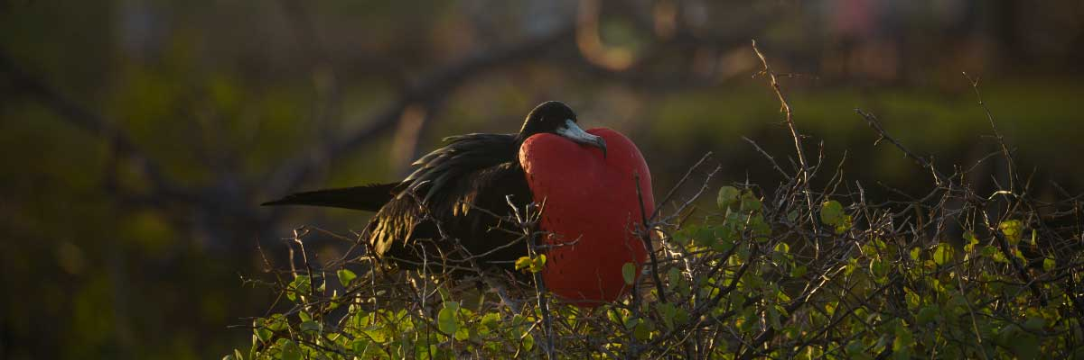

|  |  |
| --- | --- |
| **Food**: | B/L/D |
| **Trail:** | 1,2 km / 0,7 mi |
| **Lodging**: | M/C EcoGalaxy |
| **Level**: | 3 |
| **Activities:** | HIKING,SNORKEL,PANGA RIDE,PADDLE BOARD,KAYAK |

DAY 5

AM:SULLIVAN BAY

This hike is a journey into understanding the birth of these volcanic islands. You will walk in a very well preserved flow of Pahoehoe lava, which will give you endless opportunities to see the delicate textures of these types of lavas which only appear in a few places throughout the world. At first sight the barren landscape looks completely deprived of life, but look carefully for pioneer plants, lava lizards and small birds. By the shore, you can find penguins, pelicans and oystercatchers.

Snorkel Experience: You will have the option to swim or snorkel from a coral sand beach or from the dinghies. Getting underwater is like traveling to another world: if the land is almost lifeless, the sea is teaming with life, including large schools of fish, Galapagos penguins, reef sharks, turtles and rays.

**Highlights:**  Lava tubes, Galapagos penguins, Oystercatchers, Galapagos hawks

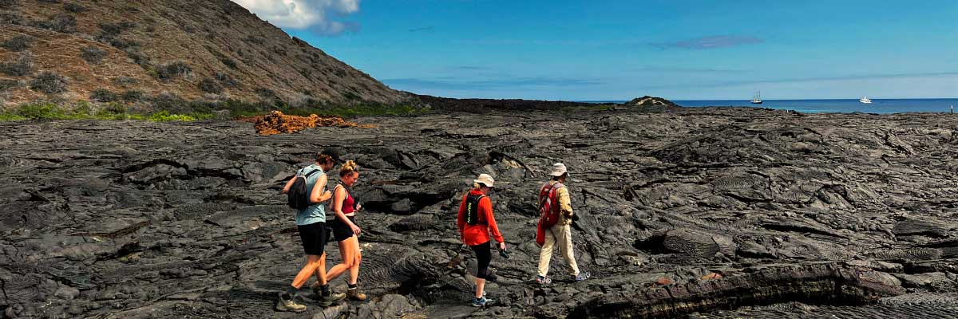

|  |  |
| --- | --- |
| **Trail:** | 2,2 km / 1,4 mi |
| **Level**: | 3 |
| **Activities:** | HIKING,SNORKEL,PANGA RIDE |

PM: BARTOLOME

Bartolome is one of the most iconic islands in Galapagos, renowned for its dramatic volcanic landscape and the famous Pinnacle Rock. Nestled beside a peach-colored sand beach, this island is one of the few places where you can spot penguins without traveling to remote Isabela and Fernandina. The hike to the summit offers breathtaking views of a lunar-like terrain dotted with volcanic cones, with stunning panoramas of Sullivan Bay and Pinnacle Rock. From the top, the vast beauty of the archipelago unfolds before you, creating a truly unforgettable experience.

Snorkel Experience: Enjoy an unforgettable snorkeling experience in Bartolome, one of Galapagos’ top spots. Swim in calm, clear waters alongside penguins, colorful fish, sea turtles, sea lions, rays, and reef sharks in a thriving marine ecosystem.

**Highlights:** Volcanic landscapes, Pinnacle rock, Herons, Bluefooted boobies, Galapagos penguins

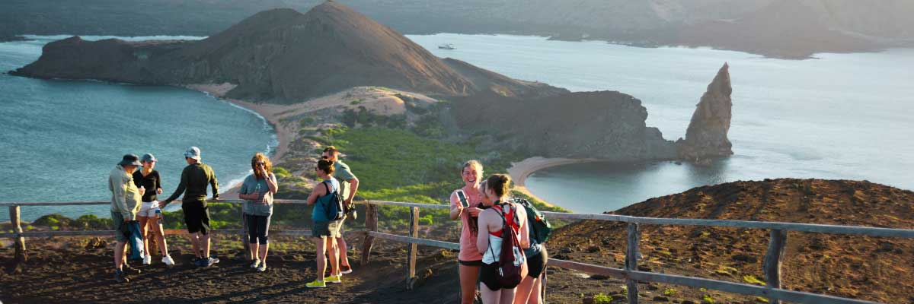

|  |  |
| --- | --- |
| **Food**: | B/L/D |
| **Trail:** | 1,5 km / 0,9 mi |
| **Lodging**: | M/C EcoGalaxy |
| **Level**: | 2 |
| **Activities:** | HIKING,SNORKEL,PANGA RIDE |

DAY 6

AM: INTERPRETATION CENTER

Located in the outskirts of Puerto Baquerizo, this center is dedicated to the history of human presence in the Galapagos. Since the times of the early Spanish explorers to the present times, including illustrious visitors such as Charles Darwin, this permanent exhibition will take you through the dangers and struggles of the first settlers trying to survive the harsh Galapagos environment.

Endemic plants and an exhibition on human history

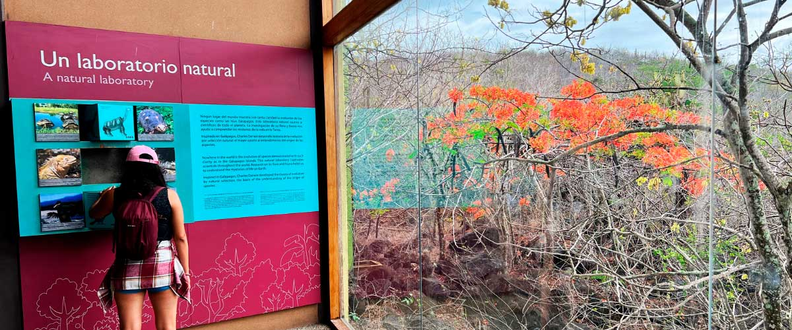

|  |  |
| --- | --- |
| **Trail:** | 0,2 km / 650 ft |
| **Level**: | 1 |
| **Activities:** | HIKING |

PM: SAN CRISTOBAL AIRPORT (RETURN)

After exploring the breathtaking biodiversity and unique landscapes of the Galapagos, it’s time to return to mainland Ecuador. You’ll be transferred to the airport, bringing this unforgettable journey to a close. Every encounter with giant tortoises, blue-footed boobies, and volcanic landscapes will remain etched in your memory. Galapagos is not just a destination—it’s a transformative experience that will stay with you forever. Wishing you a wonderful journey back!



|  |  |
| --- | --- |
| **Food**: | B/-/- |
| **Trail:** |  |
| **Lodging**: | M/C EcoGalaxy |
| **Level**: | 1 |
| **Activities:** | HIKING |

GLOSSARY

|  |  |  |
| --- | --- | --- |
| **Feeding** | **Breakfast** | B |
| **Lunch** | L |
| **Dinner** | D |
| **Difficulty of the hike** | **Level 1** | Easy |
| **Level 2** | Moderate |
| **Level 3** | Difficult |