**GALAPAGOS ONBOARD A CRUISE**

**5 DAYS / 4 NIGHTS**

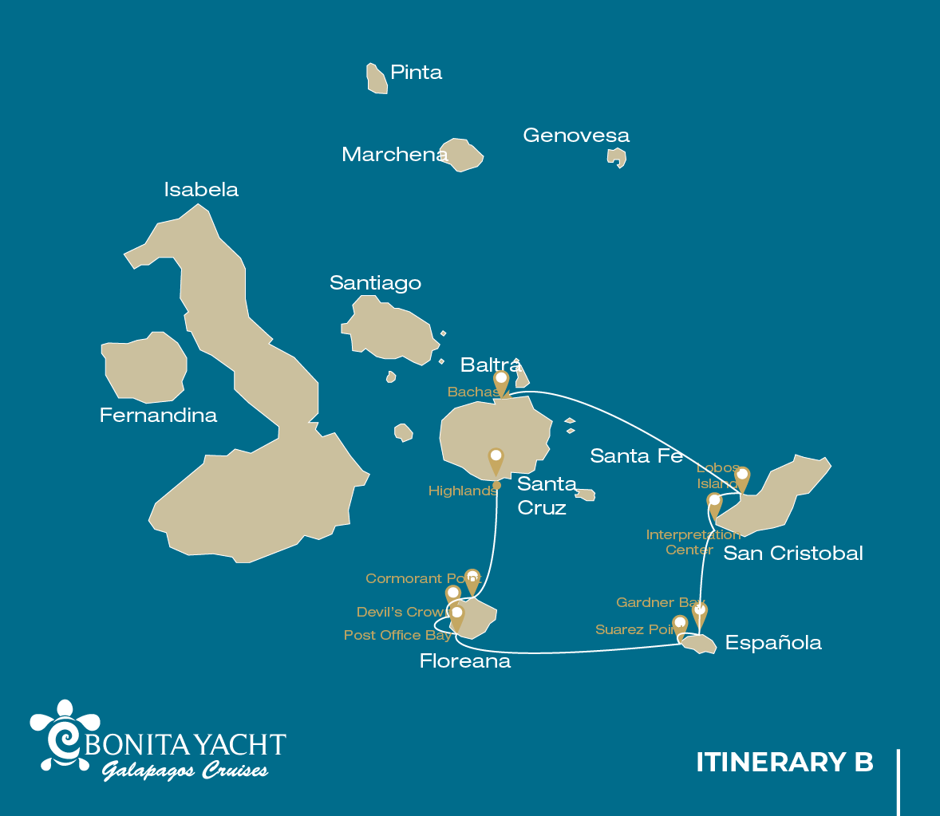

|  |  |  |  |  |  |  |  |
| --- | --- | --- | --- | --- | --- | --- | --- |
|  | | | **Hiking** | **Snorkel** | **Panga Ride** | **Paddle Board** | **Kayak** |
| SATURDAY | AM | Santa Cruz Island : Baltra - airport (arrival) |  |  |  |  |  |
|  | PM | Santa Cruz Island : Highlands | * |  |  |  |  |
| SUNDAY | AM | Floreana Island : Cormorant Point / Devil's Crown | * | * | * | * | * |
|  | PM | Floreana Island : Post Office Bay | * | * |  |  |  |
| MONDAY | AM | Española Island : Suarez Point | * |  |  |  |  |
|  | PM | Española Island : Gardner Bay / Osborn Islet | * | * |  | * | * |
| TUESDAY | AM | San Cristobal Island : Interpretation Center / Kicker Rock | * |  |  |  |  |
|  | PM | San Cristobal Island : Lobos Island | * |  |  |  |  |
| WEDNESDAY | AM | Santa Cruz Island : Bachas Beach | * |  |  |  |  |
|  | PM | Santa Cruz Island : Baltra - airport (return) |  |  |  |  |  |

DAY 1

AM: BALTRA AIRPORT

Welcome to Galapagos! Upon arrival at Baltra Airport, your naturalist guide will greet you and assist with the transfer to Itabaca Channel. This initial journey offers your first connection with the archipelago as you take a short ferry ride to Santa Cruz Island. Along the way, observe Baltra’s arid landscape and learn about its history as a former U.S. WWII airbase. This is just the beginning of the many fascinating stories awaiting you on your adventure.

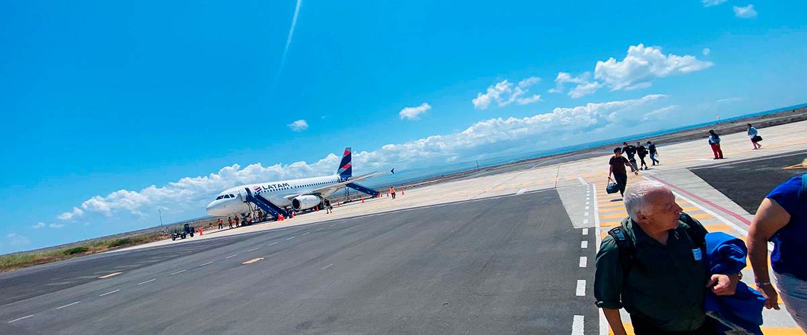

|  |  |
| --- | --- |
| **Trail:** |  |
| **Level**: | 1 |
| **Activities:** | - |

PM: HIGHLANDS

Either if you do this visit starting from Baltra or from Puerto Ayora, a bus will take you to the highlands stopping along the way at one of the reserves to visit the lush highland forests where you will look for Galapagos Giant tortoises in their natural environment. This is the best place in the Galapagos to see these gentle giants (reaching over 300 kg / 600 pounds!) casually grazing and resting in freshwater ponds. This is also home for a great diversity of birds rarely found at the lowlands, including finches (tree, woodpecker and vegetarian finches), flycatchers and several species of water birds. You will visit a lava tunnel (depending on the itinerary) and learn how these extraordinary formations were created by ancient volcanic eruptions.

Lava tunnels, Darwin finches, Galapagos flycatchers, Giant tortoises, Barn owls, White-cheeked pintails

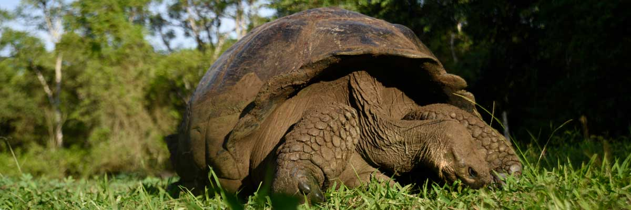

|  |  |
| --- | --- |
| **Food**: | -/L/D |
| **Trail:** | 1-1,5 km / 0,6-0,9 mi |
| **Lodging**: | M/Y Bonita |
| **Level**: | 1 |
| **Activities:** | HIKING |

DAY 2

AM: CORMORANT POINT / DEVIL’S CROWN

Punta Cormorant is located in the north of Floreana and it is known for its large coastal lagoon with American flamingos, white-cheeked pintails, black-necked stilts and other shorebirds. There is a beautiful white sand beach which is an important nesting ground for green sea turtles where we can also see rays and reef sharks. In recent years, a small group of blue footed boobies have started to breed right by the trail. This is also a great trail dayto look at endemic plants.

Snorkel Experience: It will be done at Devil’s Crown, a heavily eroded little volcano right by Floreana island. This is considered by many as one of the best snorkeling sites in the entire archipelago as the current funnels plankton through the Crown, attracting huge schools of snapper, Creole fish parrot fish, angelfish, reef sharks, sea turtles, rays and a phenomenal amount of marine life.

**Highlights:**  Sea turtle nesting site, Galapagos shearwaters, Tropicbirds, Frigatebirds, Finches, Shorebirds

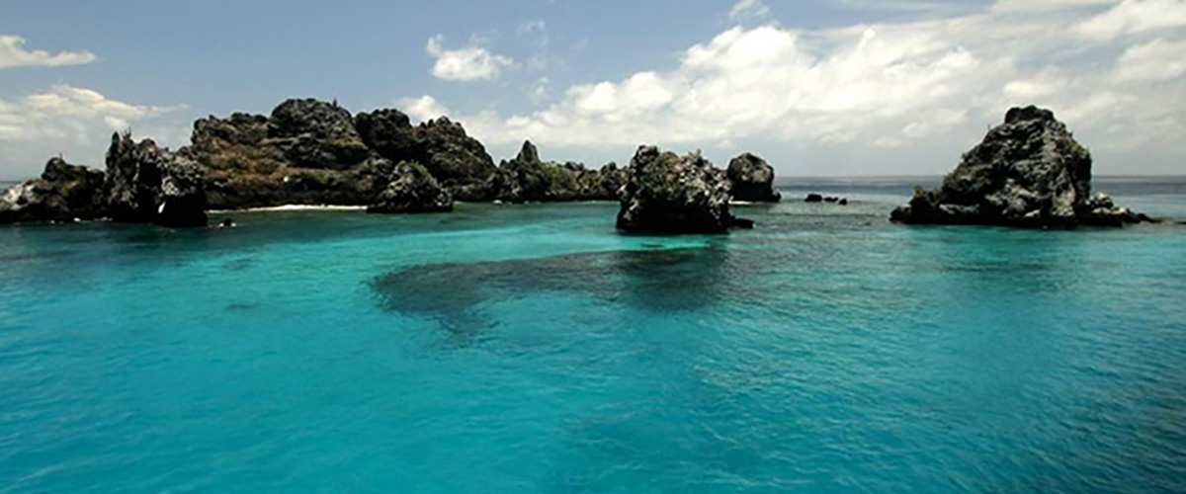

|  |  |
| --- | --- |
| **Trail:** | 1,6 km / 1 mi |
| **Level**: | 1 |
| **Activities:** | HIKING,SNORKEL,PANGA RIDE,PADDLE BOARD,KAYAK |

PM: POST OFFICE BAY

Floreana is famous for the tales of German settlers and the baroness during the late 1920’s and 30‘s. Assassinations, disappearances and other unsolved mysteries are the ingredients of this fascinating story. Post office bay was often used by whalers to anchor their ships and go up to the highlands to get freshwater and tortoises. Most boats visiting the Galapagos had to come to this place sooner or later, so a system of mail was established more than 200 years ago: a barrel near the beach became the way to leave messages to other ships and also to the outside world. This mail system is still in use and will allow you to send postcards from the Galapagos to the outside world. Aside from a small beautiful beach, the area is great for dinghy tours to look for sea lions, green sea turtles, shorebirds, small sharks and, with some luck, Galapagos penguins.

Snorkel Experience: There is great snorkel from the beach, as you can see lots of sea turtles, rays, great diversity of fish and, if you are really lucky, Galapagos penguin

**Highlights:** Galapagos penguins, Marine iguanas, Sea turtles, Finches, Shorebirds

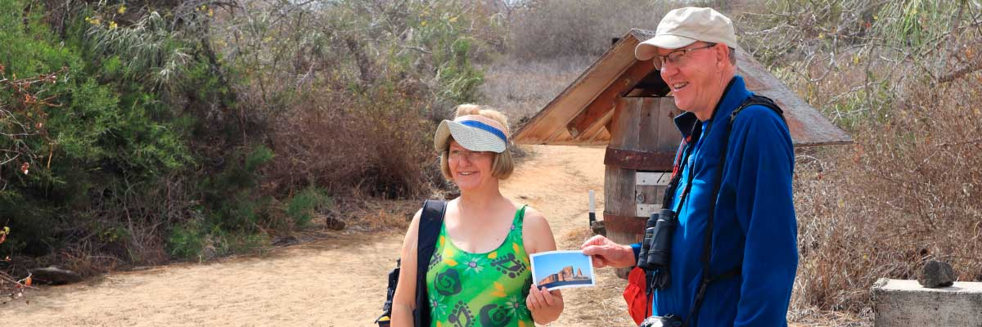

|  |  |
| --- | --- |
| **Food**: | B/L/D |
| **Trail:** | 0,7 km / 0,4 mi |
| **Lodging**: | M/Y Bonita |
| **Level**: | 1 |
| **Activities:** | HIKING,SNORKEL |

DAY 3

AM: SUAREZ POINT

This rocky trail is one the most amazing nature walks you can do in the Galapagos islands. From the moment you set foot on the island and all the way along the trail the amount and diversity of fauna is truly amazing. Sea lions and marine iguanas will be the first ones welcoming us, followed by large colonies of sea birds, including Nazca and Blue-footed boobies, gulls and tropicbirds. At the end of the trail we will visit a colony of waved albatross (April to January), the largest bird in the islands and one of the most interesting because of its powerful flight and elaborate courtship. Waved albatross only nest at Española, so this is the only place where you will see them at close range.

**Highlights:**  Stunning Views, Herons, Galapagos mockingbirds, Galapagos hawks, Darwin finches, Marine iguanas, Waved Albatross, Lava lizards

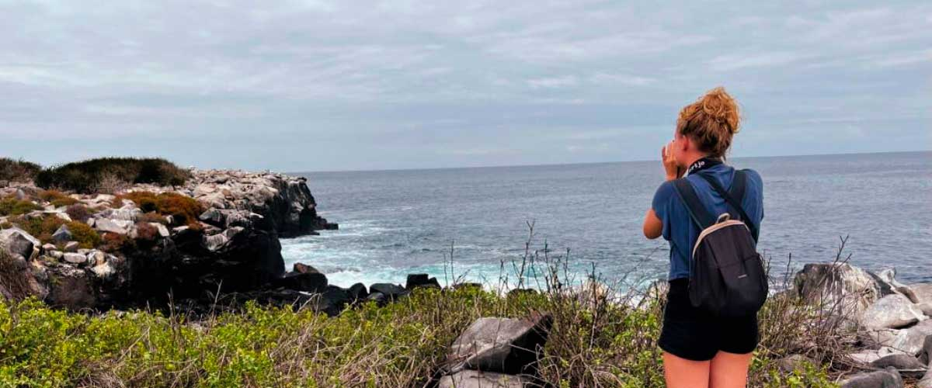

|  |  |
| --- | --- |
| **Trail:** | 1,7 km / 1,1 mi |
| **Level**: | 3 |
| **Activities:** | HIKING |

AM: GARDNER BAY

ardner Bay is one of the most stunning beaches in the Galapagos, with fine white coral sand and crystal-clear waters. Here, sea lions bask on the shore while Española mockingbirds search for food. It’s also a great spot to observe marine iguanas and Galapagos hawks. Nearby, Osborn Islet unveils a vibrant underwater world, perfect for snorkeling. In its calm waters, swim alongside sea turtles, reef sharks, and schools of tropical fish like angelfish, parrotfish, and surgeonfish, making it an unforgettable destination for marine exploration.

Snorkel Experience: Explore the waters of Gardner Bay and Osborn Islet, where you can swim with sea lions, turtles, and reef sharks. Spot rays and schools of tropical fish in a colorful, lively reef.

**Highlights:** Coral sand beach, Galapagos mockingbirds, Galapagos hawks, Darwin finches, Marine iguanas

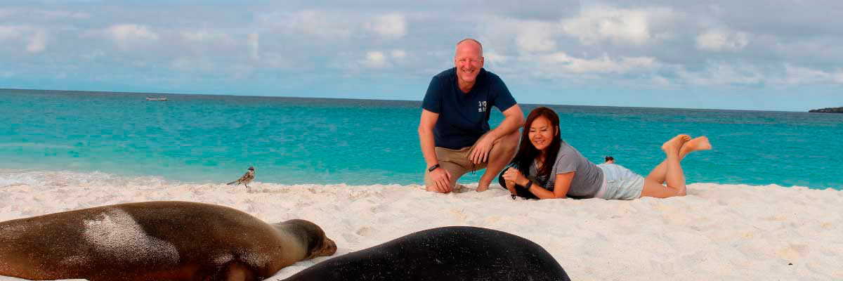

|  |  |
| --- | --- |
| **Food**: | B/L/D |
| **Trail:** | 0,8 km / 0,5 mi |
| **Lodging**: | M/Y Bonita |
| **Level**: | 1 |
| **Activities:** | HIKING,SNORKEL,PADDLE BOARD,KAYAK |

DAY 4

AM: INTERPRETATION CENTER / KICKER ROCK

Located in the outskirts of Puerto Baquerizo, this center is dedicated to the history of human presence in the Galapagos. Since the times of the early Spanish explorers to the present times, including illustrious visitors such as Charles Darwin, this permanent exhibition will take you through the dangers and struggles of the first settlers trying to survive the harsh Galapagos environment.

Snorkel Experience: Depending on the itinerary, snorkel is allowed around Kicker Rock. Very good place to see sharks, sea turtles, rays and a lot of different species of fish. Great diversity of invertebrates growing in the vertical walls.

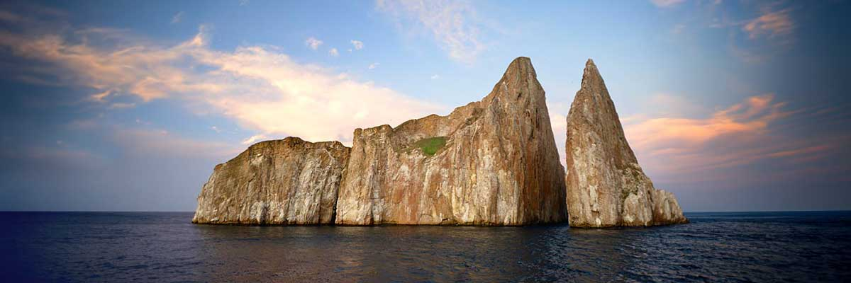

|  |  |
| --- | --- |
| **Trail:** | 0,2 km / 650 ft |
| **Level**: | 1 |
| **Activities:** | HIKING |

PM: LOBOS ISLAND

Lobos Island, a small islet near San Cristóbal, offers an unforgettable wildlife experience. Upon landing, groups of sea lions will greet you as they play in tidal pools. Walking inland, you’ll spot frigatebirds perched in bushes, displaying their inflated red pouches, while blue-footed boobies nest along the trail, performing their iconic courtship dance. In the calm waters, snorkeling provides an incredible opportunity to swim with playful sea lions, while sea turtles and rays rest on the sandy bottom.

Snorkel Experience: The calm waters of Lobos Island are perfect for swimming with playful sea lions. Sea turtles and rays are often seen resting on the sandy bottom, while tropical fish add vibrant colors to the scene.

Stunning Views, Galapagos sea lions, Magnificent and great frigatebirds, San Cristobal Lava Lizards

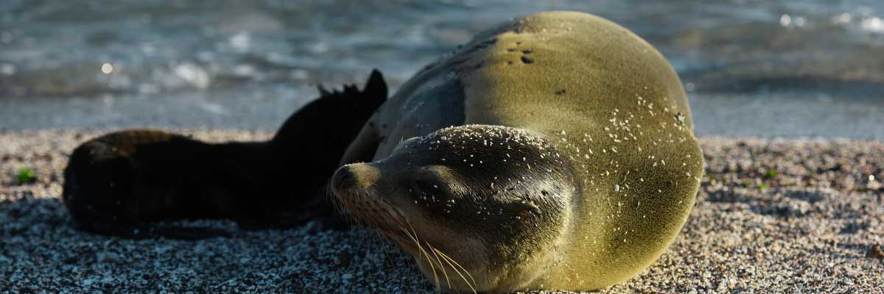

|  |  |
| --- | --- |
| **Food**: | B/L/D |
| **Trail:** | 0,6 km / 0,4 mi |
| **Lodging**: | M/Y Bonita |
| **Level**: | 3 |
| **Activities:** | HIKING |

DAY 5

AM: BACHAS

End your Galapagos adventure at Bachas Beach, a key sea turtle nesting site from November to May. At low tide, remnants of WWII barges emerge from the white sand. Explore its saltwater lagoons, home to flamingos, herons, and aquatic birds. After this final stop, transfer to the airport for your flight back to the mainland, concluding an unforgettable journey.

Stunning Views, Blue footed boobies, White-cheeked pintails, American flamingoes, Sandpipers, Lava gulls

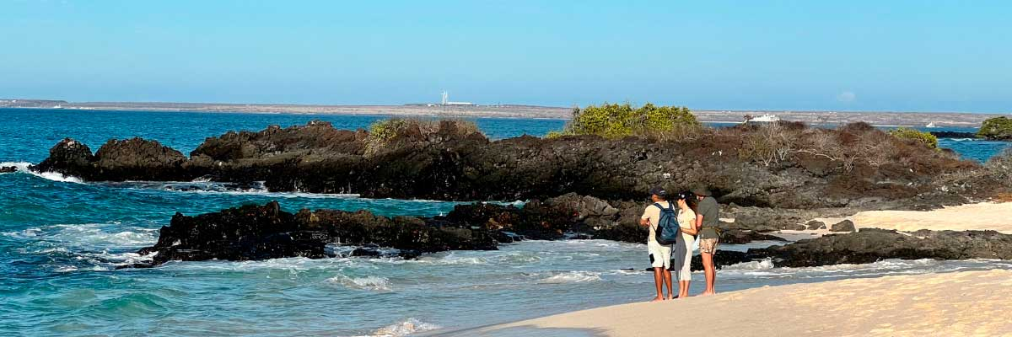

|  |  |
| --- | --- |
| **Trail:** | 1,6 km / 1 mi |
| **Level**: | 1 |
| **Activities:** | HIKING |

PM: BALTRA (AIRPORT)

Your Galapagos adventure comes to an end. Today, you will be transferred to Baltra Airport, where your National Park naturalist guide will assist you with final details before your flight back to mainland Ecuador. As you bid farewell to this paradise, take with you the unforgettable memories of one of the world’s most extraordinary destinations.



|  |  |
| --- | --- |
| **Food**: | B/-/- |
| **Trail:** |  |
| **Lodging**: | M/Y Bonita |
| **Level**: | 1 |
| **Activities:** | - |

GLOSSARY

|  |  |  |
| --- | --- | --- |
| **Feeding** | **Breakfast** | B |
| **Lunch** | L |
| **Dinner** | D |
| **Difficulty of the hike** | **Level 1** | Easy |
| **Level 2** | Moderate |
| **Level 3** | Difficult |