Costa Rica's Pacific and Rainforest Gems: An Unforgettable Journey
4 Days – 3 Nights

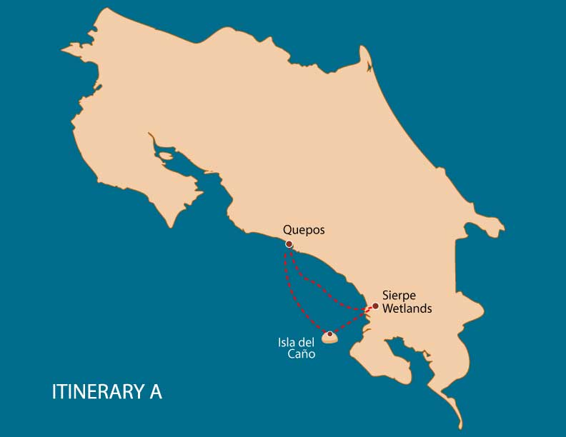

 |  | HKG | SNK | PDB | KYK | JTS | WSD | SST | BTN
DAY 1 | Costa Rica: Quepos | * |  |  |  |  |  |  | *
DAY 2 | Costa Rica: Caño Island | * | * | * | * | * | * | * | *
DAY 3 | Costa Rica: Corcovado National Park |  | * | * | * | * |  | *
DAY 4 | Costa Rica: Quepos - Marina Pez Vela

DAY 1

Costa Rica - Quepos - Marina Pez Vela
Guests arrive in the morning at Quepos, where they can unwind and relax at Marina Pez Vela. Lunch and dinner are fully covered. Your Costa Rican adventure kicks off right here! Explore the world-class marina facilities, and feel the warm Pacific breeze as the crew welcomes you onboard.
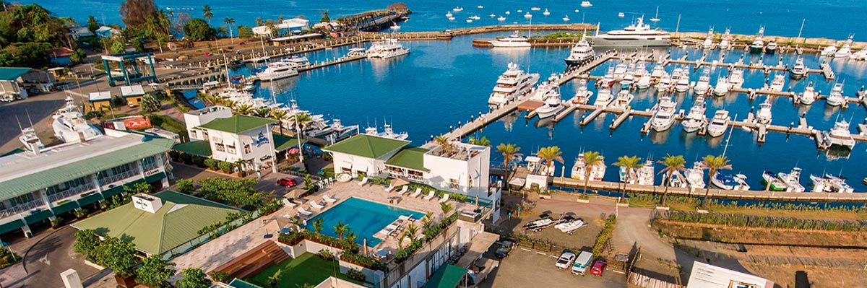

Trail: | -
Level: | 1
Activities: | HIKING,BOAT NAVIGATION

Food: | -/L/D
Trail:
Lodging: | M/Y Galaxy Zibó
Level:
Activities: | -

DAY 2

Costa Rica - Caño Island
Today, the cruise sets course for one of Costa Rica’s most legendary Pacific coast destinations: Caño Island. Surrounded by one of the country most pristine and vibrant marine ecosystems, this Biological Reserve is not only a natural haven, but also a sacred ceremonial site for pre-Columbian indigenous cultures.
As you approach the island, the water becomes stunningly clear, unveiling a colorful mosaic of coral reefs beneath the surface. The day is dedicated to non-motorized water activities, offering a peaceful and immersive experience in perfect harmony with this protected marine sanctuary.
Between adventures, unwind on the ship’s deck or relax in shaded areas with refreshing tropical fruits and natural beverages always accompanied by breathtaking ocean views.
Caño Island offers a perfect balance of conservation and exploration. This day invites you to (literally) dive into Costa Rica’s remarkable commitment to protecting its natural treasures.
To close a day full of sun, sea, and laughter, enjoy a calm and flavorful evening with our exclusive Cocktails Onboard Experience a relaxed atmosphere where you can sip, socialize, and watch the sun dip beneath the horizon.
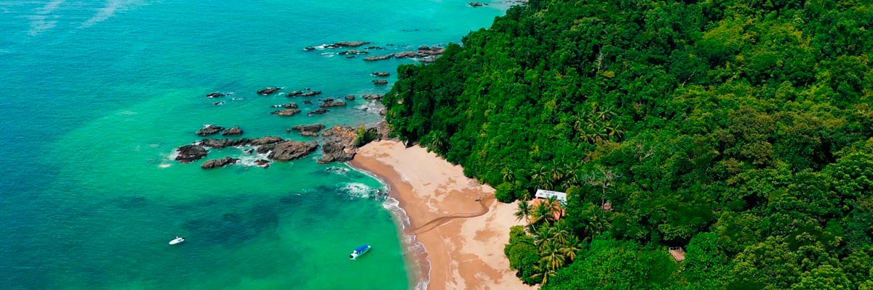

Trail: | 4 hours
Level: | 1
Activities: | HIKING,SNORKEL,PADDLE BOARD,KAYAK,JET SKIS,WATER SLIDE,SEA SCOOTER,BOAT NAVIGATION

Food: | B/L/D
Trail:
Lodging: | M/Y Galaxy Zibó
Level:
Activities: | -

DAY 3

Costa Rica - Drake Bay - Corcovado National Park
Wake up to the golden sunrise over the Osa Peninsula mountains, accompanied by the songs of tropical birds. Today’s destination is Corcovado National Park, hands down one of the most stunning spots in Costa Rica, hailed by National Geographic as the most biologically intense place on Earth per square meter. After breakfast onboard, prepare for a day of deep connection with nature. All three of your daily meals are included.
The vessel will approach one of the park’s ranger stations either, San Pedrillo or Sirena, where expert naturalist guides will lead you on a hike through primary tropical rainforest trails. Along the way, keep an eye out for three species of monkeys, sloths, tapirs, and, with a bit of luck, even the elusive jaguar. Endemic birds, colorful frogs, and dazzling blue morpho butterflies accompany every step in this unique rainforest experience. In the afternoon, the adventure shifts from the forest to the turquoise waters surrounding the park. Anchored in a secluded bay, the yacht becomes your floating base for aquatic activities: kayaking, snorkel, glide down the water slide, paddleboard, hop on a jet ski, or explore with a Sea scooter. Whether on land or at sea, today is a celebration of the wild, untamed beauty that makes Costa Rica so extraordinary.
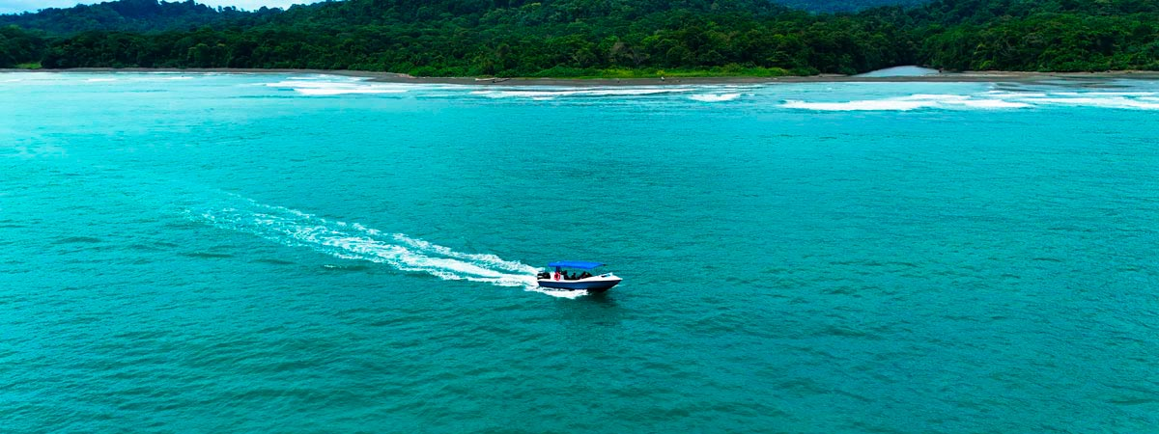

Trail: | 4.5 hours
Level: | 1
Activities: | SNORKEL,PADDLE BOARD,KAYAK,JET SKIS,SEA SCOOTER

Food: | B/L/D
Trail:
Lodging: | M/Y Galaxy Zibó
Level:
Activities: | -

DAY 4

Costa Rica - Quepos - Marina Pez Vela
This is the perfect time to savor the final moments in Costa Rica, capturing last photographs of the stunning coastline and lush surroundings, and reflecting on the unforgettable experiences of the journey. Guests prepare for departure, carrying with them lasting memories of the country’s extraordinary natural beauty.

Trail: | -
Level: | 1
Activities: | -

Food: | B/-/-
Trail:
Lodging: | M/Y Galaxy Zibó
Level:
Activities: | -

GLOSSARY
Feeding |  | Breakfast | B
 |  | Lunch | L
 |  | Dinner | D
Difficulty of the hike |  | Level 1 | Easy
 |  | Level 2 | Moderate
 |  | Level 3 | Difficult
Activities |  | HKG | Hiking
 |  | SNK | Snorkel
 |  | PDB | Paddle Board
 |  | KYK | Kayak
 |  | JTS | Jet Skis
 |  | WSD | Water Slide
 |  | SST | Sea scooter
 |  | BTN | Boat Navigation
✔ noneX none
• none

