Diving into the Wildlife Wonders and Marine Magic of the Galapagos
5 Days – 4 Nights

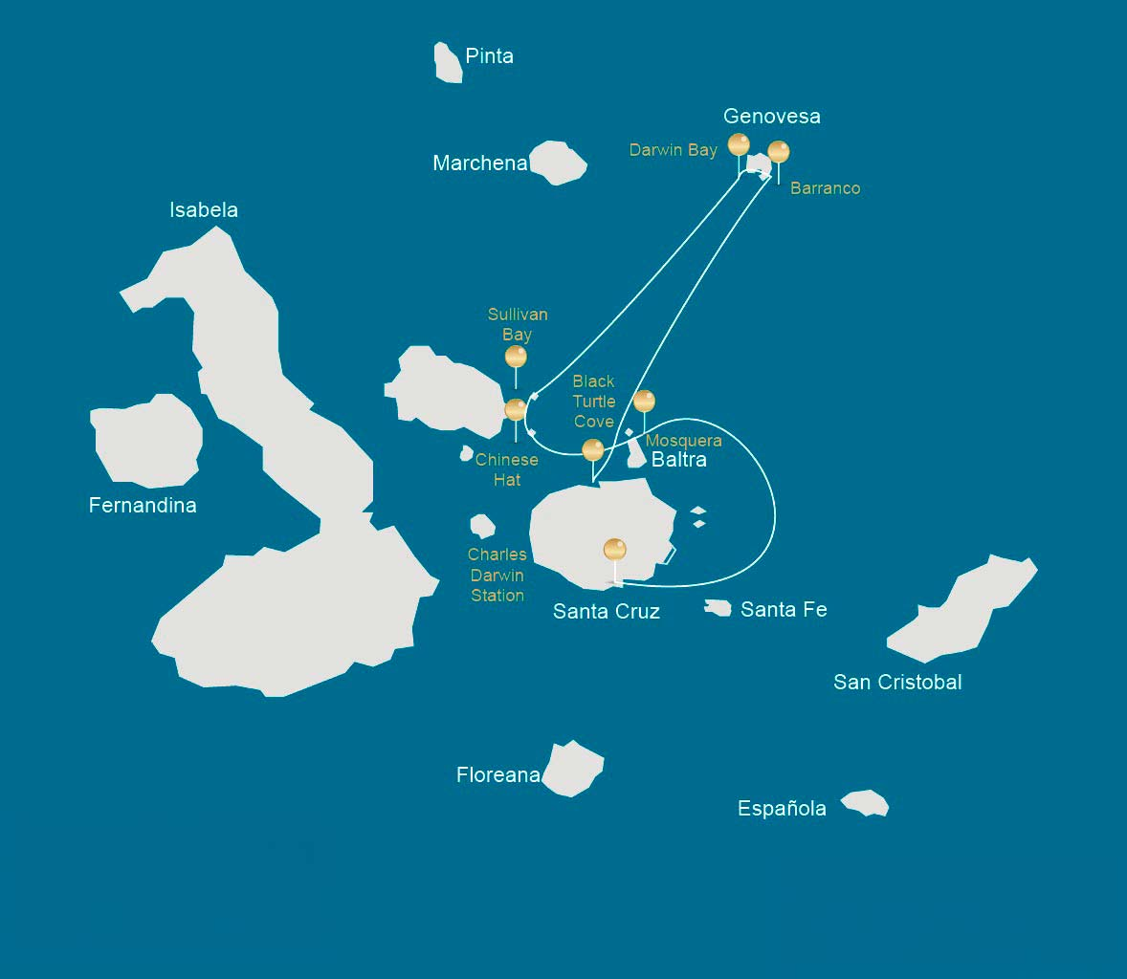

 |  |  | Hiking | Snorkel | Panga Ride | Paddle Board | Kayak
THURSDAY | AM | Santa Cruz Island : Baltra - airport (arrival)
 | PM | Santa Cruz Island : Black Turtle Cove |  |  | *
FRIDAY | AM | Genovesa Island : Darwin Bay | * | * | * | * | *
 | PM | Genovesa Island : Barranco | * | * | * | * | *
SATURDAY | AM | Santiago Island : Sullivan Bay | * | * | *
 | PM | Bartolome Island : Bartolome | * | * | *
SUNDAY | AM | Chinese Hat Island : Chinese Hat | * | * | * | * | *
 | PM | Mosquera Island : Mosquera | * | *
MONDAY | AM | Santa Cruz Island : Charles Darwin Station | *
 |  | Santa Cruz Island : Baltra - airport (return)

DAY 1

AM: ARRIVAL AT BALTRA AIRPORT
Your voyage to the captivating Galapagos Islands commences! Upon your arrival at Baltra Airport, you'll be greeted by our National Park-certified naturalist guide, ready to introduce you to the unique wonders of this pristine archipelago.

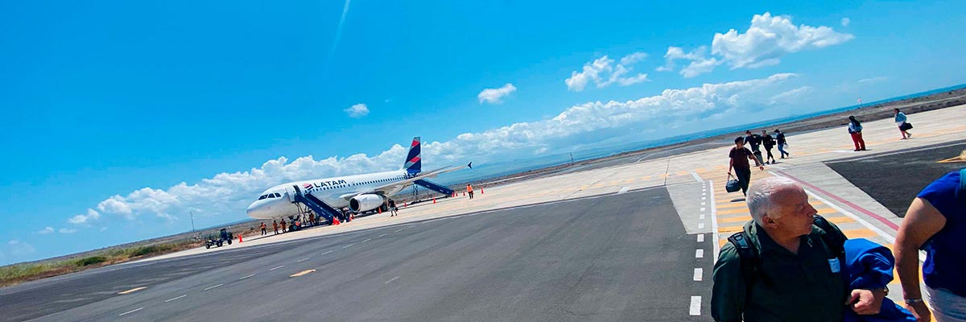

Trail:
Level: | 1
Activities: | -

PM: BLACK TURTLE COVE
We dive into our Galapagos adventure at Black Turtle Cove, aptly named for the thriving “Tortugas negras” population or green sea turtles. We navigate this natural sanctuary on dinghies, cruising amidst serene mangrove forests and tranquil water channels. Expect sightings of reef sharks, diverse ray species, and a plethora of bird species, including herons, pelicans, and boobies. Remember, this magical cove is a significant breeding ground for turtles and a nursery for various shark species!

Mangroves, White-tipped and black-tipped reef sharks, Green sea turtles, Rays, Herons, Blue footed boobies, Reef sharks

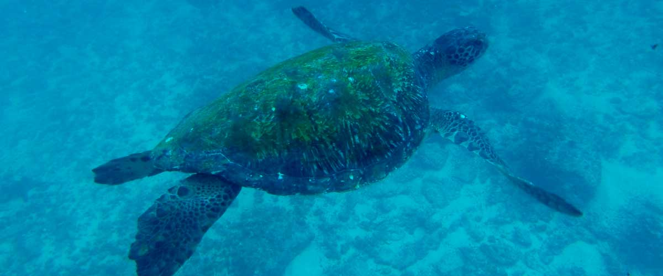

Food: | -/L/D
Trail:
Lodging: | M/C Alya
Level: | 1
Activities: | PANGA RIDE

DAY 2

AM: DARWIN BAY
Start your day surrounded by the bustling avian life of Darwin Bay on Genovesa Island, a birdwatcher's paradise. As soon as your feet touch the sandy terrain, you're welcomed by a symphony of seabird calls, with frigatebirds, boobies, and gulls soaring overhead or nestled in the foliage. The trail meanders through colonies of sea lions, marine iguanas, night herons, Darwin finches, Galapagos doves, mockingbirds, and more.

Highlights: Nesting great frigatebirds, Red-footed and Nazca boobies, Galapagos sea lions, Yellow-crowned night herons, Genovesa ground finch, Genovesa cactus finch, Galapagos mockingbirds

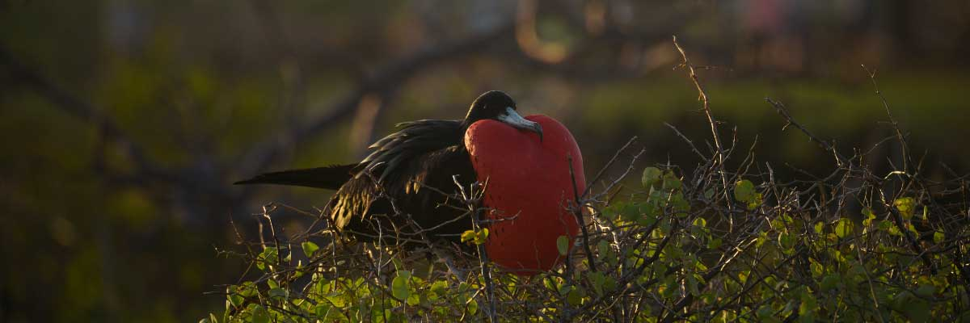

Trail: | 1,2 km / 0,7 mi
Level: | 3
Activities: | HIKING,SNORKEL,PANGA RIDE,PADDLE BOARD,KAYAK

PM: BARRANCO
Next stop, El Barranco. Known for its fractured lava cliffs serving as the perfect dwelling for storm petrel colonies, this unique ecosystem draws a significant population of short-eared owls. A trail alongside these cliffs reveals red-footed and Nazca boobies aplenty. Resting in the shadows at the cliffs' base, you may spot Galapagos fur seals and numerous seabirds.

Highlights: Nesting great frigatebirds, Galapagos sea lions, Genovesa ground finch, Genovesa cactus finch, Galapagos mockingbirds, Galapagos fur seals

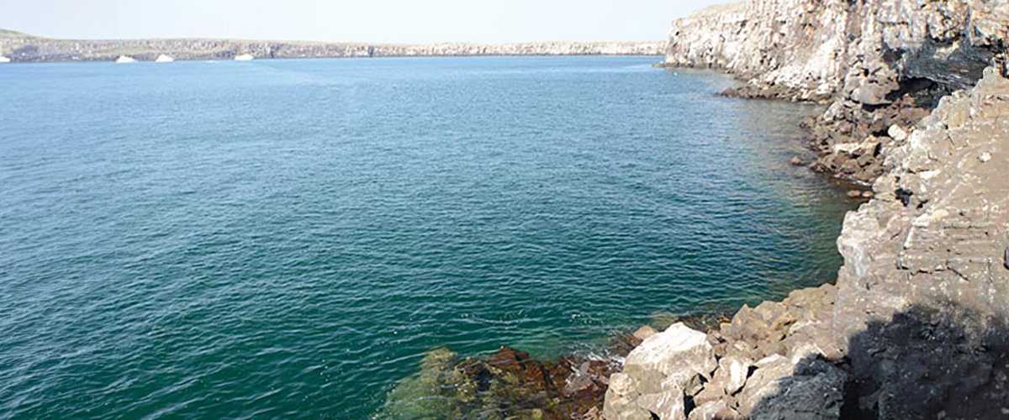

Food: | B/L/D
Trail: | 1,2 km / 0,7 mi
Lodging: | M/C Alya
Level: | 3
Activities: | HIKING,SNORKEL,PANGA RIDE,PADDLE BOARD,KAYAK

DAY 3

AM: SULLIVAN BAY
Step back in time at Sullivan Bay, an open book to the volcanic birth of these islands. Traverse the well-preserved Pahoehoe lava field, studying its delicate, unique textures. The seemingly lifeless landscape gradually unveils a resilience of nature, with pioneer plants, lava lizards, and tiny birds emerging on careful observation. Keep your eyes on the shoreline for resident penguins, pelicans, and oystercatchers.

Highlights: Lava tubes, Galapagos penguins, Oystercatchers, Galapagos hawks

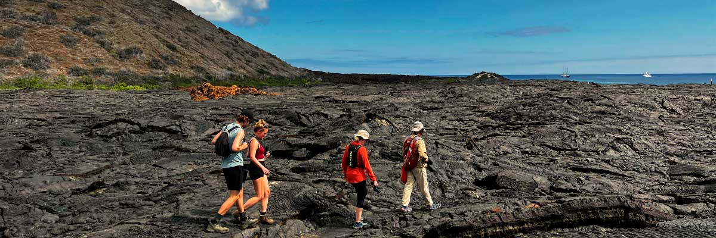

Trail: | 2,2 km / 1,4 mi
Level: | 2
Activities: | HIKING,SNORKEL,PANGA RIDE

PM: BARTOLOME
Stand atop Bartolome Island for unparalleled views of the lunar-like landscape, punctuated by scattered volcanic cones, Pinnacle Rock, and the bay of Sullivan. Bartolome is a jewel in the Galapagos crown and home to a vibrant population of penguins.

Highlights: Volcanic landscapes, Pinnacle rock, Herons, Bluefooted boobies, Galapagos penguins

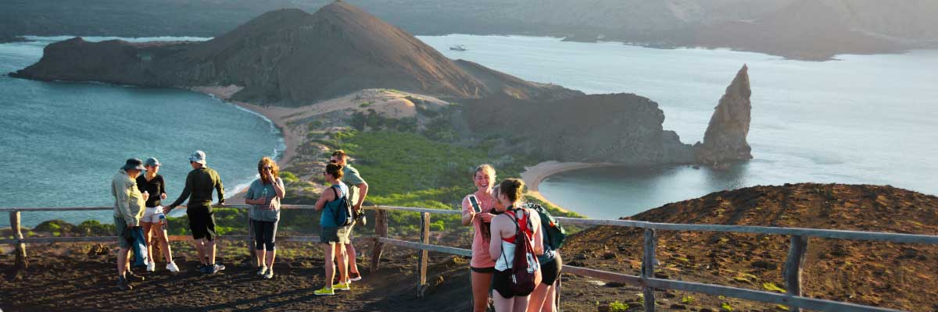

Food: | B/L/D
Trail: | 1,5 km / 0,9 mi
Lodging: | M/C Alya
Level: | 2
Activities: | HIKING,SNORKEL,PANGA RIDE

DAY 4

AM: CHINESE HAT
Welcome to the perfectly symmetrical volcanic cone of Chinese Hat! Separated from Santiago by a slender channel, this idyllic islet is framed by turquoise waters, coral sand beaches, and dark lava rocks – an unexpected haven for penguins. A shore trail brings you up close to a small colony of sea lions.

Highlights: Lava tubes, Galapagos sea lions, Galapagos penguins, Oystercatchers, Galapagos hawks

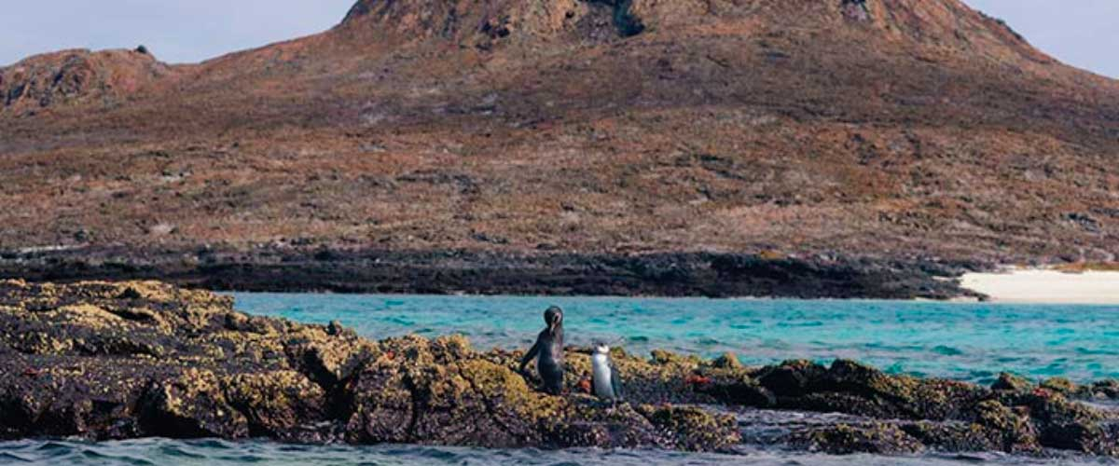

Trail: | 1,3 km / 0,8 mi
Level: | 3
Activities: | HIKING,SNORKEL,PANGA RIDE,PADDLE BOARD,KAYAK

PM: MOSQUERA
Our afternoon destination is Mosquera, largely a barren sand bar with rocky outcrops and salt-resistant vegetation. Stroll along the beach, observing the playful antics of sea lion pups in the surf and tide pools. Keep an eye out for endemic lava gulls, often spotted in mid-flight hunting for their next meal.

Highlights: Stunning Views, Galapagos sea lions, Oystercatchers, Lava gulls, Shorebirds

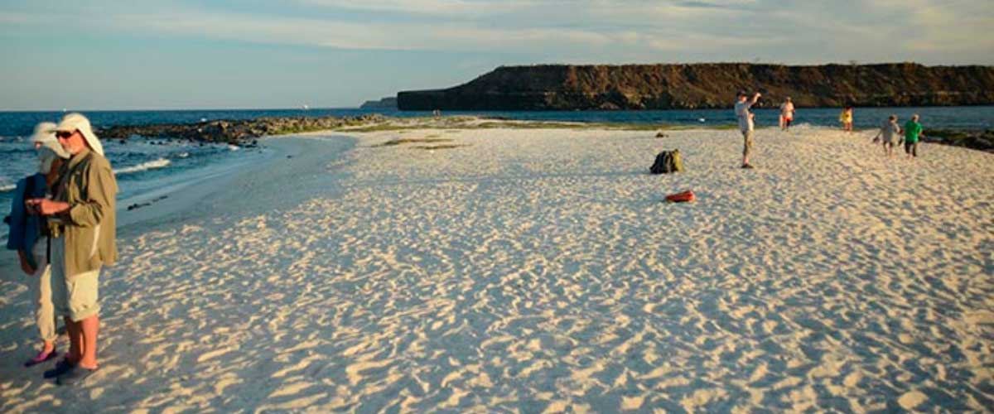

Food: | B/L/D
Trail: | sandy area of 0,6 km / 0,4mi
Lodging: | M/C Alya
Level: | 1
Activities: | HIKING,SNORKEL

DAY 5

AM: CHARLES DARWIN STATION
Spend your morning at the renowned Charles Darwin Station. As a nonprofit organization working closely with the Galapagos National Park, the station is committed to the preservation and study of the archipelago's biodiversity. Discover the myriad initiatives underway to safeguard native species and combat invasive threats to the Galapagos ecosystem. This visit offers the unique opportunity to see giant tortoises bred in captivity.

Galapagos giant tortoise and land iguanas breeding program, Galapagos mockingbirds, Darwin finches, Galapagos flycatchers

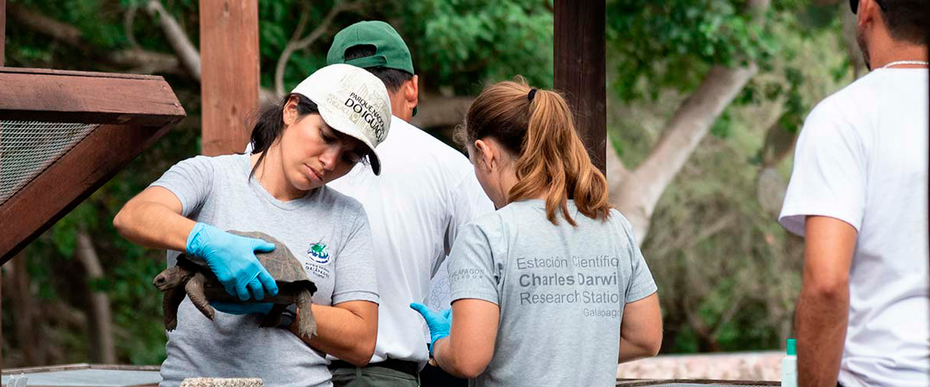

Trail: | 2 km / 1,2 mi
Level: | 1
Activities: | HIKING

AM: BALTRA (AIRPORT)
Your Galapagos adventure comes to an end. Today, you will be transferred to Baltra Airport, where your National Park naturalist guide will assist you with final details before your flight back to mainland Ecuador. As you bid farewell to this paradise, take with you the unforgettable memories of one of the world’s most extraordinary destinations.

Food: | B/-/-
Trail:
Lodging: | M/C Alya
Level: | 1
Activities: | -

GLOSSARY
Feeding |  | Breakfast | B
 |  | Lunch | L
 |  | Dinner | D
Difficulty of the hike |  | Level 1 | Easy
 |  | Level 2 | Moderate
 |  | Level 3 | Difficult
✔ noneX none
• none

