The Unforgettable Journey Among Land Giants and Marine Marvels
6 Days – 5 Nights

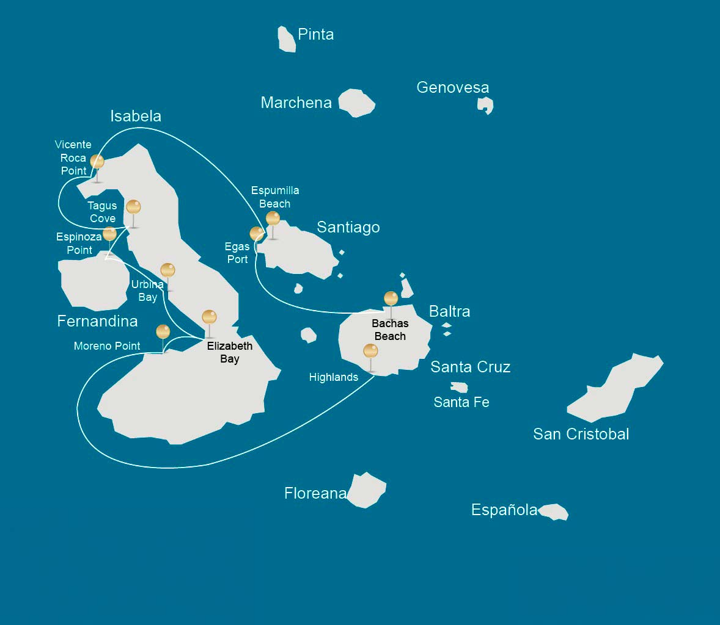

 |  |  | Hiking | Snorkel | Panga Ride | Paddle Board | Kayak
MONDAY | AM | Santa Cruz Island : Baltra - airport (arrival)
 | PM | Santa Cruz Island : Highlands |  | *
TUESDAY | AM | Isabela Island : Moreno Point | * | * | *
 | PM | Isabela Island : Elizabeth Bay |  |  | * | * | *
WEDNESDAY | AM | Isabela Island : Urbina Bay | * | *
 | PM | Fernandina Island : Espinoza Point | * | * | *
THURSDAY | AM | Isabela Island : Tagus Cove | * | * | * | * | *
 | PM | Isabela Island : Vicente Roca Point |  | * | *
FRIDAY | AM | Santiago Island : Espumilla Beach | *
 | PM | Santiago Island : Egas Port | * | *
SATURDAY | AM | Santa Cruz Island : Bachas Beach | *
 |  | Santa Cruz Island : Baltra - airport (return)

DAY 1

AM: BALTRA AIRPORT
Your voyage to the captivating Galapagos Islands commences! Upon your arrival at Baltra Airport, you'll be greeted by our National Park-certified naturalist guide, ready to introduce you to the unique wonders of this pristine archipelago.

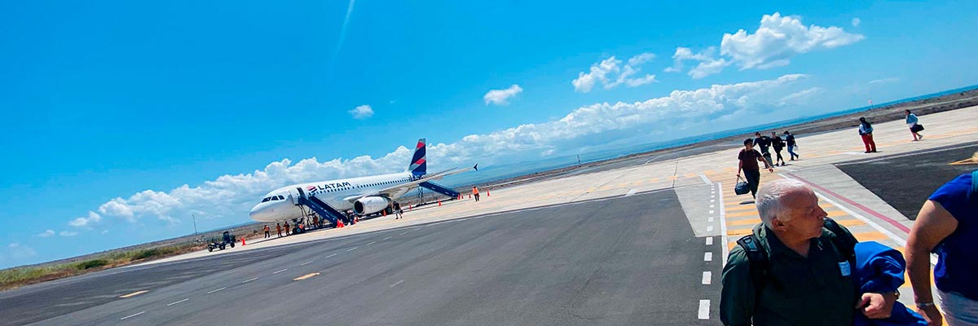

Trail:
Level: | 1
Activities: | -

PM: HIGHLANDS
Embark on a pleasant journey into the verdant highlands, where a bus ride leads you through lush forested landscapes home to Galapagos Giant Tortoises. These impressive creatures, reaching up to 300 kg/600 lbs, can often be seen peacefully grazing or resting in freshwater ponds. The highlands are also home to a variety of bird species rarely found in the lowlands. Depending on your itinerary, you may have the opportunity to visit a lava tunnel and learn about the volcanic forces that shaped these remarkable islands.

Lava tunnels, Darwin finches, Galapagos flycatchers, Giant tortoises, Barn owls, White-cheeked pintails

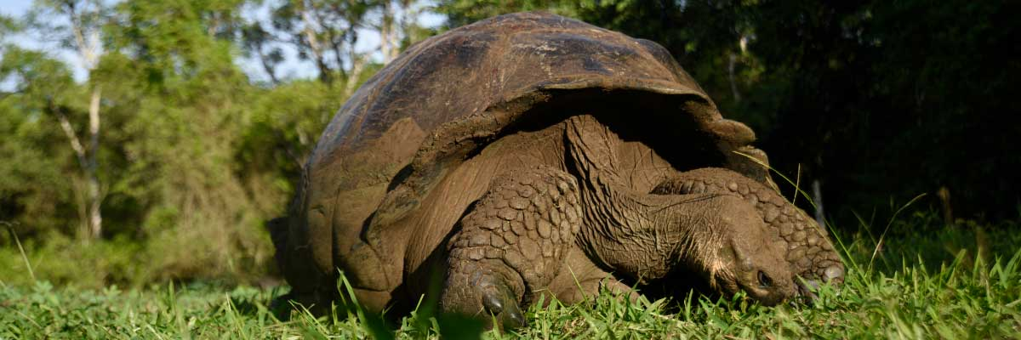

Food: | -/L/D
Trail: | 1-1,5 km / 0,6-0,9 mi
Lodging: | M/C Alya
Level: | 1
Activities: | SNORKEL

DAY 2

AM: MORENO POINT
Commence your day at the enchanted Moreno Point. The extensive lava fields may first appear lifeless, but within its borders lie scattered brackish lagoons teeming with life such as flamingos, gallinules, ducks, and herons. Along the coast, keep an eye out for penguins, marine iguanas, flightless cormorants, blue-footed boobies, sea lions, oystercatchers, and other shore birds.

Highlights: Stunning Views, Galapagos mockingbirds, Darwin finches, American flamingoes, Flightless cormorants, Marine iguanas, Ducks, Gallinules

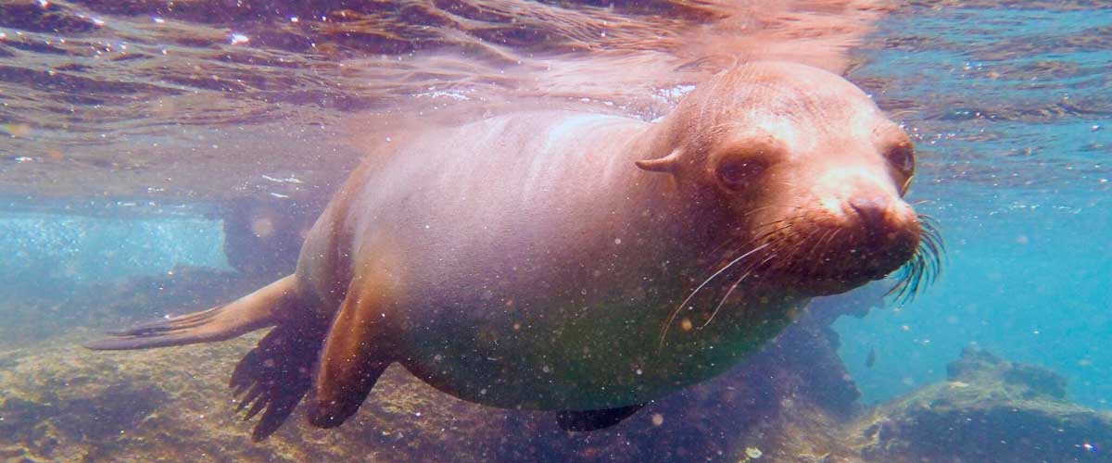

Trail: | 1,6 km / 1 mi
Level: | 3
Activities: | HIKING,SNORKEL,PANGA RIDE

PM: ELIZABETH BAY
Elizabeth Bay, your afternoon stop, is a sheltered bay encircled by towering mangroves and barren lava fields. There are no trails here, so you'll undertake a dinghy tour to explore the teeming channels, pools, and coves. This location is one of the finest to observe Galapagos penguins, flightless cormorants, blue-footed boobies, pelicans, rays, and sea turtles.

Highlights: Mangroves, Rays, Herons, Galapagos penguins, Galapagos hawks, Flightless cormorants, Sea turtles

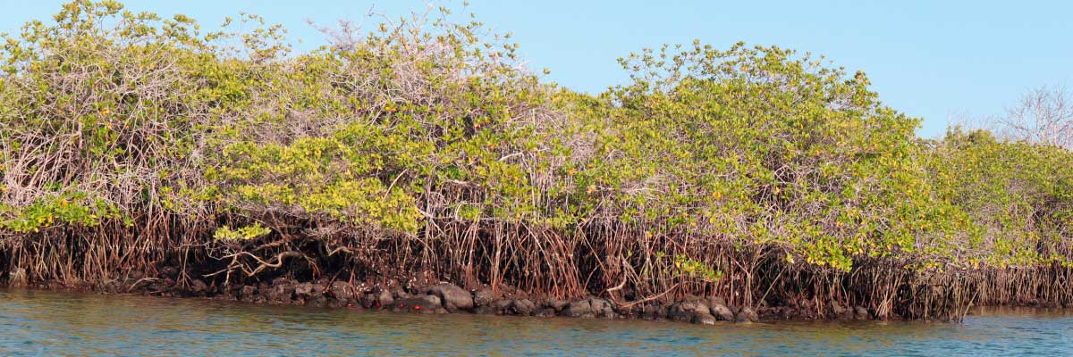

Food: | B/L/D
Trail: | 1,4 km / 0,8 mi
Lodging: | M/C Alya
Level: | 1
Activities: | PANGA RIDE,PADDLE BOARD,KAYAK

DAY 3

AM: URBINA BAY
Urbina Bay, known for its dramatic uplift during the 1950s, awaits your visit in the morning. As you traverse the trail, observe small shells and corals, indicators that this area was submerged just over sixty years ago. Here you can encounter land iguanas and, during certain seasons, giant tortoises. Galapagos hawks nest in the area, often seen soaring or perched on trees.

Highlights: Stunning Views, Galapagos mockingbirds, Galapagos hawks, Darwin finches, Galapagos flycatchers, Galapagos land iguanas

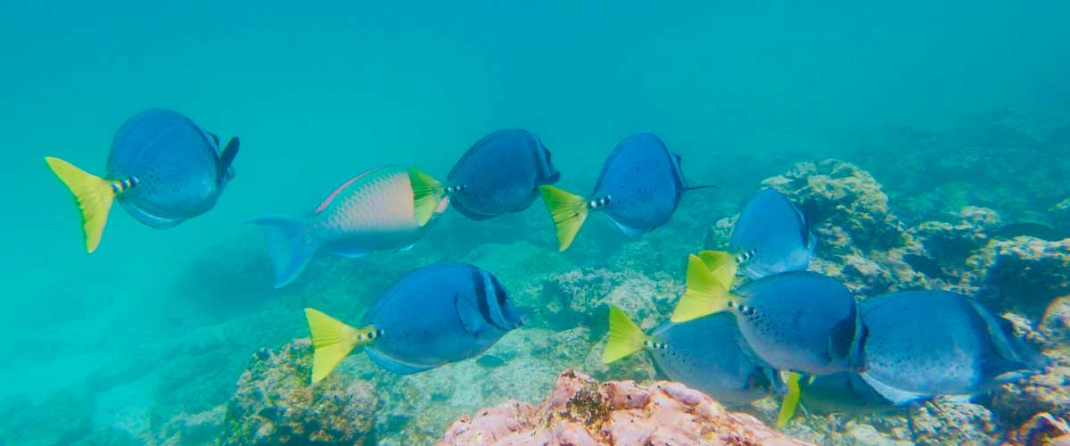

Trail: | 1,2 km / 0,7 mi. Long trail 3,0 km / 1,8 mi
Level: | 1
Activities: | HIKING,SNORKEL

PM: ESPINOZA POINT
Espinoza Point is a National Park gem located at the base of an imposing volcano (the most active in the Galapagos islands). Upon landing, be greeted by hundreds of marine iguanas in the largest colony for the species. Also present are sea lions, flightless cormorants, herons, pelicans, oystercatchers, sea turtles, shorebirds, and more. Look to the mangroves where Galapagos hawks often perch, on the lookout for prey.

Highlights: Stunning Views, Herons, Galapagos penguins, Oystercatchers, Galapagos hawks, Marine iguanas, Sea turtles, Shorebirds

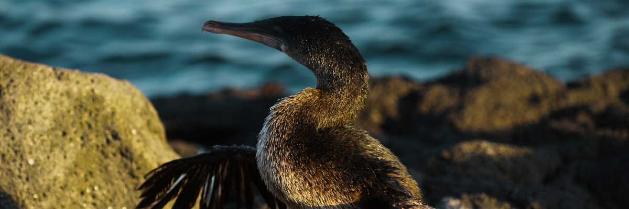

Food: | B/L/D
Trail: | 1,6 km / 1 mi
Lodging: | M/C Alya
Level: | 2
Activities: | HIKING,SNORKEL,PANGA RIDE

DAY 4

Tagus Cove, a location visited by Charles Darwin during his Galapagos exploration, offers a dry Palo Santo forest where Darwin finches and mockingbirds reside. Take in the marvelous views of Darwin's Lake and the grand volcanos of northern Isabela. A boat tour along the coast will reveal penguins, cormorants, marine iguanas, and the Galapagos martin, an endangered endemic species.

Highlights: Stunning Views, Herons, Galapagos penguins, Galapagos hawks, Flightless cormorants, Marine iguanas, Sea turtles, Sea stars

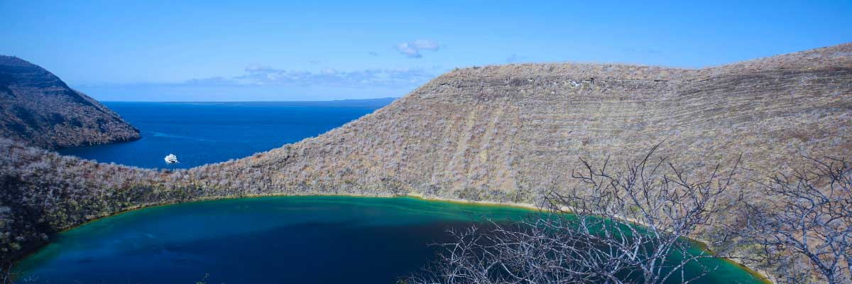

Trail: | 2,6 km / 1,6 mi
Level: | 3
Activities: | HIKING,SNORKEL,PANGA RIDE,PADDLE BOARD,KAYAK

Vicente Roca Point, surrounded by some of the tallest cliffs in the Galapagos, is ideal for observing breathtaking landscapes and interesting volcanic features. A dinghy tour will offer closer views of pelicans, flightless cormorants, sea turtles, boobies, Galapagos fur seals, and marine iguanas. Whales and dolphins also frequent the area.

Highlights: Stunning Views, Galapagos penguins, Flightless cormorants, Marine iguanas, Sea turtles

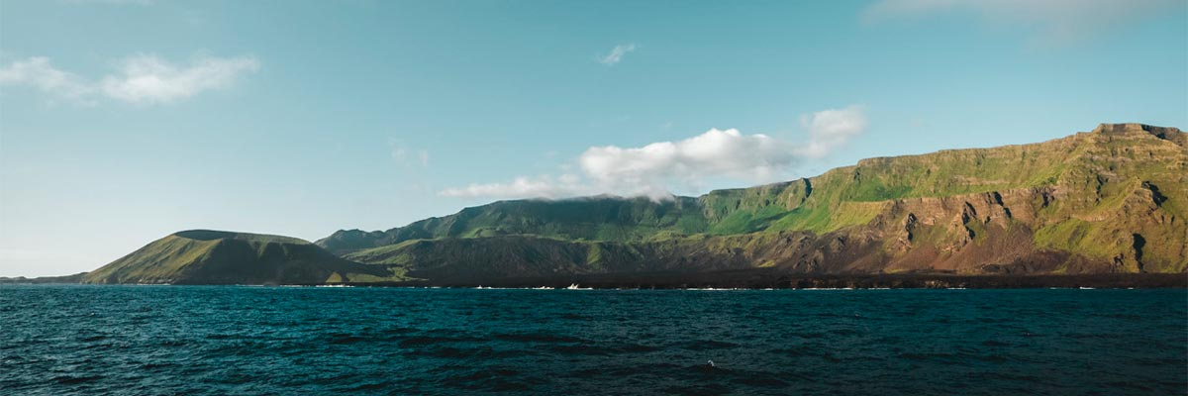

Food: | B/L/D
Trail: | 1,4 km / 0,8 mi
Lodging: | M/C Alya
Level: | 1
Activities: | SNORKEL,PANGA RIDE

DAY 5

AM: ESPUMILLA BEACH
Discover the beauty of Espumilla Beach, a long stretch of rusty-brown sand on Santiago’s northern coast. Surrounded by dense mangroves and a captivating dry forest, it is home to various bird species, including the Galapagos hawk, finches, mockingbirds, and doves. During the rainy season, the salt pan bursts with life as flamingos and ducks wade through the shallow waters. This destination blends stunning landscapes with rich biodiversity, making it a perfect spot for birdwatching and nature immersion.

Highlights: Stunning Views, Herons, Galapagos mockingbirds, Oystercatchers, Galapagos hawks, Darwin finches, Bobbies

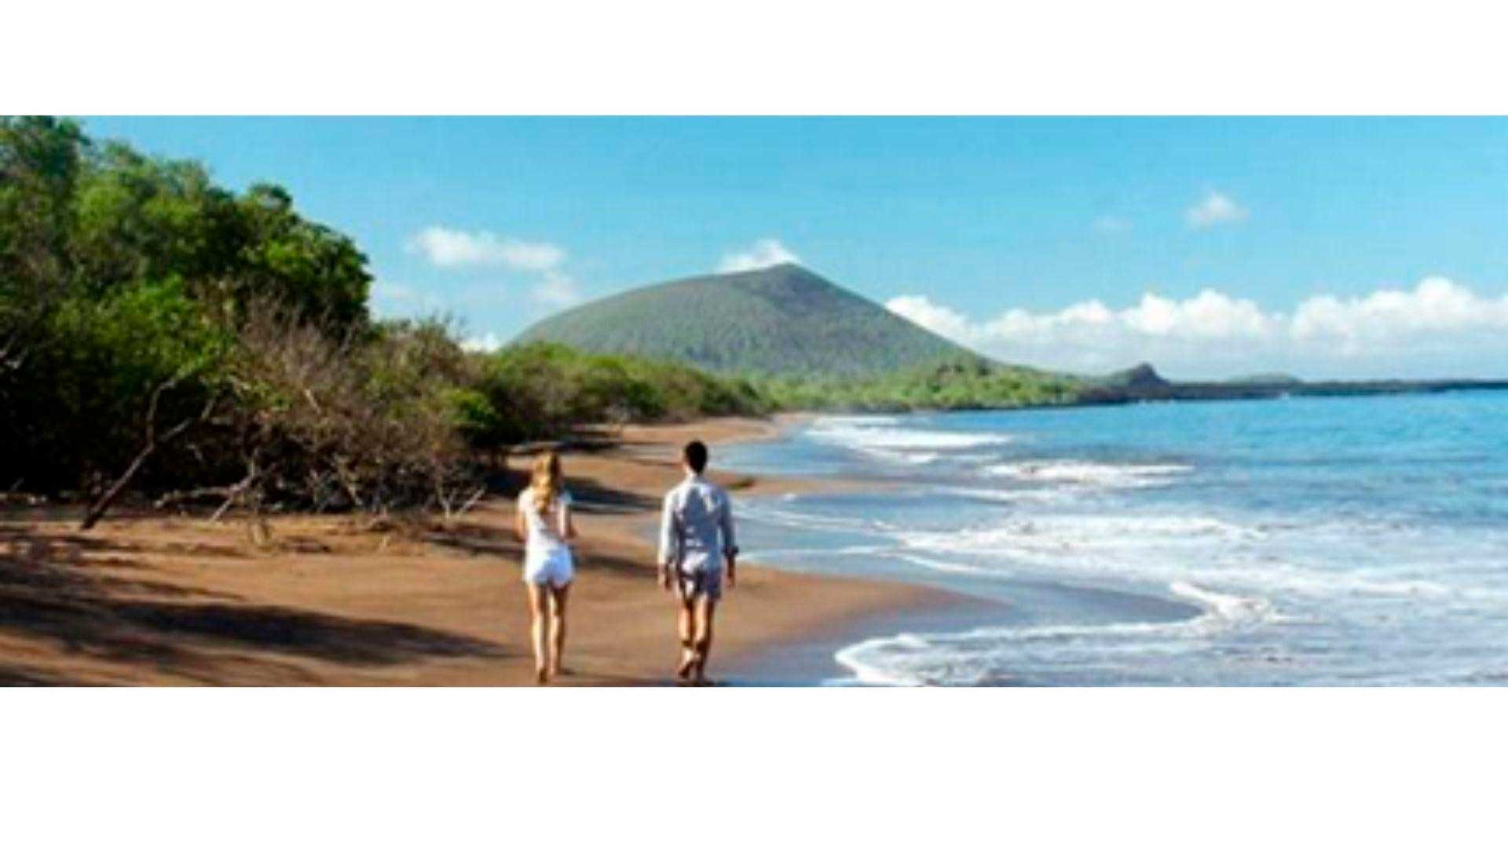

Trail: | 2,3 km / 1,4 mi (plus an extra loop 1 km - 0,6 mi)
Level: | 1
Activities: | HIKING

PM: EGAS PORT
Puerto Egas is a fascinating destination where history and wildlife intertwine. While there is no actual port, remnants of 1960s colonization attempts still stand. The coastal trail is teeming with marine iguanas basking in the sun and sea lions resting on the rocks. Herons, oystercatchers, and shorebirds complete this thriving ecosystem. Towards the end of the trail, the grottos are home to a small colony of the elusive Galapagos fur seal. Additionally, land iguanas were reintroduced to the island in 2019 after over a century of absence.

Highlights: Stunning Views, Herons, Galapagos sea lions, Galapagos fur seals, Oystercatchers, Galapagos hawks, Darwin finches, Marine and land iguanas, Galapagos doves, Shorebirds

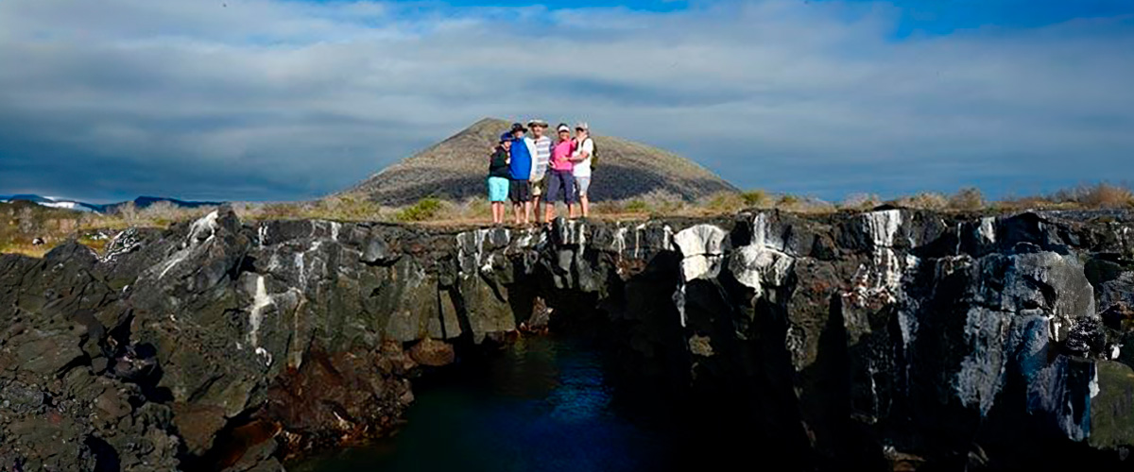

Food: | B/L/D
Trail: | 2,3 km / 1,4 mi
Lodging: | M/C Alya
Level: | 1
Activities: | HIKING,SNORKEL

DAY 6

AM:BACHAS
After, we will go to the beach known as Bachas, located north of Santa Cruz Island. Here we can snorkel or take a relaxing walk on the beach. For this, we will make a wet landing, in which we will jump from the panga to the shore of the beach. Again, we recommend disembarking barefoot and wearing light walking shoes for the rest of the journey. The saltwater lagoon behind the beach often has great blue herons and small birds. Both beaches are nesting areas for green sea turtles.

Stunning Views, Blue footed boobies, White-cheeked pintails, American flamingoes, Sandpipers, Lava gulls

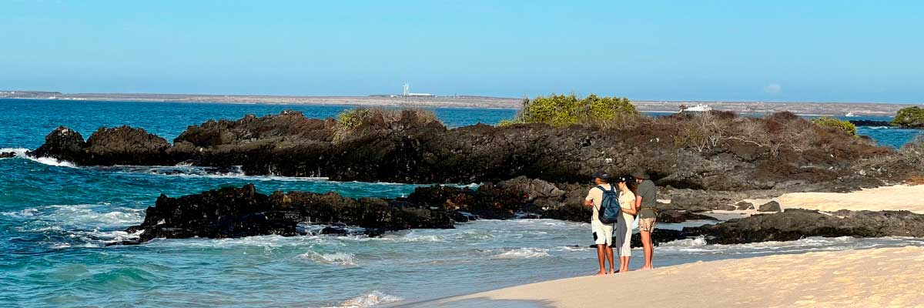

Trail: | 1,6 km / 1 mi
Level: | 1
Activities: | HIKING

AM: BALTRA (AIRPORT)
Your Galapagos adventure comes to an end. Today, you will be transferred to Baltra Airport, where your National Park naturalist guide will assist you with final details before your flight back to mainland Ecuador. As you bid farewell to this paradise, take with you the unforgettable memories of one of the world’s most extraordinary destinations.

Food: | B/-/-
Trail:
Lodging: | M/C Alya
Level: | 1
Activities: | -

GLOSSARY
Feeding |  | Breakfast | B
 |  | Lunch | L
 |  | Dinner | D
Difficulty of the hike |  | Level 1 | Easy
 |  | Level 2 | Moderate
 |  | Level 3 | Difficult
✔ noneX none
• none

