Immerse in Nature's Grandeur: A Wildlife Expedition across the Galapagos
6 Days – 5 Nights

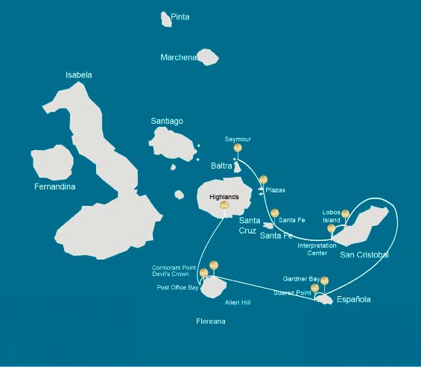

 |  |  | Hiking | Snorkel | Panga Ride | Paddle Board | Kayak
SATURDAY | AM | Santa Cruz Island : Baltra - airport (arrival)
 | PM | Seymour Island : North Seymour | *
SUNDAY | AM | South Plazas Island : South Plaza | * |  | * | * | *
 | PM | Santa Fe Island : Santa Fe | * | * | * | * | *
MONDAY | AM | San Cristobal Island : Interpretation Center / Kicker Rock | *
 | PM | San Cristobal Island : Lobos Island | * | * | *
TUESDAY | AM | Española Island : Gardner Bay | * | * |  | * | *
 | PM | Española Island : Suarez Point | *
WEDNESDAY | AM | Floreana Island : Cormorant Point / Devil's Crown | * | * | * | * | *
 | PM | Floreana Island : Post Office Bay | *
THURSDAY | AM | Santa Cruz Island : Highlands | *
 | PM | Santa Cruz Island : Baltra - airport (return)

DAY 1

AM: ARRIVAL AT BALTRA AIRPORT
Your voyage to the captivating Galapagos Islands commences! Upon your arrival at Baltra Airport, you'll be greeted by our National Park-certified naturalist guide, ready to introduce you to the unique wonders of this pristine archipelago.

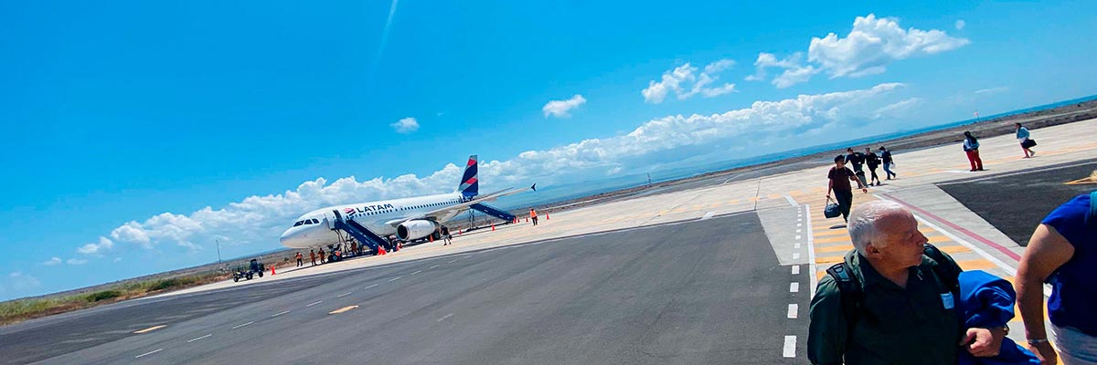

Trail:
Level: | 1
Activities: | -

PM: SEYMOUR
Immerse in the abundant wildlife of Seymour Island. Watch out for magnificent and great frigatebirds displaying their fascinating courtship ritual. Observe blue-footed boobies in their nesting grounds and catch a glimpse of land and marine iguanas in their natural habitat. Delight in the playful activities of sea lions in the surf.

Galapagos sea lions, Magnificent and great frigatebirds, Land and marine iguanas, Darwin finches

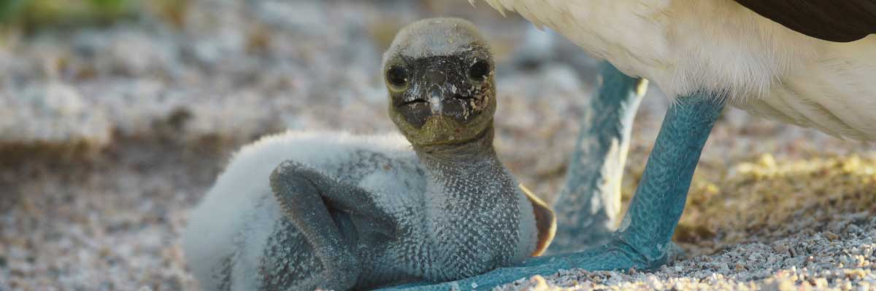

Food: | -/L/D
Trail: | 1,4 km / 0,8 mi
Lodging: | M/C Alya
Level: | 1
Activities: | HIKING

DAY 2

AM: PLAZAS
Discover the richness of South Plazas, where land iguanas feed on prickly-pear cacti and playful sea lion pups frolic in tide pools. Walk along the cliff trail and witness the flurry of sea birds such as frigatebirds, red-billed tropicbirds, boobies, swallow-tailed gulls, and pelicans.

Highlights: Stunning Views, Boobies, Galapagos sea lions, Galapagos shearwaters, Galapagos land iguanas, Tropicbirds, Pelicans

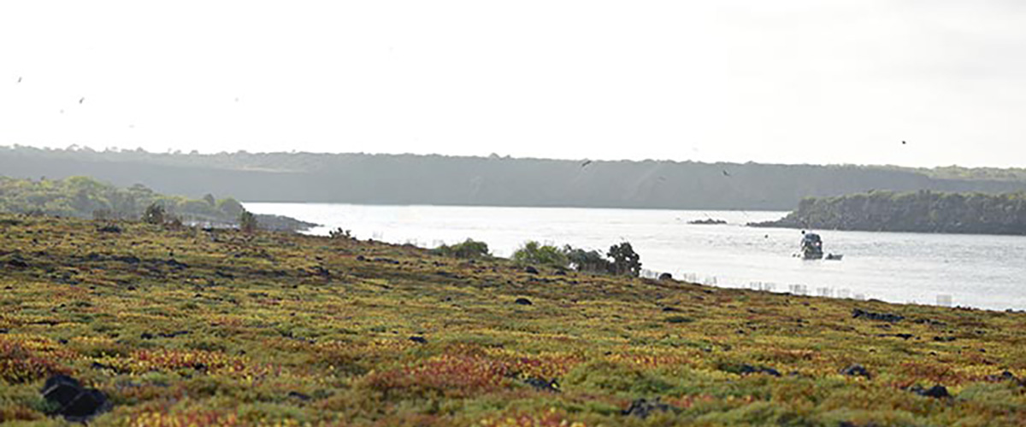

Trail: | 1,4 km / 0,8 mi
Level: | 2
Activities: | HIKING,PANGA RIDE,PADDLE BOARD,KAYAK

PM: SANTA FE
Explore the cactus-strewn, lava-rock landscapes of Santa Fe. See sea lions basking in the white sand beaches, and keep an eye out for Galapagos hawks, Darwin finches, Galapagos doves, mockingbirds and lava lizards.

Highlights: Stunning Views, Galapagos sea lions, Galapagos hawks, Galapagos doves, Santa Fe land iguanas, Reef sharks

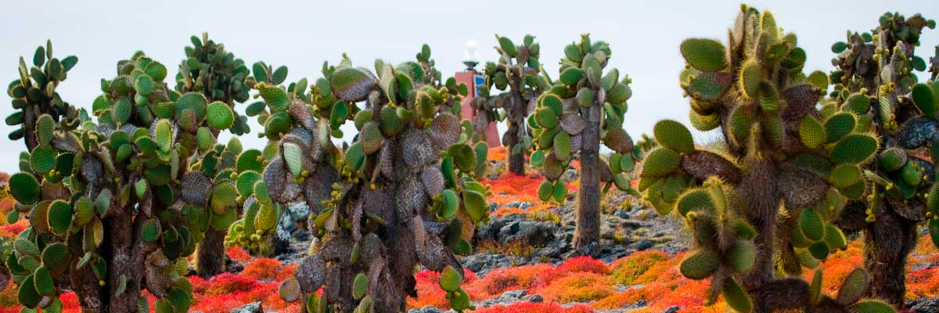

Food: | B/L/D
Trail: | 0,8 km / 0,5 mi
Lodging: | M/C Alya
Level: | 2
Activities: | HIKING,SNORKEL,PANGA RIDE,PADDLE BOARD,KAYAK

DAY 3

AM: INTERPRETATION CENTER/ KICKER ROCK
Located near Puerto Baquerizo, this center explores Galapagos’ human history, from early Spanish explorers to Charles Darwin. Learn about the struggles of the first settlers in this remote and harsh environment.

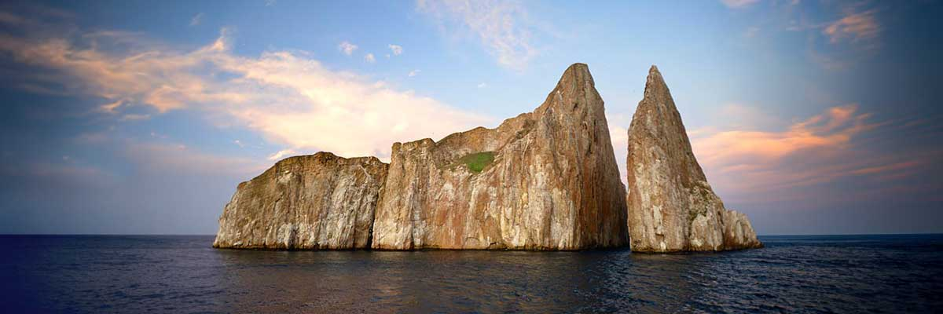

Trail: | 0,2 km / 650 ft
Level: | 1
Activities: | HIKING

PM: LOBOS ISLAND
Witness the bustling wildlife of Lobos Island, home to large groups of sea lions, male frigatebirds, and blue-footed boobies.

Stunning Views, Galapagos sea lions, Magnificent and great frigatebirds, San Cristobal Lava Lizards

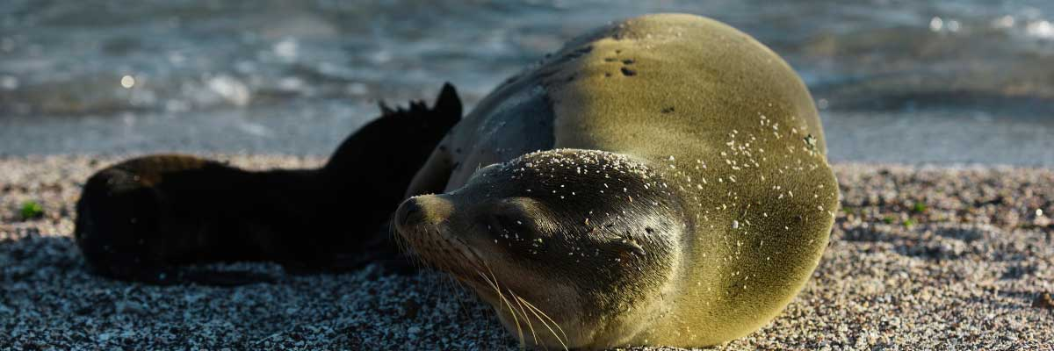

Food: | B/L/D
Trail: | 0,6 km / 0,4 mi
Lodging: | M/C Alya
Level: | 3
Activities: | HIKING,SNORKEL,PANGA RIDE

DAY 4

AM: GARDNER BAY
Gardner Bay, located on Española Island, boasts one of the most stunning beaches in the Galapagos. Its soft coral sand and crystal-clear waters create a paradise-like setting, perfect for relaxation and exploration. As you stroll along the shore, spot curious Española mockingbirds, marine iguanas basking in the sun, and Galapagos hawks soaring overhead in search of prey. This natural sanctuary is also home to playful sea lions, making for an unforgettable wildlife experience in a pristine, breathtaking environment.

Highlights: Coral sand beach, Galapagos mockingbirds, Galapagos hawks, Darwin finches, Marine iguanas

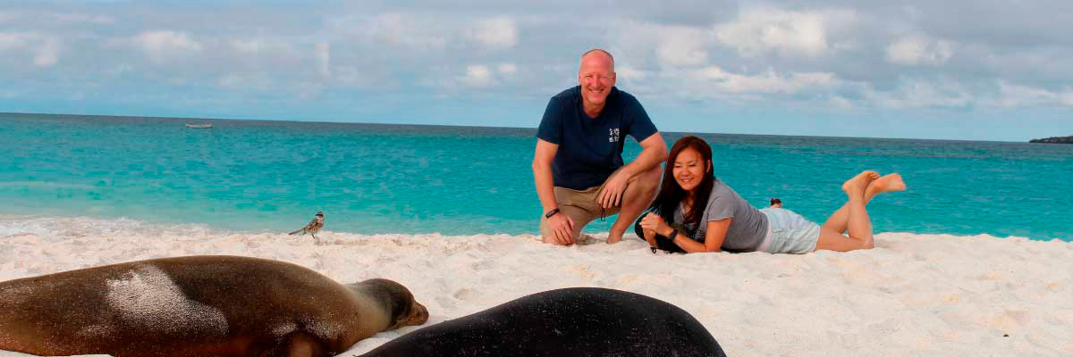

Trail: | 0,8 km / 0,5 mi
Level: | 1
Activities: | HIKING,SNORKEL,PADDLE BOARD,KAYAK

PM: SUAREZ POINT
Experience an awe-inspiring nature walk at Suarez Point. Encounter sea lions, marine iguanas, and large colonies of sea birds, and from April to January, catch a sight of the waved albatross, the largest bird on the islands.

Highlights: Stunning Views, Herons, Galapagos mockingbirds, Galapagos hawks, Darwin finches, Marine iguanas, Waved Albatross, Lava lizards

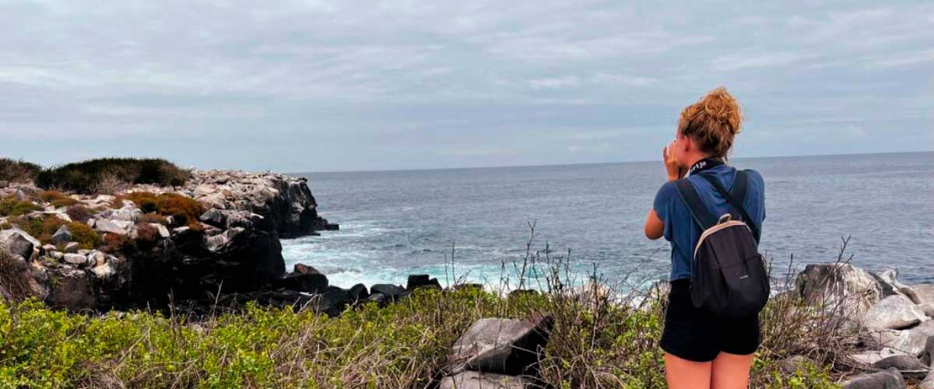

Food: | B/L/D
Trail: | 1,7 km / 1,1 mi
Lodging: | M/C Alya
Level: | 3
Activities: | HIKING

DAY 5

AM: CORMORANT POINT / DEVIL´S CROWN
Venture into Punta Cormorant, famous for its large coastal lagoon inhabited by American flamingoes, white-cheeked pintails, black-necked stilts and other shorebirds.

Highlights: Sea turtle nesting site, Galapagos shearwaters, Tropicbirds, Frigatebirds, Finches, Shorebirds

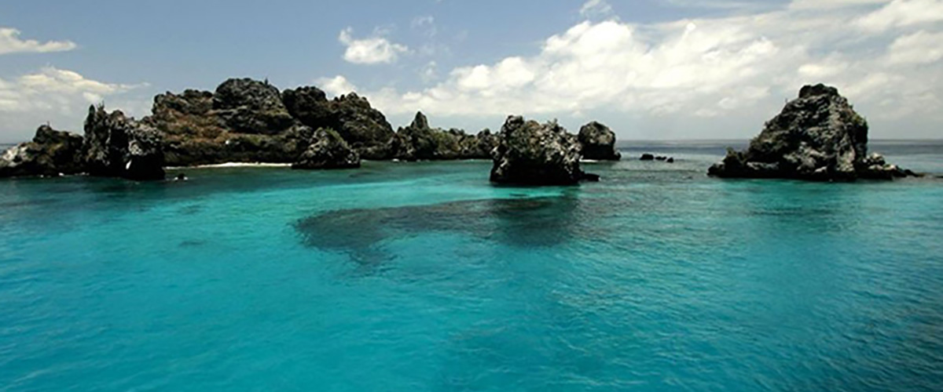

Trail: | 1,6 km / 1 mi
Level: | 1
Activities: | HIKING,SNORKEL,PANGA RIDE,PADDLE BOARD,KAYAK

PM: POST OFFICE BAY
Step into the past at Post Office Bay on Floreana, where sailors established a barrel-based mail system in the 1700s, still in use today. Beyond its historic charm, the bay was a key stop for whalers seeking freshwater and tortoises. This site also boasts a scenic beach, and incredible wildlife, including sea lions, green sea turtles, reef sharks, and, if luck is on your side, the elusive Galapagos penguin.

Highlights: Galapagos penguins, Marine iguanas, Sea turtles, Finches, Shorebirds

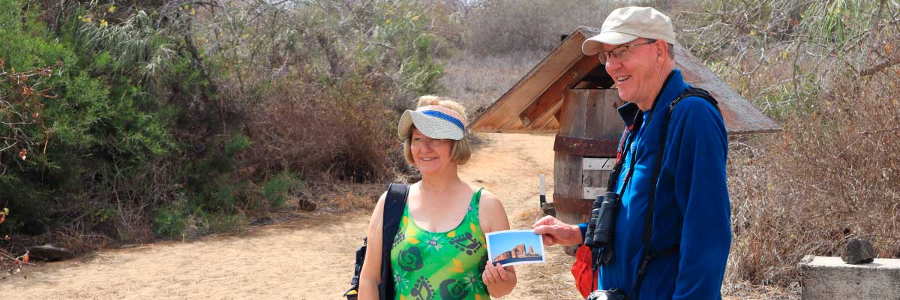

Food: | B/L/D
Trail: | 0,7 km / 0,4 mi
Lodging: | M/C Alya
Level: | 3
Activities: | HIKING

DAY 6

AM: HIGHLANDS
Embark on a pleasant journey into the verdant highlands, where a bus ride leads you through lush forested landscapes home to Galapagos Giant Tortoises. These impressive creatures, reaching up to 300 kg/600 lbs, can often be seen peacefully grazing or resting in freshwater ponds. The highlands are also home to a variety of bird species rarely found in the lowlands. Depending on your itinerary, you may have the opportunity to visit a lava tunnel and learn about the volcanic forces that shaped these remarkable islands.

Lava tunnels, Darwin finches, Galapagos flycatchers, Giant tortoises, Barn owls, White-cheeked pintails

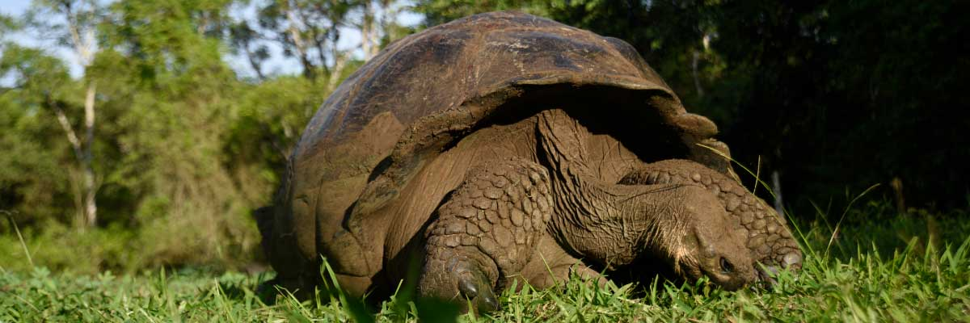

Trail: | 1-1,5 km / 0,6-0,9 mi
Level: | 1
Activities: | HIKING

PM: RETURN AT BALTRA AIRPORT
Your Galapagos adventure comes to an end. Today, you will be transferred to Baltra Airport, where your National Park naturalist guide will assist you with final details before your flight back to mainland Ecuador. As you bid farewell to this paradise, take with you the unforgettable memories of one of the world’s most extraordinary destinations.

Food: | B/-/-
Trail:
Lodging: | M/C Alya
Level: | 1
Activities: | -

GLOSSARY
Feeding |  | Breakfast | B
 |  | Lunch | L
 |  | Dinner | D
Difficulty of the hike |  | Level 1 | Easy
 |  | Level 2 | Moderate
 |  | Level 3 | Difficult
✔ noneX none
• none

