GALAPAGOS DIVING ITINERARY
8 Days – 7 Nights
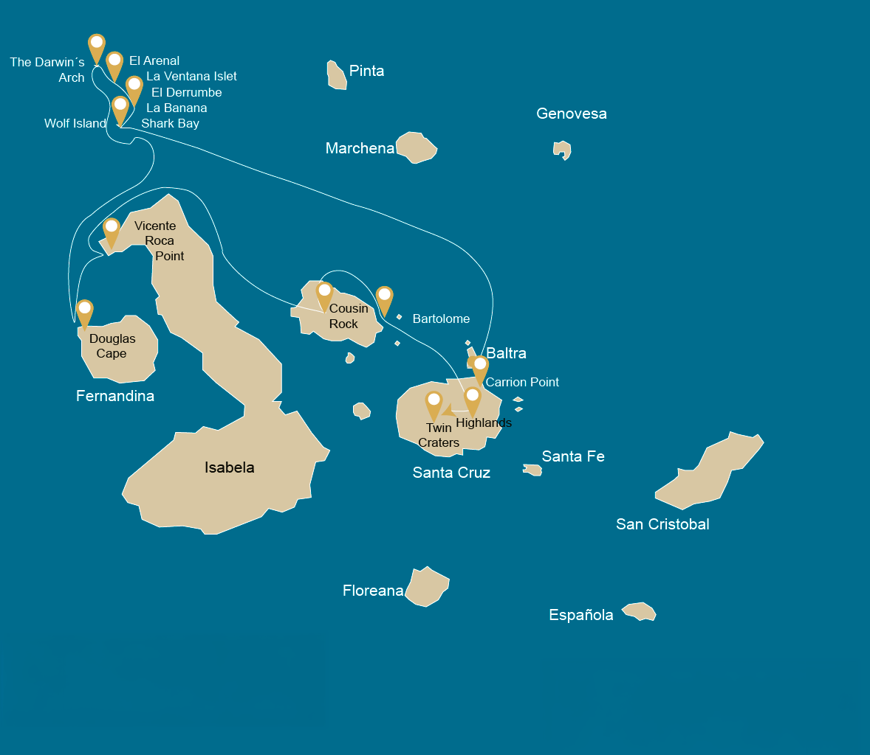
 |  |  | # DIVING
WEDNESDAY | AM | Santa Cruz Island : Baltra - airport (arrival) | -
 | PM | Santa Cruz Island : Baltra Check Dive | 1
THURSDAY | AM | Santa Cruz Island : Diving at Punta Carrion | 2
 | PM | Navigation : In route to Wolf Island | -
FRIDAY | AM | Wolf Island : Shark Bay / La Banana | 2
 | PM | Wolf Island : La Ventana Islet / El Derrumbe | 2
SATURDAY | AM | Darwin Island : El Arenal | 2
 | PM | Darwin Island : The Darwin's Tower | 2
SUNDAY | AM | Wolf Island : El Derrumbe and Shark Bay | 2
 | PM | Darwin Island : El Arenal | 2
MONDAY | AM | Isabela Island : Vicente Roca Point | 1
 | PM | Fernandina Island : Douglas Cape | 1
TUESDAY | AM | Santiago Island : Cousin Rock | 2
 | PM | Santa Cruz Island : Highlands
WEDNESDAY | AM | Santa Cruz Island : Baltra - airport (return) | -
 |  | Santa Cruz Island : Baltra - airport (return) | -

DAY 1

AM: BALTRA (AIRPORT)
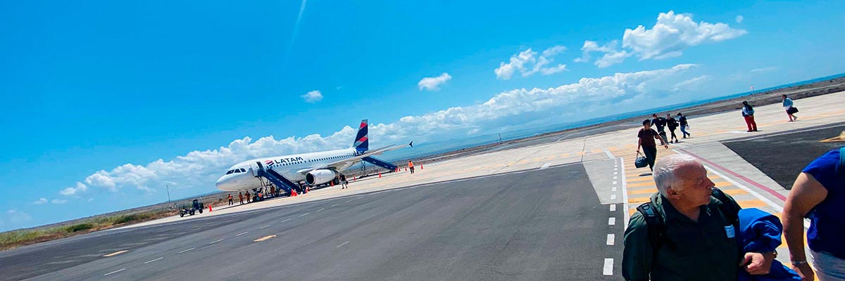
Immersions: | -

Welcome to Galapagos! Upon arrival at Baltra Airport, your naturalist guide will greet you and assist with the transfer to Itabaca Channel. This initial journey offers your first connection with the archipelago as you take a short ferry ride to Santa Cruz Island. Along the way, observe Baltra’s arid landscape and learn about its history as a former U.S. WWII airbase. This is just the beginning of the many fascinating stories awaiting you on your adventure.

PM: BALTRA NORTHEAST / CHECK DIVE
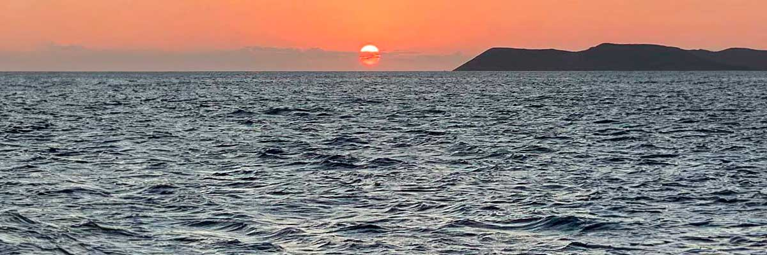
Immersions: | 1

Welcome to the Galapagos Islands! Today, we embark on an exciting diving adventure. Our journey begins at Baltra Airport, where our guide and the friendly crew will welcome us and assist with our luggage. From there, we’ll transfer to the yacht, settle in, and prepare to explore the stunning dive sites awaiting us in the days ahead. With crystal-clear waters and mesmerizing marine life, this expedition promises to be unforgettable.

DAY 2

AM: CARRION POINT
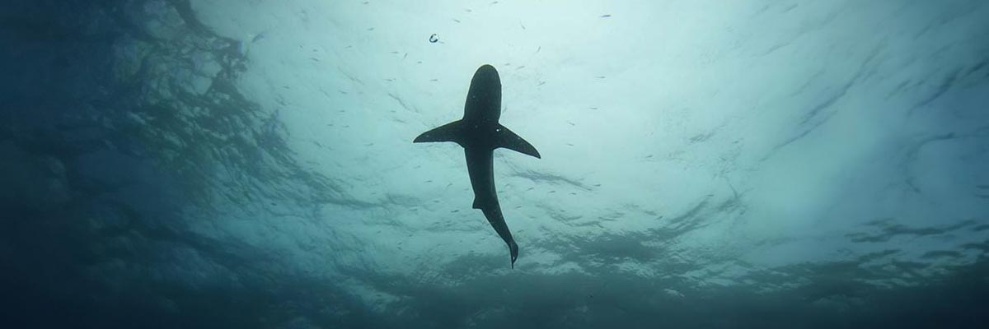
Immersions: | 2

Descend into the depths of Punta Carrion and discover an underwater paradise with stunning visibility. Schools of hammerhead sharks glide through the blue, while from June to December, the majestic whale sharks make their grand appearance. All around, playful sea lions weave through the submerged cliffs, creating a truly mesmerizing marine spectacle.

PM: IN ROUTE TO WOLF ISLAND
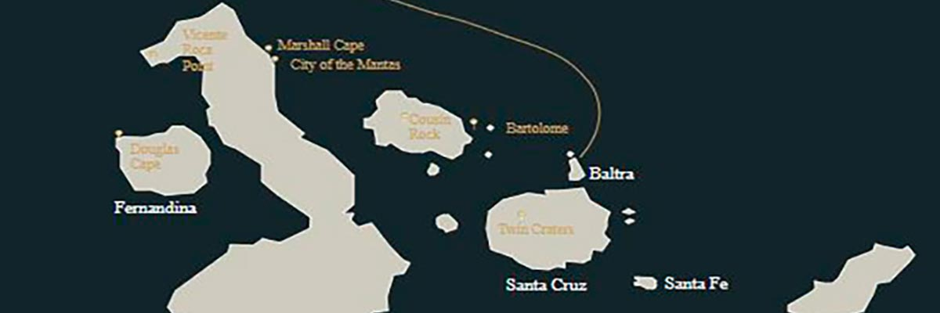
Immersions: | -

After an unforgettable day of diving, we return to the Galaxy Diver to excitedly share our experiences. Meanwhile, our onboard chef prepares a delicious lunch, helping us recharge for what lies ahead. As the sun begins to set, we prepare for our 14-hour journey to Wolf Island. The Pacific waters carry us forward as we relax, listening to the sounds of the ocean and anticipating the incredible marine encounters awaiting us at our next destination.

DAY 3

AM: SHARK BAY / LA BANANA - A MAGNIFICENT MARINE EXPEDITION
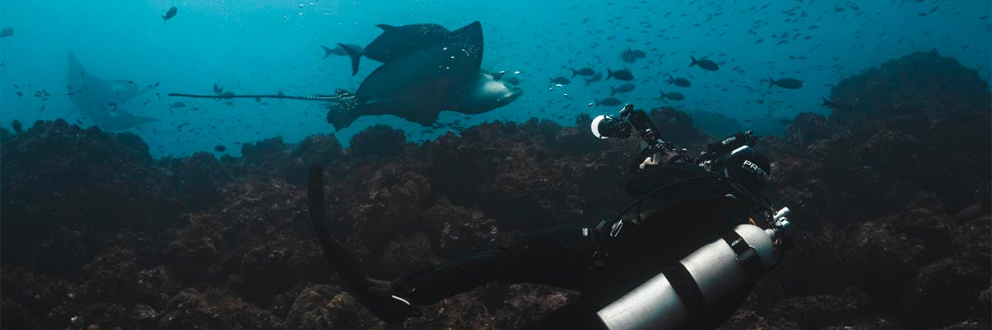
Immersions: | 2

Shark Bay at Wolf Island is one of the most exhilarating dive sites in the Galapagos. Its waters are home to massive schools of hammerhead and Galapagos sharks, and with some luck, we might even spot the ocean’s giants—whale sharks. The area is teeming with marine life, from Galapagos rays to sea turtles and tropical fish. After an unforgettable dive, we head to La Banana for a more playful but equally mesmerizing experience: sea lions darting and twirling around us, showcasing their incredible agility and curiosity in their natural habitat.

PM: LA VENTANA ISLET / EL DERRUMBE A MAGNIFICENT MARINE EXPEDITION
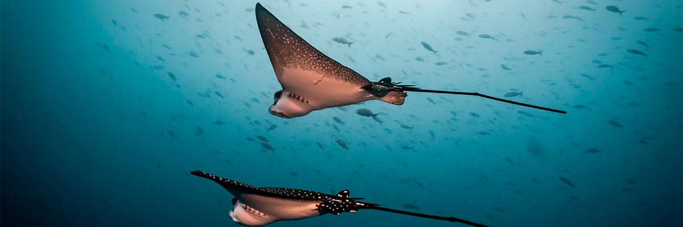
Immersions: | 2

The Landslide at Wolf Island is one of the most famous dive sites in the Galapagos, accessible only by liveaboard. Named after German geologist Theodor Wolf, who mapped and studied the archipelago, this marine sanctuary teems with life. Schools of hammerhead and Galapagos sharks dominate the scene, while the occasional whale shark graces the depths. Rays, sea turtles, marine mammals, and an array of tropical fish add to the site’s dynamic ecosystem, making every dive an extraordinary adventure.

DAY 4

AM: EL ARENAL

Immersions: | 2

Located deep in the Pacific, Darwin Island is a marine sanctuary renowned for its biodiversity. Alongside Wolf, it is one of the world’s premier dive spots. At El Arenal, a legendary site beneath Darwin’s Arch, nutrient-rich waters create an unparalleled spectacle. Dolphins hunt schools of fish while hammerhead and Galapagos sharks patrol the depths. If lucky, you may encounter whale sharks, tiger sharks, or even orcas. With moderate to strong currents and outstanding visibility, this site offers an unforgettable experience for diving enthusiasts.

PM: THE DARWINS TOWER
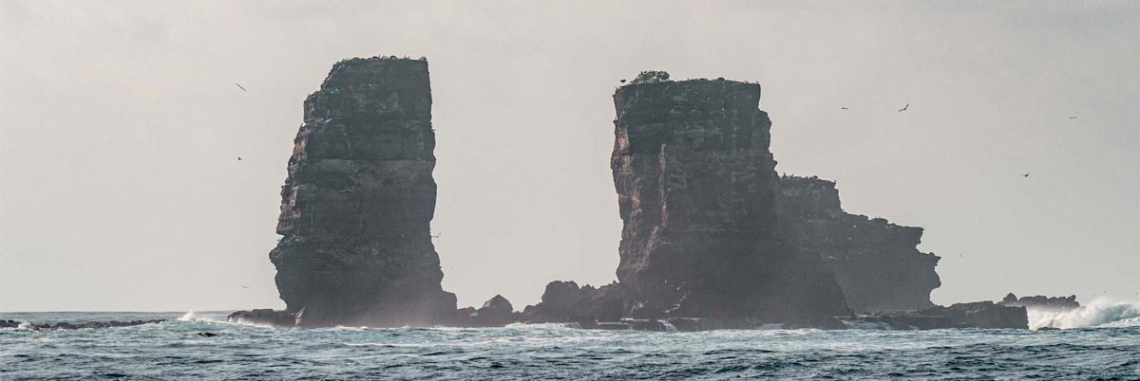
Immersions: | 2

We head to Darwin’s Tower, better known as Darwin’s Arch, one of the most legendary dive sites on the planet. This majestic rock formation serves as a gathering point for Galapagos’ incredible marine biodiversity. Beneath the waves, an awe-inspiring spectacle unfolds: vibrant coral reefs teeming with life, schools of colorful tropical fish, and, most impressively, the imposing presence of hammerhead sharks gliding gracefully through the depths. The experience of diving here is truly unmatched—one that will stay with you forever.

DAY 5

AM: EL DERRUMBE AND SHARK BAY
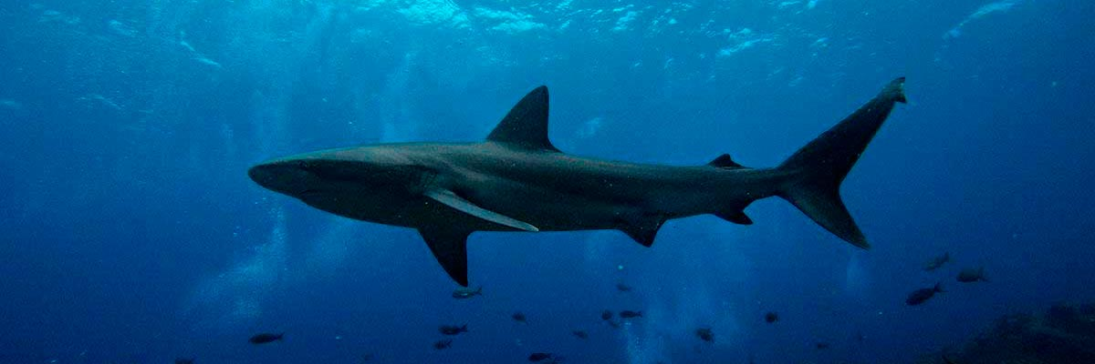
Immersions: | 2

Explore the legendary waters of Wolf Island at two of its most iconic sites. At El Derrumbe, you will navigate underwater cliffs and caves teeming with sea turtles, eagle rays, and playful sea lions, with the rare and thrilling opportunity to spot bull sharks in the shallows. The adventure continues at Shark Bay, an underwater paradise dominated by Galapagos sharks. For those diving between July and November, this site offers a breathtaking chance to encounter the majestic whale shark, one of the ocean’s most awe-inspiring giants.

PM: EL ARENAL
Immersions: | 2

Located deep in the Pacific, Darwin Island is a marine sanctuary renowned for its biodiversity. Alongside Wolf, it is one of the world’s premier dive spots. At El Arenal, a legendary site beneath Darwin’s Arch, nutrient-rich waters create an unparalleled spectacle. Dolphins hunt schools of fish while hammerhead and Galapagos sharks patrol the depths. If lucky, you may encounter whale sharks, tiger sharks, or even orcas. With moderate to strong currents and outstanding visibility, this site offers an unforgettable experience for diving enthusiasts.

DAY 6

AM: VICENTE ROCA POINT
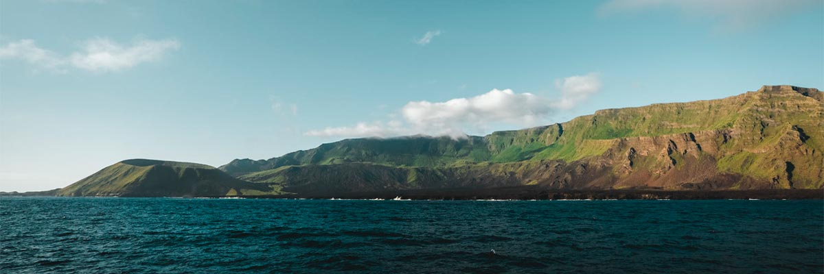
Immersions: | 1

Vicente Roca Point offers a breathtaking natural spectacle, featuring some of the tallest cliffs in Galapagos and intriguing volcanic formations. While there are no trails, a dinghy tour along the shore provides an up-close look at the areaand#039;s rich wildlife. Highlights include flightless cormorants, blue-footed boobies, pelicans, and sea turtles. The site is also home to Galapagos fur seals and marine iguanas basking on the rocks. Moreover, the deep waters surrounding the area make it an excellent spot for dolphin and whale sightings.
Stunning Views, Galapagos penguins, Flightless cormorants, Marine iguanas, Sea turtles
PM: DOUGLAS CAPE
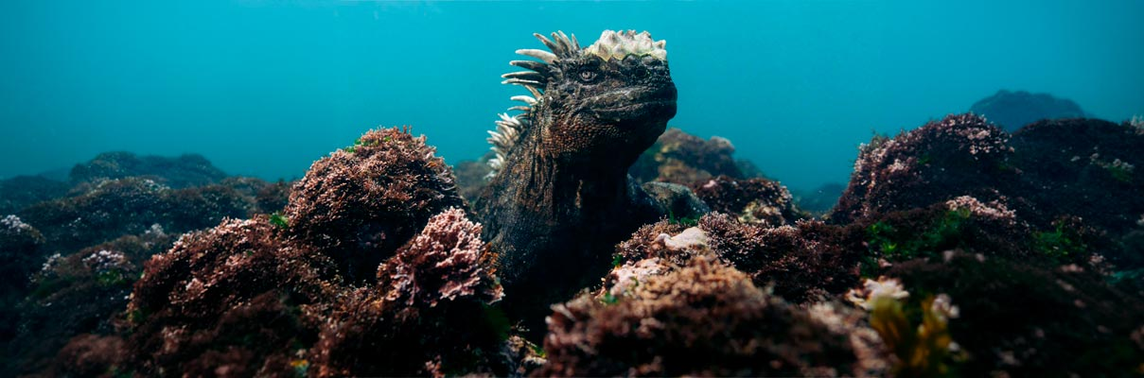
Immersions: | 1

Experience the magic of Douglas Cape, a unique site famous for the world’s only seafaring lizards: the Galapagos marine iguanas. Observe these prehistoric creatures as they bask on the volcanic rocks before plunging into the sea for their underwater feeding sessions. Watching them glide gracefully to feed on algae is a mesmerizing spectacle found nowhere else on Earth. The adventure doesnand#039;t end there; the nutrient-rich waters of Douglas Cape also offer frequent encounters with Galapagos penguins, sea lions, and vibrant schools of tropical fish.

DAY 7

AM: COUSIN ROCK
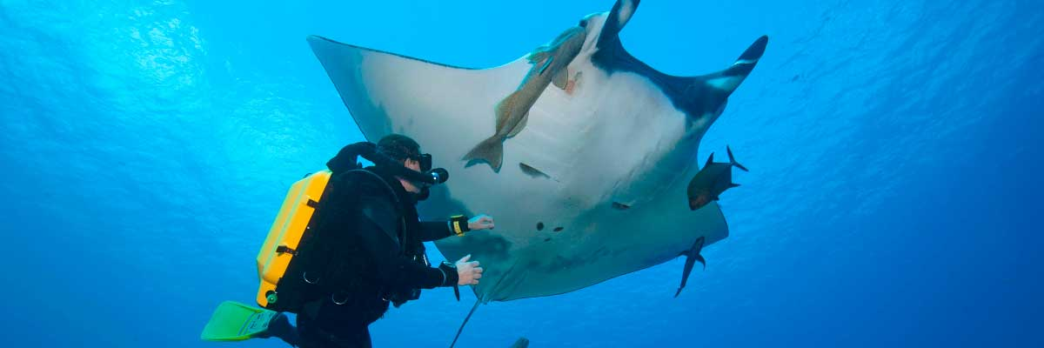
Immersions: | 2

Our final dive takes us to Cousin Rock, a fascinating dive site where corals and gorgonians create a mesmerizing underwater scene. Seahorses, reef fish, and colorful nudibranchs hide among the formations. Watch the agile coral hawkfish darting around, and as we dive deeper, we might spot graceful eagle rays gliding by or a white-tip shark resting in a crevice. If lucky, we could encounter schools of barracudas and mobula rays. To end on a high note, playful sea lions will join us for a final underwater adventure.

PM: HIGHLANDS
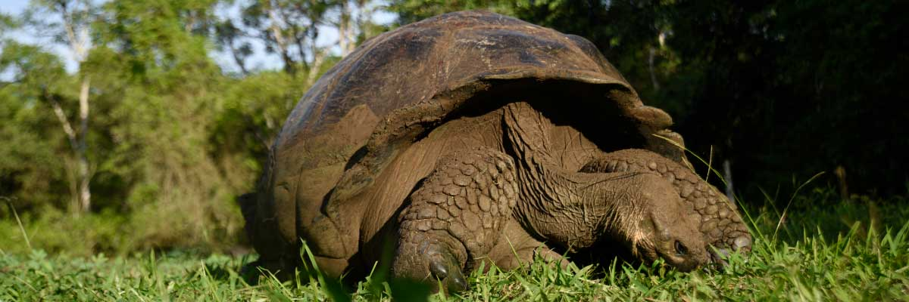
Immersions: | HIKING

Enjoy a scenic journey into the lush highlands of Santa Cruz. Walk through a reserve where you may spot giant tortoises—some weighing over 600 pounds—grazing peacefully. Observe endemic birds such as finches and flycatchers. If included in your itinerary, explore a lava tunnel, a fascinating remnant of the volcanic forces that shaped these islands.
Lava tunnels, Darwin finches, Galapagos flycatchers, Giant tortoises, Barn owls, White-cheeked pintails
DAY 8

AM: BALTRA (AIRPORT)
Immersions: | -

Your Galapagos adventure comes to an end. Today, you will be transferred to Baltra Airport, where your National Park naturalist guide will assist you with final details before your flight back to mainland Ecuador. As you bid farewell to this paradise, take with you the unforgettable memories of one of the world’s most extraordinary destinations.

AM: BALTRA (AIRPORT)
Immersions: | -

Your Galapagos adventure comes to an end. Today, you will be transferred to Baltra Airport, where your National Park naturalist guide will assist you with final details before your flight back to mainland Ecuador. As you bid farewell to this paradise, take with you the unforgettable memories of one of the world’s most extraordinary destinations.

✔ noneX none
• none

