Deep Pacific: A Rainforest and Sea Sanctuary in 6 Days
6 Days – 5 Nights

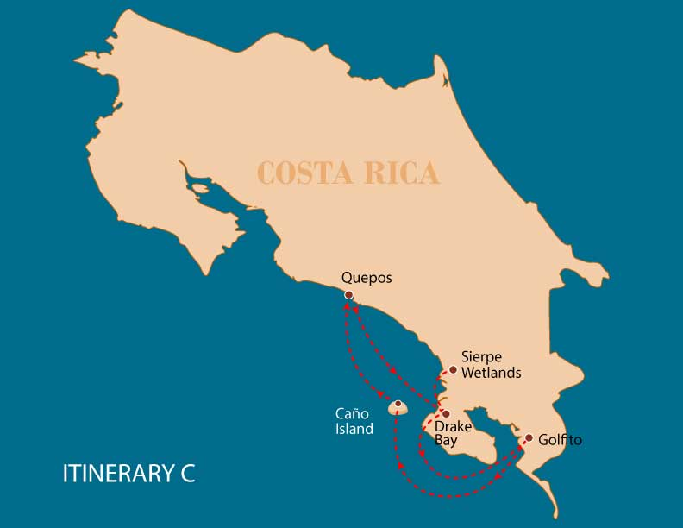

 |  | HKG | SNK | PDB | KYK | JTS | WSD | SST | BTN
DAY 1 | Costa Rica: Quepos - Biesanz Beach
DAY 2 | Costa Rica: Drake Bay – Sierpe Wetlands | * | * | * |  | * | * | * | *
DAY 3 | Costa Rica: Corcovado National Park
DAY 4 | Costa Rica: Golfito - Zamia Wildlife Refuge
DAY 5 | Costa Rica: Caño Island |  | * | * | * | * |  | *
DAY 6 | Costa Rica: Quepos - Marina Pez Vela

DAY 1

Costa Rica - Quepos - Biesanz Beach.
Your journey begins at Marina Pez Vela, Quepos, where the crew welcomes you aboard the Zibó with an exquisite lunch overlooking the Pacific coast. In the afternoon, we sail to the peaceful Biesanz Beach, a hidden cove surrounded by pristine rainforest and crystal-clear waters. It is the perfect setting to explore marine life while snorkeling or to kayak along the shore, spotting sloths and monkeys in the forest canopy. The day concludes with a sunset cocktail and an elegant dinner on deck, followed by a tranquil night anchored under the starlit sky.
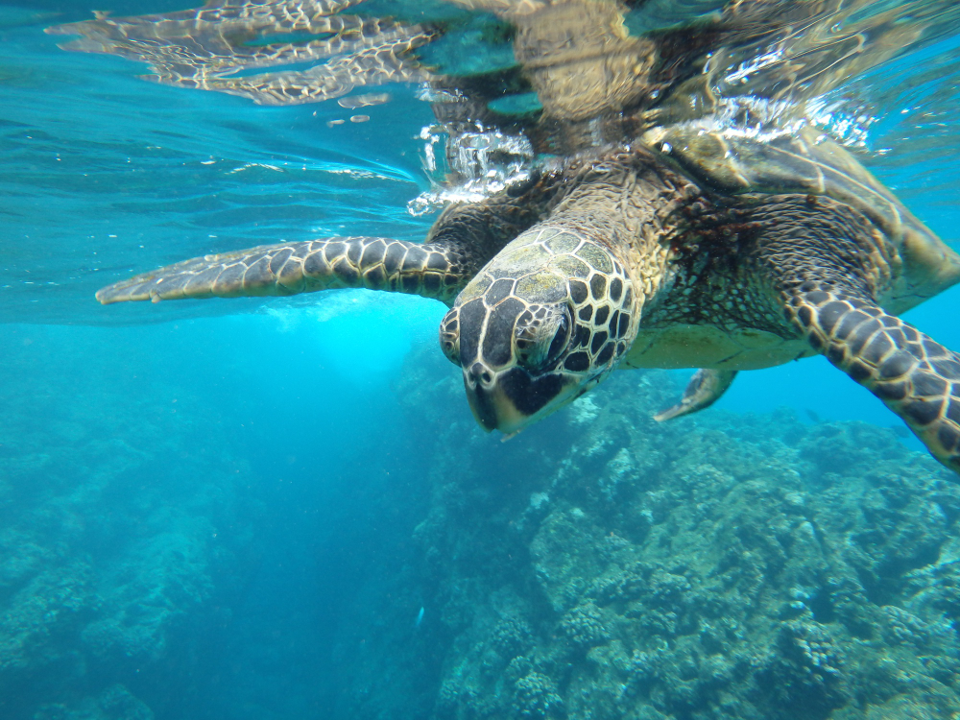

Trail: | -
Level: | 1
Activities: | -

Food: | -/L/D
Trail:
Lodging: | M/Y Galaxy Zibó
Level:
Activities: | -

DAY 2

Costa Rica - Drake Bay - Sierpe Wetlands
The day starts with our arrival in Drake Bay, a secluded cove on the northern Osa Peninsula, embraced by pristine jungle and hidden beaches. Named after the legendary corsair Sir Francis Drake, this region retains an air of mystery and uncharted exploration. After breakfast, the adventure continues upriver into the Sierpe Wetlands, one of Central America’s most extensive and biodiverse mangrove systems. Aboard our smaller expedition boats, you’ll navigate green labyrinths where aerial mangrove roots shelter wildlife such as caimans, white-faced capuchin monkeys, tiger herons, kingfishers, and vibrant roseate spoonbills. The experience is like gliding into a living, breathing jungle. Back on the Zibó, the afternoon is dedicated to aquatic fun and relaxation. In the calm waters of the southern Pacific coast, choose from a full menu of water-based activities, whether you seek adrenaline or serenity. As the day ends, a golden sunset paints the ocean in warm hues, providing the perfect close to a day rich in discovery and natural beauty.
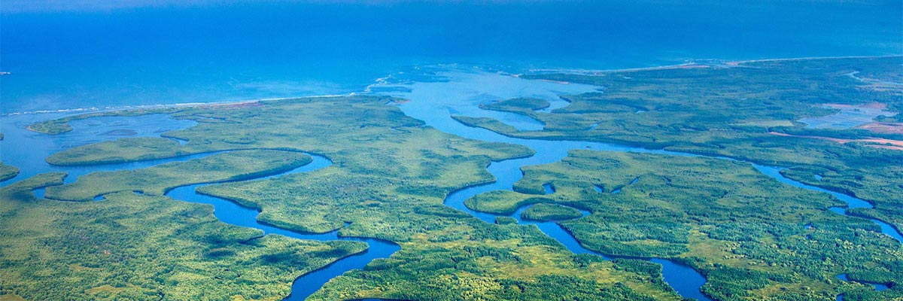

Trail: | 4 hours
Level: | 1
Activities: | HIKING,SNORKEL,PADDLE BOARD,JET SKIS,WATER SLIDE,SEA SCOOTER,BOAT NAVIGATION

Food: | B/L/D
Trail:
Lodging: | M/Y Galaxy Zibó
Level:
Activities: | -

DAY 3

Costa Rica - Corcovado National Park
Wake up to the golden sunrise over the Osa Peninsula mountains, accompanied by the songs of tropical birds. Today’s destination is Corcovado National Park, hands down one of the most stunning spots in Costa Rica, hailed by National Geographic as the most biologically intense place on Earth per square meter. After breakfast onboard, prepare for a day of deep connection with nature. All three of your daily meals are included.
The vessel will approach one of the park’s ranger stations either, San Pedrillo or Sirena, where expert naturalist guides will lead you on a hike through primary tropical rainforest trails. Along the way, keep an eye out for three species of monkeys, sloths, tapirs, and, with a bit of luck, even the elusive jaguar. Endemic birds, colorful frogs, and dazzling blue morpho butterflies accompany every step in this unique rainforest experience. In the afternoon, the adventure shifts from the forest to the turquoise waters surrounding the park. Anchored in a secluded bay, the yacht becomes your floating base for aquatic activities: kayaking, snorkel, glide down the water slide, paddleboard, hop on a jet ski, or explore with a Sea scooter. Whether on land or at sea, today is a celebration of the wild, untamed beauty that makes Costa Rica so extraordinary.
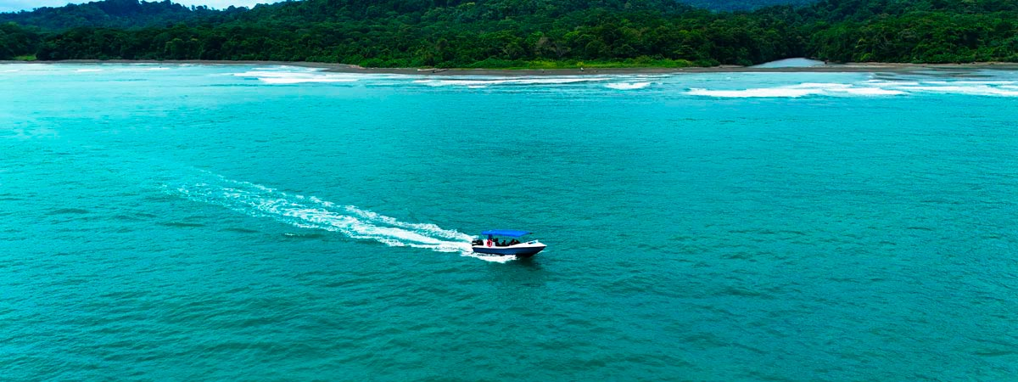

Trail: | 4.5 hours
Level: | 1
Activities: | -

Food: | B/L/D
Trail:
Lodging: | M/Y Galaxy Zibó
Level:
Activities: | -

DAY 4

Costa Rica - Zamia Wildlife Refuge - Los Mogos
Our journey begins in Golfito, a tranquil port town nestled between lush mountains and the calm waters of the Golfo Dulce. Here, the scenery transforms dramatically from urban life to pristine rainforest and gentle ocean breezes. We sail directly to the Zamia Wildlife Refuge, a small but vital conservation project protecting the region’s unique flora and fauna. Your expert guide will detail local restoration efforts and the importance of preserving coastal ecosystems. As the sun sets, savor a cocktail on deck while the evening chorus of the rainforest echoes across the gulf.
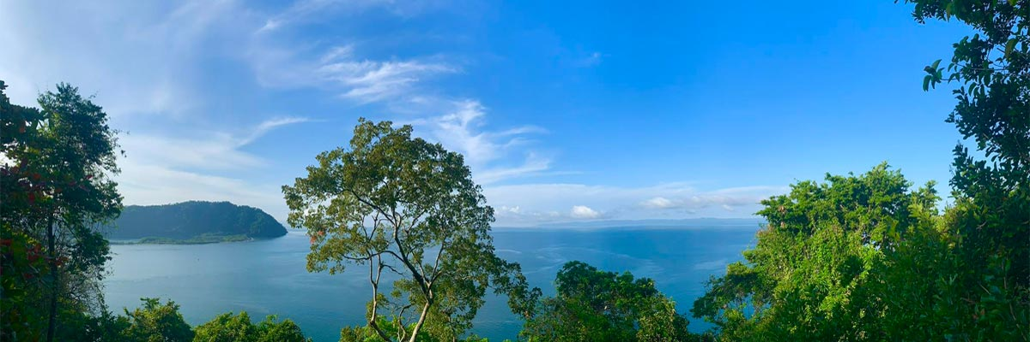

Trail: | 3 hours
Level: | 1
Activities: | -

Food: | B/L/D
Trail:
Lodging: | M/Y Galaxy Zibó
Level:
Activities: | -

DAY 5

Costa Rica - Caño Island
Today, the cruise sets course for one of Costa Rica’s most legendary Pacific coast destinations: Caño Island. Surrounded by one of the country most pristine and vibrant marine ecosystems, this Biological Reserve is not only a natural haven, but also a sacred ceremonial site for pre-Columbian indigenous cultures.
As you approach the island, the water becomes stunningly clear, unveiling a colorful mosaic of coral reefs beneath the surface. The day is dedicated to non-motorized water activities, offering a peaceful and immersive experience in perfect harmony with this protected marine sanctuary.
Between adventures, unwind on the ship’s deck or relax in shaded areas with refreshing tropical fruits and natural beverages always accompanied by breathtaking ocean views.
Caño Island offers a perfect balance of conservation and exploration. This day invites you to (literally) dive into Costa Rica’s remarkable commitment to protecting its natural treasures.
To close a day full of sun, sea, and laughter, enjoy a calm and flavorful evening with our exclusive Cocktails Onboard Experience a relaxed atmosphere where you can sip, socialize, and watch the sun dip beneath the horizon.
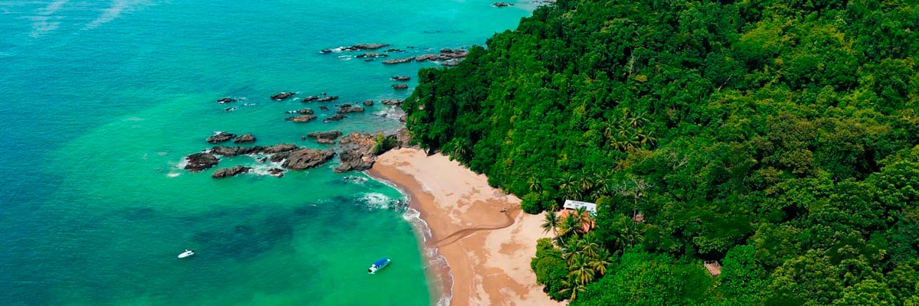

Trail: | 4 hours
Level: | 1
Activities: | SNORKEL,PADDLE BOARD,KAYAK,JET SKIS,SEA SCOOTER

Food: | B/L/D
Trail:
Lodging: | M/Y Galaxy Zibó
Level:
Activities: | -

DAY 6

Costa Rica - Quepos - Marina Pez Vela
This is the perfect time to savor the final moments in Costa Rica, capturing last photographs of the stunning coastline and lush surroundings, and reflecting on the unforgettable experiences of the journey. Guests prepare for departure, carrying with them lasting memories of the country’s extraordinary natural beauty.
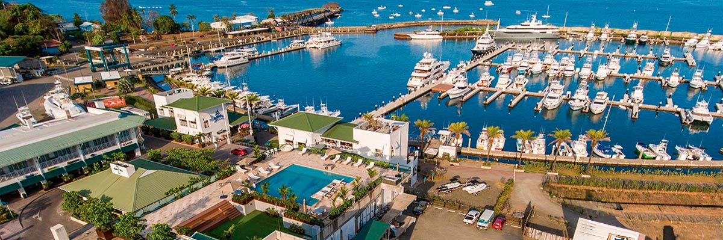

Trail: | -
Level: | 1
Activities: | -

Food: | B/-/-
Trail:
Lodging: | M/Y Galaxy Zibó
Level:
Activities: | -

GLOSSARY
Feeding |  | Breakfast | B
 |  | Lunch | L
 |  | Dinner | D
Difficulty of the hike |  | Level 1 | Easy
 |  | Level 2 | Moderate
 |  | Level 3 | Difficult
Activities |  | HKG | Hiking
 |  | SNK | Snorkel
 |  | PDB | Paddle Board
 |  | KYK | Kayak
 |  | JTS | Jet Skis
 |  | WSD | Water Slide
 |  | SST | Sea scooter
 |  | BTN | Boat Navigation
✔ noneX none
• none

