Galapagos Southeastern Splendor And Secrets
4 Days - 3 Nights

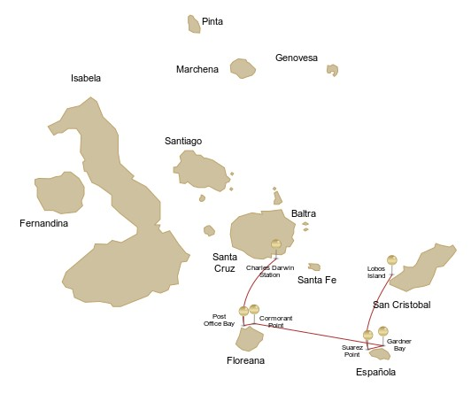
 |  |  | Hiking | Snorkel | Panga Ride | Paddle Board | Kayak
SUNDAY | AM | San Cristobal Island : San Cristobal- Airport (arrival)
 | PM | San Cristobal Island : Lobos Island | * | * | *
MONDAY | AM | Española Island : Suarez Point | *
 | PM | Española Island : Gardner Bay | * | * |  | * | *
TUESDAY | AM | Floreana Island : Cormorant Point | * | * | * | * | *
 | PM | Floreana Island : Post Office Bay | * | *
WEDNESDAY | AM | Santa Cruz Island : Charles Darwin Station | *
 |  | Santa Cruz Island : Baltra - airport (return)

DAY 1 - SUNDAY

AM: SAN CRISTOBAL AIRPORT (ARRIVAL)
Embark on an unforgettable journey to the Galapagos Islands, where nature thrives in its purest form. Your adventure begins at San Cristobal’s modest yet bustling airport, where a seasoned naturalist guide will greet you. This guardian of the ecosystem will introduce you to a world of breathtaking landscapes and unparalleled biodiversity. Feel the excitement as you step into this living sanctuary, a UNESCO World Heritage site, marking the beginning of an extraordinary exploration.


Trail:
Level: | 1
Activities: | -

PM: LOBOS ISLAND
Lobos Island, a small islet near San Cristóbal, offers an unforgettable wildlife experience. Upon landing, groups of sea lions will greet you as they play in tidal pools. Walking inland, you’ll spot frigatebirds perched in bushes, displaying their inflated red pouches, while blue-footed boobies nest along the trail, performing their iconic courtship dance. In the calm waters, snorkeling provides an incredible opportunity to swim with playful sea lions, while sea turtles and rays rest on the sandy bottom.

Stunning Views, Galapagos sea lions, Magnificent and great frigatebirds, San Cristobal Lava Lizards
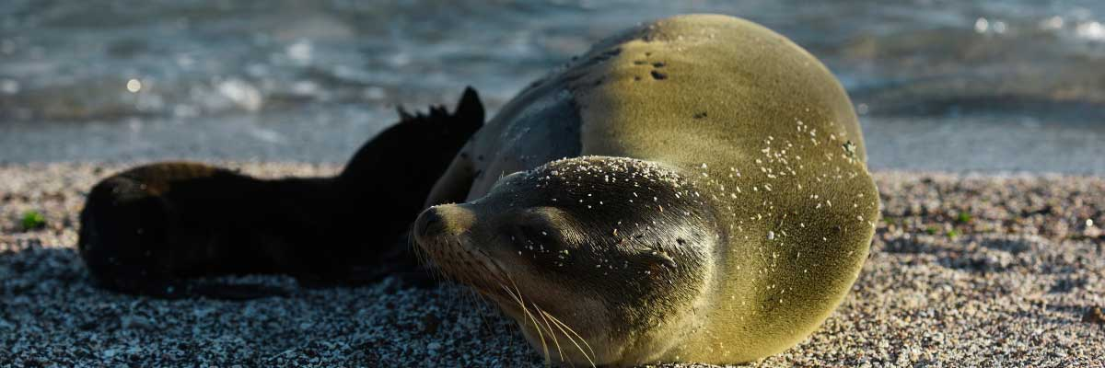
Food: | -/L/D
Trail: | 0,6 km / 0,4 mi
Lodging: | M/Y Galaxy Stella
Level: | 2
Activities: | HIKING,SNORKEL,PANGA RIDE
DAY 2 - MONDAY

AM: SUAREZ POINT
Embark on an adventure to Suarez Point, one of the Galapagos’ greatest natural wonders. This rocky trail is a haven for wildlife lovers, featuring an incredible array of species. Upon arrival, sea lions and marine iguanas welcome you as the first hosts of this nature spectacle. As you explore further, witness a vibrant mosaic of seabird colonies, from blue-footed and Nazca boobies to graceful frigatebirds and tropicbirds. The highlight of this journey is meeting the waved albatross, the island’s largest bird, impressing visitors with its powerful flight and intricate courtship display (present from April to January).

Highlights: Stunning Views, Herons, Galapagos mockingbirds, Galapagos hawks, Darwin finches, Marine iguanas, Waved Albatross, Lava lizards
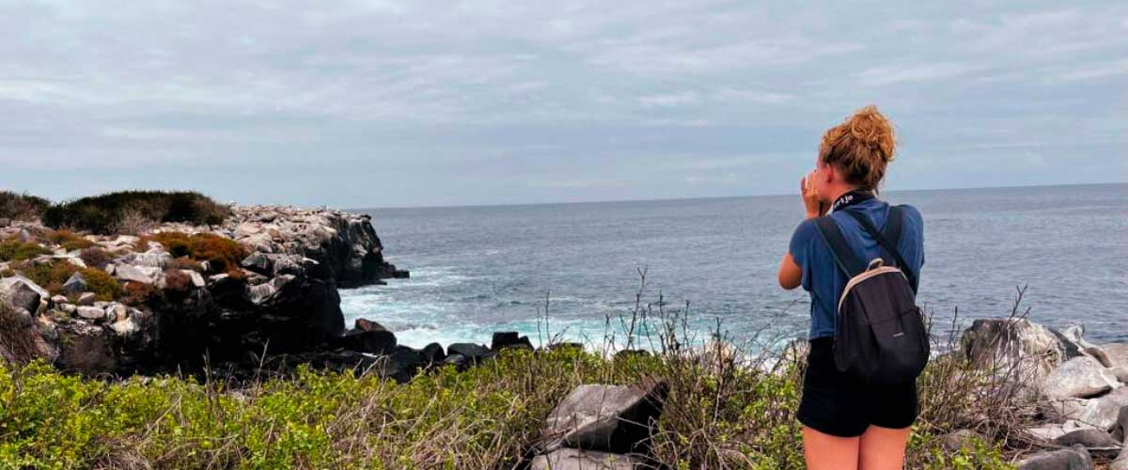
Trail: | 1,7 km / 1,1 mi
Level: | 1
Activities: | HIKING

PM: GARDNER BAY
Gardner Bay, located on Española Island, boasts one of the most stunning beaches in the Galapagos. Its soft coral sand and crystal-clear waters create a paradise-like setting, perfect for relaxation and exploration. As you stroll along the shore, spot curious Española mockingbirds, marine iguanas basking in the sun, and Galapagos hawks soaring overhead in search of prey. This natural sanctuary is also home to playful sea lions, making for an unforgettable wildlife experience in a pristine, breathtaking environment.

Highlights: Coral sand beach, Galapagos mockingbirds, Galapagos hawks, Darwin finches, Marine iguanas
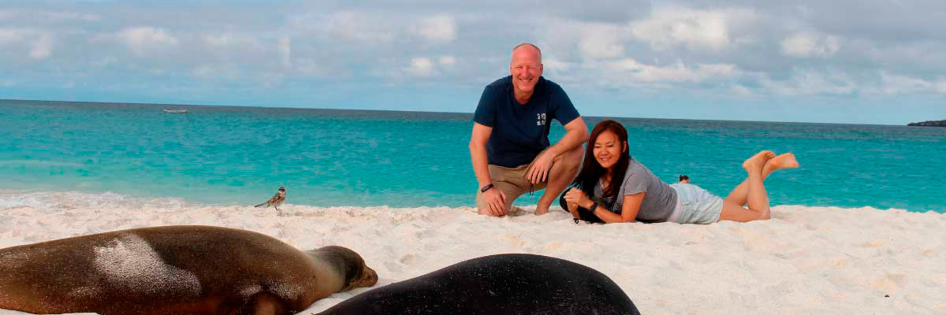
Food: | B/L/D
Trail: | 0,8 km / 0,5 mi
Lodging: | M/Y Galaxy Stella
Level: | 3
Activities: | HIKING,SNORKEL,PADDLE BOARD,KAYAK
DAY 3 - TUESDAY

AM: CORMORANT POINT
Located in northern Floreana, Punta Cormorant is a paradise for nature lovers. Its coastal lagoon hosts flamingos, white-cheeked pintails, and black-necked stilts, while its white sand beach is a crucial nesting site for green sea turtles. In recent years, blue-footed boobies have started nesting along the trail. This is also a great site for spotting endemic plants. For snorkeling, Devil’s Crown—a heavily eroded volcanic formation—offers an unparalleled experience, attracting reef sharks, rays, sea turtles, and massive schools of tropical fish.

Highlights: Galapagos sea lions, Blue footed boobies, Galapagos shearwaters, American flamingoes, Sea turtles, Tropicbirds, Frigatebirds
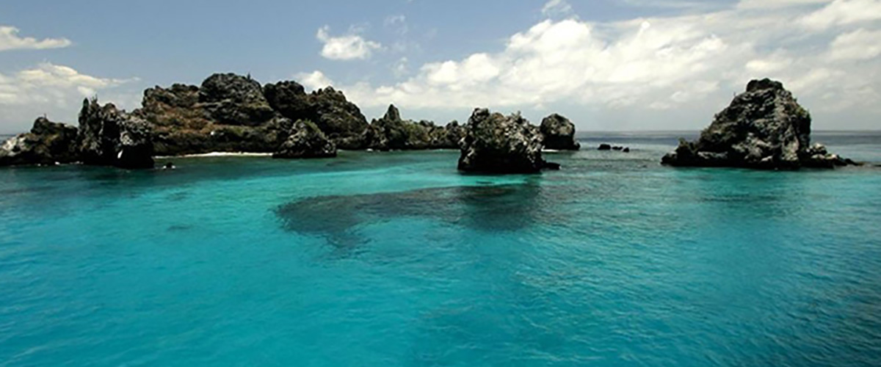
Trail: | 1,6 km / 1 mi
Level: | 3
Activities: | HIKING,SNORKEL,PANGA RIDE,PADDLE BOARD,KAYAK

PM: POST OFFICE BAY
Step into the past at Post Office Bay on Floreana, where sailors established a barrel-based mail system in the 1700s, still in use today. Beyond its historic charm, the bay was a key stop for whalers seeking freshwater and tortoises. This site also boasts a scenic beach, and incredible wildlife, including sea lions, green sea turtles, reef sharks, and, if luck is on your side, the elusive Galapagos penguin.

Highlights: Galapagos penguins, Marine iguanas, Sea turtles, Finches, Shorebirds
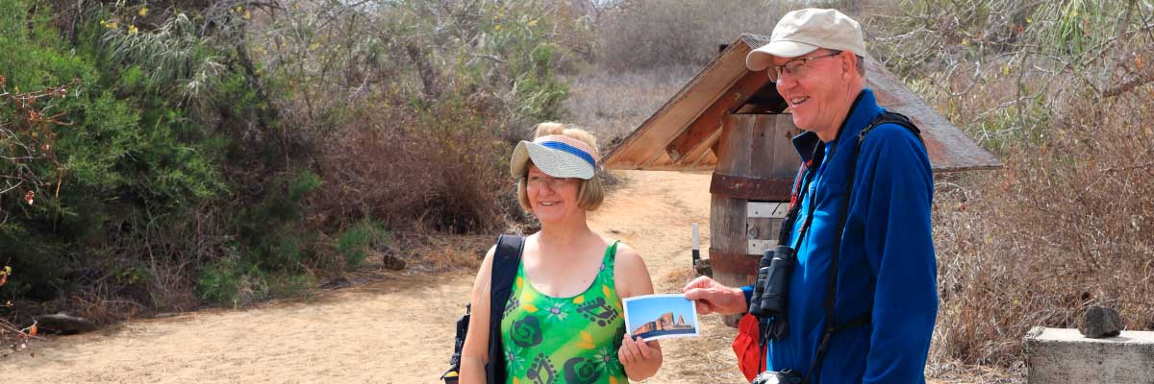
Food: | B/L/D
Trail: | 0,7 km / 0,4 mi
Lodging: | M/Y Galaxy Stella
Level: | 2
Activities: | HIKING,SNORKEL
DAY 4 - WEDNESDAY

AM: CHARLES DARWIN STATION
Explore the Charles Darwin Research Station, a center dedicated to wildlife conservation and research. Witness breeding programs helping restore giant tortoise populations, learn about projects tackling invasive species, and see conservationists working to protect the fragile Galapagos ecosystem.

Galapagos giant tortoise and land iguanas breeding program, Galapagos mockingbirds, Darwin finches, Galapagos flycatchers
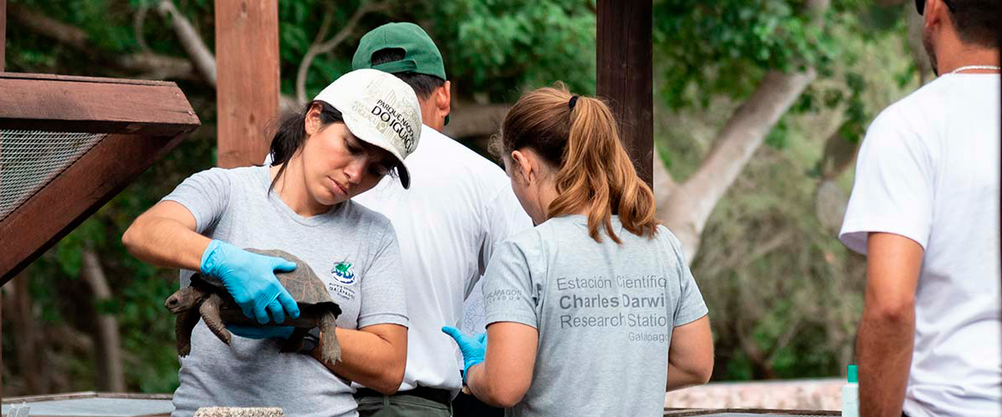
Trail: | 2 km / 1,2 mi
Level: | 1
Activities: | HIKING

AM: BALTRA AIRPORT (RETURN)
Your Galapagos adventure comes to an end. Today, you will be transferred to Baltra Airport, where your National Park naturalist guide will assist you with final details before your flight back to mainland Ecuador. As you bid farewell to this paradise, take with you the unforgettable memories of one of the world’s most extraordinary destinations.

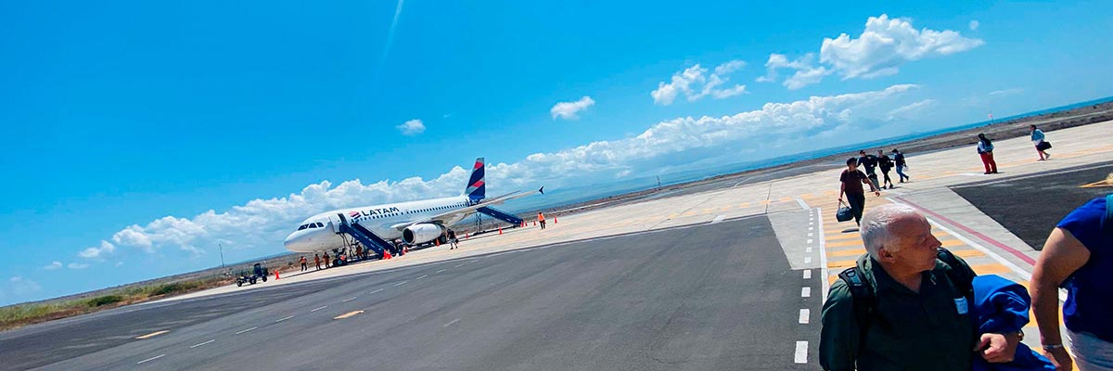
Food: | B/-/-
Trail:
Lodging: | M/Y Galaxy Stella
Level: | 1
Activities: | -
GLOSSARY
Feeding | Breakfast | B
Feeding | Lunch | L
Feeding | Dinner | D
Difficulty of the hike | Level 1 | Easy
Difficulty of the hike | Level 2 | Moderate
Difficulty of the hike | Level 3 | Difficult

✔ noneX none
• none

