**GALAPAGOS ONBOARD A CRUISE**

**5 DAYS / 4 NIGHTS**

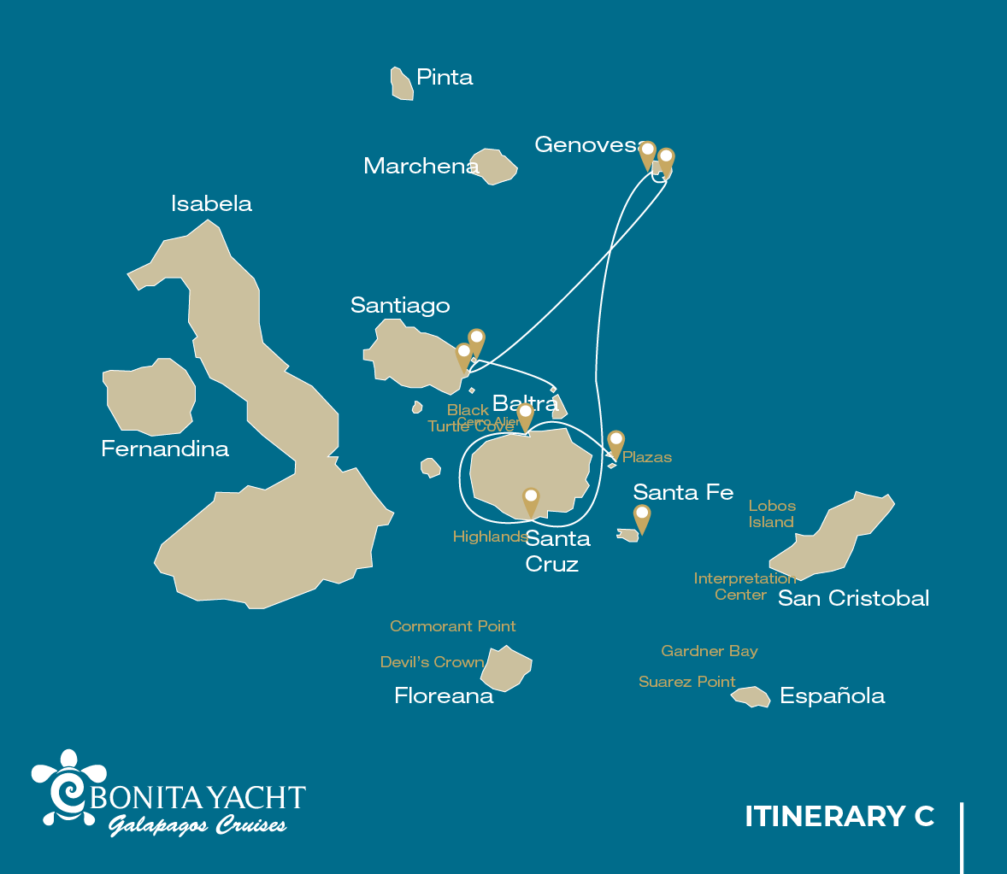

|  |  |  |  |  |  |  |  |
| --- | --- | --- | --- | --- | --- | --- | --- |
|  | | | **Hiking** | **Snorkel** | **Panga Ride** | **Paddle Board** | **Kayak** |
| WEDNESDAY | AM | Santa Cruz Island : Baltra - airport (arrival) |  |  |  |  |  |
|  | PM | South Plazas Island : South Plaza | * |  |  |  |  |
| THURSDAY | AM | Santa Cruz Island : Black Turtle Cove |  |  | * |  |  |
|  | PM | Santa Cruz Island : Highlands | * |  |  |  |  |
| FRIDAY | AM | Genovesa Island : Darwin Bay | * | * | * | * | * |
|  | PM | Genovesa Island : Barranco | * | * | * | * | * |
| SATURDAY | AM | Santiago Island : Sullivan Bay | * | * | * |  |  |
|  | PM | Bartolome Island : Bartolome | * | * | * |  |  |
| SUNDAY | AM | Seymour Island : North Seymour | * |  |  |  |  |
|  | PM | Santa Cruz Island : Baltra - airport (return) |  |  |  |  |  |

DAY 1

AM: BALTRA AIRPORT

Welcome to Galapagos! Upon arrival at Baltra Airport, your naturalist guide will greet you and assist with the transfer to Itabaca Channel. This initial journey offers your first connection with the archipelago as you take a short ferry ride to Santa Cruz Island. Along the way, observe Baltra’s arid landscape and learn about its history as a former U.S. WWII airbase. This is just the beginning of the many fascinating stories awaiting you on your adventure.

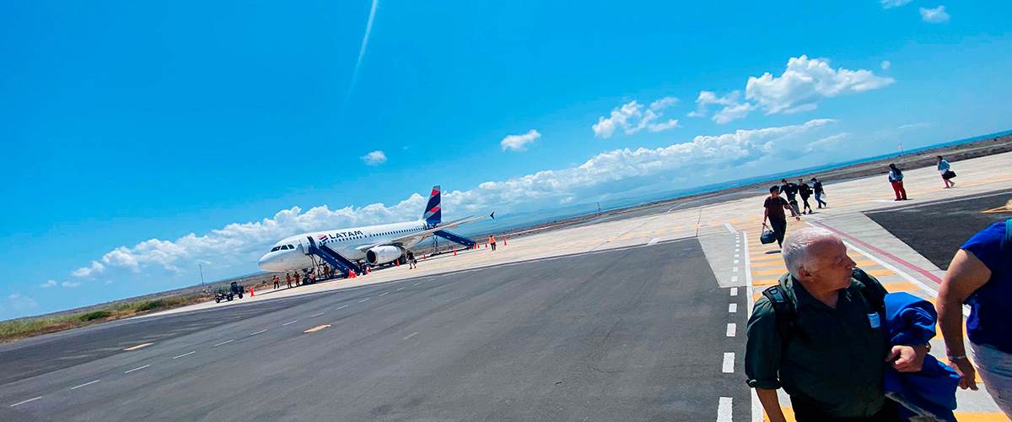

|  |  |
| --- | --- |
| **Trail:** |  |
| **Level**: | 1 |
| **Activities:** | - |

PM: PLAZAS

Of the two twin islands, only South Plazas is open to visitors, while North Plazas remains a scientific research site. Despite its small size, South Plazas is teeming with wildlife. Upon landing, ll find land iguanas lounging beneath Opuntia cacti, waiting for fallen fruit. A large sea lion colony dominates the shore, where playful pups explore tide pools while massive bulls defend their territory. The trail leads to a dramatic cliffside, offering breathtaking ocean views where frigatebirds, blue-footed boobies, red-billed tropicbirds, and swallow-tailed gulls soar. A blanket of reddish succulents covering the island adds to its striking beauty.

Stunning Views, Boobies, Galapagos sea lions, Galapagos shearwaters, Galapagos land iguanas, Tropicbirds, Pelicans

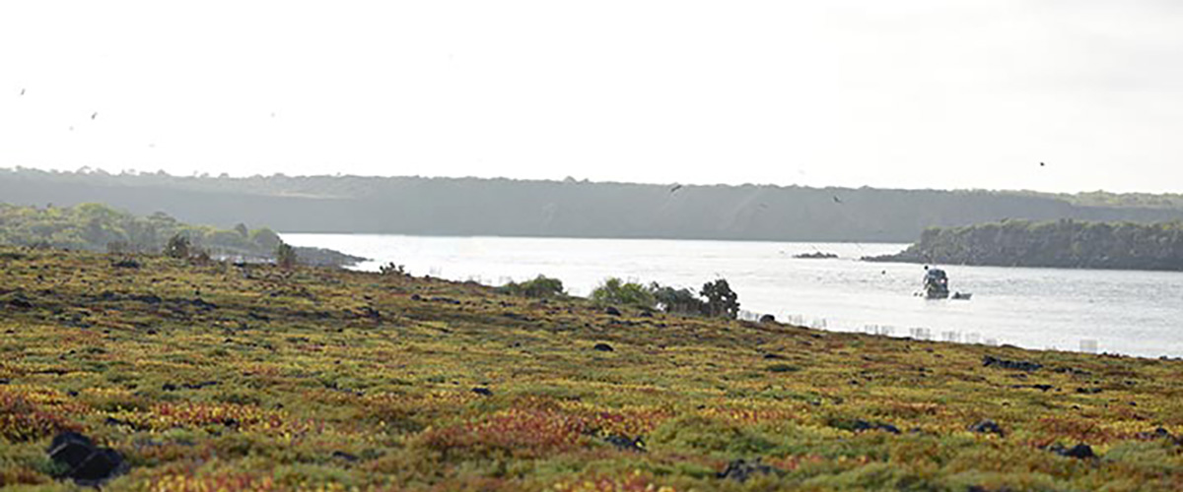

|  |  |
| --- | --- |
| **Food**: | -/L/D |
| **Trail:** | 1,4 km / 0,8 mi |
| **Lodging**: | M/Y Bonita |
| **Level**: | 2 |
| **Activities:** | HIKING |

DAY 2

AM: BLACK TURTLE COVE

Black Turtle Cove gets its name from the abundance of green sea turtles, locally known as: “tortugas negras”. There is no landing here so you will be doing a boat tour on the dinghies, exploring shallow channels and small coves surrounded by beautiful mangrove forests. Reef sharks, sea turtles and several species of rays inhabit this beautiful area which is considered an important mating area for turtles and a nursery for several species of sharks. Herons, pelicans and boobies are also common here as they pray in schools of anchovies.

**Highlights:**  Mangroves, White-tipped and black-tipped reef sharks, Green sea turtles, Rays, Herons, Blue footed boobies, Reef sharks

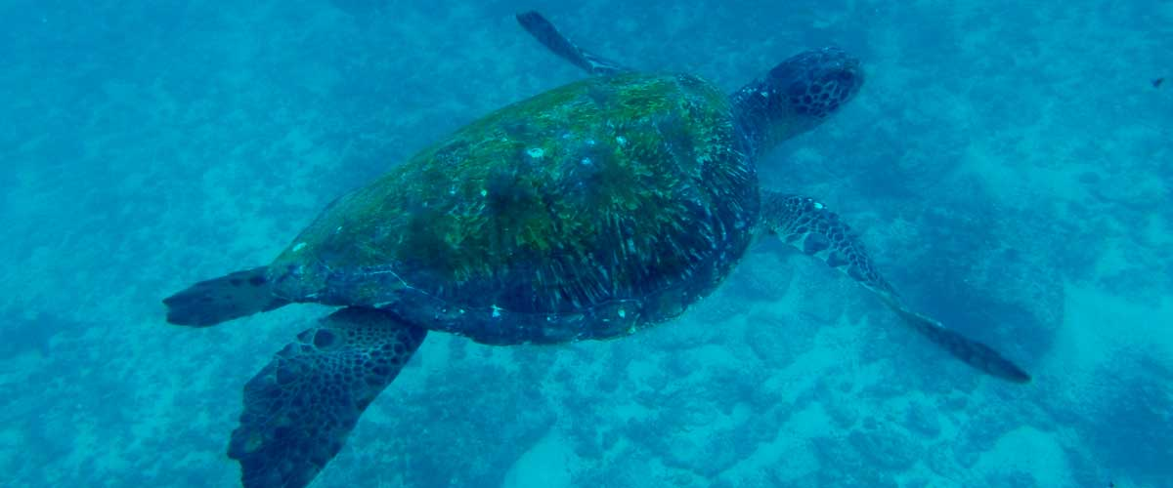

|  |  |
| --- | --- |
| **Trail:** |  |
| **Level**: | 1 |
| **Activities:** | PANGA RIDE |

PM: HIGHLANDS

Either if you do this visit starting from Baltra or from Puerto Ayora, a bus will take you to the highlands stopping along the way at one of the reserves to visit the lush highland forests where you will look for Galapagos Giant tortoises in their natural environment. This is the best place in the Galapagos to see these gentle giants (reaching over 300 kg / 600 pounds!) casually grazing and resting in freshwater ponds. This is also home for a great diversity of birds rarely found at the lowlands, including finches (tree, woodpecker and vegetarian finches), flycatchers and several species of water birds. You will visit a lava tunnel (depending on the itinerary) and learn how these extraordinary formations were created by ancient volcanic eruptions.

**Highlights:** Lava tunnels, Darwin finches, Galapagos flycatchers, Giant tortoises, Barn owls, White-cheeked pintails

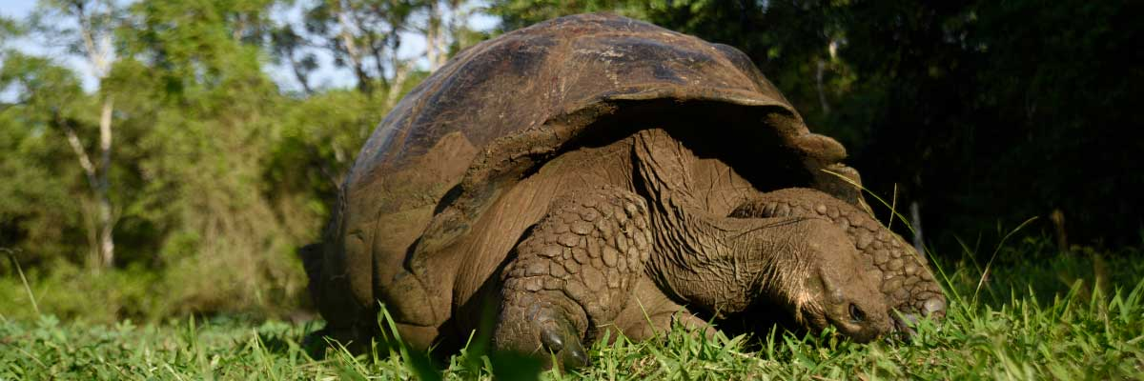

|  |  |
| --- | --- |
| **Food**: | B/L/D |
| **Trail:** | 1-1,5 km / 0,6-0,9 mi |
| **Lodging**: | M/Y Bonita |
| **Level**: | 1 |
| **Activities:** | HIKING |

DAY 3

AM: DARWIN BAY

Genovesa is a favorite island for birdwatchers as it is home for very large colonies of seabirds. From the minute you set foot at the beach you will be amazed by the noise of hundreds of boobies, gulls and frigatebirds flying over your heads, perched in the bushes or nesting on the sandy terrain. The trail is an ultimate wildlife experience as there are animals everywhere; sea lions and marine iguanas near the sea; night herons, lava and swallow tailed gulls, Darwin finches, Galapagos doves, mockingbirds and many more species inland.

Snorkel Experience: The bay offers several places to snorkel; from deep waters along the cliffs across the bay, to shallow waters by the beach. In either case, there are many fish to see and great chances of seeing sharks, rays and sea lions.

**Highlights:**  Nesting great frigatebirds, Red-footed and Nazca boobies, Galapagos sea lions, Yellow-crowned night herons, Genovesa ground finch, Genovesa cactus finch, Galapagos mockingbirds

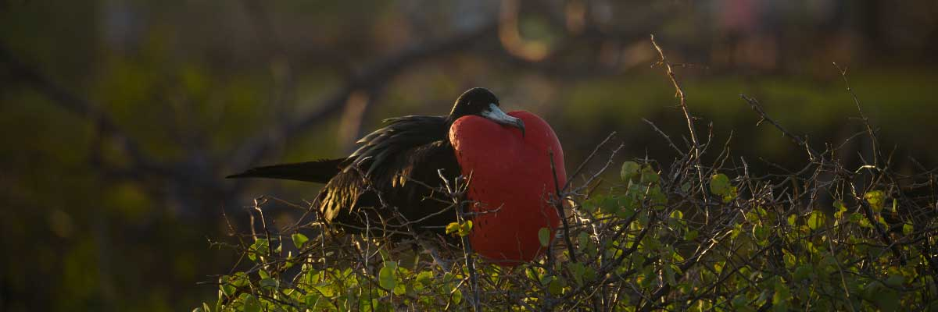

|  |  |
| --- | --- |
| **Trail:** | 1,2 km / 0,7 mi |
| **Level**: | 3 |
| **Activities:** | HIKING,SNORKEL,PANGA RIDE,PADDLE BOARD,KAYAK |

PM: BARRANCO

El Barranco is located in the southern part of Darwin Bay at Genovesa Island. The cliffs facing the sea are made of very fragile fractured lava, making it the ideal place for storm petrels to build their colonies, which attracts an important population of short-eared owls preying on the nesting birds. Red footed and Nazca boobies are abundant along the trail. At the base of the cliffs you can see Galapagos fur seals resting in shaded areas, as well as several species of seabirds.

Snorkel Experience: You can snorkel along the cliffs where there are many fish and great chances of seeing sharks, rays and sea lions.

**Highlights:** Nesting great frigatebirds, Galapagos sea lions, Genovesa ground finch, Genovesa cactus finch, Galapagos mockingbirds, Galapagos fur seals

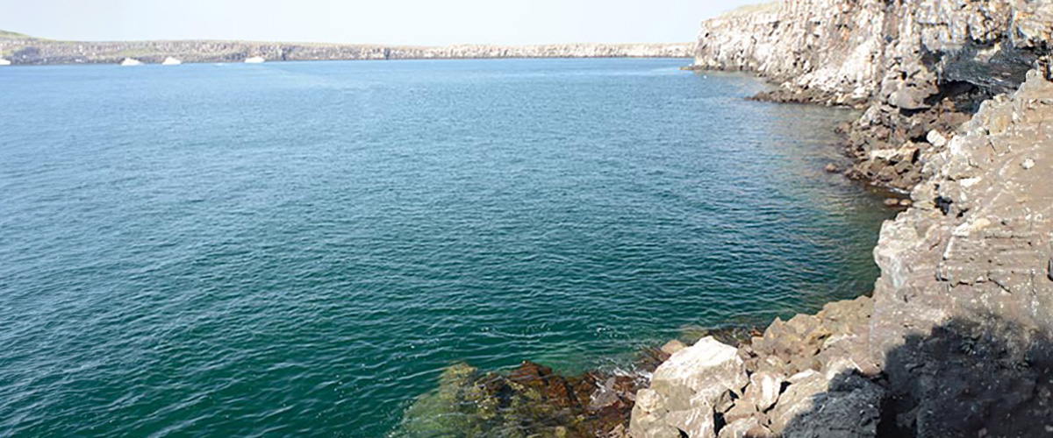

|  |  |
| --- | --- |
| **Food**: | B/L/D |
| **Trail:** | 1,2 km / 0,7 mi |
| **Lodging**: | M/Y Bonita |
| **Level**: | 3 |
| **Activities:** | HIKING,SNORKEL,PANGA RIDE,PADDLE BOARD,KAYAK |

DAY 4

AM: SULLIVAN BAY

This hike is a journey into understanding the birth of these volcanic islands. You will walk in a very well preserved flow of Pahoehoe lava, which will give you endless opportunities to see the delicate textures of these types of lavas which only appear in a few places throughout the world. At first sight the barren landscape looks completely deprived of life, but look carefully for pioneer plants, lava lizards and small birds. By the shore, you can find penguins, pelicans and oystercatchers.

Snorkel Experience: You will have the option to swim or snorkel from a coral sand beach or from the dinghies. Getting underwater is like traveling to another world: if the land is almost lifeless, the sea is teaming with life, including large schools of fish, Galapagos penguins, reef sharks, turtles and rays.

**Highlights:**  Lava tubes, Galapagos penguins, Oystercatchers, Galapagos hawks

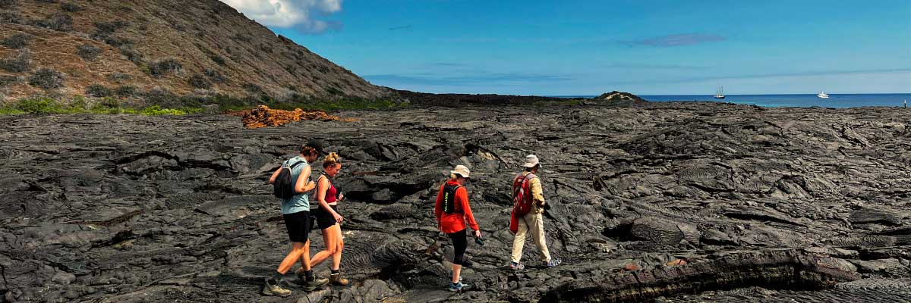

|  |  |
| --- | --- |
| **Trail:** | 2,2 km / 1,4 mi |
| **Level**: | 3 |
| **Activities:** | HIKING,SNORKEL,PANGA RIDE |

PM: BARTOLOME

Bartolome is one of the most iconic islands in Galapagos, renowned for its dramatic volcanic landscape and the famous Pinnacle Rock. Nestled beside a peach-colored sand beach, this island is one of the few places where you can spot penguins without traveling to remote Isabela and Fernandina. The hike to the summit offers breathtaking views of a lunar-like terrain dotted with volcanic cones, with stunning panoramas of Sullivan Bay and Pinnacle Rock. From the top, the vast beauty of the archipelago unfolds before you, creating a truly unforgettable experience.

Snorkel Experience: Enjoy an unforgettable snorkeling experience in Bartolome, one of Galapagos’ top spots. Swim in calm, clear waters alongside penguins, colorful fish, sea turtles, sea lions, rays, and reef sharks in a thriving marine ecosystem.

**Highlights:** Volcanic landscapes, Pinnacle rock, Herons, Bluefooted boobies, Galapagos penguins

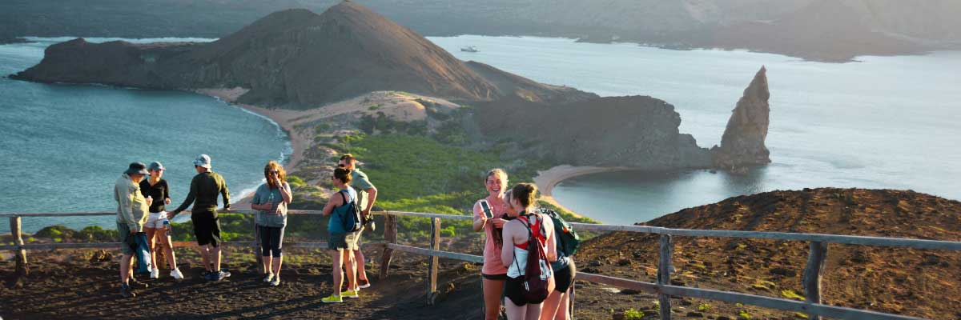

|  |  |
| --- | --- |
| **Food**: | B/L/D |
| **Trail:** | 1,5 km / 0,9 mi |
| **Lodging**: | M/Y Bonita |
| **Level**: | 2 |
| **Activities:** | HIKING,SNORKEL,PANGA RIDE |

DAY 5

AM: SEYMOUR

Seymour Island is a paradise for bird watchers, with large colonies of magnificent and great frigatebirds inflating their red throat pouches in an impressive courtship display. On the ground, blue-footed boobies perform their famous mating dance, while swallow-tailed gulls perch on cliffs overlooking the sea. Inland, land iguanas have thrived thanks to conservation efforts, while marine iguanas bask on the rocks near playful sea lions body surfing the waves.

Snorkel Experience: Swim alongside sea lions, sharks, turtles, rays, and tropical fish. If you're lucky, you might spot eels hiding among the rocks in this thriving marine ecosystem.

Galapagos sea lions, Magnificent and great frigatebirds, Land and marine iguanas, Darwin finches

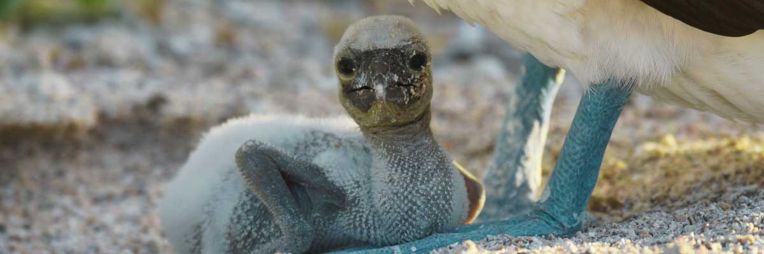

|  |  |
| --- | --- |
| **Trail:** | 1,4 km / 0,8 mi |
| **Level**: | 1 |
| **Activities:** | HIKING |

PM: BALTRA (AIRPORT)

Your Galapagos adventure comes to an end. Today, you will be transferred to Baltra Airport, where your National Park naturalist guide will assist you with final details before your flight back to mainland Ecuador. As you bid farewell to this paradise, take with you the unforgettable memories of one of the world’s most extraordinary destinations.



|  |  |
| --- | --- |
| **Food**: | B/-/- |
| **Trail:** |  |
| **Lodging**: | M/Y Bonita |
| **Level**: | 1 |
| **Activities:** | - |

GLOSSARY

|  |  |  |
| --- | --- | --- |
| **Feeding** | **Breakfast** | B |
| **Lunch** | L |
| **Dinner** | D |
| **Difficulty of the hike** | **Level 1** | Easy |
| **Level 2** | Moderate |
| **Level 3** | Difficult |