Western Galapagos Wildlife And Volcanic Wonders
8 Days – 7 Nights

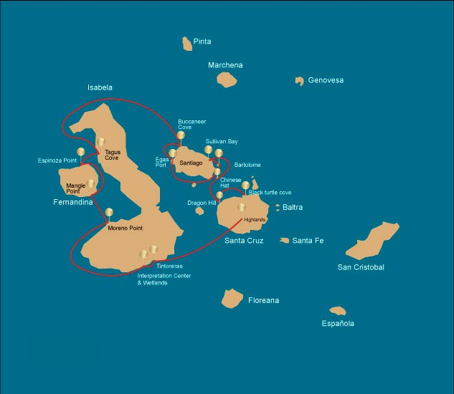
 |  |  | Hiking | Snorkel | Panga Ride | Paddle Board | Kayak
WEDNESDAY | AM | Santa Cruz Island : Baltra - airport (arrival)
 | PM | Santa Cruz Island : Highlands | *
THURSDAY | AM | Isabela Island : Tintoreras |  | * | *
 | PM | Isabela Island : Isabela's Wetlands and Interpretation Center | *
FRIDAY | AM | Isabela Island : Moreno Point | * | * | *
 | PM | Fernandina Island : Mangle Point |  | * | * | * | *
SATURDAY | AM | Fernandina Island : Espinoza Point | * | * | *
 | PM | Isabela Island : Tagus Cove | * | * | * | * | *
SUNDAY | AM | Santiago Island : Buccaneer Cove | * | *
 | PM | Santiago Island : Egas Port | * | * | * | * | *
MONDAY | AM | Bartolome Island : Bartolome |  |  | *
 | PM | Santiago Island : Sullivan Bay | * | *
TUESDAY | AM | Chinese Hat Island : Chinese Hat | * | * | * | * | *
 | PM | Santa Cruz Island : Dragon Hill | * |  | * | *
WEDNESDAY | AM | Santa Cruz Island : Black Turtle Cove | * | *
 |  | Santa Cruz Island : Baltra - airport (return)

DAY 1 - WEDNESDAY

AM: BALTRA AIRPORT (ARRIVAL)
Welcome to Galapagos! Upon arrival at Baltra Airport, your naturalist guide will greet you and assist with the transfer to Itabaca Channel. This initial journey offers your first connection with the archipelago as you take a short ferry ride to Santa Cruz Island. Along the way, observe Baltra’s arid landscape and learn about its history as a former U.S. WWII airbase. This is just the beginning of the many fascinating stories awaiting you on your adventure.

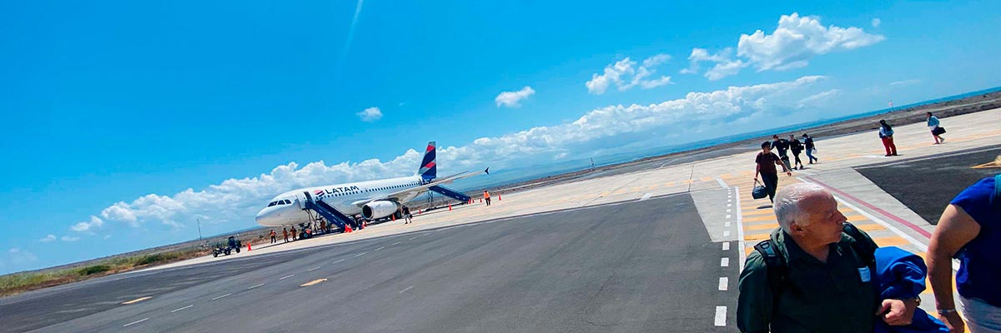
Trail:
Level: | 1
Activities: | -

PM: HIGHLANDS
Enjoy a scenic journey into the lush highlands of Santa Cruz. Walk through a reserve where you may spot giant tortoises—some weighing over 600 pounds—grazing peacefully. Observe endemic birds such as finches and flycatchers. If included in your itinerary, explore a lava tunnel, a fascinating remnant of the volcanic forces that shaped these islands.

Lava tunnels, Darwin finches, Galapagos flycatchers, Giant tortoises, Barn owls, White-cheeked pintails
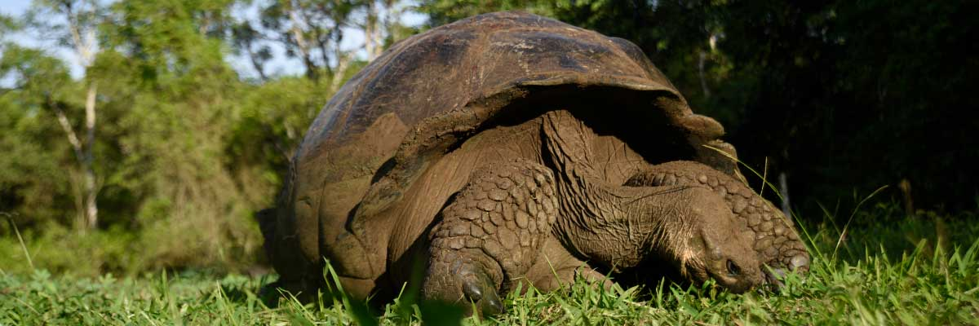
Food: | -/L/D
Trail: | 1-1,5 km / 0,6-0,9 mi
Lodging: | M/Y Galaxy Stella
Level: | 1
Activities: | HIKING
DAY 2 - THURSDAY

AM: TINTORERAS
Located close to Puerto Villamil, Tintoreras is a small islet teeming with wildlife. Its shores are filled with sunbathing marine iguanas and resting sea lions. In its shallow channels, rays and sea turtles glide gracefully, while reef sharks, locally known as "Tintoreras" patrol the area. Herons and gulls are frequent visitors, and with some luck, you might spot a Galapagos penguin, as a few individuals inhabit the region. This site offers a perfect glimpse into Isabela's rich natural heritage.

Highlights: White-tipped and black-tipped reef sharks, Sea turtles, Manta rays
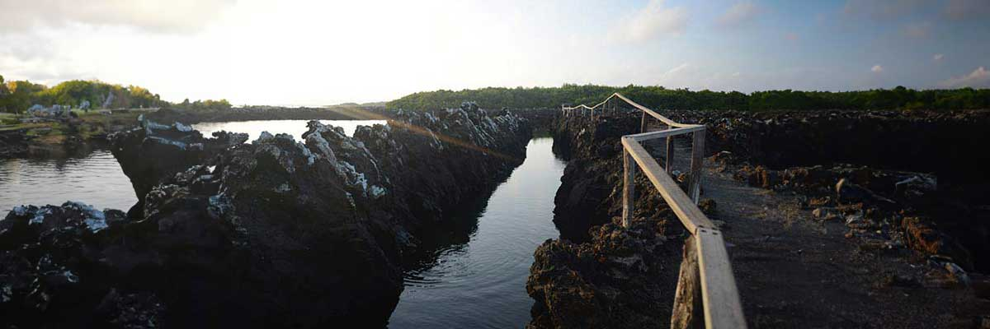
Trail: | 1,1 km / 0,7 mi
Level: | 2
Activities: | SNORKEL,PANGA RIDE

PM: ISABELA’S WETLANDS AND INTERPRETATION CENTER
In the afternoon, immerse yourself in Isabela’s wetlands, a crucial ecosystem for Galapagos’ biodiversity. Walk along trails through mangroves and saline lagoons, where pink flamingos, blue-billed ducks, and other aquatic birds thrive. This natural sanctuary showcases the island’s remarkable wildlife. Conclude your day at the Interpretation Center, where you’ll gain insight into Galapagos’ natural and human history, its conservation challenges, and the ongoing efforts to protect this UNESCO World Heritage Site.

Highlights: Mangroves, Flamingoes, Ducks
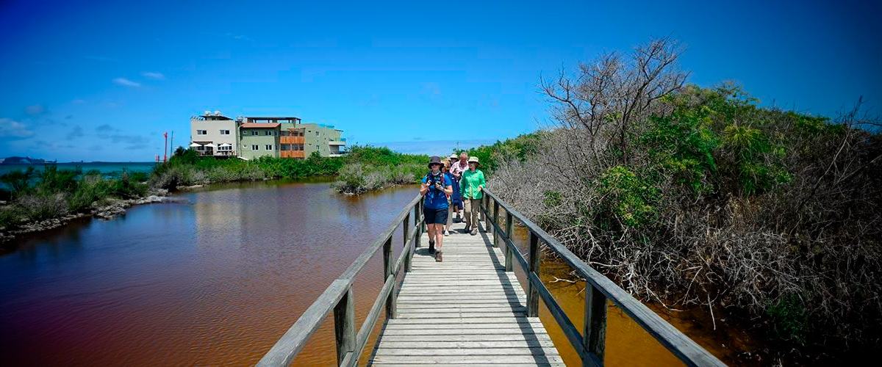
Food: | B/L/D
Trail: | 3 km / 1.86 mi
Lodging: | M/Y Galaxy Stella
Level: | 1
Activities: | HIKING
DAY 3 - FRIDAY

AM: MORENO POINT
Start your day exploring Moreno Point, a stunning volcanic landscape that appears barren but is brimming with life. Venture inland to discover brackish lagoons, home to flamingos, gallinules, ducks, and herons. Along the rugged coast, spot Galapagos penguins, flightless cormorants, marine iguanas, and blue-footed boobies. Sea lions and oystercatchers are also frequent visitors, making this site a remarkable showcase of how life thrives even in Galapagos’ harshest environments.

Highlights: Stunning Views, Galapagos mockingbirds, Darwin finches, American flamingoes, Flightless cormorants, Marine iguanas, Ducks, Gallinules
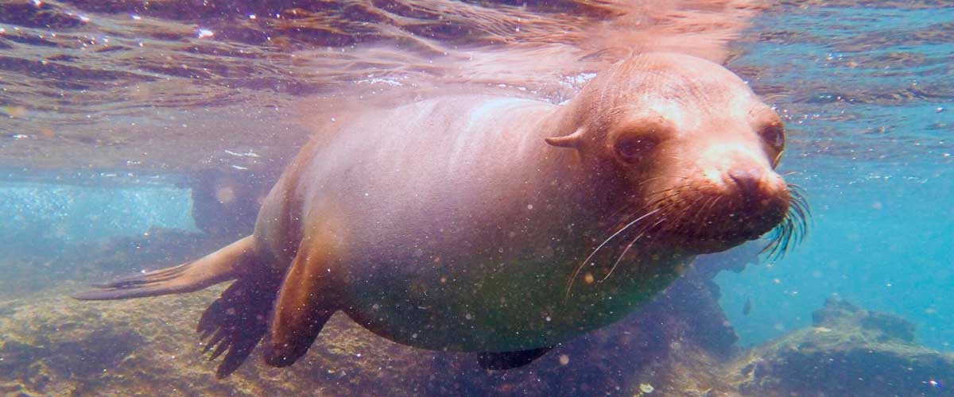
Trail: | 1,6 km / 1 mi
Level: | 3
Activities: | HIKING,SNORKEL,PANGA RIDE

PM: MANGLE POINT
Start your day at Mangle Point, an ecological paradise on the untouched Fernandina Island. This site is a biodiversity haven where mangrove forests provide a crucial habitat for many marine species. As your boat glides through crystal-clear waters, observe sea turtles weaving through the mangrove roots and rays resting on the sandy bottom. This location offers a rare opportunity to connect with nature, experiencing firsthand the intricate symbiosis between the mangrove ecosystem and marine life.

Highlights: Mangroves, Rays, Sea turtles
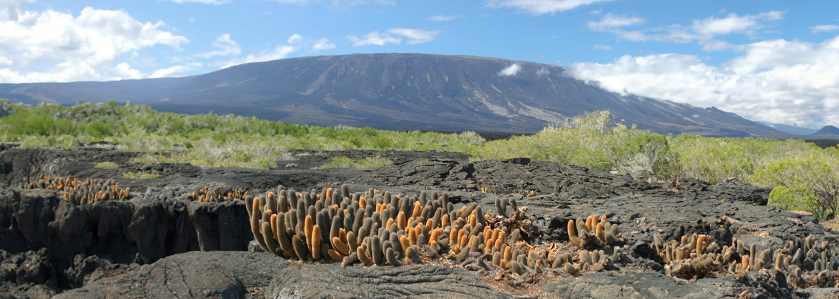
Food: | B/L/D
Trail: | N/A (mainly a water-based activity)
Lodging: | M/Y Galaxy Stella
Level: | 1
Activities: | SNORKEL,PANGA RIDE,PADDLE BOARD,KAYAK
DAY 4 - SATURDAY

AM: ESPINOZA POINT
Espinoza Point is a true natural wonder, set at the base of the most active volcano in Galapagos. As you step ashore, you’ll be greeted by the largest colony of marine iguanas basking on black volcanic rocks. Sea lions lounge on the beach while their pups explore tide pools. Flightless cormorants patrol the shoreline, and in the mangroves, Galapagos hawks scan for prey. Blessed with cold, plankton-rich waters, this area teems with life—herons, oystercatchers, pelicans, and sea turtles all thrive in this untouched habitat.

Highlights: Stunning Views, Herons, Galapagos penguins, Oystercatchers, Galapagos hawks, Marine iguanas, Sea turtles, Shorebirds
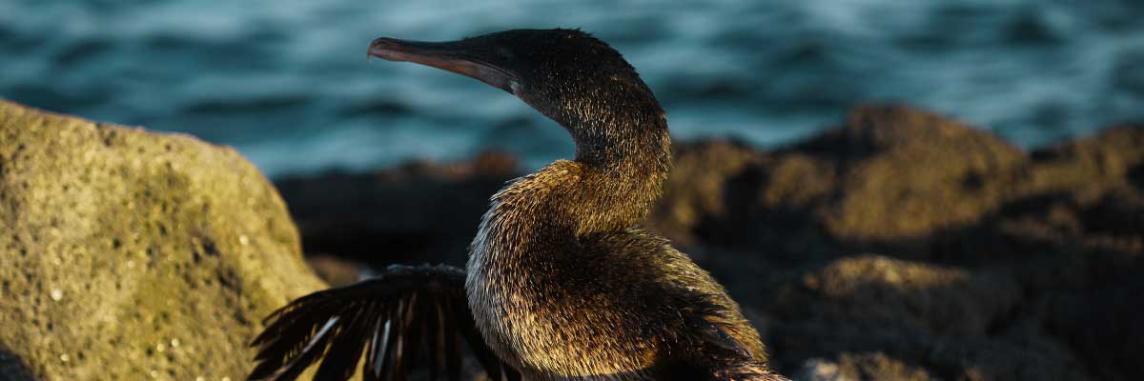
Trail: | 1,6 km / 1 mi
Level: | 2
Activities: | HIKING,SNORKEL,PANGA RIDE

PM: TAGUS COVE
Tagus Cove is steeped in history, once visited by Charles Darwin during his Galapagos exploration. A scenic trail winds through dry Palo Santo forests, where Darwin’s finches and mockingbirds can be spotted. At the top, breathtaking views of Lake Darwin and Isabela’s towering volcanoes await. A boat tour along the shore provides a chance to observe Galapagos penguins, flightless cormorants, marine iguanas, and the elusive Galapagos martin, one of the rarest and most endangered birds in the archipelago.

Highlights: Stunning Views, Herons, Galapagos penguins, Galapagos hawks, Flightless cormorants, Marine iguanas, Sea turtles, Sea stars
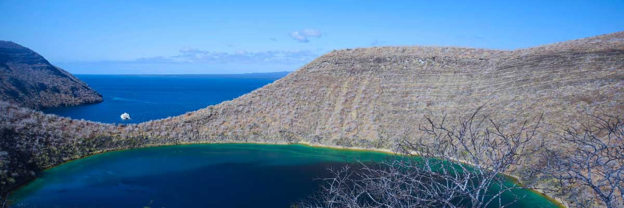
Food: | B/L/D
Trail: | 2,6 km / 1,6 mi
Lodging: | M/Y Galaxy Stella
Level: | 3
Activities: | HIKING,SNORKEL,PANGA RIDE,PADDLE BOARD,KAYAK
DAY 5 - SUNDAY

AM: BUCCANEER COVE
Known as a hideout for pirates and buccaneers in the 17th and 18th centuries, Buccaneer Cove is a site steeped in history and natural beauty. Here, sailors hid their treasures and gathered fresh water and tortoises for long voyages. Today, this stunning landscape of cliffs and rock formations is home to diverse wildlife. While there is no trail, a dinghy ride allows you to explore the cove, admire its dramatic scenery, and observe seabirds and other species that inhabit this legendary Galapagos site.

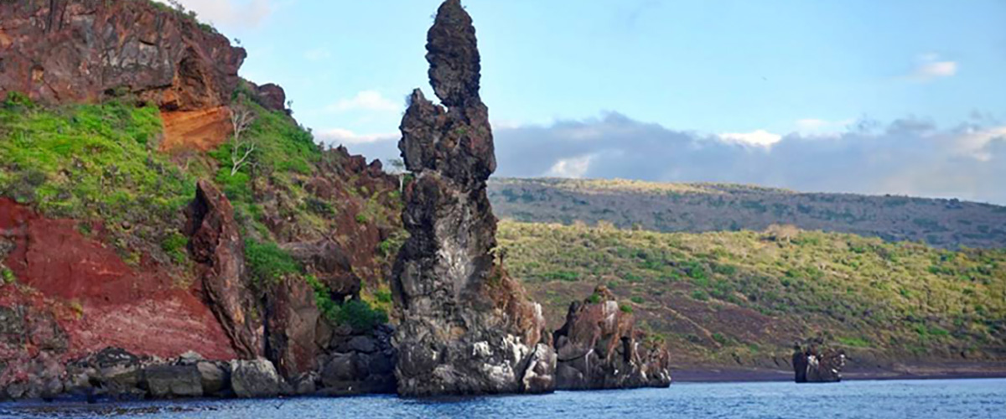
Trail: | 2,3 km / 1,4 mi (plus an extra loop 1 km - 0,6 mi)
Level: | 1
Activities: | HIKING,SNORKEL

PM: EGAS PORT
Puerto Egas is a fascinating destination where history and wildlife intertwine. While there is no actual port, remnants of 1960s colonization attempts still stand. The coastal trail is teeming with marine iguanas basking in the sun and sea lions resting on the rocks. Herons, oystercatchers, and shorebirds complete this thriving ecosystem. Towards the end of the trail, the grottos are home to a small colony of the elusive Galapagos fur seal. Additionally, land iguanas were reintroduced to the island in 2019 after over a century of absence.

Stunning Views, Herons, Galapagos sea lions, Galapagos fur seals, Oystercatchers, Galapagos hawks, Darwin finches, Marine and land iguanas, Galapagos doves, Shorebirds
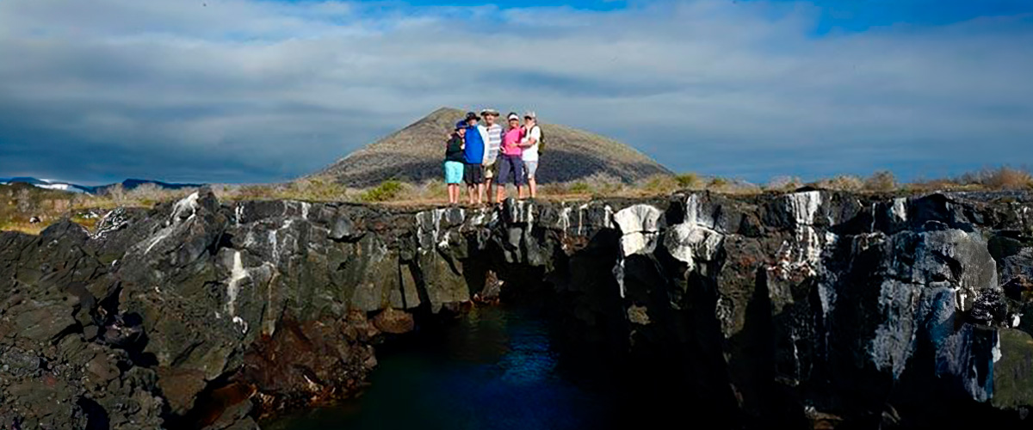
Food: | B/L/D
Trail: | 2,3 km / 1,4 mi
Lodging: | M/Y Galaxy Stella
Level: | 3
Activities: | HIKING,SNORKEL,PANGA RIDE,PADDLE BOARD,KAYAK
DAY 6 - MONDAY

AM: BARTOLOME
Bartolome is one of the most iconic islands in Galapagos, renowned for its dramatic volcanic landscape and the famous Pinnacle Rock. Nestled beside a peach-colored sand beach, this island is one of the few places where you can spot penguins without traveling to remote Isabela and Fernandina. The hike to the summit offers breathtaking views of a lunar-like terrain dotted with volcanic cones, with stunning panoramas of Sullivan Bay and Pinnacle Rock. From the top, the vast beauty of the archipelago unfolds before you, creating a truly unforgettable experience.

Highlights: Volcanic landscapes, Pinnacle rock, Herons, Bluefooted boobies, Galapagos penguins
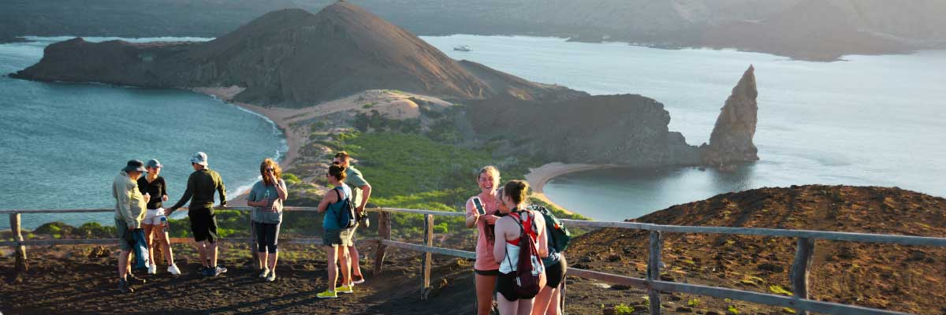
Trail: | 1,5 km / 0,9 mi
Level: | 1
Activities: | PANGA RIDE

PM: SULLIVAN BAY
Walking through Sullivan Bay is a fascinating journey into the volcanic origins of the Galapagos Islands. The trail crosses a vast Pahoehoe lava flow, showcasing unique textures that reveal the story of past eruptions. While the terrain may seem desolate at first, a closer look unveils pioneer plants, scurrying lava lizards, and small birds adapted to this extreme environment. Along the shore, the stark landscape is brightened by the presence of penguins, pelicans, and oystercatchers, adding a vibrant contrast to the stunning volcanic scenery.

Highlights: Lava tubes, Galapagos penguins, Oystercatchers, Galapagos hawks
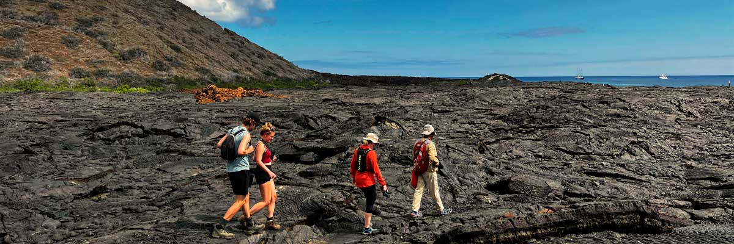
Food: | B/L/D
Trail: | 2,2 km / 1,4 mi
Lodging: | M/Y Galaxy Stella
Level: | 1
Activities: | HIKING,SNORKEL
DAY 7 - TUESDAY

AM: CHINESE HAT
Named for its distinctive cone shape, Chinese Hat is a small islet separated from Santiago by a narrow channel, forming one of Galapagos’ most picturesque bays. Its turquoise waters, coral-sand beaches, and volcanic rocks create a stunning landscape. A coastal trail leads you through a sea lion colony, while on the lava rocks, you may spot penguins resting. This site perfectly blends breathtaking scenery with Galapagos’ remarkable wildlife, making for an unforgettable experience.

Highlights: Lava tubes, Galapagos sea lions, Galapagos penguins, Oystercatchers, Galapagos hawks
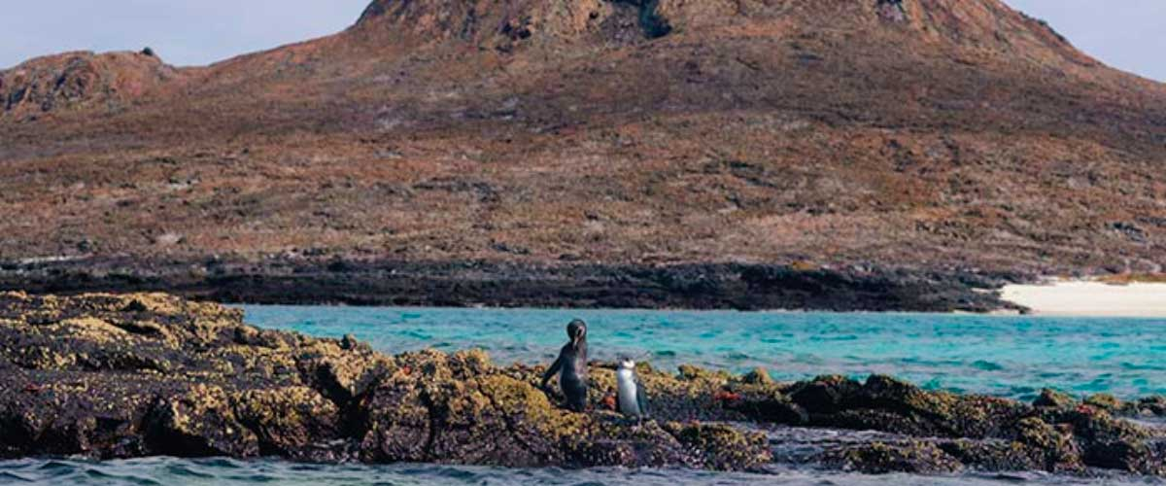
Trail: | 1,3 km / 0,8 mi
Level: | 2
Activities: | HIKING,SNORKEL,PANGA RIDE,PADDLE BOARD,KAYAK

PM: DRAGON HILL
Located on Santa Cruz’s northern coast, Dragon Hill is the only place on the island where land iguanas roam freely. Once near extinction in the 70s and 80s, their population has successfully rebounded. As you explore this unique ecosystem, you’ll also spot a saltwater lagoon where flamingos, ducks, and shorebirds often gather.

Highlights: Herons, Darwin finches, Galapagos flycatchers, White-cheeked pintails, American flamingoes, Galapagos land iguanas
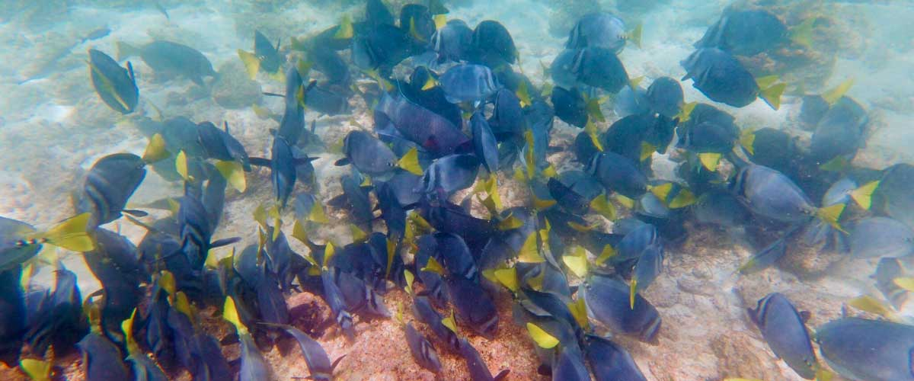
Food: | B/L/D
Trail: | 2,2 km / 1,4 mi
Lodging: | M/Y Galaxy Stella
Level: | 2
Activities: | HIKING,PANGA RIDE,PADDLE BOARD
DAY 8 - WEDNESDAY

AM: BLACK TURTLE COVE
Black Turtle Cove is a protected mangrove estuary located on the northern shore of Santa Cruz Island, just west of the Itabaca channel. The area is accessible exclusively by dinghy. The shallow, clear, and calm waters provide a highly protected haven for young marine life to grow before heading into the open ocean. The cove earns its name from the Pacific green sea turtles that frequent the area. There are easy-to-spot schools of golden cow-nosed rays, spotted eagle rays, juvenile white-tipped reef sharks, black-tipped reef sharks, baby hammerheads, and Galapagos stingrays gliding just beneath the surface.

Mangroves, White-tipped and black-tipped reef sharks, Green sea turtles, Rays, Herons, Blue footed boobies, Reef sharks
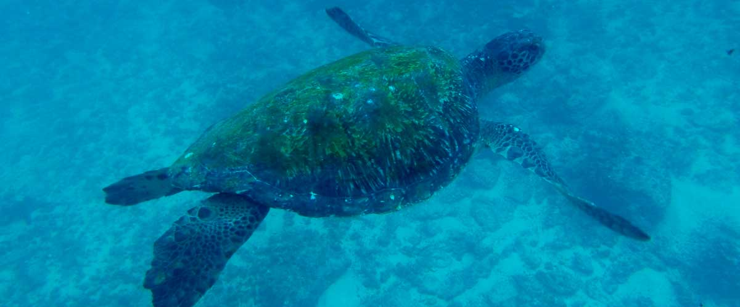
Trail:
Level: | 1
Activities: | HIKING,SNORKEL

AM: BALTRA AIRPORT (RETURN)
Your Galapagos adventure comes to an end. Today, you will be transferred to Baltra Airport, where your National Park naturalist guide will assist you with final details before your flight back to mainland Ecuador. As you bid farewell to this paradise, take with you the unforgettable memories of one of the world’s most extraordinary destinations.

Food: | B/-/-
Trail:
Lodging: | M/Y Galaxy Stella
Level: | 1
Activities: | -
GLOSSARY
Feeding | Breakfast | B
Feeding | Lunch | L
Feeding | Dinner | D
Difficulty of the hike | Level 1 | Easy
Difficulty of the hike | Level 2 | Moderate
Difficulty of the hike | Level 3 | Difficult

✔ noneX none
• none

