Galapagos Northeast Discovery and Diversity
8 Days – 7 Nights

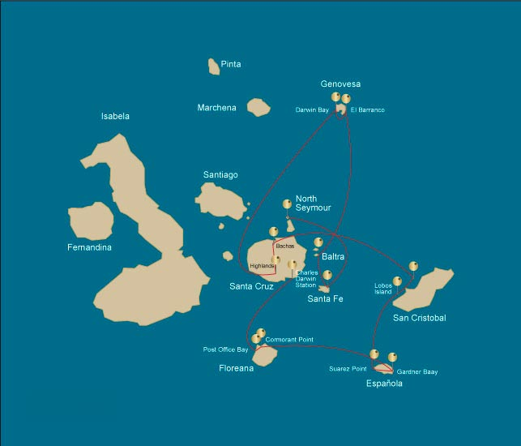
 |  |  | Hiking | Snorkel | Panga Ride | Paddle Board | Kayak
WEDNESDAY | AM | Santa Cruz Island : Baltra - airport (arrival)
 | PM | Seymour Island : North Seymour | * | * | *
THURSDAY | AM | Santa Fe Island : Santa Fe | * | * | *
 | PM | South Plazas Island : South Plaza | * | *
FRIDAY | AM | Genovesa Island : Barranco | * | * | * | * | *
 | PM | Genovesa Island : Darwin Bay | * | * | * | * | *
SATURDAY | AM | Santa Cruz Island : Highlands | *
 | PM | Santa Cruz Island : Bachas Beach | * | * | * | * | *
SUNDAY | AM | San Cristobal Island : Kicker Rock
 | PM | San Cristobal Island : Lobos Island | * | * | *
MONDAY | AM | Española Island : Suarez Point | *
 | PM | Española Island : Gardner Bay | * | * |  | * | *
TUESDAY | AM | Floreana Island : Cormorant Point | * | * | * | * | *
 | PM | Floreana Island : Post Office Bay | * | *
WEDNESDAY | AM | Santa Cruz Island : Charles Darwin Station
 |  | Santa Cruz Island : Baltra - airport (return)

DAY 1 - WEDNESDAY

AM: AIRPORT (ARRIVAL)
Welcome to Galapagos! Upon arrival at Baltra Airport, your naturalist guide will greet you and assist with the transfer to Itabaca Channel. This initial journey offers your first connection with the archipelago as you take a short ferry ride to Santa Cruz Island. Along the way, observe Baltra’s arid landscape and learn about its history as a former U.S. WWII airbase. This is just the beginning of the many fascinating stories awaiting you on your adventure.

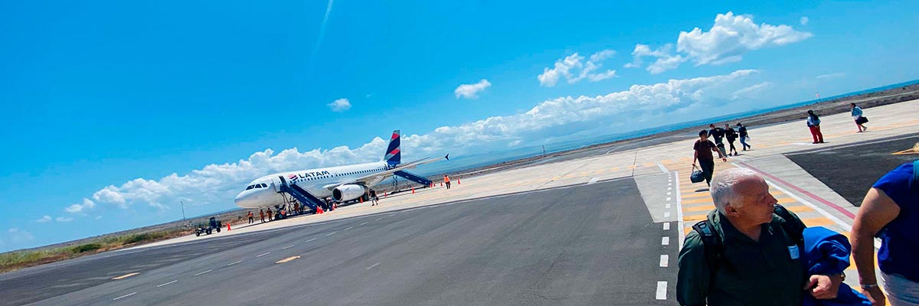
Trail:
Level: | 1
Activities: | -

PM: NORTH SEYMOUR
North Seymour Island is a paradise for bird watchers, with large colonies of magnificent and great frigatebirds inflating their red throat pouches in an impressive courtship display. On the ground, blue-footed boobies perform their famous mating dance, while swallow-tailed gulls perch on cliffs overlooking the sea. Inland, land iguanas have thrived thanks to conservation efforts, while marine iguanas bask on the rocks near playful sea lions body surfing the waves.

Galapagos sea lions, Magnificent and great frigatebirds, Land and marine iguanas, Darwin finches
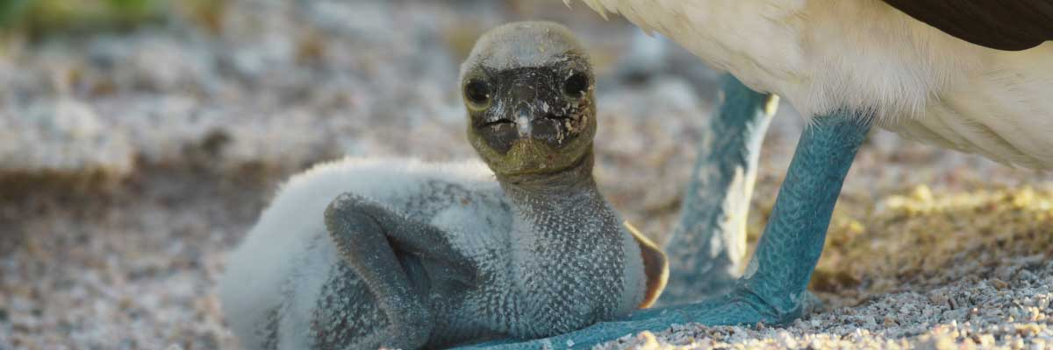
Food: | -/L/D
Trail: | 1,4 km / 0,8 mi
Lodging: | M/Y Galaxy Stella
Level: | 2
Activities: | HIKING,SNORKEL,PANGA RIDE
DAY 2 - THURSDAY

AM: SANTA FE
Santa Fe Island, nestled in one of the most stunning bays in the Galapagos, boasts towering prickly-pear cacti and ancient lava formations. Its white-sand beach and turquoise waters are home to a large sea lion colony basking under the sun. As you follow the trail, look for the endemic Santa Fe land iguana and, if lucky, a Galapagos hawk perched atop a cactus scanning for prey. Along the way, Darwin’s finches, Galapagos doves, mockingbirds, and lava lizards are commonly seen, making this hike a true wildlife experience.

Highlights: Stunning Views, Galapagos sea lions, Galapagos hawks, Galapagos doves, Santa Fe land iguanas, Reef sharks
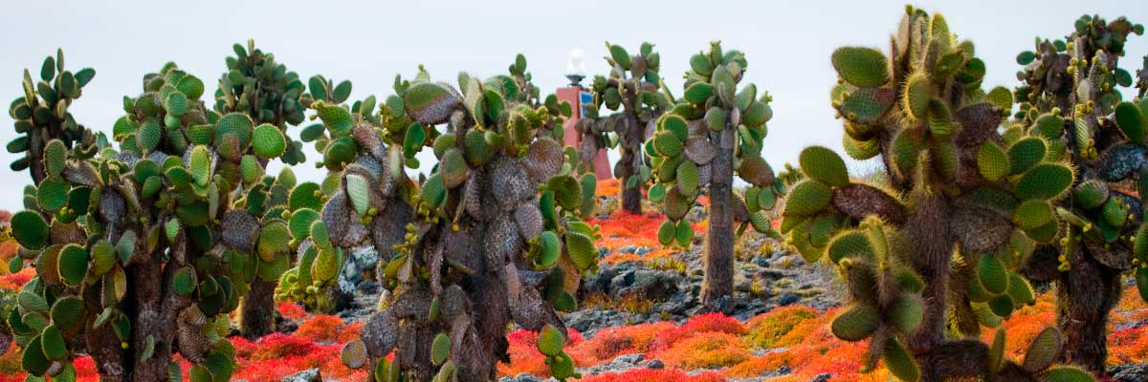
Trail: | 0,8 km / 0,5 mi
Level: | 2
Activities: | HIKING,SNORKEL,PANGA RIDE

PM: SOUTH PLAZA
Of the two twin islands, only South Plazas is open to visitors, while North Plazas remains a scientific research site. Despite its small size, South Plazas is teeming with wildlife. Upon landing, ll find land iguanas lounging beneath Opuntia cacti, waiting for fallen fruit. A large sea lion colony dominates the shore, where playful pups explore tide pools while massive bulls defend their territory. The trail leads to a dramatic cliffside, offering breathtaking ocean views where frigatebirds, blue-footed boobies, red-billed tropicbirds, and swallow-tailed gulls soar. A blanket of reddish succulents covering the island adds to its striking beauty.

Highlights: Stunning Views, Boobies, Galapagos sea lions, Galapagos shearwaters, Galapagos land iguanas, Tropicbirds, Pelicans
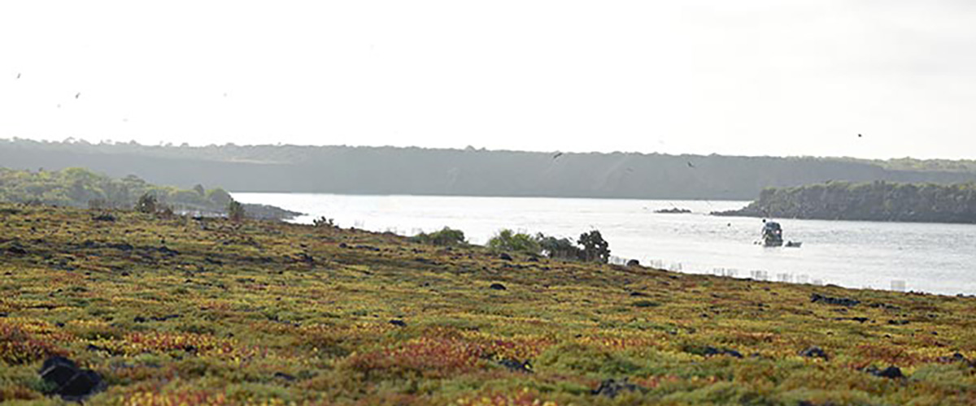
Food: | B/L/D
Trail: | 1,4 km / 0,8 mi
Lodging: | M/Y Galaxy Stella
Level: | 3
Activities: | HIKING,SNORKEL
DAY 3 - FRIDAY

AM: BARRANCO
Located in the southern part of Darwin Bay on Genovesa Island, El Barranco is a wildlife sanctuary. Its fragile lava cliffs provide shelter for storm petrels and a remarkable population of short-eared owls. Along the trail, red-footed and Nazca boobies nest on the volcanic rock. At the base of the cliffs, Galapagos fur seals rest in shaded areas, while seabirds soar above this breathtaking landscape, making El Barranco an unforgettable destination for nature lovers.

Highlights: Nesting great frigatebirds, Galapagos sea lions, Genovesa ground finch, Genovesa cactus finch, Galapagos mockingbirds, Galapagos fur seals
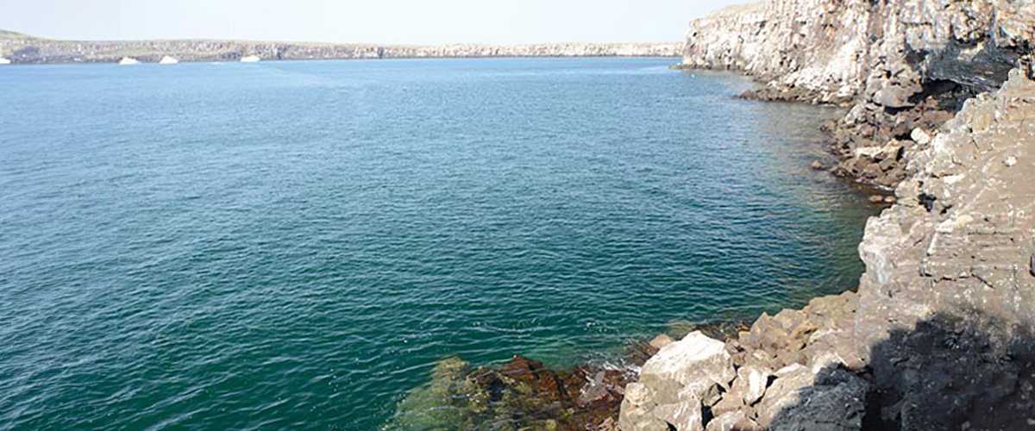
Trail: | 1,2 km / 0,7 mi
Level: | 3
Activities: | HIKING,SNORKEL,PANGA RIDE,PADDLE BOARD,KAYAK

PM: DARWIN BAY
Darwin Bay on Genovesa Island is a breathtaking sight for birdwatchers. As you step onto the beach, you’ll be amazed by the presence of hundreds of boobies, gulls, and frigatebirds soaring, nesting in bushes, or resting on the sand. Along the shore, sea lions and marine iguanas blend into the scenery, while inland you may spot night herons, swallow-tailed gulls, Darwin finches, Galapagos doves, and mockingbirds. This immersive experience brings you face-to-face with a thriving ecosystem.

Highlights: Nesting great frigatebirds, Red-footed and Nazca boobies, Galapagos sea lions, Yellow-crowned night herons, Genovesa ground finch, Genovesa cactus finch, Galapagos mockingbirds
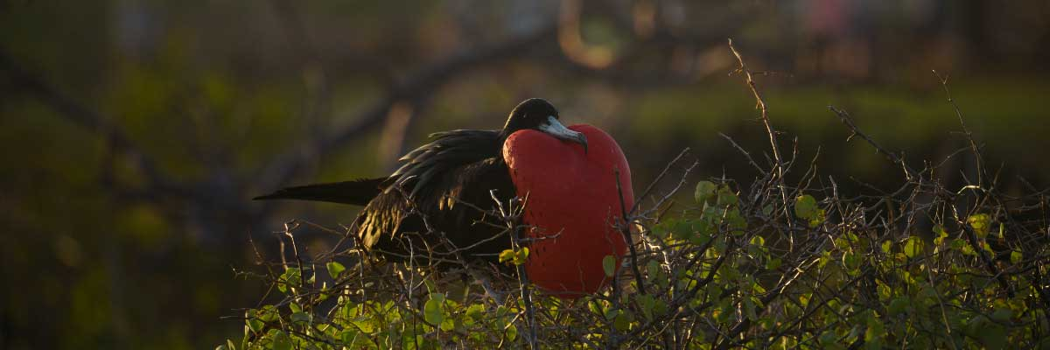
Food: | B/L/D
Trail: | 1,2 km / 0,7 mi
Lodging: | M/Y Galaxy Stella
Level: | 3
Activities: | HIKING,SNORKEL,PANGA RIDE,PADDLE BOARD,KAYAK
DAY 4 - SATURDAY

AM: HIGHLANDS
Enjoy a scenic journey into the lush highlands of Santa Cruz. Walk through a reserve where you may spot giant tortoises—some weighing over 600 pounds—grazing peacefully. Observe endemic birds such as finches and flycatchers. If included in your itinerary, explore a lava tunnel, a fascinating remnant of the volcanic forces that shaped these islands.

Highlights: Lava tunnels, Darwin finches, Galapagos flycatchers, Giant tortoises, Barn owls, White-cheeked pintails
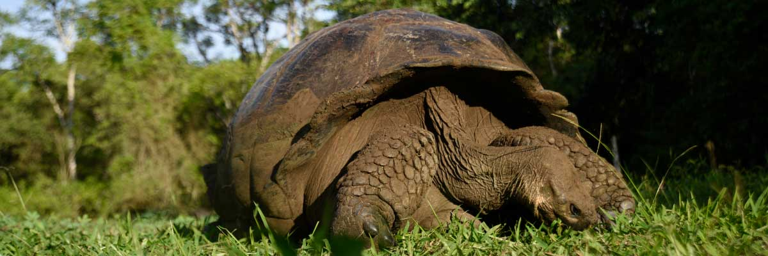
Trail: | 1-1,5 km / 0,6-0,9 mi
Level: | 1
Activities: | HIKING

PM: BACHAS BEACH
After, we will go to the beach known as Bachas, located north of Santa Cruz Island. Here we can snorkel or take a relaxing walk on the beach. For this, we will make a wet landing, in which we will jump from the panga to the shore of the beach. Again, we recommend disembarking barefoot and wearing light walking shoes for the rest of the journey. The saltwater lagoon behind the beach often has great blue herons and small birds. Both beaches are nesting areas for green sea turtles.

Highlights: Stunning Views, Blue footed boobies, White-cheeked pintails, American flamingoes, Sandpipers, Lava gulls
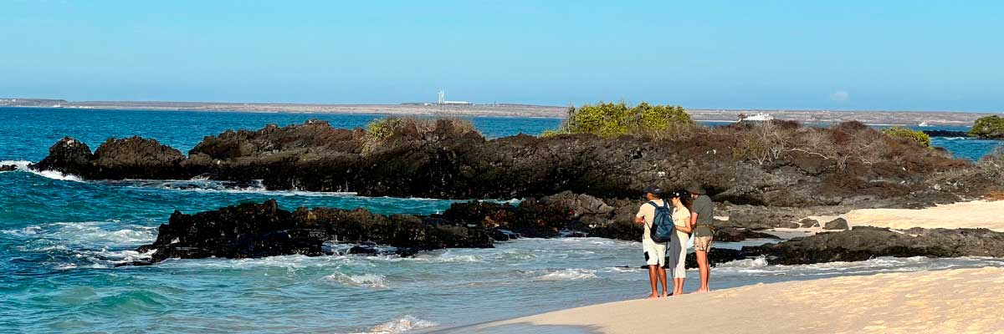
Food: | B/L/D
Trail: | 1,6 km / 1 mi
Lodging: | M/Y Galaxy Stella
Level: | 3
Activities: | HIKING,SNORKEL,PANGA RIDE,PADDLE BOARD,KAYAK
DAY 5 - SUNDAY

AM: KICKER ROCK
León Dormido, also known as Kicker Rock, is one of the most iconic rock formations in the Galapagos. Located off the coast of San Cristóbal, this towering islet with sheer cliffs offers an unparalleled setting for diving and snorkeling. Dive into crystal-clear waters and swim alongside hammerhead sharks, sea turtles, and majestic manta rays. The marine life here is abundant, with schools of tropical fish and sea lions exploring the reefs. For those seeking adventure and a deep connection with the Galapagos’ underwater world, this is an experience not to be missed.

Highlights: Boobies, Pelicans, Frigatebirds
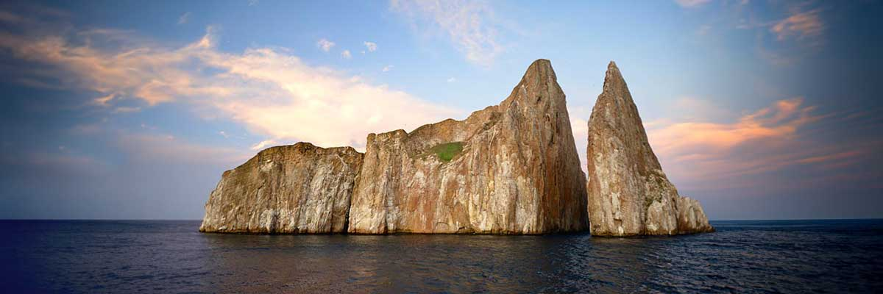
Trail:
Level: | 1
Activities: | -

PM: LOBOS ISLAND
Lobos Island, a small islet near San Cristóbal, offers an unforgettable wildlife experience. Upon landing, groups of sea lions will greet you as they play in tidal pools. Walking inland, you’ll spot frigatebirds perched in bushes, displaying their inflated red pouches, while blue-footed boobies nest along the trail, performing their iconic courtship dance. In the calm waters, snorkeling provides an incredible opportunity to swim with playful sea lions, while sea turtles and rays rest on the sandy bottom.

Highlights: Stunning Views, Galapagos sea lions, Magnificent and great frigatebirds, San Cristobal Lava Lizards
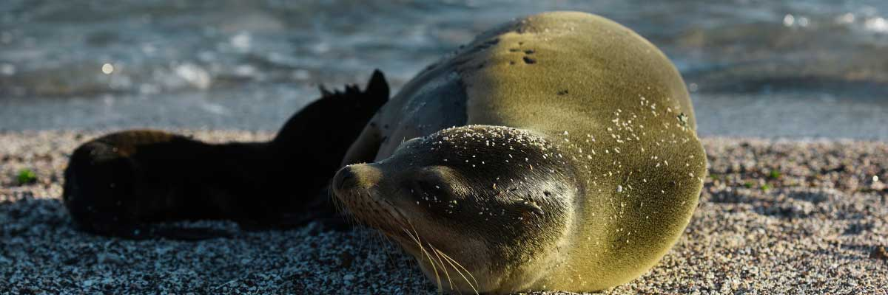
Food: | -/L/D
Trail: | 0,6 km / 0,4 mi
Lodging: | M/Y Galaxy Stella
Level: | 2
Activities: | HIKING,SNORKEL,PANGA RIDE
DAY 6 - MONDAY

AM: SUAREZ POINT
Embark on an adventure to Suarez Point, one of the Galapagos’ greatest natural wonders. This rocky trail is a haven for wildlife lovers, featuring an incredible array of species. Upon arrival, sea lions and marine iguanas welcome you as the first hosts of this nature spectacle. As you explore further, witness a vibrant mosaic of seabird colonies, from blue-footed and Nazca boobies to graceful frigatebirds and tropicbirds. The highlight of this journey is meeting the waved albatross, the island’s largest bird, impressing visitors with its powerful flight and intricate courtship display (present from April to January).

Highlights: Stunning Views, Herons, Galapagos mockingbirds, Galapagos hawks, Darwin finches, Marine iguanas, Waved Albatross, Lava lizards
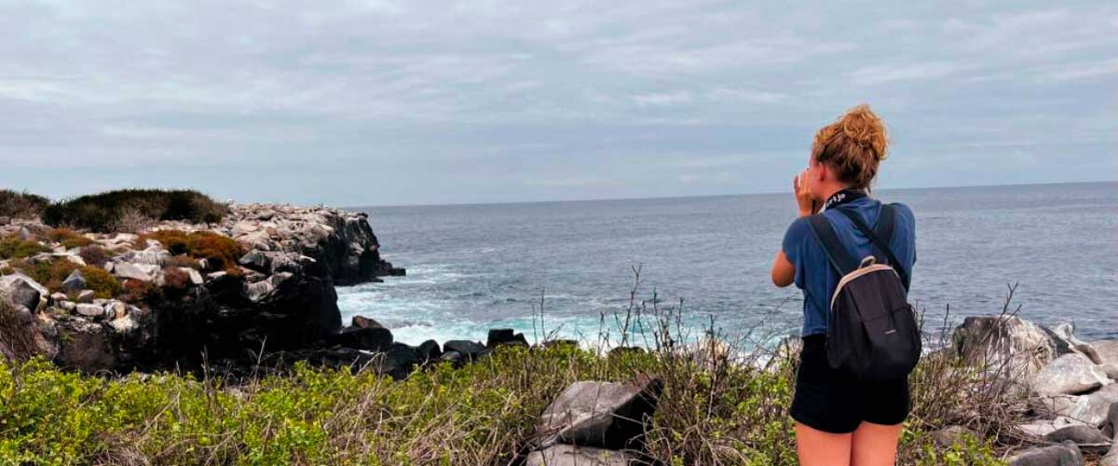
Trail: | 1,7 km / 1,1 mi
Level: | 3
Activities: | HIKING

PM: GARDNER BAY
Gardner Bay, located on Española Island, boasts one of the most stunning beaches in the Galapagos. Its soft coral sand and crystal-clear waters create a paradise-like setting, perfect for relaxation and exploration. As you stroll along the shore, spot curious Española mockingbirds, marine iguanas basking in the sun, and Galapagos hawks soaring overhead in search of prey. This natural sanctuary is also home to playful sea lions, making for an unforgettable wildlife experience in a pristine, breathtaking environment.

Highlights: Coral sand beach, Galapagos mockingbirds, Galapagos hawks, Darwin finches, Marine iguanas
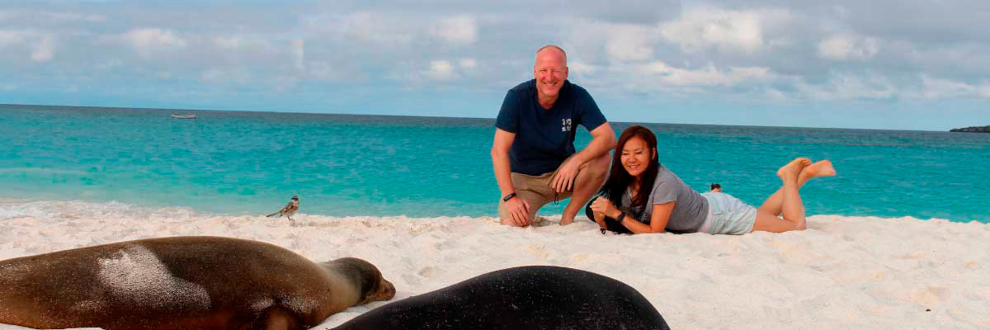
Food: | B/L/D
Trail: | 0,8 km / 0,5 mi
Lodging: | M/Y Galaxy Stella
Level: | 2
Activities: | HIKING,SNORKEL,PADDLE BOARD,KAYAK
DAY 7 - TUESDAY

AM: CORMORANT POINT
Located in northern Floreana, Punta Cormorant is a paradise for nature lovers. Its coastal lagoon hosts flamingos, white-cheeked pintails, and black-necked stilts, while its white sand beach is a crucial nesting site for green sea turtles. In recent years, blue-footed boobies have started nesting along the trail. This is also a great site for spotting endemic plants. For snorkeling, Devil’s Crown—a heavily eroded volcanic formation—offers an unparalleled experience, attracting reef sharks, rays, sea turtles, and massive schools of tropical fish.

Highlights: Galapagos sea lions, Blue footed boobies, Galapagos shearwaters, American flamingoes, Sea turtles, Tropicbirds, Frigatebirds
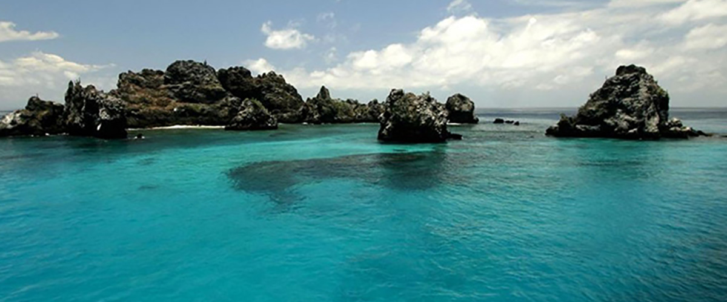
Trail: | 1,6 km / 1 mi
Level: | 2
Activities: | HIKING,SNORKEL,PANGA RIDE,PADDLE BOARD,KAYAK

PM: POST OFFICE BAY
Step into the past at Post Office Bay on Floreana, where sailors established a barrel-based mail system in the 1700s, still in use today. Beyond its historic charm, the bay was a key stop for whalers seeking freshwater and tortoises. This site also boasts a scenic beach, and incredible wildlife, including sea lions, green sea turtles, reef sharks, and, if luck is on your side, the elusive Galapagos penguin.

Highlights: Galapagos penguins, Marine iguanas, Sea turtles, Finches, Shorebirds
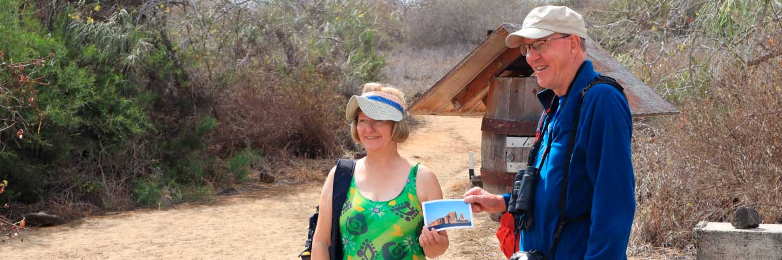
Food: | B/L/D
Trail: | 0,7 km / 0,4 mi
Lodging: | M/Y Galaxy Stella
Level: | 1
Activities: | HIKING,SNORKEL
DAY 8 - WEDNESDAY

AM: CHARLES DARWIN STATION
Explore the Charles Darwin Research Station, a center dedicated to wildlife conservation and research. Witness breeding programs helping restore giant tortoise populations, learn about projects tackling invasive species, and see conservationists working to protect the fragile Galapagos ecosystem.

Galapagos giant tortoise and land iguanas breeding program, Galapagos mockingbirds, Darwin finches, Galapagos flycatchers
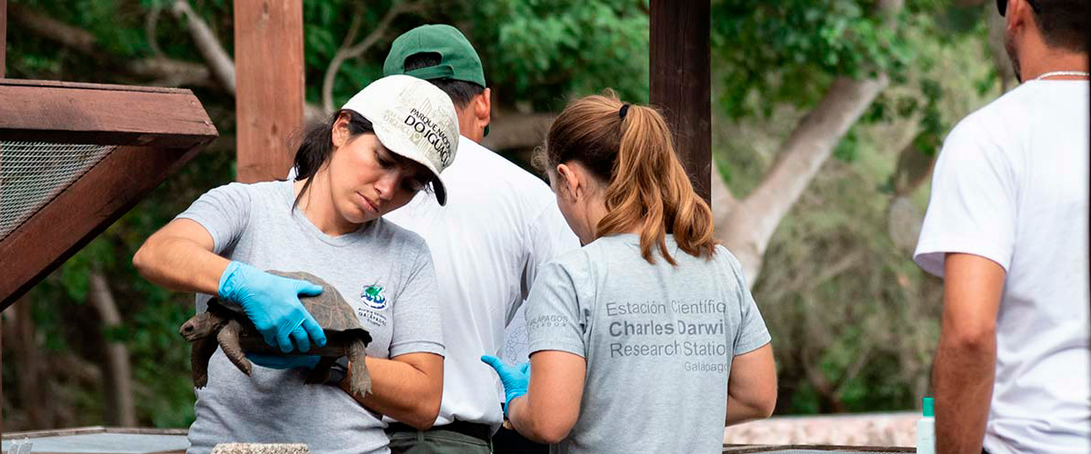
Trail: | 2 km / 1,2 mi
Level: | 1
Activities: | -

AM: BALTRA AIRPORT (RETURN)
Your Galapagos adventure comes to an end. Today, you will be transferred to Baltra Airport, where your National Park naturalist guide will assist you with final details before your flight back to mainland Ecuador. As you bid farewell to this paradise, take with you the unforgettable memories of one of the world’s most extraordinary destinations.

Food: | B/-/-
Trail:
Lodging: | M/Y Galaxy Stella
Level: | 1
Activities: | -
GLOSSARY
Feeding | Breakfast | B
Feeding | Lunch | L
Feeding | Dinner | D
Difficulty of the hike | Level 1 | Easy
Difficulty of the hike | Level 2 | Moderate
Difficulty of the hike | Level 3 | Difficult

✔ noneX none
• none

