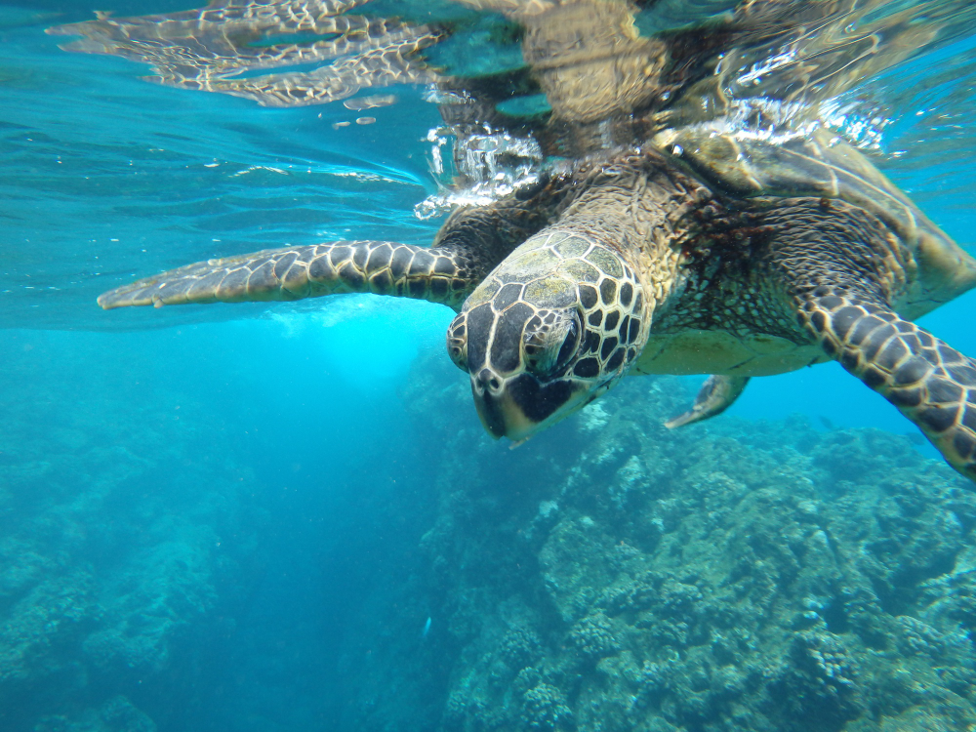
THURSDAY
SOUTH PLAZAS - CARRION POINT
Operation Day: Every Thursday
Meeting point and hour: 8h15 / At the entrance of Puerto Ayora's Church, in front of the pier. Please arrive 15 minutes before the departing hour.
Departing pier: Itabaca Channel
Arriving pier: Itabaca Channel
Coming hour: 16h00 approx
SOUTH PLAZAS
South Plazas Island is located on the east side of Santa Cruz Island. Plazas have an incredible landscape, and on our arrival, we will have a dry landing while sea lions welcome us at the shore.
We will begin our walk along a path through an Opuntia Cactus forest. Stay focused on landscape beauty; we must watch out for our steps. There are many land iguanas, the smallest species in the archipelago! Continuing our tour, we will reach the fantastic, windy cliff. Here we can see the red-billed tropical birds, swallow-tailed gulls, brown pelicans, and the impressive frigate bird usually flying around. The trail meanders along the edge of the ridge for a few hundred meters.
While we continue our walk, we will find the well-known "single sea lion colony": a heterogeneous collection of male sea lions, mostly elderly, who have lost their territories. Yet, surprisingly, they climb up the cliff via some rocky steps.
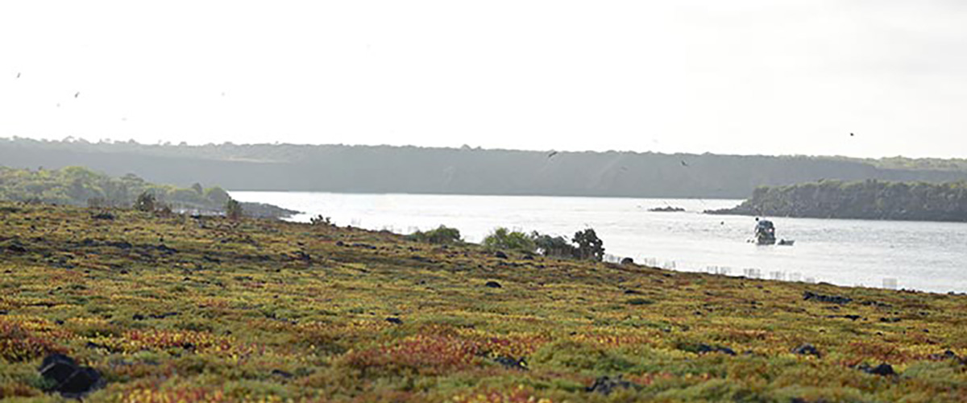

At Carrion Point, we will discover the Galapagos marine fauna while snorkeling. With some luck, we will see white-tip sharks and a great variety of fish, sea turtles, and rays.
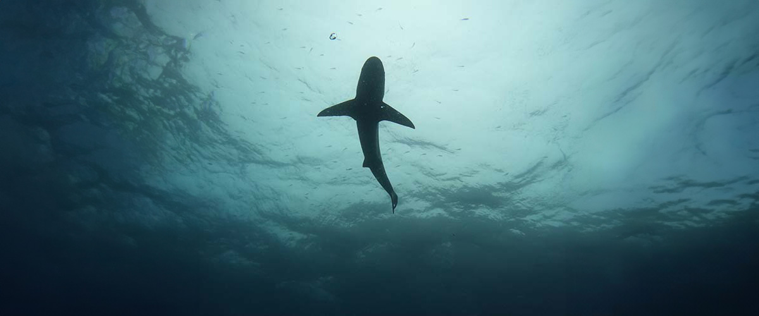

Included Services | Not Included Services
✔ Transportation to and from the meeting point at the Itabaca Channel | X International flights to/from Ecuador
✔ Coffee and tea station | X Airfare to/from the Galapagos Islands (Quito or Guayaquil)
✔ Snorkeling equipment (mask and snorkel) | X Galapagos National Park entrance fee (USD 200 per person)
✔ Visits, excursions, and activities according to the itinerary | X Transit Control Card (USD 20 per person)
✔ Wetsuits (only if the size is provided at least 72 hours before the trip) | X Alcoholic beverages
✔ 1 Bilingual naturalist guide (English-Spanish) | X Tips
✔ Fins (only if the size is provided at least 72 hours before the trip) | X Personal expenses
✔ Lunch on board | X Travel insurance (highly recommended)
✔ Towels | X Additional services not listed
✔ Local tax
Don't forget to bring
• Comfortable trekking shoes
• Sandals for the beach
• Swimsuit
• Hat and sunglasses
• Sunscreen

