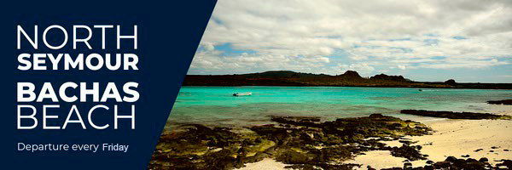
FRIDAY
NORTH SEYMOUR AND BACHAS BEACH
Operation Day: Every Friday
Meeting point and hour: 8h15 / At the entrance of Puerto Ayora's Church, in front of the pier and aside from the restaurant “El Descanso del Guía”
Departing pier: Itabaca Channel
Arriving pier: Itabaca Channel
Coming hour: 16h00 approx
AM : NORTH SEYMUR
Today we will join the tour group at the indicated meeting point and time. Then, we will depart by bus to the Itabaca Channel, where we will board the Galaxy Skape, thus beginning our adventure to North Seymour Island.
This island is located north of Santa Cruz Island. It is known for its large colonies of blue-footed boobies and frigate birds, known as the Galapagos pirates.
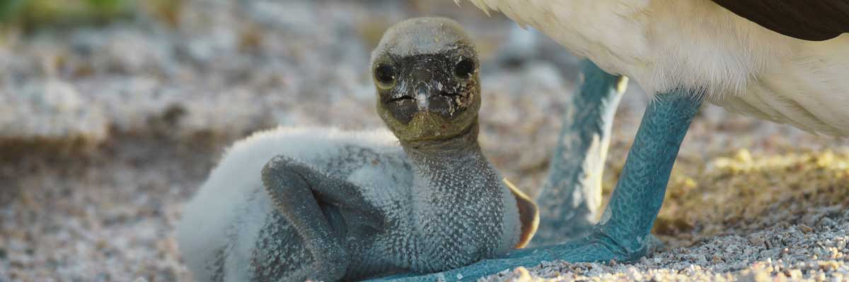

After we visit North Seymour and have a delicious lunch aboard, we will go to the beach known as Bachas, located north of Santa Cruz Island. Here we can snorkel or take a relaxing walk on the beach. For this, we will make a wet landing, in which we will jump from the panga to the shore of the beach. Again, we recommend disembarking barefoot and wearing light walking shoes for the rest of the journey. Bachas beach is lovely, ideal for swimming, with a lagoon behind and a longer coast for walking and wildlife watching. The saltwater lagoon behind the beach often has great blue herons and small birds. Both the large and small beaches are nesting areas for green sea turtles. As for snorkeling, during the activity, we may see many types of colorful reef fish and various rays, among other marine species. At the end of our experience in Bachas, we will return to the Itabaca Channel. Then, we will be transferred to Puerto Ayora's pier to end our day-long adventure.
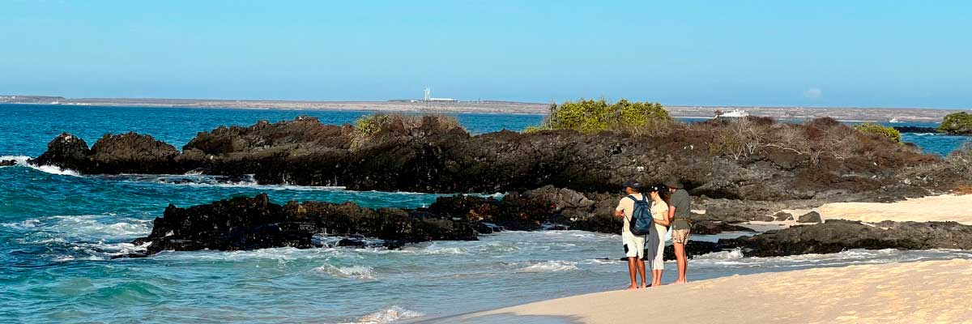

Included Services | Not Included Services
✔ Transportation to and from the meeting point at the Itabaca Channel | X International flights to/from Ecuador
✔ Coffee and tea station | X Airfare to/from the Galapagos Islands (Quito or Guayaquil)
✔ Snorkeling equipment (mask and snorkel) | X Galapagos National Park entrance fee (USD 200 per person)
✔ Visits, excursions, and activities according to the itinerary | X Transit Control Card (USD 20 per person)
✔ Wetsuits (only if the size is provided at least 72 hours before the trip) | X Alcoholic beverages
✔ 1 Bilingual naturalist guide (English-Spanish) | X Tips
✔ Fins (only if the size is provided at least 72 hours before the trip) | X Personal expenses
✔ Lunch on board | X Travel insurance (highly recommended)
✔ Towels | X Additional services not listed
✔ Local tax
Don't forget to bring
• Comfortable trekking shoes
• Sandals for the beach
• Swimsuit
• Hat and sunglasses
• Sunscreen

