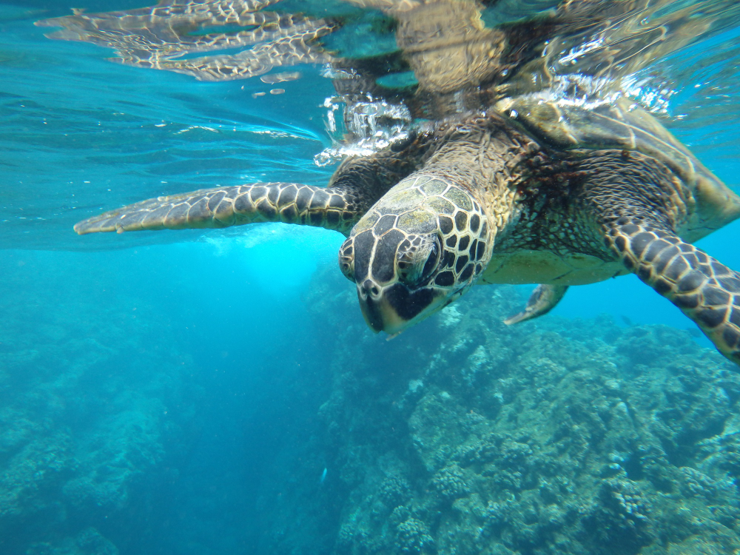
SUNDAY
SOUTH PLAZAS - CARRION POINT
Operation Day: Every Sunday
Meeting point and hour: 8h15 / At the entrance of Puerto Ayora's Church, in front of the pier. Please arrive 15 minutes before the departing hour
Departing pier: Itabaca Channel
Arriving pier: Puerto Ayora
Coming hour: 16h00 approx
SOUTH PLAZA
South Plazas Island, east of Santa Cruz, offers one of the most scenic hikes in the archipelago. After a dry landing, we are greeted by sea lions before walking through an Opuntia cactus forest, home to Galapagos; smallest land iguanas. The trail leads to the island’s dramatic cliffs, where frigatebirds, red-billed tropicbirds, swallow-tailed gulls, and pelicans soar. Along the ridge, we encounter the unique “bachelor colony,” where aging male sea lions rest after losing their territories. Many bear scars from past battles and shark bites, making this one of the most intriguing wildlife encounters on the island.
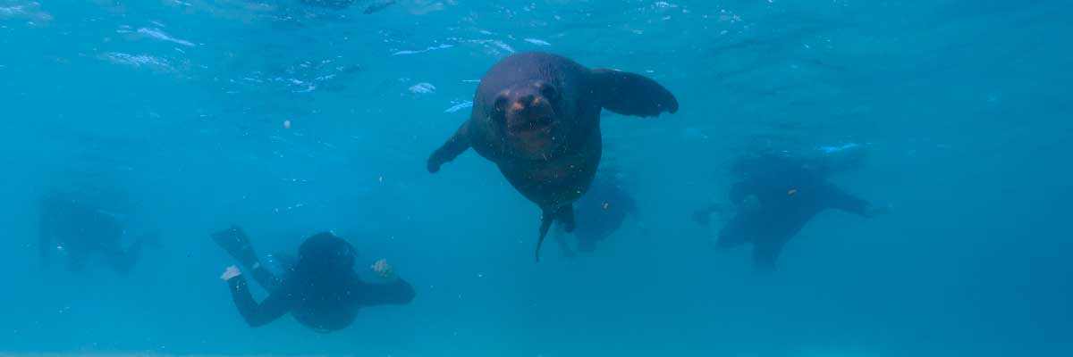

CARRION POINT
At Carrion Point, we will discover the Galapagos marine fauna while snorkeling. With some luck, we will see white-tip sharks and a great variety of fish, sea turtles, and rays.
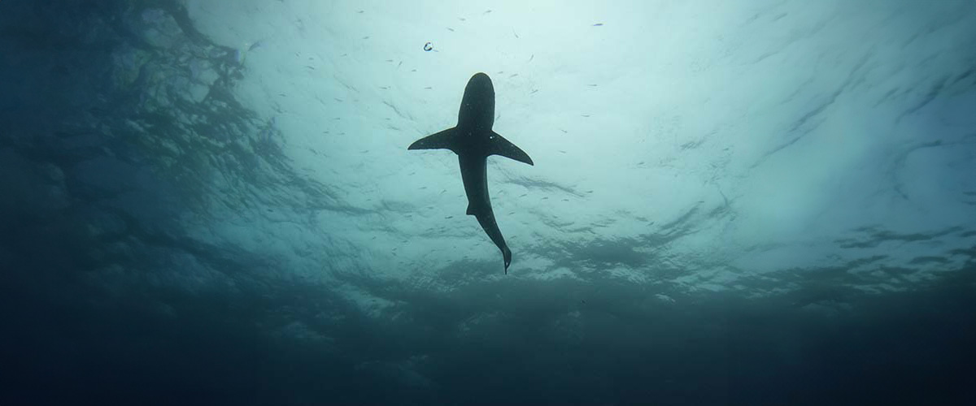

Included Services | Not Included Services
✔ Transportation to and from the meeting point at the Itabaca Channel | X International flights to/from Ecuador
✔ Coffee and tea station | X Airfare to/from the Galapagos Islands (Quito or Guayaquil)
✔ Snorkeling equipment (mask and snorkel) | X Galapagos National Park entrance fee (USD 200 per person)
✔ Visits, excursions, and activities according to the itinerary | X Transit Control Card (USD 20 per person)
✔ Wetsuits (only if the size is provided at least 72 hours before the trip) | X Alcoholic beverages
✔ 1 Bilingual naturalist guide (English-Spanish) | X Tips
✔ Fins (only if the size is provided at least 72 hours before the trip) | X Personal expenses
✔ Lunch on board | X Travel insurance (highly recommended)
✔ Towels | X Additional services not listed
✔ Local tax
Don't forget to bring
• Comfortable trekking shoes
• Sandals for the beach
• Swimsuit
• Hat and sunglasses
• Sunscreen

