**GALAPAGOS ONBOARD A CRUISE**

**5 DAYS / 4 NIGHTS**

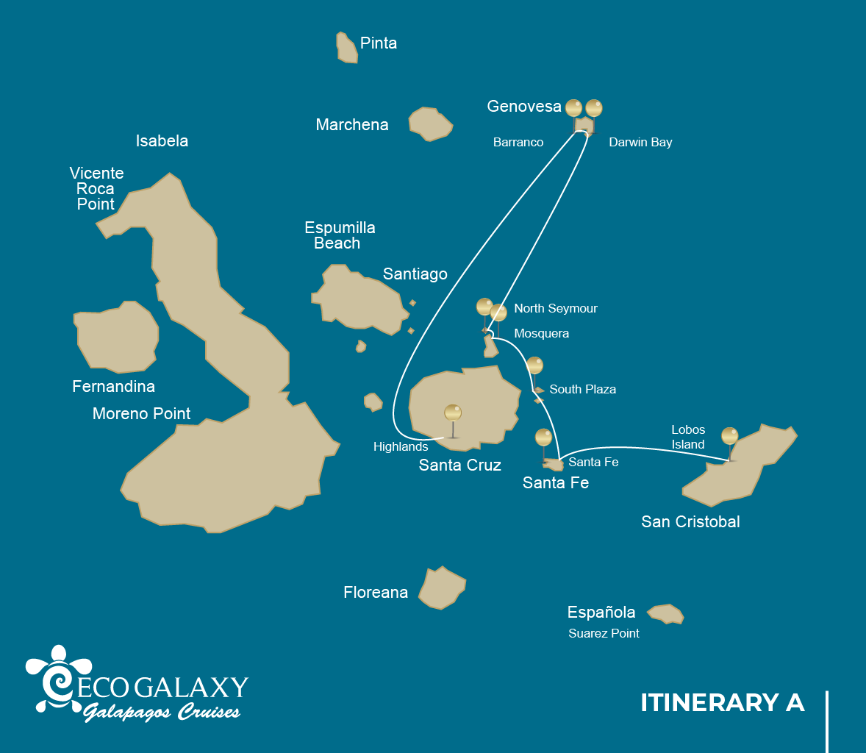

|  |  |  |  |  |  |  |  |
| --- | --- | --- | --- | --- | --- | --- | --- |
|  | | | **Hiking** | **Snorkel** | **Panga Ride** | **Paddle Board** | **Kayak** |
| TUESDAY | AM | **San Cristobal Island :** San Cristobal- Airport (arrival) |  |  |  |  |  |
|  | PM | **San Cristobal Island :** Lobos Island | * |  |  |  |  |
| WEDNESDAY | AM | **Santa Fe Island :** Santa Fe | * | * | * | * | * |
|  | PM | **South Plazas Island :** South Plaza | * |  | * | * | * |
| THURSDAY | AM | **Seymour Island :** North Seymour | * | * | * |  |  |
|  | PM | **Mosquera Island :** Mosquera | * | * |  |  |  |
| FRIDAY | AM | **Genovesa Island :** Darwin Bay | * | * | * | * | * |
|  | PM | **Genovesa Island :** Barranco | * | * | * | * | * |
| SATURDAY | AM | **Santa Cruz Island :** Highlands | * |  |  |  |  |
|  | PM | **Santa Cruz Island :** Baltra - airport (return) |  |  |  |  |  |

DAY 1

AM: ARRIVAL AT SAN CRISTOBAL AIRPORT

Embark on an unforgettable journey to the Galapagos Islands, where nature thrives in its purest form. Your adventure begins at San Cristobal’s modest yet bustling airport, where a seasoned naturalist guide will greet you. This guardian of the ecosystem will introduce you to a world of breathtaking landscapes and unparalleled biodiversity. Feel the excitement as you step into this living sanctuary, a UNESCO World Heritage site, marking the beginning of an extraordinary exploration.



|  |  |
| --- | --- |
| **Trail:** |  |
| **Level**: | 1 |
| **Activities:** | - |

PM: LOBOS ISLAND

Lobos Island, a small islet near San Cristóbal, offers an unforgettable wildlife experience. Upon landing, groups of sea lions will greet you as they play in tidal pools. Walking inland, you’ll spot frigatebirds perched in bushes, displaying their inflated red pouches, while blue-footed boobies nest along the trail, performing their iconic courtship dance. In the calm waters, snorkeling provides an incredible opportunity to swim with playful sea lions, while sea turtles and rays rest on the sandy bottom.

Snorkel Experience: The calm waters of Lobos Island are perfect for swimming with playful sea lions. Sea turtles and rays are often seen resting on the sandy bottom, while tropical fish add vibrant colors to the scene.

Stunning Views, Galapagos sea lions, Magnificent and great frigatebirds, San Cristobal Lava Lizards

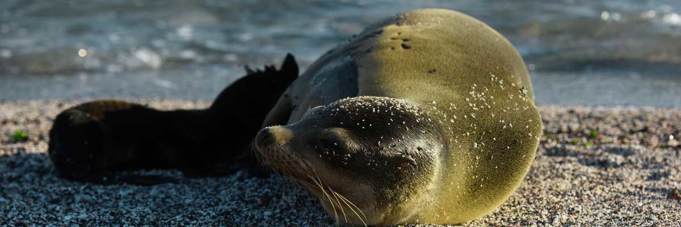

|  |  |
| --- | --- |
| **Food**: | -/L/D |
| **Trail:** | 0,6 km / 0,4 mi |
| **Lodging**: | M/C EcoGalaxy |
| **Level**: | 3 |
| **Activities:** | HIKING |

DAY 2

AM: SANTA FE

Santa Fe Island, nestled in one of the most stunning bays in the Galapagos, boasts towering prickly-pear cacti and ancient lava formations. Its white-sand beach and turquoise waters are home to a large sea lion colony basking under the sun. As you follow the trail, look for the endemic Santa Fe land iguana and, if lucky, a Galapagos hawk perched atop a cactus scanning for prey. Along the way, Darwin’s finches, Galapagos doves, mockingbirds, and lava lizards are commonly seen, making this hike a true wildlife experience.

Snorkel Experience: After the hike, snorkel in the bay’s sheltered waters. Swim alongside playful sea lions, reef sharks, and sea turtles. Spot rays and schools of tropical fish, including surgeonfish and parrotfish, for an unforgettable underwater experience.

**Highlights:**  Stunning Views, Galapagos sea lions, Galapagos hawks, Galapagos doves, Santa Fe land iguanas, Reef sharks

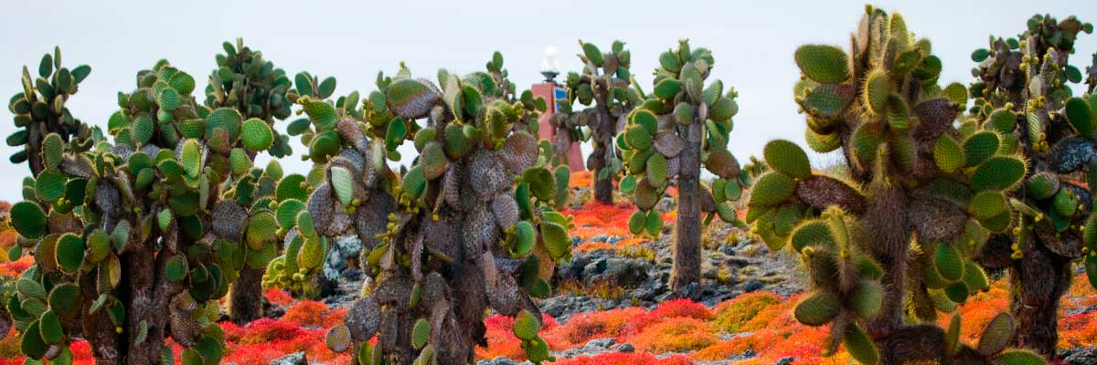

|  |  |
| --- | --- |
| **Trail:** | 0,8 km / 0,5 mi |
| **Level**: | 2 |
| **Activities:** | HIKING,SNORKEL,PANGA RIDE,PADDLE BOARD,KAYAK |

PM: PLAZAS

Of the two twin islands, only South Plazas is open to visitors, while North Plazas remains a scientific research site. Despite its small size, South Plazas is teeming with wildlife. Upon landing, ll find land iguanas lounging beneath Opuntia cacti, waiting for fallen fruit. A large sea lion colony dominates the shore, where playful pups explore tide pools while massive bulls defend their territory. The trail leads to a dramatic cliffside, offering breathtaking ocean views where frigatebirds, blue-footed boobies, red-billed tropicbirds, and swallow-tailed gulls soar. A blanket of reddish succulents covering the island adds to its striking beauty.

**Highlights:** Stunning Views, Boobies, Galapagos sea lions, Galapagos shearwaters, Galapagos land iguanas, Tropicbirds, Pelicans

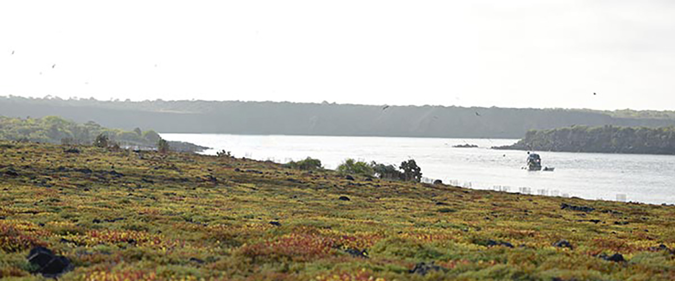

|  |  |
| --- | --- |
| **Food**: | B/L/D |
| **Trail:** | 1,4 km / 0,8 mi |
| **Lodging**: | M/C EcoGalaxy |
| **Level**: | 2 |
| **Activities:** | HIKING,PANGA RIDE,PADDLE BOARD,KAYAK |

DAY 3

AM: SEYMOUR

This island is home for large colonies of both magnificent and great frigatebirds and you can see them displaying their red balloons to attract a female. Blue-footed boobies nest in the ground and perform their famous dance in the open areas, while swallow-tailed gulls perch on the cliff edges. Land iguanas are common inland while their marine cousins bask in the rocks by the sea, close to sea lions, which often like to body surf in the waves.

Snorkel Experience: This place is a really great snorkeling location, as it has tremendous diversity and amount of fish, but also sea lions, sharks, eels, turtles, rays and many more.

**Highlights:**  Galapagos sea lions, Magnificent and great frigatebirds, Land and marine iguanas, Darwin finches

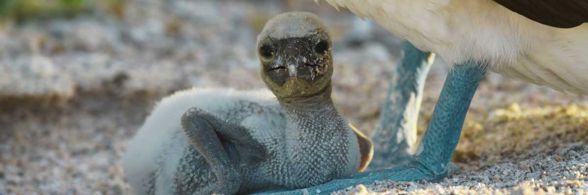

|  |  |
| --- | --- |
| **Trail:** | 1,4 km / 0,8 mi |
| **Level**: | 1 |
| **Activities:** | HIKING,SNORKEL,PANGA RIDE |

PM: MOSQUERA

Mosquera is mostly a barren sand bar with some rocky areas and scattered salt-resistant plants. You can walk along the beach and enjoy seeing playful sea lion pups surfing the waves and having a great time in the tide pools. Look for endemic lava gulls which are often seen flying over the beach in the search of food.

Snorkel Experience: If the waves are not too big you can snorkel at the northern tip of the island or at one of the small beaches in the sheltered side.

**Highlights:** Stunning Views, Galapagos sea lions, Oystercatchers, Lava gulls, Shorebirds

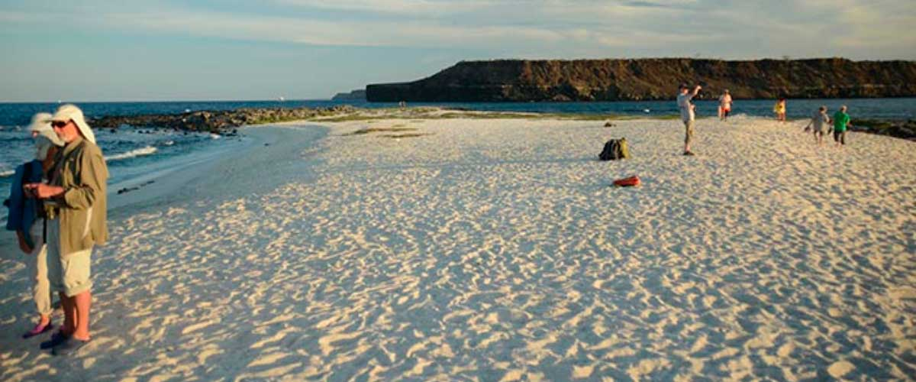

|  |  |
| --- | --- |
| **Food**: | B/L/D |
| **Trail:** | sandy area of 0,6 km / 0,4mi |
| **Lodging**: | M/C EcoGalaxy |
| **Level**: | 1 |
| **Activities:** | HIKING,SNORKEL |

DAY 4

AM: DARWIN BAY

Genovesa is a favorite island for birdwatchers as it is home for very large colonies of seabirds. From the minute you set foot at the beach you will be amazed by the noise of hundreds of boobies, gulls and frigatebirds flying over your heads, perched in the bushes or nesting on the sandy terrain. The trail is an ultimate wildlife experience as there are animals everywhere; sea lions and marine iguanas near the sea; night herons, lava and swallow tailed gulls, Darwin finches, Galapagos doves, mockingbirds and many more species inland.

Snorkel Experience: The bay offers several places to snorkel; from deep waters along the cliffs across the bay, to shallow waters by the beach. In either case, there are many fish to see and great chances of seeing sharks, rays and sea lions.

**Highlights:**  Nesting great frigatebirds, Red-footed and Nazca boobies, Galapagos sea lions, Yellow-crowned night herons, Genovesa ground finch, Genovesa cactus finch, Galapagos mockingbirds

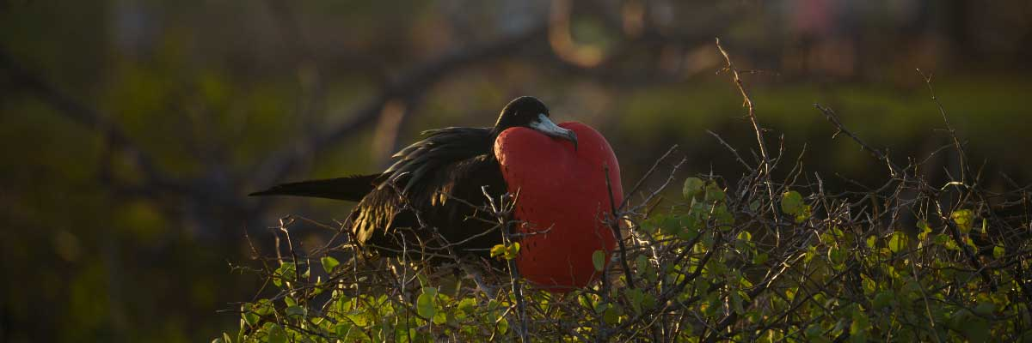

|  |  |
| --- | --- |
| **Trail:** | 1,2 km / 0,7 mi |
| **Level**: | 3 |
| **Activities:** | HIKING,SNORKEL,PANGA RIDE,PADDLE BOARD,KAYAK |

PM: BARRANCO

El Barranco is located in the southern part of Darwin Bay at Genovesa Island. The cliffs facing the sea are made of very fragile fractured lava, making it the ideal place for storm petrels to build their colonies, which attracts an important population of short-eared owls preying on the nesting birds. Red footed and Nazca boobies are abundant along the trail. At the base of the cliffs you can see Galapagos fur seals resting in shaded areas, as well as several species of seabirds.

Snorkel Experience: You can snorkel along the cliffs where there are many fish and great chances of seeing sharks, rays and sea lions.

**Highlights:** Nesting great frigatebirds, Galapagos sea lions, Genovesa ground finch, Genovesa cactus finch, Galapagos mockingbirds, Galapagos fur seals

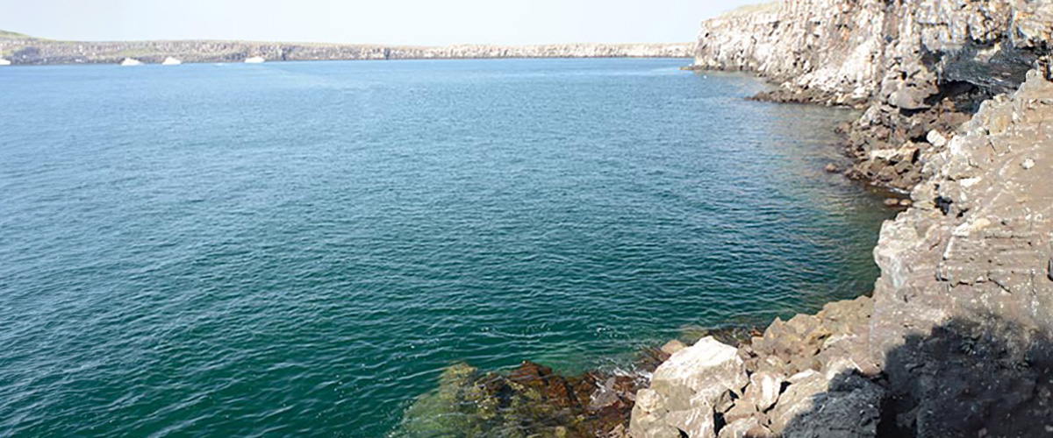

|  |  |
| --- | --- |
| **Food**: | B/L/D |
| **Trail:** | 1,2 km / 0,7 mi |
| **Lodging**: | M/C EcoGalaxy |
| **Level**: | 3 |
| **Activities:** | HIKING,SNORKEL,PANGA RIDE,PADDLE BOARD,KAYAK |

DAY 5

AM: HIGHLANDS

Either if you do this visit starting from Baltra or from Puerto Ayora, a bus will take you to the highlands stopping along the way at one of the reserves to visit the lush highland forests where you will look for Galapagos Giant tortoises in their natural environment. This is the best place in the Galapagos to see these gentle giants (reaching over 300 kg / 600 pounds!) casually grazing and resting in freshwater ponds. This is also home for a great diversity of birds rarely found at the lowlands, including finches (tree, woodpecker and vegetarian finches), flycatchers and several species of water birds. You will visit a lava tunnel (depending on the itinerary) and learn how these extraordinary formations were created by ancient volcanic eruptions.

Lava tunnels, Darwin finches, Galapagos flycatchers, Giant tortoises, Barn owls, White-cheeked pintails

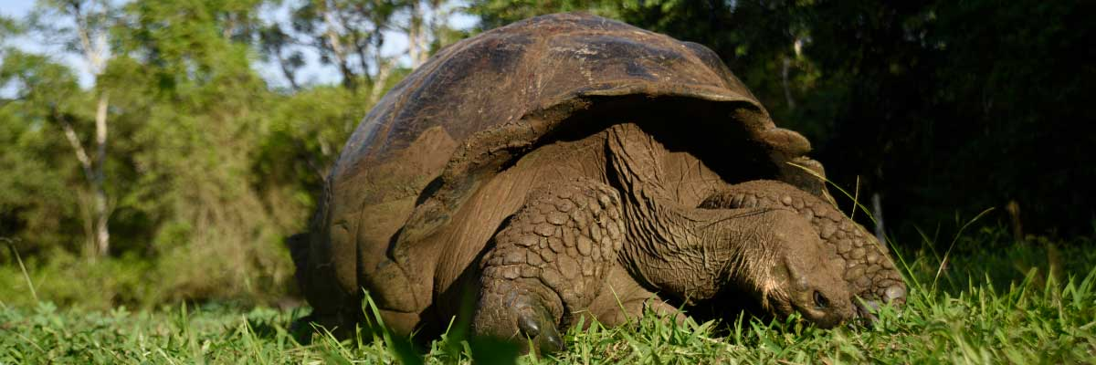

|  |  |
| --- | --- |
| **Trail:** | 1-1,5 km / 0,6-0,9 mi |
| **Level**: | 1 |
| **Activities:** | HIKING |

PM: BALTRA (AIRPORT)

Your Galapagos adventure comes to an end. Today, you will be transferred to Baltra Airport, where your National Park naturalist guide will assist you with final details before your flight back to mainland Ecuador. As you bid farewell to this paradise, take with you the unforgettable memories of one of the world’s most extraordinary destinations.

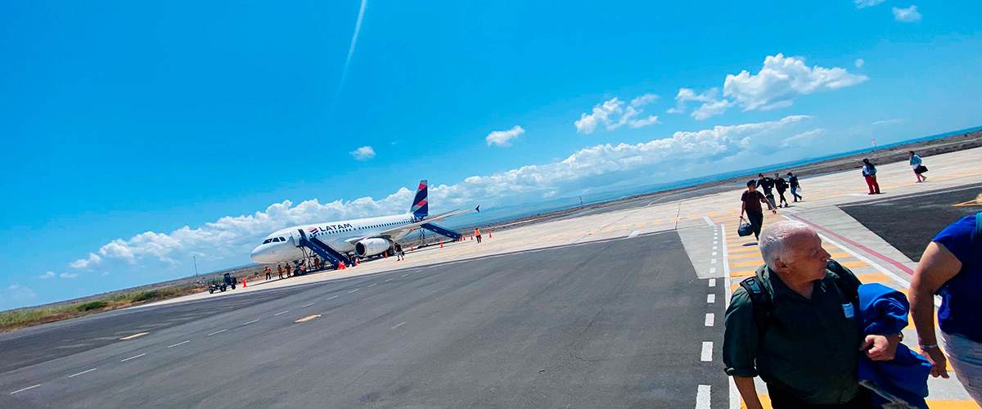

|  |  |
| --- | --- |
| **Food**: | B/-/- |
| **Trail:** |  |
| **Lodging**: | M/C EcoGalaxy |
| **Level**: | 1 |
| **Activities:** | - |

GLOSSARY

|  |  |  |
| --- | --- | --- |
| **Feeding** | **Breakfast** | B |
| **Lunch** | L |
| **Dinner** | D |
| **Difficulty of the hike** | **Level 1** | Easy |
| **Level 2** | Moderate |
| **Level 3** | Difficult |