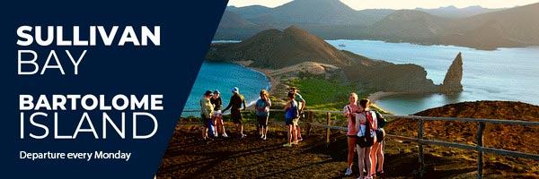
MONDAY
AM SULLIVAN BAY - PM BARTOLOME ISLAND
Operation Day: Every Monday
Meeting point and hour: 7h00 / At the entrance of Puerto Ayora's Church, in front of the p
Departing pier: Itabaca Channel
Arriving pier: Itabaca Channel
Coming hour: 17h00 aprox

Our day begins in Sullivan Bay, a spectacular snorkeling destination in Galapagos. Its crystal-clear waters unveil a thriving underwater world where schools of tropical fish weave through rocky formations. With luck, you might spot reef sharks patrolling the ocean floor, sea turtles gliding gracefully, and even playful sea lions interacting with swimmers. This pristine, wildlife-rich environment makes Sullivan Bay a must-visit for ocean and nature lovers.
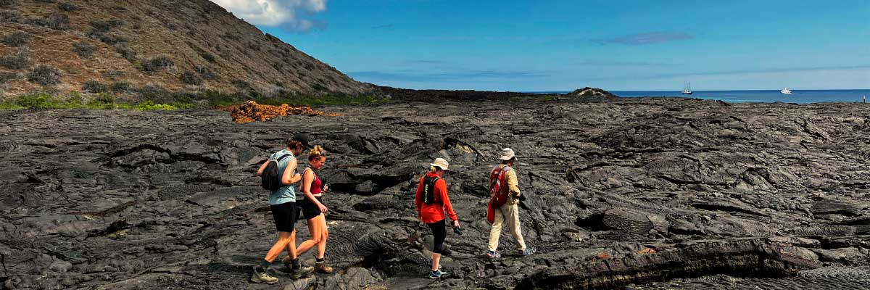

Upon arriving at Bartolome, we will have a dry landing. Then, we will begin the walk along a path that will take us to the top of the island. The 395 steps will end with a spectacular panoramic view of the island and its pinnacle, being the moment to take that stunning photo of our trip. We will observe small lava tunnels from the last eruption during the walk. The terrain is full of endemic vegetation, such as lava cacti and tiquilla plants, generally surrounded by Darwin's finches.
Did you know that volcanic ash made Pinnacle Rock?
After the walk and being impressed by the view, we will enjoy a zodiac ride along the coast. Then, with some luck, we will see the only tropical penguin and the second smallest in the world, the penguin from Galapagos.
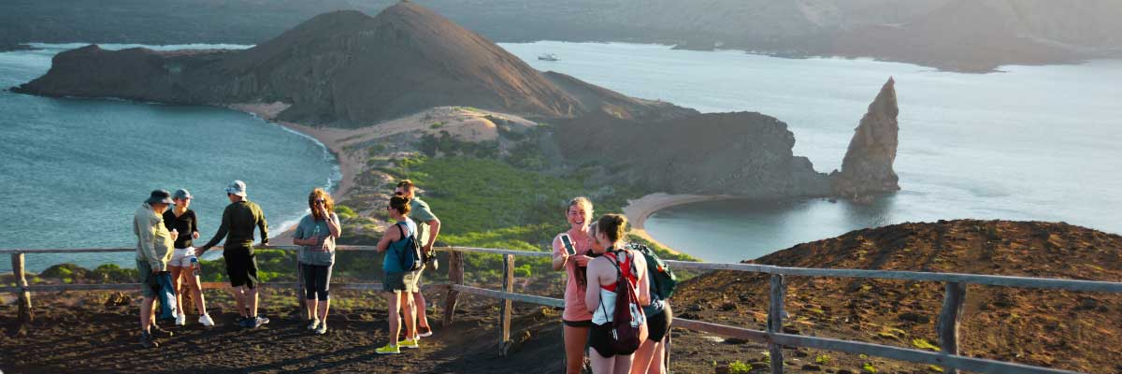

Included Services | Not Included Services
✔ Transportation to and from the meeting point at the Itabaca Channel | X International flights to/from Ecuador
✔ Coffee and tea station | X Airfare to/from the Galapagos Islands (Quito or Guayaquil)
✔ Snorkeling equipment (mask and snorkel) | X Galapagos National Park entrance fee (USD 200 per person)
✔ Visits, excursions, and activities according to the itinerary | X Transit Control Card (USD 20 per person)
✔ Wetsuits (only if the size is provided at least 72 hours before the trip) | X Alcoholic beverages
✔ 1 Bilingual naturalist guide (English-Spanish) | X Tips
✔ Fins (only if the size is provided at least 72 hours before the trip) | X Personal expenses
✔ Lunch on board | X Travel insurance (highly recommended)
✔ Towels | X Additional services not listed
✔ Local tax
Don't forget to bring
• Comfortable trekking shoes
• Sandals for the beach
• Swimsuit
• Hat and sunglasses
• Sunscreen

