**GALAPAGOS ONBOARD A CRUISE**

**6 DAYS / 5 NIGHTS**

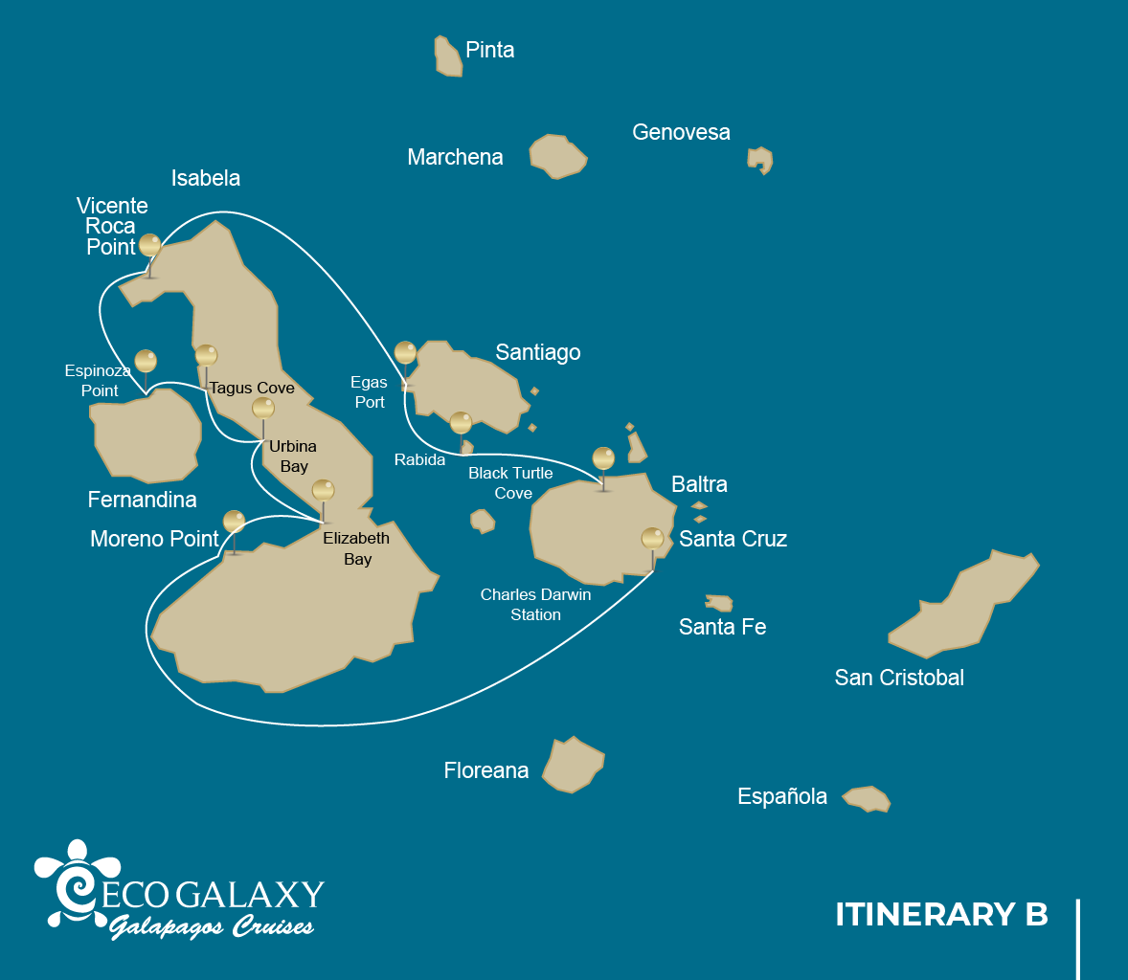

|  |  |  |  |  |  |  |  |
| --- | --- | --- | --- | --- | --- | --- | --- |
|  | | | **Hiking** | **Snorkel** | **Panga Ride** | **Paddle Board** | **Kayak** |
| SATURDAY | AM | **Santa Cruz Island :** Baltra - airport (arrival) |  |  |  |  |  |
|  | PM | **Santa Cruz Island :** Charles Darwin Station | * |  |  |  |  |
| SUNDAY | AM | **Isabela Island :** Moreno Point | * | * | * |  |  |
|  | PM | **Isabela Island :** Elizabeth Bay |  |  | * | * | * |
| MONDAY | AM | **Isabela Island :** Urbina Bay | * | * |  |  |  |
|  | PM | **Isabela Island :** Tagus Cove | * | * | * | * | * |
| TUESDAY | AM | **Fernandina Island :** Espinoza Point | * | * | * |  |  |
|  | PM | **Isabela Island :** Vicente Roca Point |  | * | * |  |  |
| WEDNESDAY | AM | **Santiago Island :** Egas Port | * | * |  |  |  |
|  | PM | **Rabida Island :** Rabida | * | * | * | * | * |
| THURSDAY | AM | **Santa Cruz Island :** Black Turtle Cove |  |  | * |  |  |
|  | PM | **Santa Cruz Island :** Baltra - airport (return) |  |  |  |  |  |

DAY 1

AM: BALTRA AIRPORT

Welcome to Galapagos! Upon arrival at Baltra Airport, your naturalist guide will greet you and assist with the transfer to Itabaca Channel. This initial journey offers your first connection with the archipelago as you take a short ferry ride to Santa Cruz Island. Along the way, observe Baltra’s arid landscape and learn about its history as a former U.S. WWII airbase. This is just the beginning of the many fascinating stories awaiting you on your adventure.

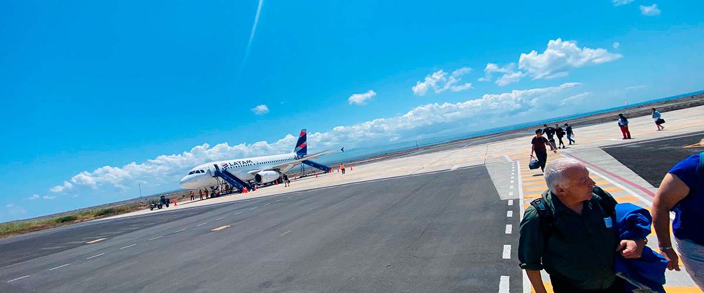

|  |  |
| --- | --- |
| **Trail:** |  |
| **Level**: | 1 |
| **Activities:** | - |

PM: CHARLES DARWIN STATION

The Charles Darwin Station is a nonprofit organization which has been working for decades together with the Galapagos National Park to preserve the biodiversity of these unique islands. During this visit you will learn about the projects that both institutions carry together to protect the native species and eradicate the invasive ones which are threatening the Galapagos environment. One of the most important and emblematic projects has been reproducing giant tortoises in captivity. The visit is mostly outdoors in a beautiful dry native forest with giant cactus and many other interesting native plants. It is also a fantastic place to find several endemic Darwin finches, as well as flycatchers and mockingbirds.

Galapagos giant tortoise and land iguanas breeding program, Galapagos mockingbirds, Darwin finches, Galapagos flycatchers

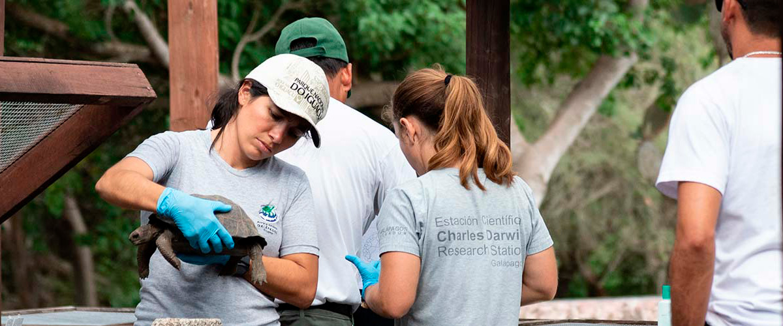

|  |  |
| --- | --- |
| **Food**: | -/L/D |
| **Trail:** | 2 km / 1,2 mi |
| **Lodging**: | M/C EcoGalaxy |
| **Level**: | 1 |
| **Activities:** | HIKING |

DAY 2

AM: MORENO POINT

Moreno Point is a magical place with extensive lava fields which look lifeless at first sight. Once inland, scattered brackish lagoons form an oasis of life where you can find flamingos, gallinules, ducks and herons. Along the shore we will look for penguins, marine iguanas, flightless cormorants, blue-footed boobies, sea lions, oystercatchers and other shore birds.

Snorkel Experience: We will snorkel to see sea turtles, cormorants and many species of fish. Look carefully in the long seaweeds and you might find a seahorse.

**Highlights:**  Stunning Views, Galapagos mockingbirds, Darwin finches, American flamingoes, Flightless cormorants, Marine iguanas, Ducks, Gallinules

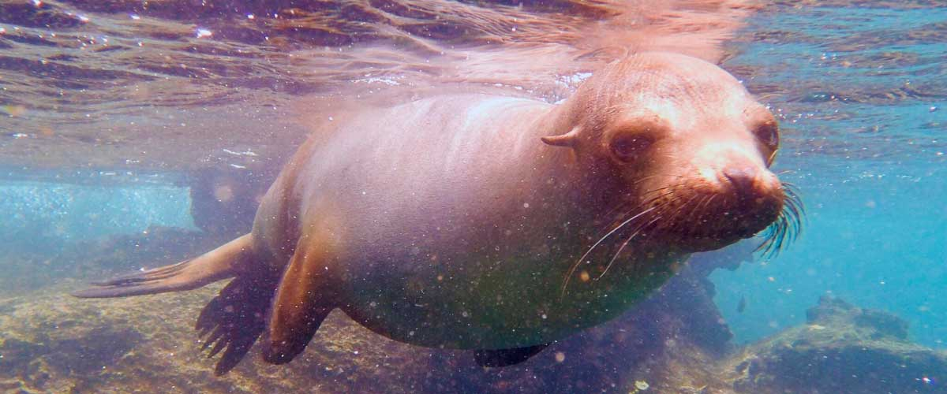

|  |  |
| --- | --- |
| **Trail:** | 1,6 km / 1 mi |
| **Level**: | 3 |
| **Activities:** | HIKING,SNORKEL,PANGA RIDE |

PM: ELIZABETH BAY

Elizabeth Bay is a beautiful sheltered bay surrounded by large mangroves and barren lava fields. There is no trail here so you will take a dinghy tour to explore many channels, pools and coves teeming with life. This is one of the best locations in the islands to see Galapagos penguins, but don’t expect to see thousands of them, as the entire population of the islands is only about 3.000 of them. Flightless cormorants also nest in the area and blue-footed boobies and pelicans often fish in these shallow and rich waters. Rays and sea turtles are also very abundant.

**Highlights:** Mangroves, Rays, Herons, Galapagos penguins, Galapagos hawks, Flightless cormorants, Sea turtles

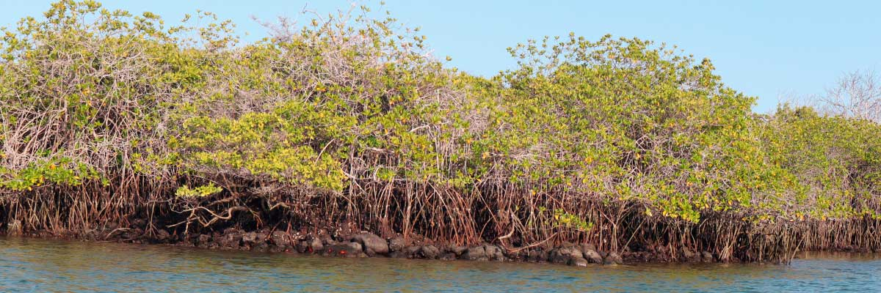

|  |  |
| --- | --- |
| **Food**: | B/L/D |
| **Trail:** | 1,4 km / 0,8 mi |
| **Lodging**: | M/C EcoGalaxy |
| **Level**: | 1 |
| **Activities:** | PANGA RIDE,PADDLE BOARD,KAYAK |

DAY 3

AM: URBINA BAY

This place is known for the dramatic uplifting that happened here during the 1950’s. A large portion of the coast was pushed up, exposing many hectares of previously submerged land. Look carefully along the trail and you will find small shells and corals, a proof that the area was underwater more than sixty years ago. The trail will give the opportunity to see land iguanas and, during certain seasons, giant tortoises. Galapagos hawks nest in the area and are often seen flying or perched on the trees.

Snorkel Experience: You can snorkel from the beach to see sea turtles, cormorants and penguins. Fish are also abundant in the area.

**Highlights:**  Stunning Views, Galapagos mockingbirds, Galapagos hawks, Darwin finches, Galapagos flycatchers, Galapagos land iguanas

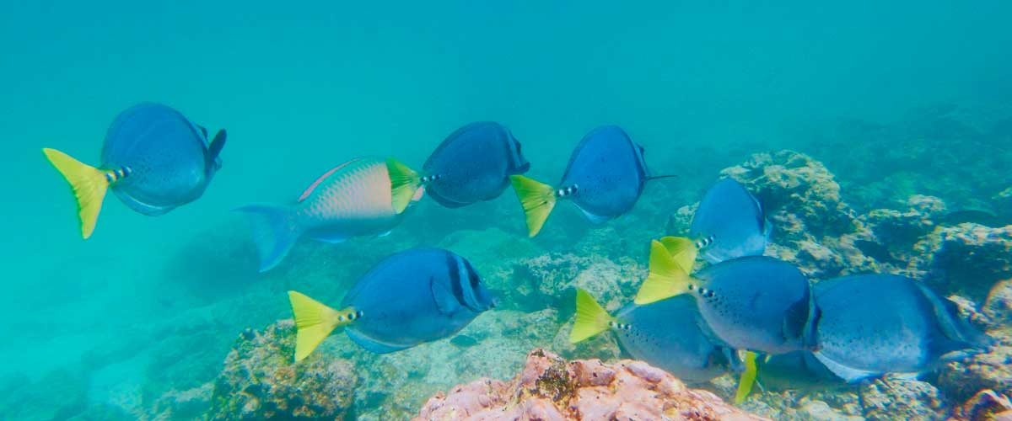

|  |  |
| --- | --- |
| **Trail:** | 1,2 km / 0,7 mi. Long trail 3,0 km / 1,8 mi |
| **Level**: | 1 |
| **Activities:** | HIKING,SNORKEL |

PM: TAGUS COVE

Tagus Cove is steeped in history, once visited by Charles Darwin during his Galapagos exploration. A scenic trail winds through dry Palo Santo forests, where Darwin’s finches and mockingbirds can be spotted. At the top, breathtaking views of Lake Darwin and Isabela’s towering volcanoes await. A boat tour along the shore provides a chance to observe Galapagos penguins, flightless cormorants, marine iguanas, and the elusive Galapagos martin, one of the rarest and most endangered birds in the archipelago.

Snorkel Experience: The nutrient-rich waters of Tagus Cove attract sea turtles, tropical fish, and penguins feasting on anchovies. Flightless cormorants can often be seen chasing fish underwater, creating a truly unique snorkeling experience.

**Highlights:** Stunning Views, Herons, Galapagos penguins, Galapagos hawks, Flightless cormorants, Marine iguanas, Sea turtles, Sea stars

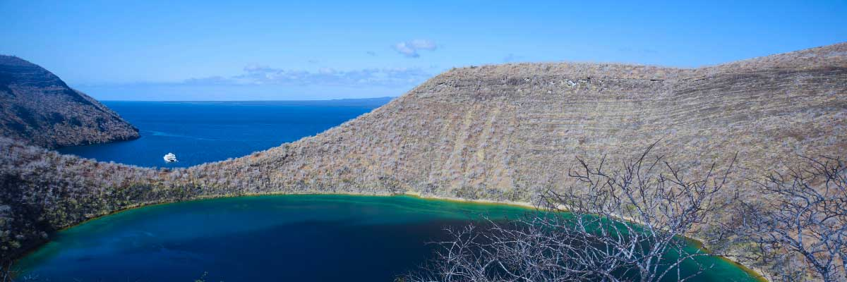

|  |  |
| --- | --- |
| **Food**: | B/L/D |
| **Trail:** | 2,6 km / 1,6 mi |
| **Lodging**: | M/C EcoGalaxy |
| **Level**: | 3 |
| **Activities:** | HIKING,SNORKEL,PANGA RIDE,PADDLE BOARD,KAYAK |

DAY 4

AM: ESPINOZA POINT

Located at the base of an imposing volcano (the most active in the Galapagos islands) this site is one of the jewels of the Galapagos National Park. As soon as you disembark you will be surrounded by hundreds of marine iguanas, as this is the largest colony for the species. Sea lions bask in the beaches while their pups play in tide pools. Along the shore you will see flightless cormorants, which are restricted to the western areas of the archipelago. Surrounded by cold plankton-rich waters, Punta Espinosa is home for an array of species, including herons, pelicans, oystercatchers, sea turtles, shorebird and many more. Look up in the mangroves as Galapagos hawks often perch to look for their prey.

Snorkel Experience: The nutrient-rich waters around Punta Espinosa attracts great numbers and diversity of fish and sea turtles. Seaweeds are also abundant, making this place the best for seeing marine iguanas feeding underwater. Following a cormorant underwater as it chases fish through the reef is one on the most amazing snorkel experiences you may have on your trip.

**Highlights:**  Stunning Views, Herons, Galapagos penguins, Oystercatchers, Galapagos hawks, Marine iguanas, Sea turtles, Shorebirds

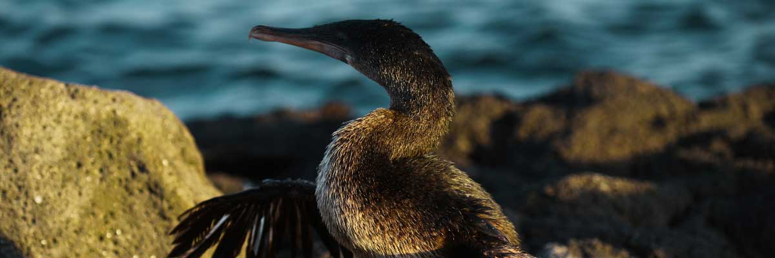

|  |  |
| --- | --- |
| **Trail:** | 1,6 km / 1 mi |
| **Level**: | 1 |
| **Activities:** | HIKING,SNORKEL,PANGA RIDE |

PM: VICENTE ROCA POINT

Vicente Roca Point offers a breathtaking natural spectacle, featuring some of the tallest cliffs in Galapagos and intriguing volcanic formations. While there are no trails, a dinghy tour along the shore provides an up-close look at the areaand#039;s rich wildlife. Highlights include flightless cormorants, blue-footed boobies, pelicans, and sea turtles. The site is also home to Galapagos fur seals and marine iguanas basking on the rocks. Moreover, the deep waters surrounding the area make it an excellent spot for dolphin and whale sightings.

Snorkel Experience: Snorkel in the cove to look for sea turtles, penguins, sea lions, cormorants, rays and many different species of fish. Look for fan corals, sponges and other invertebrates growing on the walls.

**Highlights:** Stunning Views, Galapagos penguins, Flightless cormorants, Marine iguanas, Sea turtles

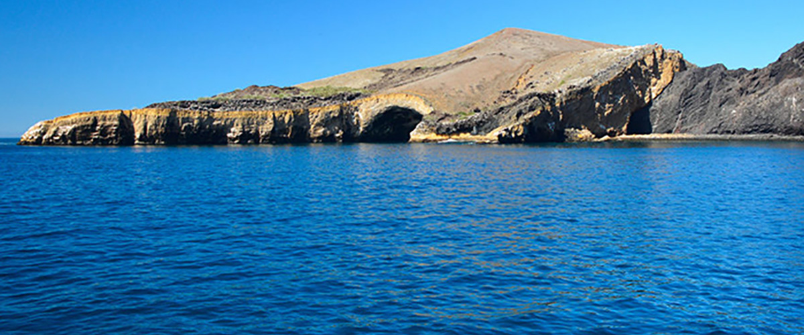

|  |  |
| --- | --- |
| **Food**: | B/L/D |
| **Trail:** | 1,4 km / 0,8 mi |
| **Lodging**: | M/C EcoGalaxy |
| **Level**: | 1 |
| **Activities:** | SNORKEL,PANGA RIDE |

DAY 5

AM: EGAS PORT

Puerto Egas is a fascinating destination where history and wildlife intertwine. While there is no actual port, remnants of 1960s colonization attempts still stand. The coastal trail is teeming with marine iguanas basking in the sun and sea lions resting on the rocks. Herons, oystercatchers, and shorebirds complete this thriving ecosystem. Towards the end of the trail, the grottos are home to a small colony of the elusive Galapagos fur seal. Additionally, land iguanas were reintroduced to the island in 2019 after over a century of absence.

Snorkel Experience: A snorkeling session from the beach will lead you to an area of rocky bottoms, excellent for observing fish, turtles, and reef sharks. Sea lions often frequent this area and are typically open to interacting with divers.

**Highlights:**  Stunning Views, Herons, Galapagos sea lions, Galapagos fur seals, Oystercatchers, Galapagos hawks, Darwin finches, Marine and land iguanas, Galapagos doves, Shorebirds

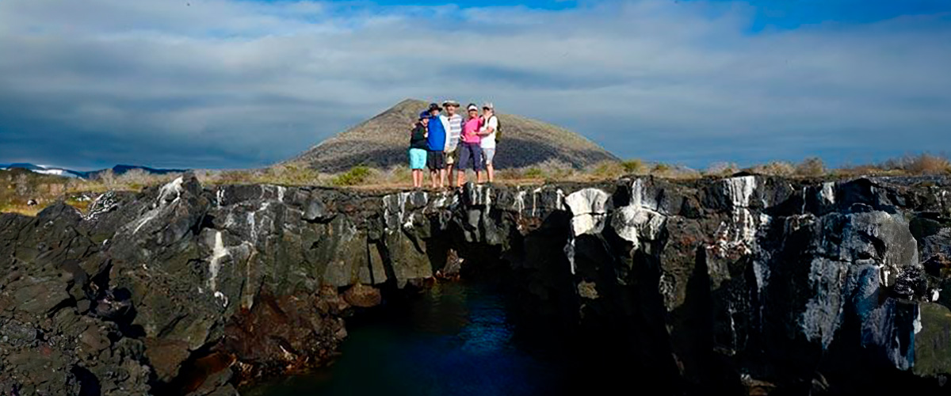

|  |  |
| --- | --- |
| **Trail:** | 2,3 km / 1,4 mi |
| **Level**: | 1 |
| **Activities:** | HIKING,SNORKEL |

PM: RABIDA

Rabida is a small island famous for its reddish lava rocks (rich in iron) which gives it a unique look. The beach is also red and hosts a small colony of sea lions. There is a small salt water lagoon where we will see ducks and stilts and sometimes flamingoes. The trail will take you inland to get beautiful views of the beach and the lagoon. Look for Darwin finches, flycatchers and mockingbirds. In the cliffs along the coast you can find Nazca and blue-footed boobies, brown noddy, herons and the two species of sea lions: Galapagos and fur seals.

Snorkel Experience: You can snorkel from the beach and explore a sheltered rocky area, which is excellent for fish, sea lions and reef sharks. Look at the high diversity of small invertebrates attached to the vertical walls.

**Highlights:** Red-sand beach, Galapagos sea lions, Galapagos hawks, Darwin finches, Galapagos flycatchers

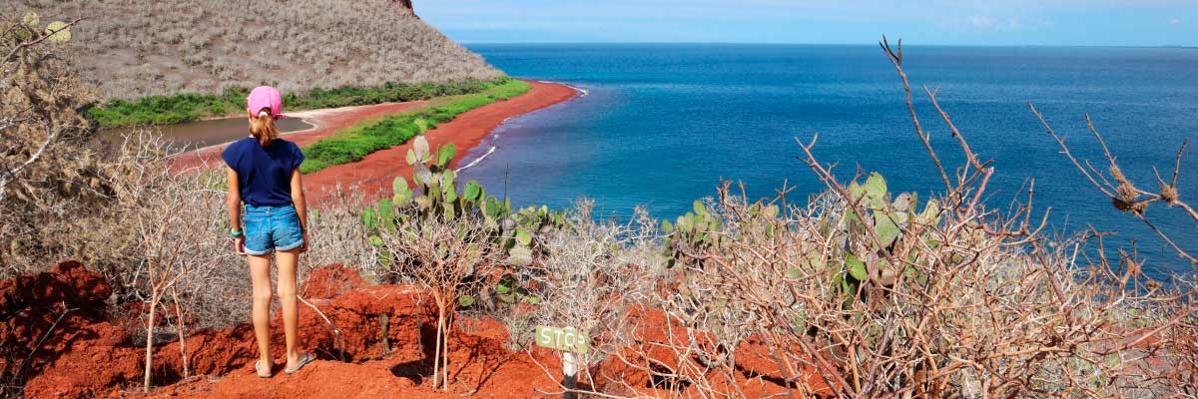

|  |  |
| --- | --- |
| **Food**: | B/L/D |
| **Trail:** | 2 km / 1,2 mi |
| **Lodging**: | M/C EcoGalaxy |
| **Level**: | 1 |
| **Activities:** | HIKING,SNORKEL,PANGA RIDE,PADDLE BOARD,KAYAK |

DAY 6

AM: BLACK TURTLE COVE

Black Turtle Cove gets its name from the abundance of green sea turtles, locally known as: “tortugas negras”. There is no landing here so you will be doing a boat tour on the dinghies, exploring shallow channels and small coves surrounded by beautiful mangrove forests. Reef sharks, sea turtles and several species of rays inhabit this beautiful area which is considered an important mating area for turtles and a nursery for several species of sharks. Herons, pelicans and boobies are also common here as they pray in schools of anchovies.

Mangroves, White-tipped and black-tipped reef sharks, Green sea turtles, Rays, Herons, Blue footed boobies, Reef sharks

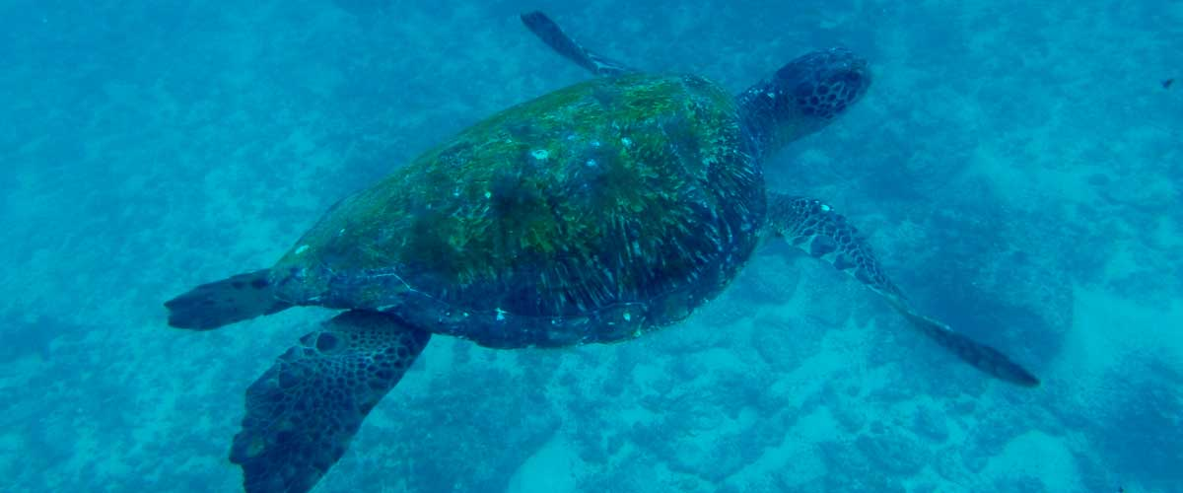

|  |  |
| --- | --- |
| **Trail:** |  |
| **Level**: | 1 |
| **Activities:** | PANGA RIDE |

PM: BALTRA (AIRPORT)

Your Galapagos adventure comes to an end. Today, you will be transferred to Baltra Airport, where your National Park naturalist guide will assist you with final details before your flight back to mainland Ecuador. As you bid farewell to this paradise, take with you the unforgettable memories of one of the world’s most extraordinary destinations.



|  |  |
| --- | --- |
| **Food**: | B/-/- |
| **Trail:** |  |
| **Lodging**: | M/C EcoGalaxy |
| **Level**: | 1 |
| **Activities:** | - |

GLOSSARY

|  |  |  |
| --- | --- | --- |
| **Feeding** | **Breakfast** | B |
| **Lunch** | L |
| **Dinner** | D |
| **Difficulty of the hike** | **Level 1** | Easy |
| **Level 2** | Moderate |
| **Level 3** | Difficult |