GALAPAGOS ONBOARD A CRUISE
6 Days – 5 Nights
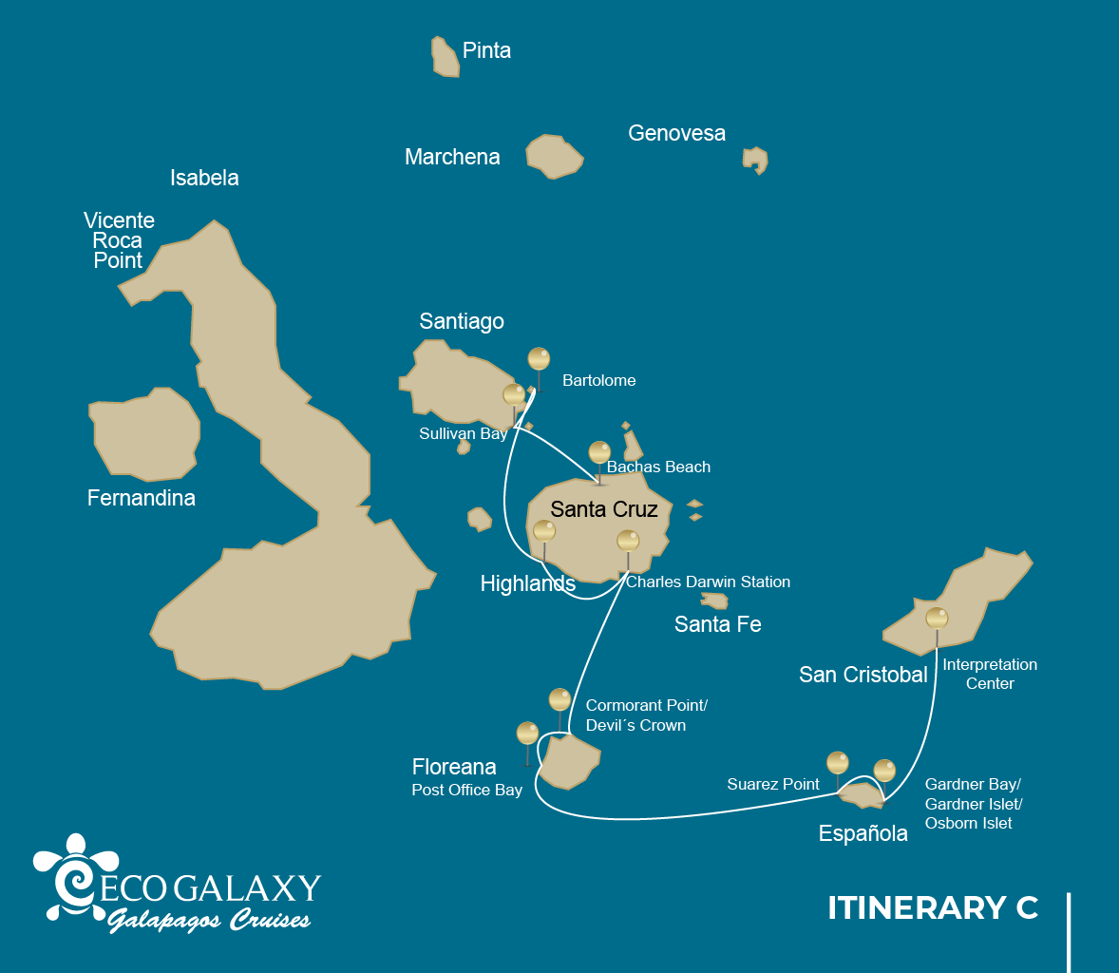
 |  |  | Hiking | Snorkel | Panga Ride | Paddle Board | Kayak
THURSDAY | AM | Santa Cruz Island : Baltra - airport (arrival)
 | PM | Santa Cruz Island : Bachas Beach | *
FRIDAY | AM | Santiago Island : Sullivan Bay | * | *
 | PM | Bartolome Island : Bartolome | * | * | *
SATURDAY | AM | Santa Cruz Island : Highlands | *
 | PM | Santa Cruz Island : Charles Darwin Station | *
SUNDAY | AM | Floreana Island : Cormorant Point / Devil's Crown | * | * | *
 | PM | Floreana Island : Post Office Bay | * | *
MONDAY | AM | Española Island : Suarez Point | *
 | PM | Española Island : Gardner Bay / Islote Gardner / Osborn Islote | * | * | * | * | *
TUESDAY | AM | San Cristobal Island : San Cristobal Interpretation Center | *
 | PM | San Cristobal Island : San Cristobal - airport (return)

DAY 1

AM: BALTRA AIRPORT
Welcome to Galapagos! Upon arrival at Baltra Airport, your naturalist guide will greet you and assist with the transfer to Itabaca Channel. This initial journey offers your first connection with the archipelago as you take a short ferry ride to Santa Cruz Island. Along the way, observe Baltra’s arid landscape and learn about its history as a former U.S. WWII airbase. This is just the beginning of the many fascinating stories awaiting you on your adventure.

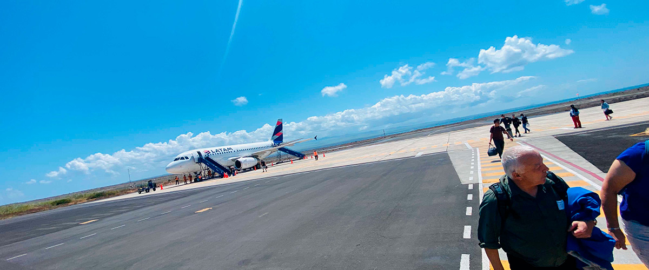
Trail:
Level: | 1
Activities: | -

PM: BACHAS BEACH
After, we will go to the beach known as Bachas, located north of Santa Cruz Island. Here we can snorkel or take a relaxing walk on the beach. For this, we will make a wet landing, in which we will jump from the panga to the shore of the beach. Again, we recommend disembarking barefoot and wearing light walking shoes for the rest of the journey. The saltwater lagoon behind the beach often has great blue herons and small birds. Both beaches are nesting areas for green sea turtles.

Stunning Views, Blue footed boobies, White-cheeked pintails, American flamingoes, Sandpipers, Lava gulls
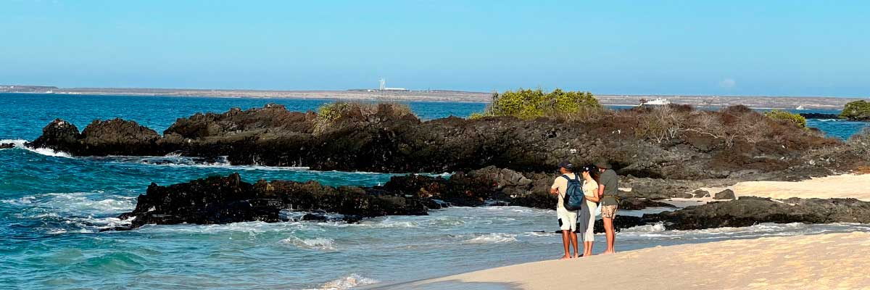
Food: | -/L/D
Trail: | 1,6 km / 1 mi
Lodging: | M/C EcoGalaxy
Level: | 1
Activities: | HIKING

DAY 2

AM: SULLIVAN BAY
This hike is a journey into understanding the birth of these volcanic islands. You will walk in a very well preserved flow of Pahoehoe lava, which will give you endless opportunities to see the delicate textures of these types of lavas which only appear in a few places throughout the world. At first sight the barren landscape looks completely deprived of life, but look carefully for pioneer plants, lava lizards and small birds. By the shore, you can find penguins, pelicans and oystercatchers.

Highlights: Lava tubes, Galapagos penguins, Oystercatchers, Galapagos hawks
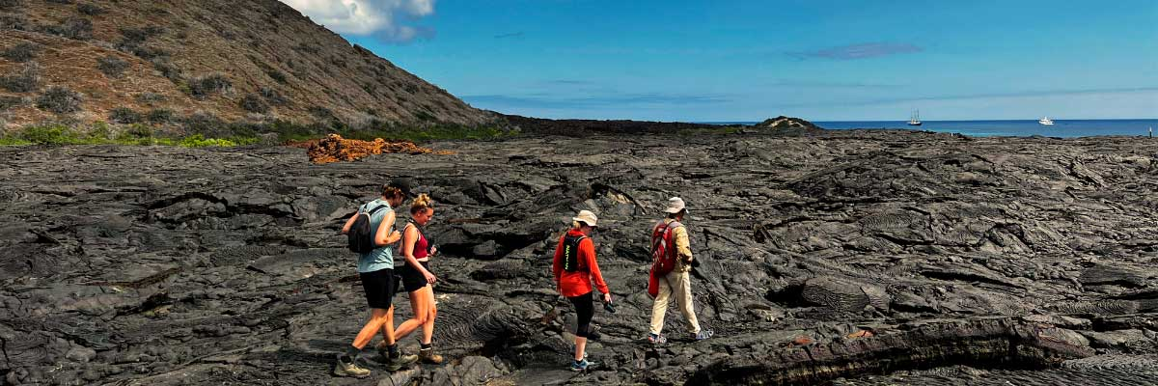
Trail: | 2,2 km / 1,4 mi
Level: | 3
Activities: | HIKING,SNORKEL

PM: BARTOLOME
Bartolome is one of the most iconic islands in Galapagos, renowned for its dramatic volcanic landscape and the famous Pinnacle Rock. Nestled beside a peach-colored sand beach, this island is one of the few places where you can spot penguins without traveling to remote Isabela and Fernandina. The hike to the summit offers breathtaking views of a lunar-like terrain dotted with volcanic cones, with stunning panoramas of Sullivan Bay and Pinnacle Rock. From the top, the vast beauty of the archipelago unfolds before you, creating a truly unforgettable experience.

Highlights: Volcanic landscapes, Pinnacle rock, Herons, Bluefooted boobies, Galapagos penguins
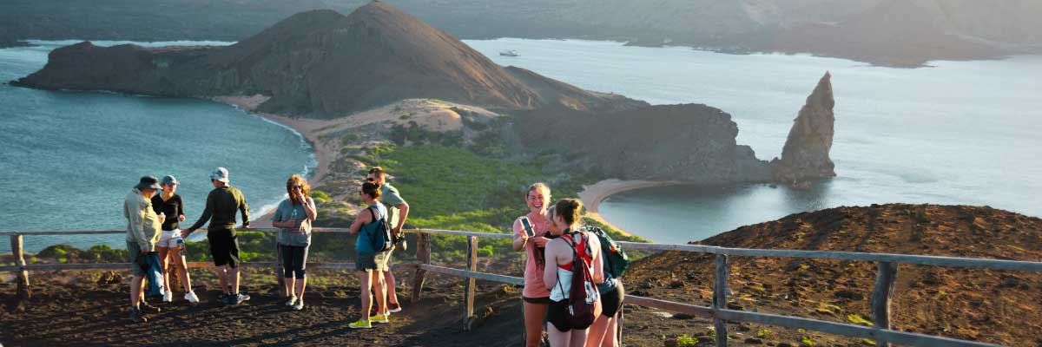
Food: | B/L/D
Trail: | 1,5 km / 0,9 mi
Lodging: | M/C EcoGalaxy
Level: | 2
Activities: | HIKING,SNORKEL,PANGA RIDE

DAY 3

AM: HIGHLANDS
Embark on a pleasant journey into the verdant highlands, where a bus ride leads you through lush forested landscapes home to Galapagos Giant Tortoises. These impressive creatures, reaching up to 300 kg/600 lbs, can often be seen peacefully grazing or resting in freshwater ponds. The highlands are also home to a variety of bird species rarely found in the lowlands. Depending on your itinerary, you may have the opportunity to visit a lava tunnel and learn about the volcanic forces that shaped these remarkable islands.

Highlights: Lava tunnels, Darwin finches, Galapagos flycatchers, Giant tortoises, Barn owls, White-cheeked pintails
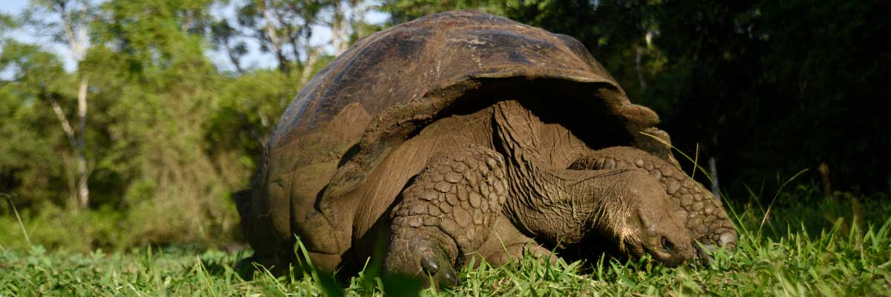
Trail: | 1-1,5 km / 0,6-0,9 mi
Level: | 1
Activities: | HIKING

PM: CHARLES DARWIN STATION
The Charles Darwin Station is a nonprofit organization which has been working for decades together with the Galapagos National Park to preserve the biodiversity of these unique islands. During this visit you will learn about the projects that both institutions carry together to protect the native species and eradicate the invasive ones which are threatening the Galapagos environment. One of the most important and emblematic projects has been reproducing giant tortoises in captivity. The visit is mostly outdoors in a beautiful dry native forest with giant cactus and many other interesting native plants. It is also a fantastic place to find several endemic Darwin finches, as well as flycatchers and mockingbirds.

Highlights: Galapagos giant tortoise and land iguanas breeding program, Galapagos mockingbirds, Darwin finches, Galapagos flycatchers
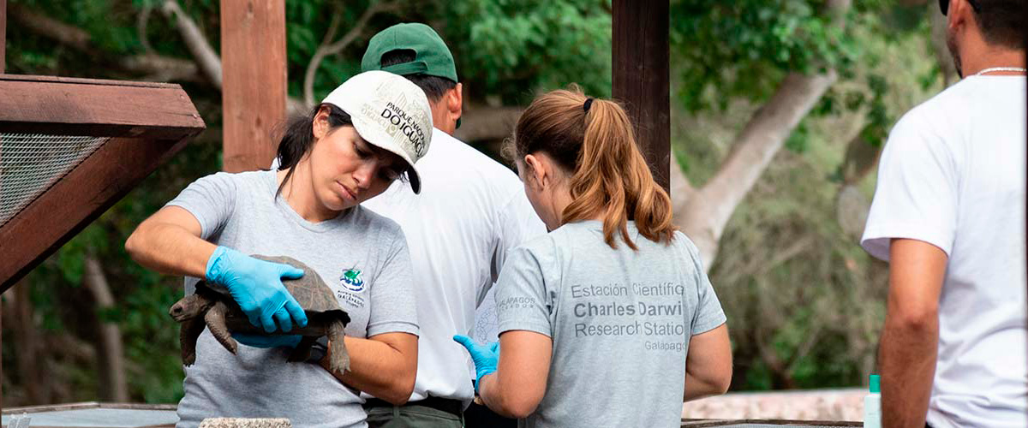
Food: | B/L/D
Trail: | 2 km / 1,2 mi
Lodging: | M/C EcoGalaxy
Level: | 1
Activities: | HIKING

DAY 4

AM: CORMORANT POINT / DEVIL´S CROWN
Punta Cormorant is located in the north of Floreana and it is known for its large coastal lagoon with American flamingos, white-cheeked pintails, black-necked stilts and other shorebirds. There is a beautiful white sand beach which is an important nesting ground for green sea turtles where we can also see rays and reef sharks. In recent years, a small group of blue footed boobies have started to breed right by the trail. This is also a great trail dayto look at endemic plants.

Highlights: Sea turtle nesting site, Galapagos shearwaters, Tropicbirds, Frigatebirds, Finches, Shorebirds
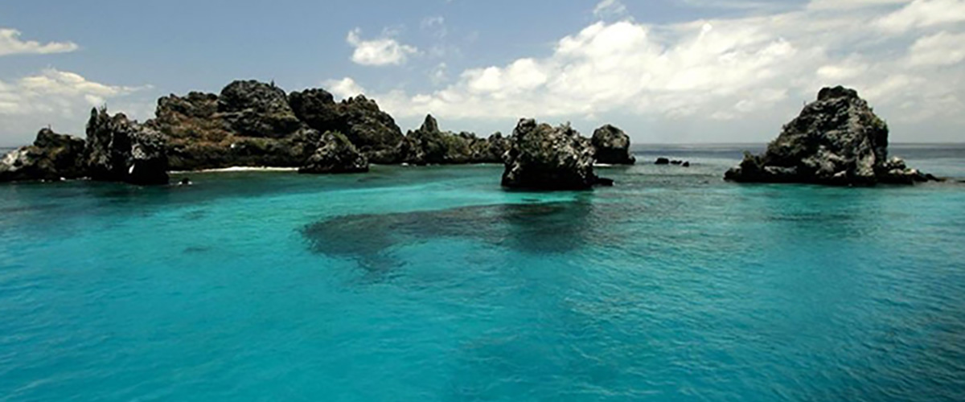
Trail: | 1,6 km / 1 mi
Level: | 1
Activities: | HIKING,SNORKEL,PANGA RIDE

PM: POST OFFICE BAY
Floreana is famous for the tales of German settlers and the baroness during the late 1920’s and 30 ‘s. Assassinations, disappearances and other unsolved mysteries are the ingredients of this fascinating story. Post office bay was often used by whalers to anchor their ships and go up to the highlands to get freshwater and tortoises. Most boats visiting the Galapagos had to came to this place sooner or later, so a system of mail was established more than 200 years ago: a barrel near the beach became the way to leave messages to other ships and also to the outside world. This mail system is still in use and will allow you to send postcards from the Galapagos to the outside world. Aside from a small beautiful beach, the area is great for dinghy tours to look for sea lions, green sea turtles, shorebirds, small sharks and, with some luck, Galapagos penguins.

Highlights: Galapagos penguins, Marine iguanas, Sea turtles, Finches, Shorebirds
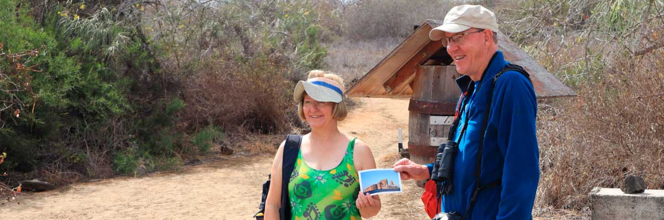
Food: | B/L/D
Trail: | 0,7 km / 0,4 mi
Lodging: | M/C EcoGalaxy
Level: | 1
Activities: | HIKING,SNORKEL

DAY 5

AM: SUAREZ POINT
This rocky trail is one the most amazing nature walks you can do in the Galapagos islands. From the moment you set foot on the island and all the way along the trail the amount and diversity of fauna is truly amazing. Sea lions and marine iguanas will be the first ones welcoming us, followed by large colonies of sea birds, including Nazca and Blue-footed boobies, gulls and tropicbirds. At the end of the trail we will visit a colony of waved albatross (April to January), the largest bird in the islands and one of the most interesting because of its powerful flight and elaborate courtship. Waved albatross only nest at Española, so this is the only place where you will see them at close range.

Highlights: Stunning Views, Herons, Galapagos mockingbirds, Galapagos hawks, Darwin finches, Marine iguanas, Waved Albatross, Lava lizards
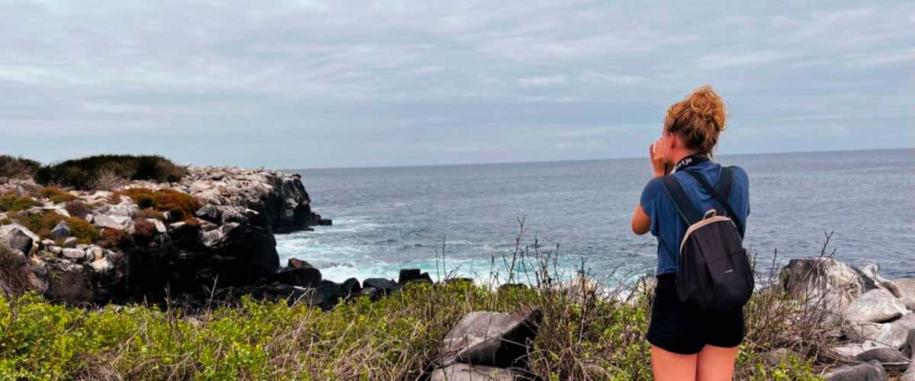
Trail: | 1,7 km / 1,1 mi
Level: | 3
Activities: | HIKING

PM: GARDNER BAY
Gardner beach is undoubtedly one of the most beautiful and interesting beaches to visit in the Galapagos. Its fine coral sand and turquoise water give it a totally tropical appearance, which contrasts with the presence of sea lions basking in the beach. You will have the opportunity to walk along the beach and learn about the biology of sea lions and other endemic species, such as the Española mockingbird, marine iguanas and Galapagos hawks.

Highlights: Herons, Galapagos mockingbirds, Galapagos hawks, Darwin finches, Marine iguanas, Waved Albatross, Lava lizards
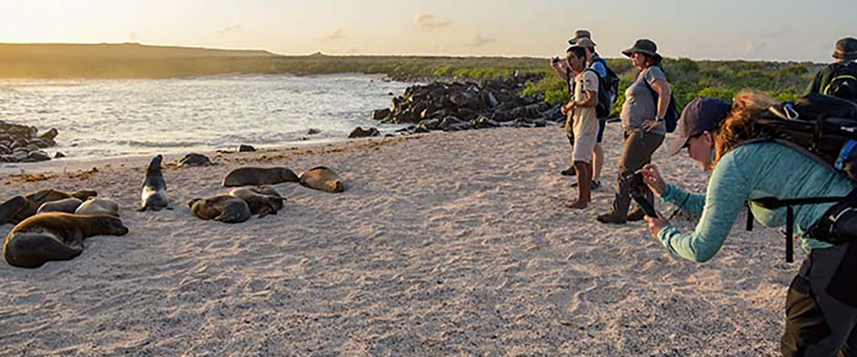
Food: | B/L/D
Trail: | 0,8 km / 0,5 mi
Lodging: | M/C EcoGalaxy
Level: | 1
Activities: | HIKING,SNORKEL,PANGA RIDE,PADDLE BOARD,KAYAK

DAY 6

AM: INTERPRETATION CENTER
Located in the outskirts of Puerto Baquerizo, this center is dedicated to the history of human presence in the Galapagos. Since the times of the early Spanish explorers to the present times, including illustrious visitors such as Charles Darwin, this permanent exhibition will take you through the dangers and struggles of the first settlers trying to survive the harsh Galapagos environment.

Endemic plants and an exhibition on human history
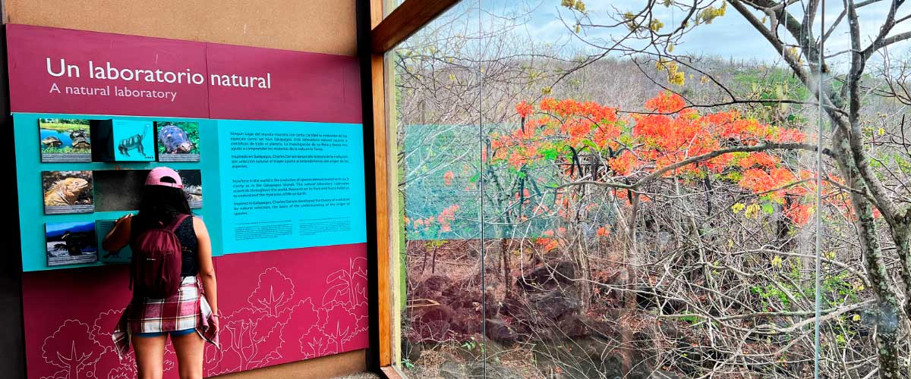
Trail: | 0,2 km / 650 ft
Level: | 1
Activities: | HIKING

PM: AIRPORT (SAN CRISTOBAL)
After exploring the breathtaking biodiversity and unique landscapes of the Galapagos, it’s time to return to mainland Ecuador. You’ll be transferred to the airport, bringing this unforgettable journey to a close. Every encounter with giant tortoises, blue-footed boobies, and volcanic landscapes will remain etched in your memory. Galapagos is not just a destination—it’s a transformative experience that will stay with you forever. Wishing you a wonderful journey back!

Food: | B/-/-
Trail:
Lodging: | M/C EcoGalaxy
Level: | 1
Activities: | -

GLOSSARY
Feeding | Breakfast | B
Feeding | Lunch | L
Feeding | Dinner | D
Difficulty of the hike | Level 1 | Easy
Difficulty of the hike | Level 2 | Moderate
Difficulty of the hike | Level 3 | Difficult

